COMPUTER NETWORKS - UE24CS252B
Lab 3: Exploring UDP with DNS using Wireshark

SRN: PES1UG24CS493
NAME: Tanmayi Nagabhairava
SEC: I

Part 1: DNS Analysis

1. Observe DNS Caching
Question: Run dig www.google.com twice and observe the difference.
Answer: In the first query, the resolution time was 28 msec. In the second query, the recorded time was 43 msec. While a second query is technically expected to be faster (near 0 msec) due to the local resolver (127.0.0.53) caching the result, these results show minor fluctuations likely due to virtual machine processing overhead or internal resolver latency.
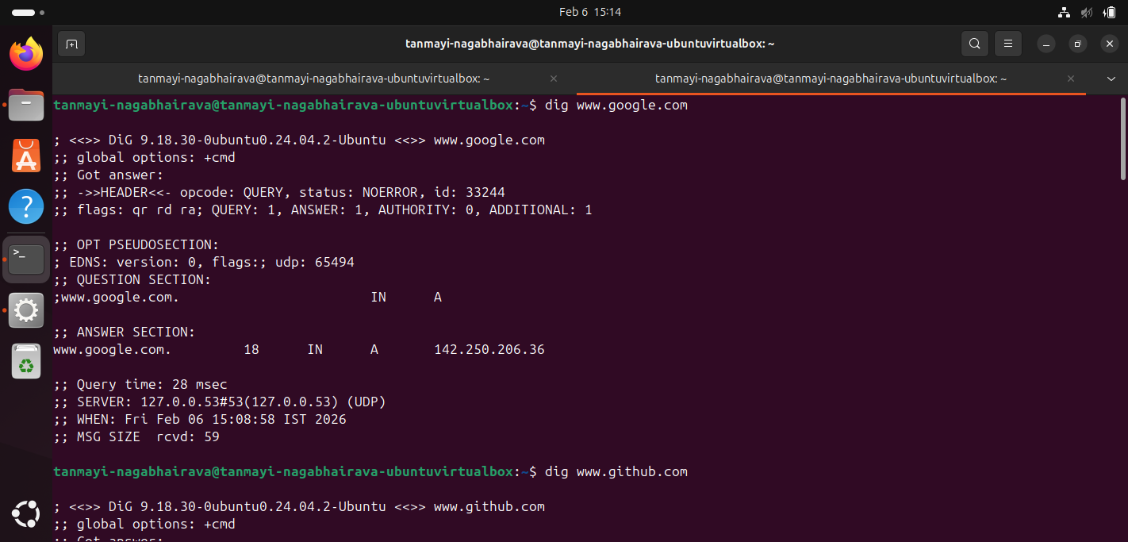
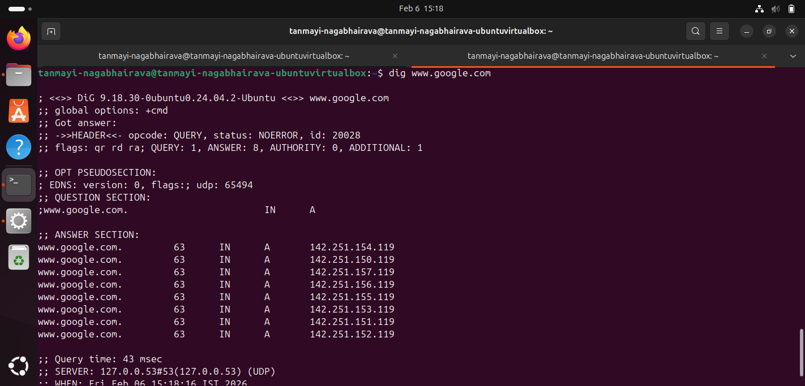
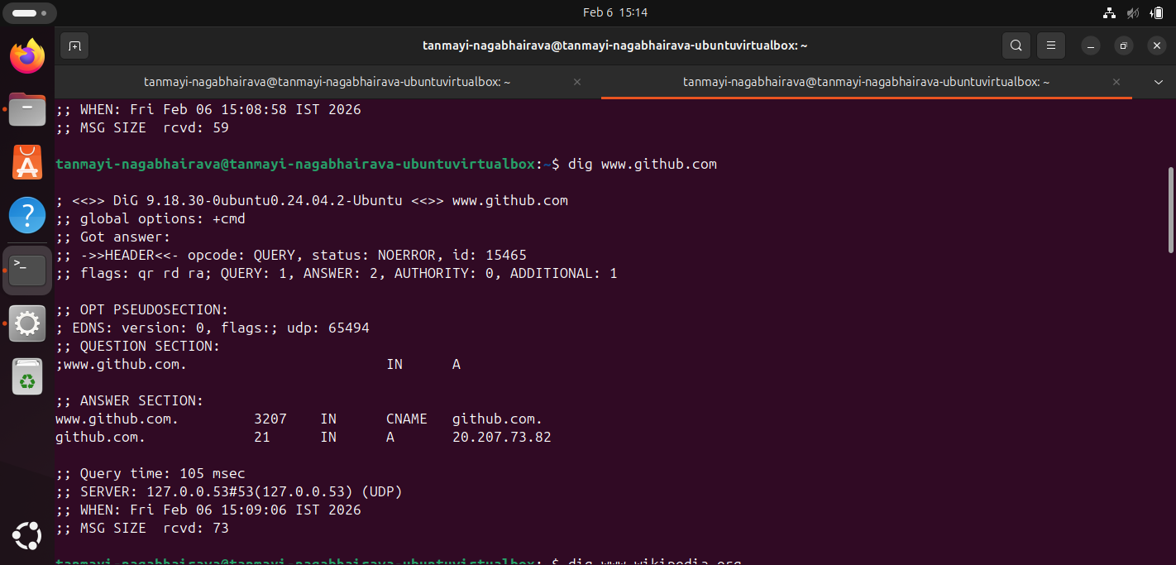
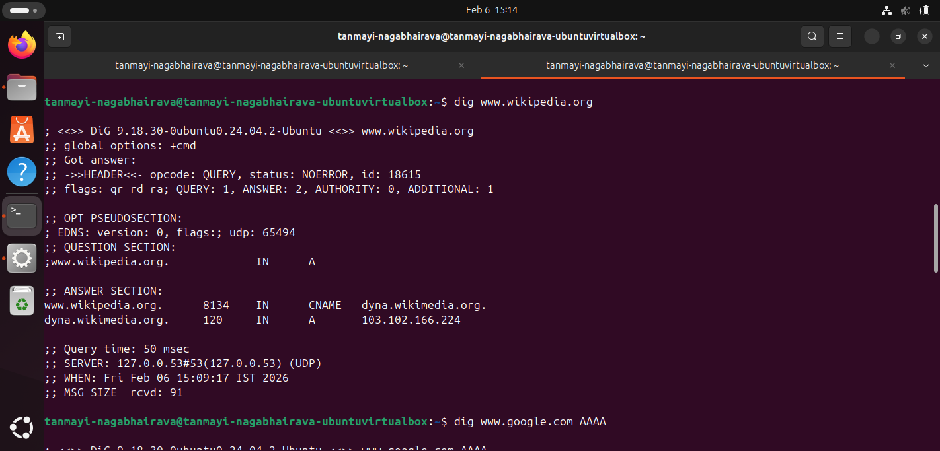
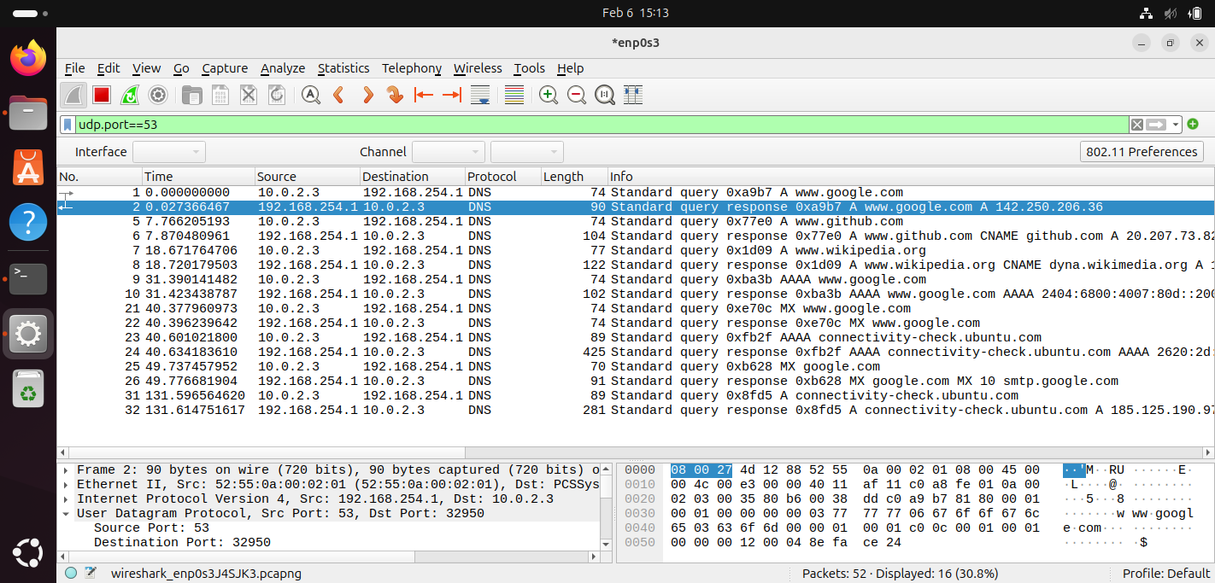

2. Query for Other Record Types
Question: Observe IPv6 and mail server records using dig.
Answer:
• IPv6 (AAAA Record): Using dig www.google.com AAAA, the domain resolved to the IPv6 address 2404:6800:4007:80d::2004.
• Mail Server (MX Record): The command dig google.com MX identified the authoritative mail server as smtp.google.com.

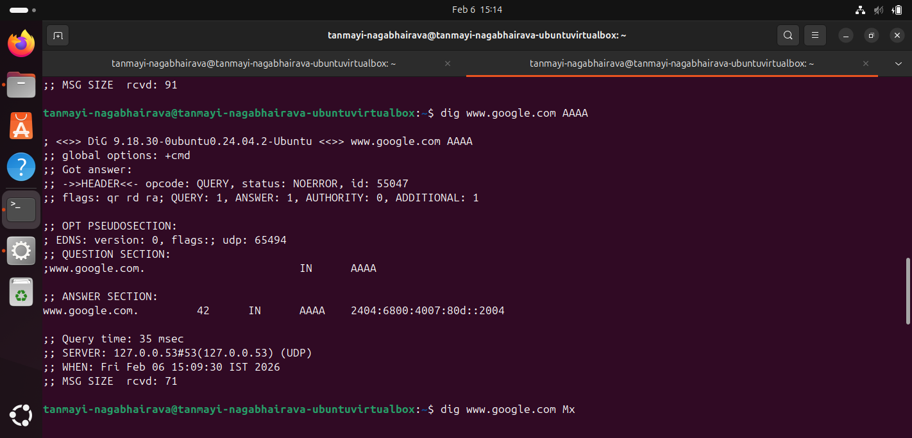
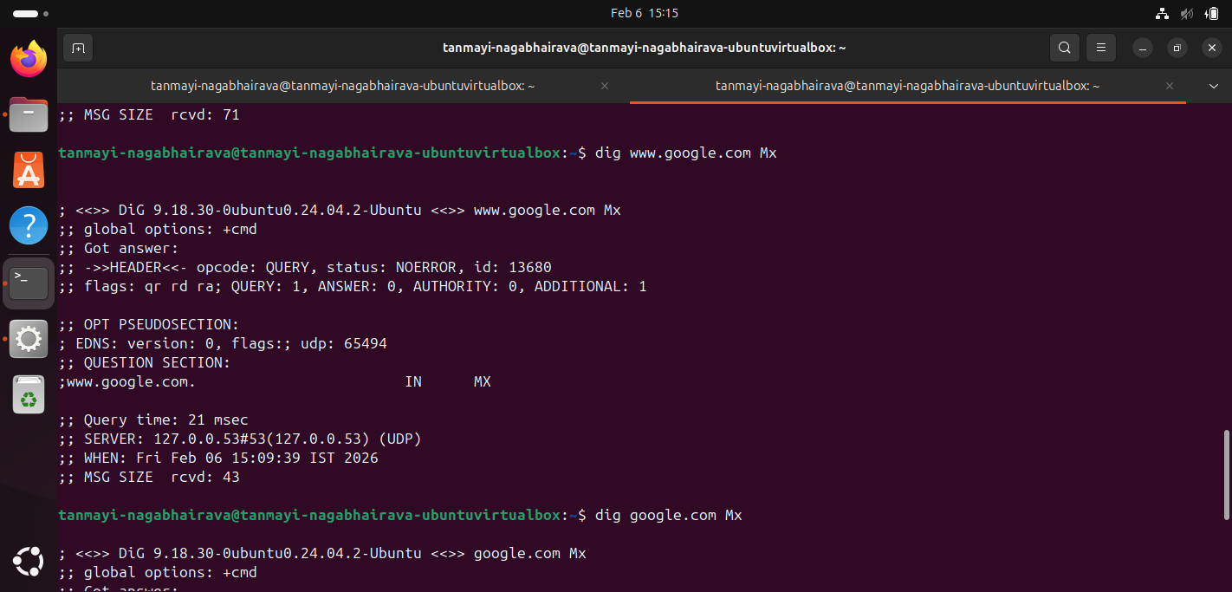
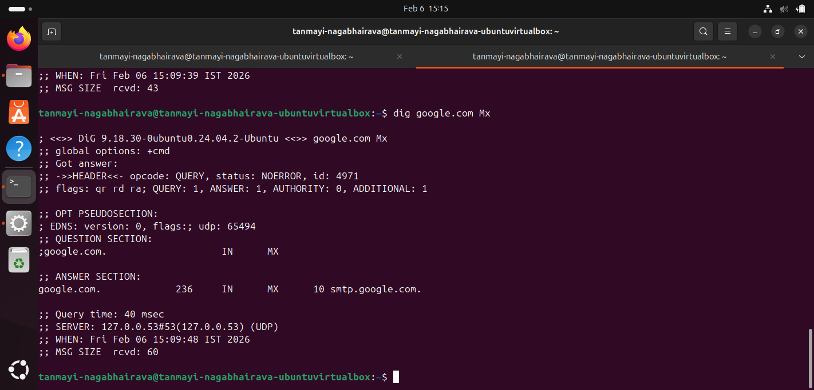

3. Modify DNS Servers
Question: Change the DNS server to a public one like 8.8.8.8 and compare.
Answer: Using the Google DNS server (@8.8.8.8), the resolution bypassed the local cache and resulted in a query time of 17 msec.

4. Analyze DNS over TCP
Question: Use dig +tcp to force DNS over TCP and explain the packet behavior.
Answer: Forcing DNS over TCP introduces a connection-oriented overhead. Wireshark captured the required TCP 3-way handshake ([SYN], [SYN, ACK], [ACK]) before the DNS query was transmitted, demonstrating that TCP requires a formal connection setup whereas UDP does not.
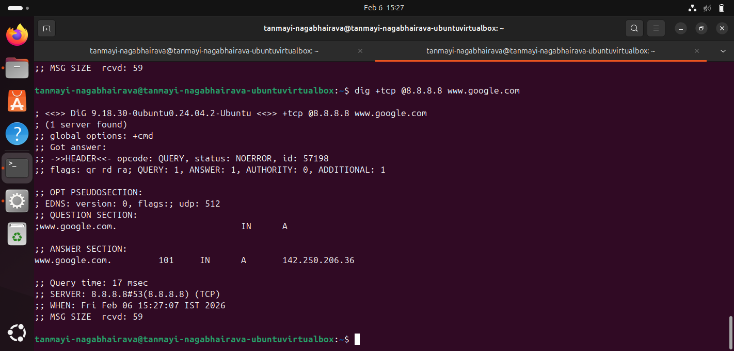

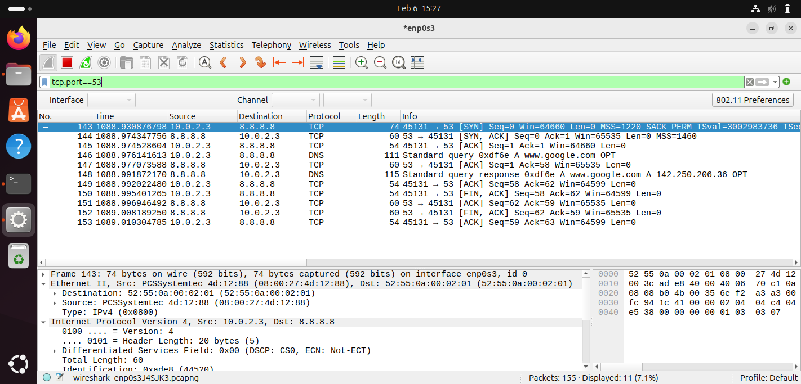

Part 2: UDP Communication

1. UDP Traffic Capture
Question: Set up a UDP server on port 54321, send three messages, and capture the traffic.
Answer: The server was set up using nc -u -l 54321 , and messages "Hello", "PES1UG24CS493", and "CN LAB 3" were sent from the client. Wireshark shows the direct transmission of these UDP packets without any handshake.
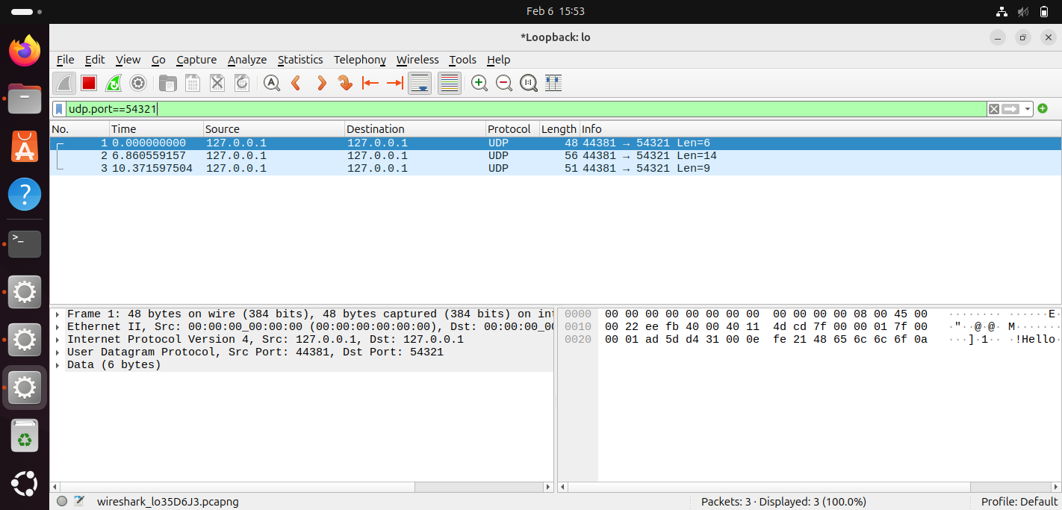
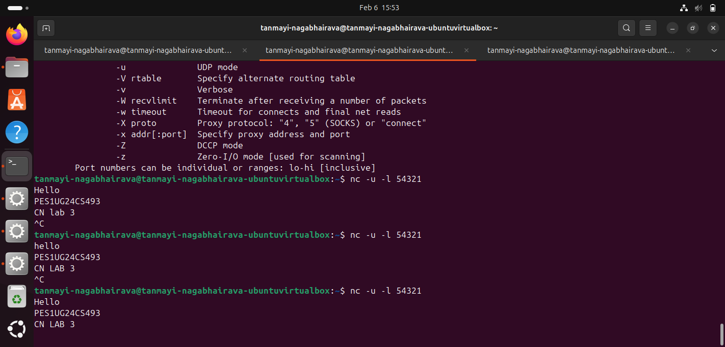
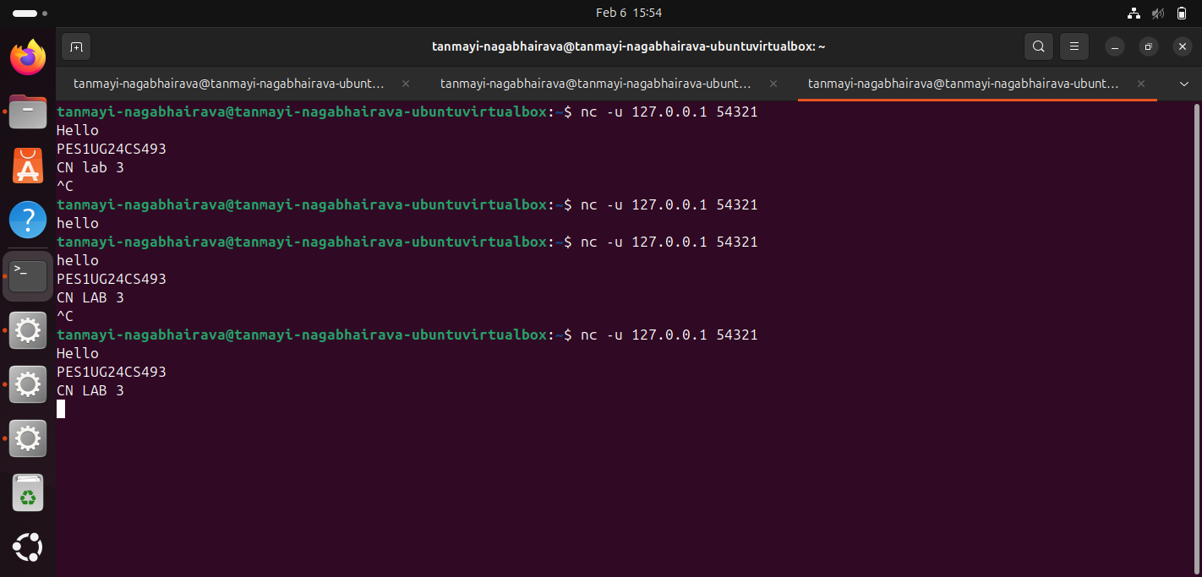

2. UDP Analysis Report
Question: How does UDP differ from TCP and why is it suitable for DNS?
Answer: UDP is a connectionless protocol that lacks the setup delays, retransmissions, and error recovery found in TCP.
Question: Why is UDP suitable for DNS?
Answer: It is ideal for DNS as it provides fast communication without the setup delays associated with TCP handshakes.
Question: What are your observations about UDP traffic in Wireshark?
Answer: Based on the captured traffic, UDP appears as immediate data transfers between the source and destination without any connection-setup packets like SYN or ACK. Each message sent from the terminal results in a single UDP segment where the "Length" field in Wireshark specifically matches the size of the text string sent (e.g., 6 bytes for "Hello"). Unlike the TCP capture, there are no extra packets for handshaking or acknowledgment.

Part 3: Analysis of the UDP protocol in DNS

1. Select the first UDP segment in your trace.
- 1. What is the packet number of this segment in the trace file?
ANS: The packet number is 1.
- 2. What type of application-layer payload or protocol message is being carried in this UDP segment?
ANS: It is carrying a DNS (Domain Name System) query for www.google.com
- 3. How many fields are there in the UDP header? What are the names of these fields?
ANS: There are 4 fields. The names are Source Port, Destination Port, Length, and Checksum.
2. By consulting the displayed information in Wireshark’s packet content field for this packet, what is the length (in bytes) of the UDP header field?
ANS: The UDP header is 8 bytes long. (Each of the four fields is 16 bits, or 2 bytes, totaling 8 bytes).

3. Examine the pair of UDP packets (Query and Reply).
- A. What is the packet number of these two UDP segments in the trace file?
ANS: The packet numbers are 1 (the query) and 2 (the response).
- B. What is the value in the source port field in this UDP segment (Query)?
ANS: The source port is 32950.
- C. What is the value in the destination port field in this UDP segment (Query)?
ANS: The destination port is 53.
- D. What is the value in the source port field in this second UDP segment (Reply)?
ANS: The source port is 53.
- E. What is the value in the destination port field in this second UDP segment (Reply)?
ANS: The destination port is 32950.
Relationship between the port numbers: The port numbers are swapped between the query and the reply. The destination port of the query becomes the source port of the reply, and the source port of the query becomes the destination port of the reply to ensure the data is returned to the correct application.

