COMPUTER NETWORKS - UE24CS252B

Lab 4: TCP Congestion Window using Wireshark

SRN: PES1UG24CS493
NAME: Tanmayi Nagabhairava
SEC: I

Task A: Capture TCP traffic and plot the Congestion Window

1. Three-Way Handshake Capture
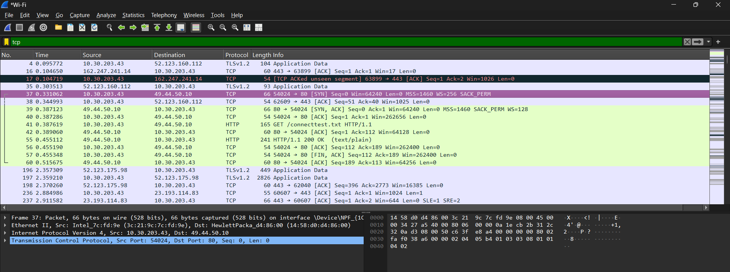

2. TCP SYN Segment Details
- Question: What is the sequence number of the TCP SYN segment used to initiate the TCP connection? Additionally, which field or flag indicates that the segment is a SYN packet?
- Answer:
  - Sequence Number: The relative sequence number is 0.
  - Flag: The SYN flag (specifically, the Syn bit set to 1 in the TCP header) tells us that it is a SYN packet.
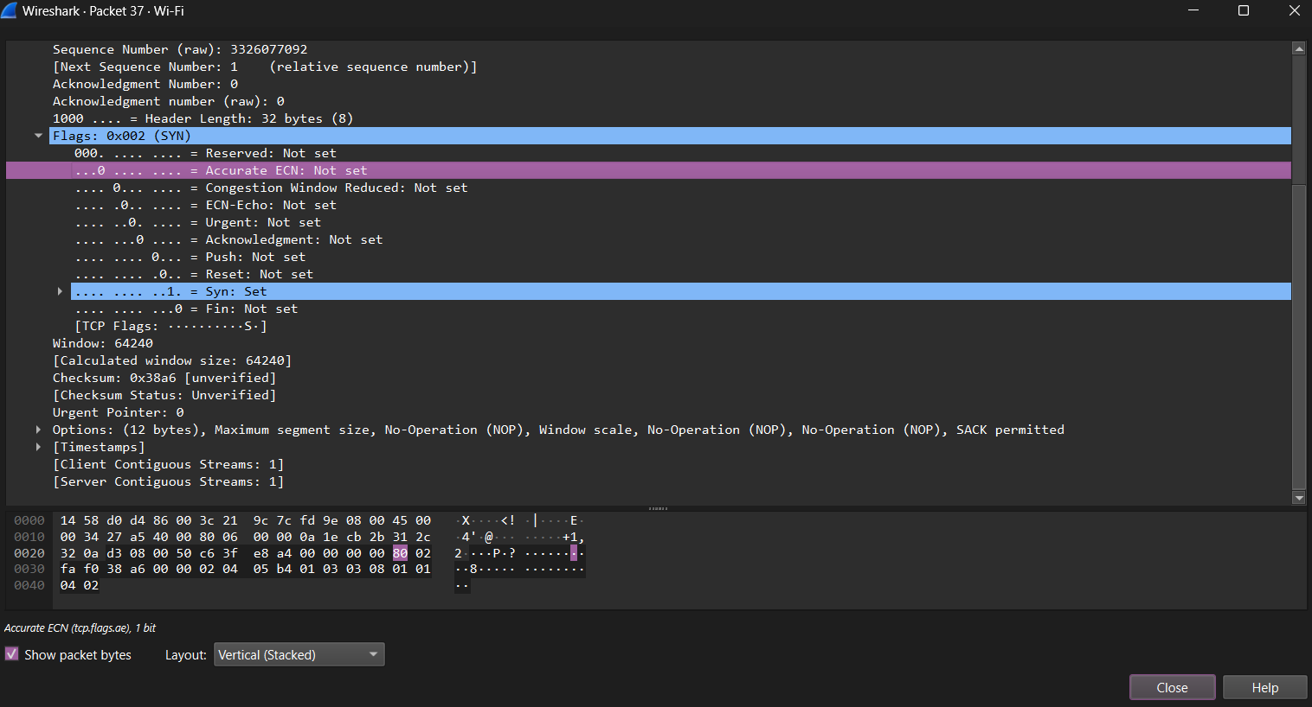

3. SYN-ACK Segment Details
- Question: What is the sequence number of the SYN-ACK segment? Which field or flag indicates it is a SYN-ACK packet? What is the value of the Acknowledgement field, and why is it set to that value?
- Answer:
  - Sequence Number: The relative sequence number is 0.
  - Flag: Both the SYN flag and the Acknowledgment (ACK) flag are set to 1.
  - Acknowledgment Value: The value is 1.
  - Reasoning: It is set to 1 because the server is acknowledging the client's SYN packet (Seq 0) and is now expecting the next byte to be Sequence 1.
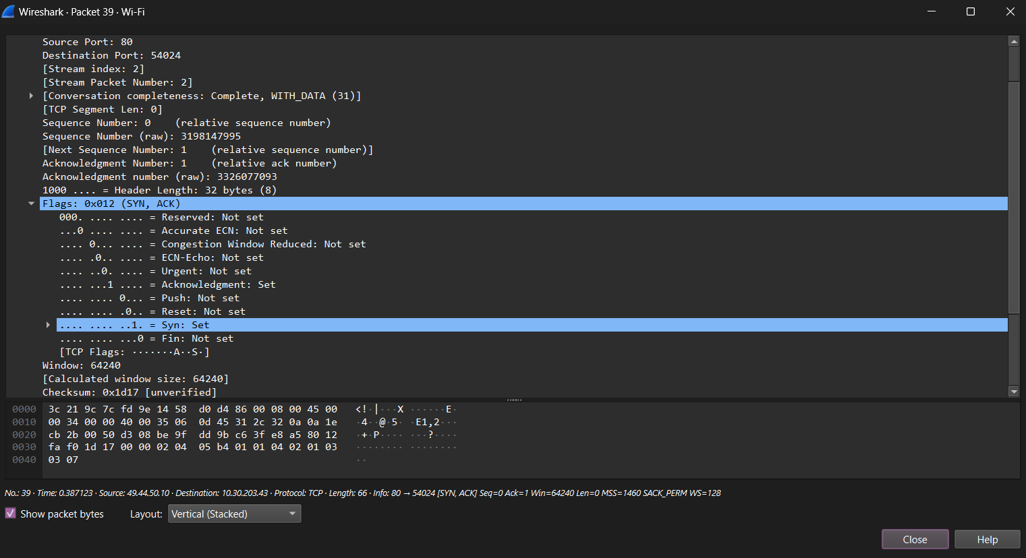

4. Congestion Window Plot Analysis
- Question: Provide a screenshot of the congestion window. What do the blue and green lines represent?
- Answer:
  - Blue Line/Dots: Represent the Unacked (Outstanding) Bytes, which are the data packets currently "in flight" on the network.
  - Green Line: Represents the Receiver’s Window (Rcv Win), showing the maximum buffer capacity the receiver has available.
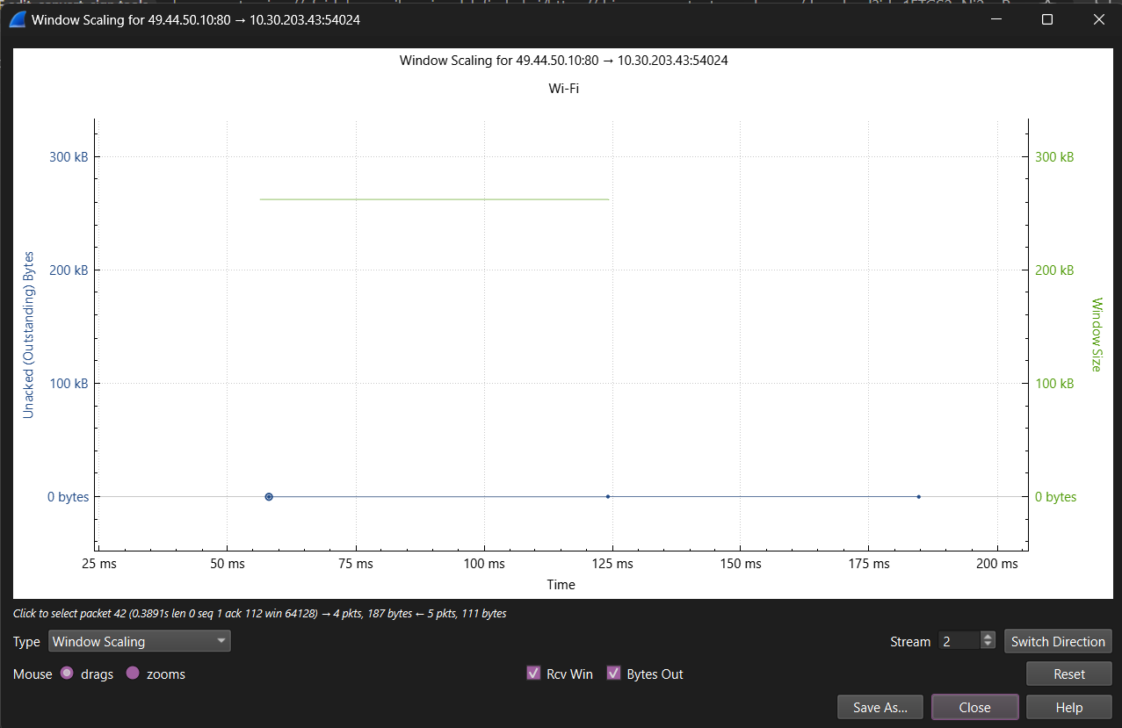

5. Transmission Behavior Inference
- Question: What can you infer about TCP transmission behavior (receiver-side or sender-side congestion control) and why?
- Answer:
  - Inference: The plot indicates sender-side congestion control.
  - Reasoning: In this plot that is being observed, it can be noticed that the blue dots (data being sent) are significantly lower than the green line (receiver's capacity). This shows that the sender is limiting its transmission rate according to its internal window.

Task B: Analyzing the Congestion Window from the packet capture

1. TCP Phases and Variant Identification
- Question: Provide a screenshot of the congestion window and clearly mark the different phases of TCP, such as Slow Start and Congestion Avoidance. Identify which TCP variant (flavor) is being used.
- Answer:
  - Slow Start Phase: This is seen in the sharp, exponential "step" in window size growth, such as from 0 to 2 seconds.
  - Congestion Avoidance Phase: This is seen in the more gradual, linear diagonal line after a window restarts due to a loss, such as from 6.5 to 10 seconds.
  - TCP Variant: TCP Reno is used.
  - Reasoning: From the graph, it is seen that the window is divided by two in Multiplicative Decrease when a loss is detected by duplicate ACKs, instead of always dropping to 1.
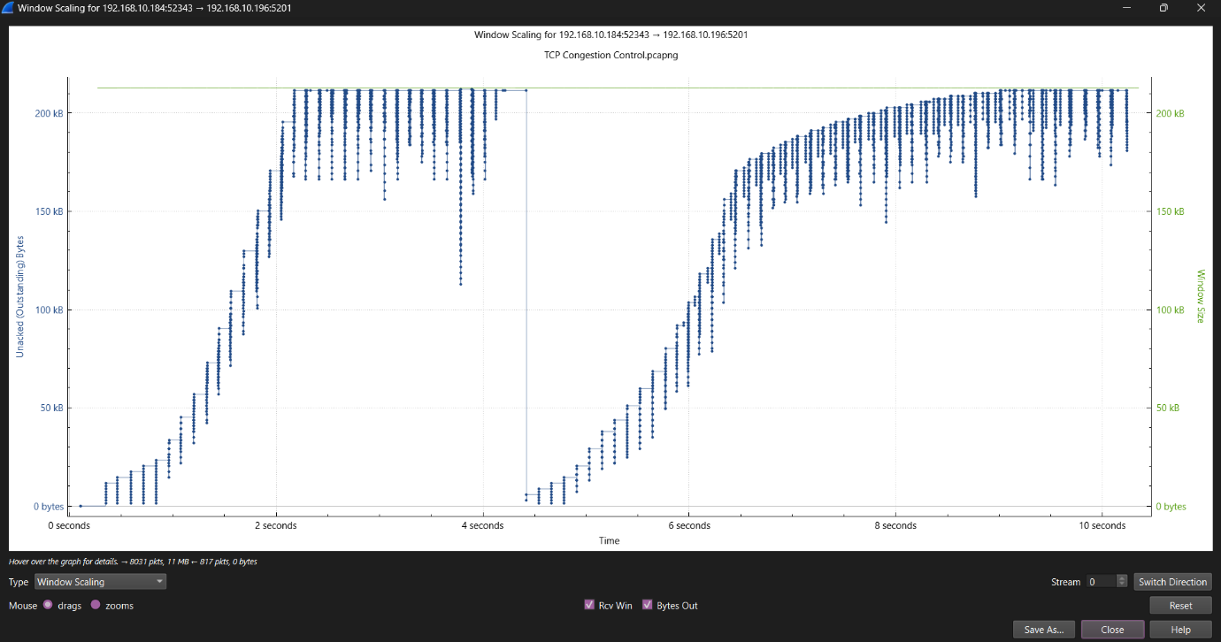

2. Three Duplicate ACKs and Fast Retransmit
- Question: Provide a screenshot that shows three duplicate ACKs. What do you observe in the subsequent packet transmission, and how would you explain this behavior?
- Answer:
  - Observation: In the packet list, three similar TCP Dup ACK packets are received (Frames 3358 to 3360). Immediately after this, a TCP Fast Retransmission packet is sent (Frame 3361).
  - Explanation: This is the "Fast Retransmit" mechanism. The sender receives three duplicate ACKs for the same segment, which implies that the segment has been lost, and it immediately retransmits the segment.
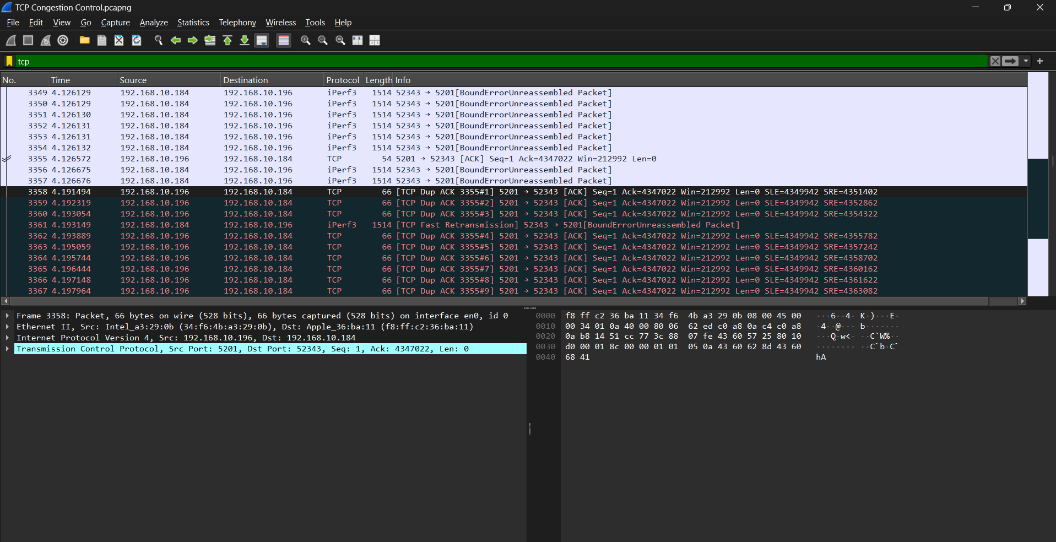

3. Conditions for Window Reduction to 1
- Question: Explain under what conditions the TCP congestion window (cwnd) decreases to 1, and describe the network event that causes this behavior.
- Answer:
  - Conditions: The cwnd decreases to 1 when a Retransmission Timeout (RTO) occurs.
  - Network Event: The reason for this is that this situation is caused by severe network congestion. In this case, where the network is so congested that even duplicate ACKs are not being sent, the timer is triggered. In order to clear this kind of congestion, the window size is reset to 1 and Slow Start is initiated again.

4. Post-Reduction Packet Observation
- Question: Provide a screenshot of the packets observed after the congestion window is reduced to 1. Describe how the congestion window size changes over time.
- Answer:
  - Observation: After the drop to window size 1 at the 4.4s mark, a TCP Retransmission event is observed after a large time gap.
  - Growth Over Time: Based on the trend established by the next few packets, the cwnd starts growing exponentially. It can be observed that the cwnd doubles with each Round Trip Time as the sender goes back to the Slow Start phase to test the available bandwidth again.


