COMPUTER NETWORKS - UE24CS252B

Lab 5: Understanding Ethernet and ARP using Wireshark

SRN: PES1UG24CS493
NAME: Tanmayi Nagabhairava
SEC: I

Part A: Understanding Ethernet

1. HTTP GET Screenshot
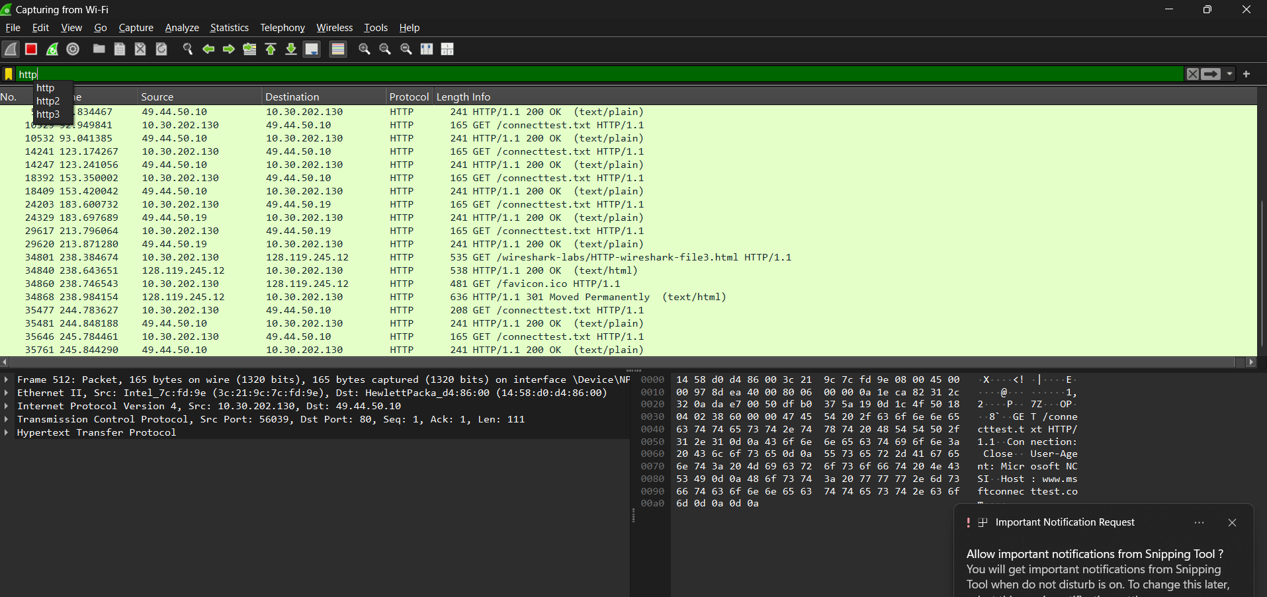

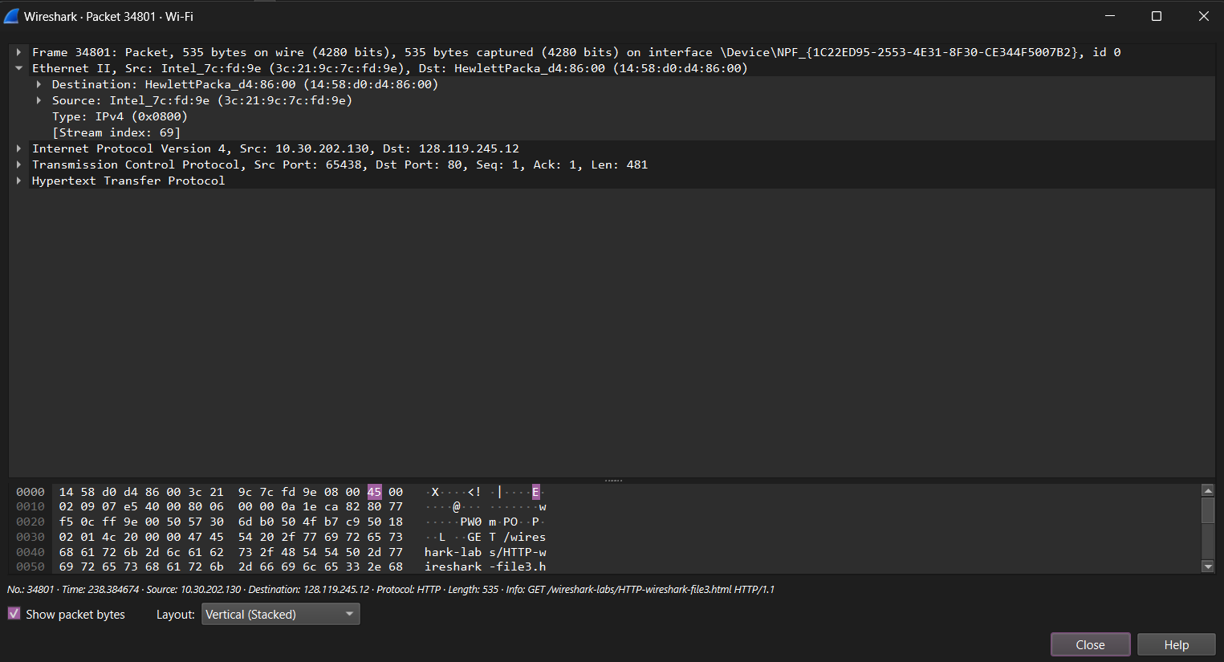

2. Ethernet Source Address
- Source Address: 3c:21:9c:7c:fd:9e (Intel_7c:fd:9e).
- Physical Address: Yes, this is the MAC address of your device's network interface.

3. Ethernet Destination Address
- Destination Address: 14:58:d0:d4:86:00 (HewlettPacka_d4:86:00).
- Physical Address of Server? No.
- Justification: This MAC address belongs to your default gateway (router). Ethernet frames only travel between devices on the same local segment; your router receives the frame and forwards the IP packet toward the UMass server.

4. Destination IP Address
- Destination IP: 128.119.245.12.
- Corresponds to Server? Yes, this is the IP address for the server gaia.cs.umass.edu.

5. HTTP Response Screenshot

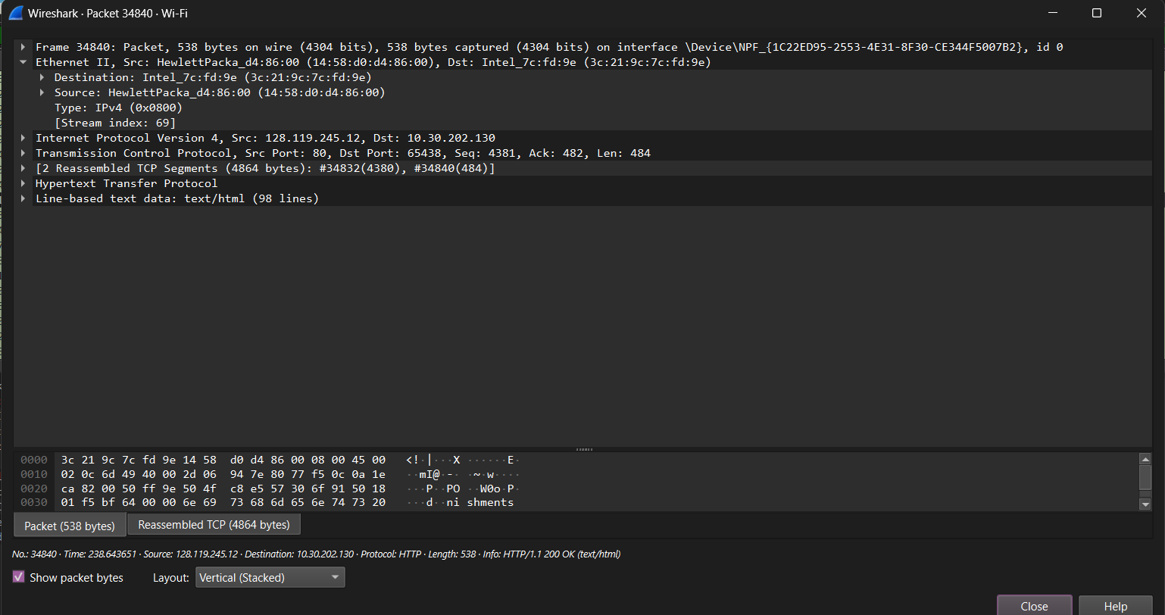

6. Comparison and Changes
- Address Swap: The Ethernet source and destination addresses are reversed compared to the GET packet.
- Source Address: Now 14:58:d0:d4:86:00, which belongs to your router.
- Destination Address: Now 3c:21:9c:7c:fd:9e, which is your own device.

Part B: Understanding ARP

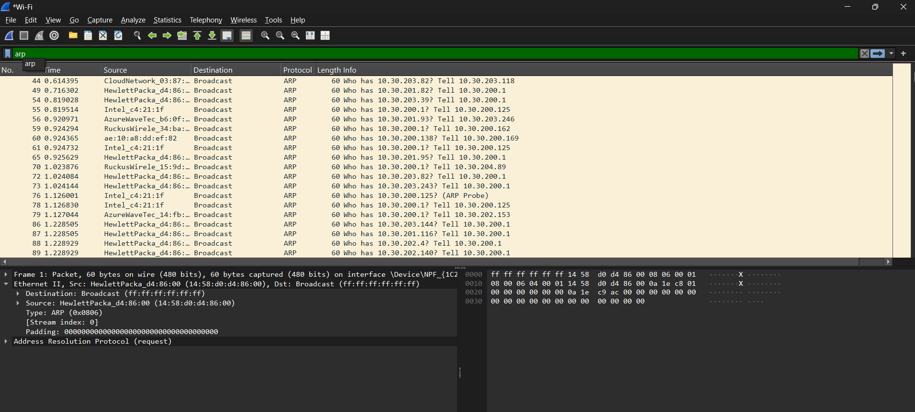

1.ARP Probe Packet

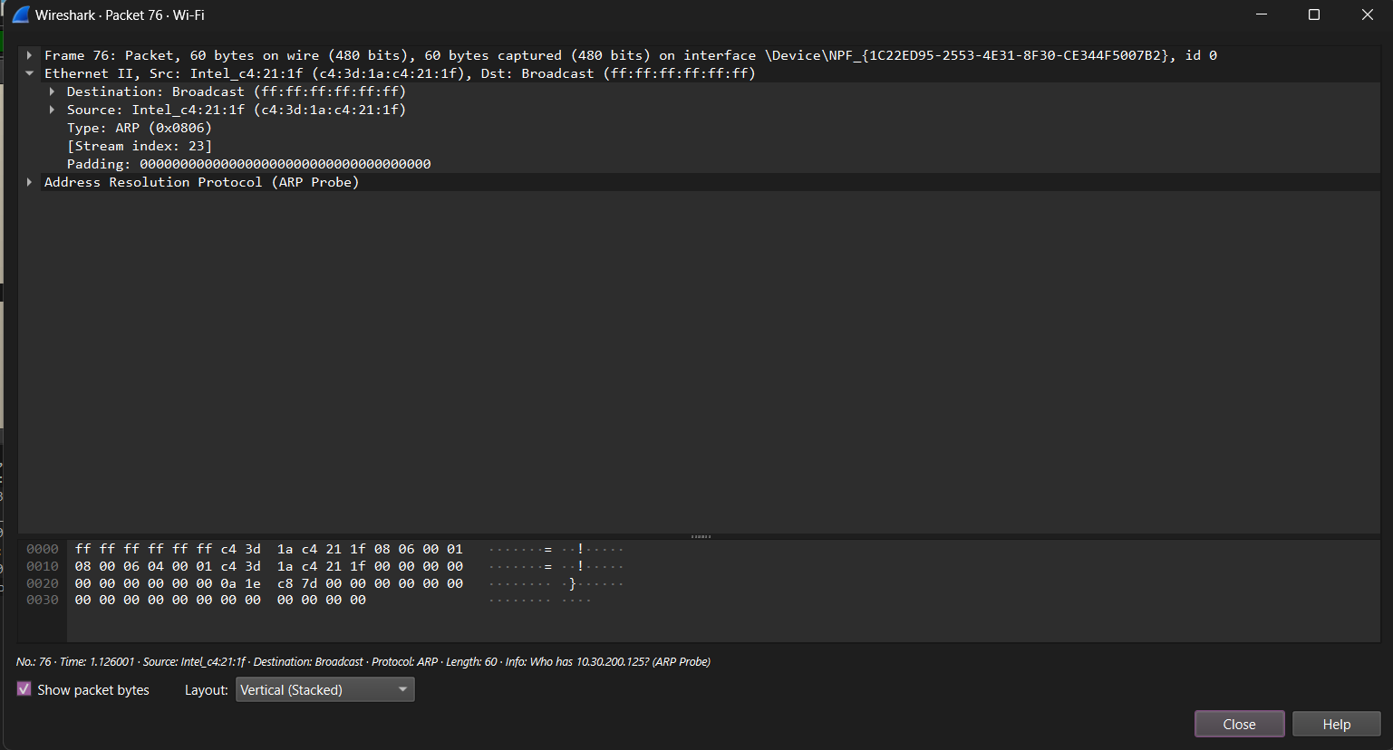
- Sender IP: 0.0.0.0.
- Target IP: 10.30.200.125.
- Why it's transmitted: It is used for IPv4 Address Conflict Detection. Your device sends this to ensure no other device on the network is already using the IP address it intends to take.

2: ARP Request Packet

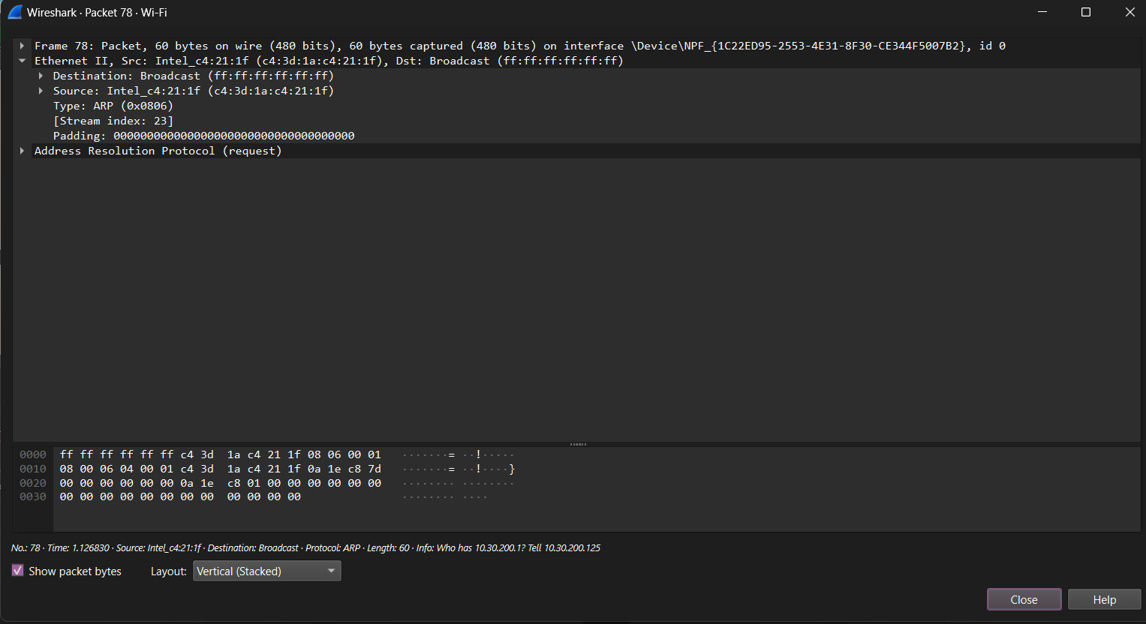

- A. What differences do you observe when compared with the ARP probe packet?
  - In the ARP Probe (Packet 76), the Sender IP address is set to 0.0.0.0 because the device hasn't officially claimed the IP yet.
  - In the ARP Request (Packet 78), the Sender IP address is now set to your device's actual IP: 10.30.200.125.
- B. What is the target MAC address in this packet? Justify your answer.
  - Target MAC Address: 00:00:00:00:00:00 (00:00:00:00:00:00).
  - Justification: The device does not yet know the physical MAC address of the target (10.30.200.1); the primary purpose of an ARP request is to broadcast a query to find this unknown address.
- C. Which opcode value in the packet indicates that it is an ARP request?
  - The Opcode value is 1.
  - (In Wireshark, this is listed under the Address Resolution Protocol section as request (1)).

3: ARP Response Packet
- A. What changes do you observe compared to the ARP request packet?
  - The Sender and Target fields have been swapped: the device that was the "Target" in the request (the gateway) is now the "Sender" of this reply.
  - The Sender IP is now 10.30.200.1 and the Target IP is your device 10.30.200.125.
  - The Info column changes from a query ("Who has...?") to a functional statement: 10.30.200.1 is at 14:58:d0:d4:86:00.
- B. What is the target MAC address in this packet? Justify your answer.
  - Target MAC Address: 3c:21:9c:7c:fd:9e (Your device's MAC).
  - Justification: ARP replies are unicast messages. Unlike the request, which is a broadcast sent to every device (ff:ff:ff:ff:ff:ff), the reply is sent directly back to the specific MAC address that requested the information to reduce network congestion.
- C. Which opcode value indicates that the packet is an ARP reply?
  - The Opcode value is 2.
  - (In Wireshark, this is listed under the Address Resolution Protocol hardware details as reply (2)).

