PES UNIVERSITY, Bangalore
Established under Karnataka Act No. 16 of 2013)
Department of Computer Science & Engineering
UE24CS251A: DIGITAL DESIGN AND COMPUTER ORGANIZATION

Student 1:
Name: Tanmayi Nagabhairava
SRN: PES1UG24CS493

Student 2:
Name: Vaishnavi
SRN: PES1UG24CS514

Student 3:
Name: Varsha Anil Patil
SRN: PES1UG24CS516

Student 4:
Name: Kotra Sai Soumya Sri
SRN: PES1UG24CS911

Problem statement:
FSM-based Vending Machine with Python Simulation
Design a FSM-based vending machine in Verilog.
- The machine accepts coins of ₹5 and ₹10.
- Item costs ₹15.
- Machine dispenses the item and resets after purchase.

Tasks
- Design FSM (Moore or Mealy). Show state diagram + table.
- Implement in Verilog and simulate coin inputs.
- Write a Python script that:
- Generates random coin insertion sequences
- Runs Verilog simulation.
- Checks if the machine correctly dispenses at 15.
- Logs any mismatch between expected & simulated behaviour.

Solution:
1.Code
- vending_machine.v

module vending_machine (
input clk,
input reset,
input [1:0] coin, // 2'b01 = ₹5, 2'b10 = ₹10
output reg dispense
);

// State encoding
parameter S0 = 2'b00;
parameter S5 = 2'b01;
parameter S10 = 2'b10;
parameter S15 = 2'b11;

reg [1:0] current_state, next_state;

// State transition logic
always @(posedge clk or posedge reset) begin
if (reset)
current_state <= S0;
else
current_state <= next_state;
end

// Next state logic
always @(*) begin
case (current_state)
S0: case(coin)
2'b01: next_state = S5;
2'b10: next_state = S10;
default: next_state = S0;
endcase
S5: case(coin)
2'b01: next_state = S10;
2'b10: next_state = S15;
default: next_state = S5;
endcase
S10: case(coin)
2'b01: next_state = S15;
2'b10: next_state = S15;
default: next_state = S10;
endcase
S15: next_state = S0; // dispense and reset
default: next_state = S0;
endcase
end

// Output logic
always @(*) begin
dispense = 0;
if (current_state == S15)
dispense = 1;
end

endmodule

- vending_tb.v

`timescale 1ns/1ps

module tb_vm;

reg clk;
reg reset;
reg [1:0] coin;
wire dispense;

// Instantiate the vending machine
vending_machine uut (
.clk(clk),
.reset(reset),
.coin(coin),
.dispense(dispense)
);

initial begin
clk = 0;
forever #5 clk = ~clk; // 100MHz clock
end

initial begin
$dumpfile("vending_machine.vcd");
$dumpvars(0, tb_vm);

reset = 1;
coin = 2'b00;
#10;
reset = 0;

// Insert ₹5
coin = 2'b01;
#10;

// Insert ₹10
coin = 2'b10;
#10;

// Wait and reset
coin = 2'b00;
#20;

// Insert ₹10
coin = 2'b10;
#10;

// Insert ₹10 again
coin = 2'b10;
#10;

// Finish simulation
$finish;
end

endmodule

- vending_machine.py

import random
import matplotlib.pyplot as plt

class VendingMachine:
def _init_(self):
self.total = 0 # Tracks total coins inserted

def insert_coin(self, coin):
if coin not in [5, 10]:
raise ValueError("Invalid coin")

self.total += coin
dispense = False

if self.total >= 15:
dispense = True
self.total = 0 # Reset after dispensing

return dispense

def simulate(num_trials=20):
times = []
coin5 = []
coin10 = []
dispense_list = []

time = 0
for trial in range(num_trials):
vm = VendingMachine()

while True:
coin = random.choice([5, 10])
c5 = 1 if coin == 5 else 0
c10 = 1 if coin == 10 else 0

d = vm.insert_coin(coin)

times.append(time)
coin5.append(c5)
coin10.append(c10)
dispense_list.append(1 if d else 0)

time += 10000

if d:
break # Move to next trial after dispensing

return times, coin5, coin10, dispense_list

def plot_simulation(times, coin5, coin10, dispense_list):
plt.figure(figsize=(12,6))
plt.plot(times, coin5, label='coin5')
plt.plot(times, coin10, label='coin10')
plt.plot(times, dispense_list, label='dispense')
plt.xlabel('Time (ns)')
plt.ylabel('Signal')
plt.title('Vending Machine FSM Simulation')
plt.legend()
plt.grid(True)
plt.show()

def print_table(times, coin5, coin10, dispense_list):
print("time coin5 coin10 dispense")
print("------------------------------")
for t, c5, c10, d in zip(times, coin5, coin10, dispense_list):
print(f"{t:6} {c5} {c10} {d}")

if _name_ == "_main_":
times, coin5, coin10, dispense_list = simulate(num_trials=20)
print_table(times, coin5, coin10, dispense_list)
plot_simulation(times, coin5, coin10, dispense_list)

2. Screen shot of output
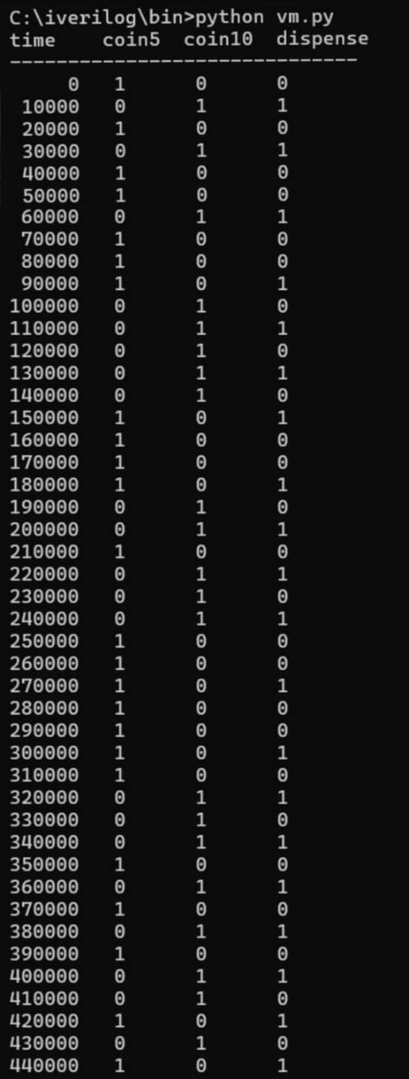
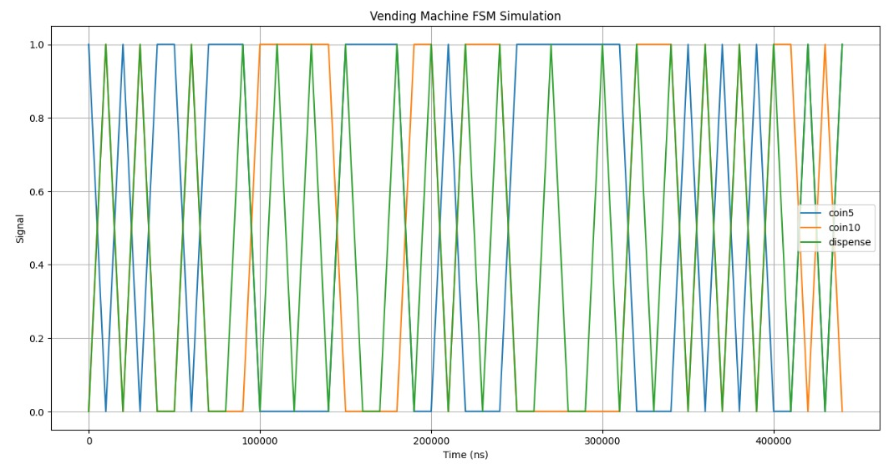
State diagram
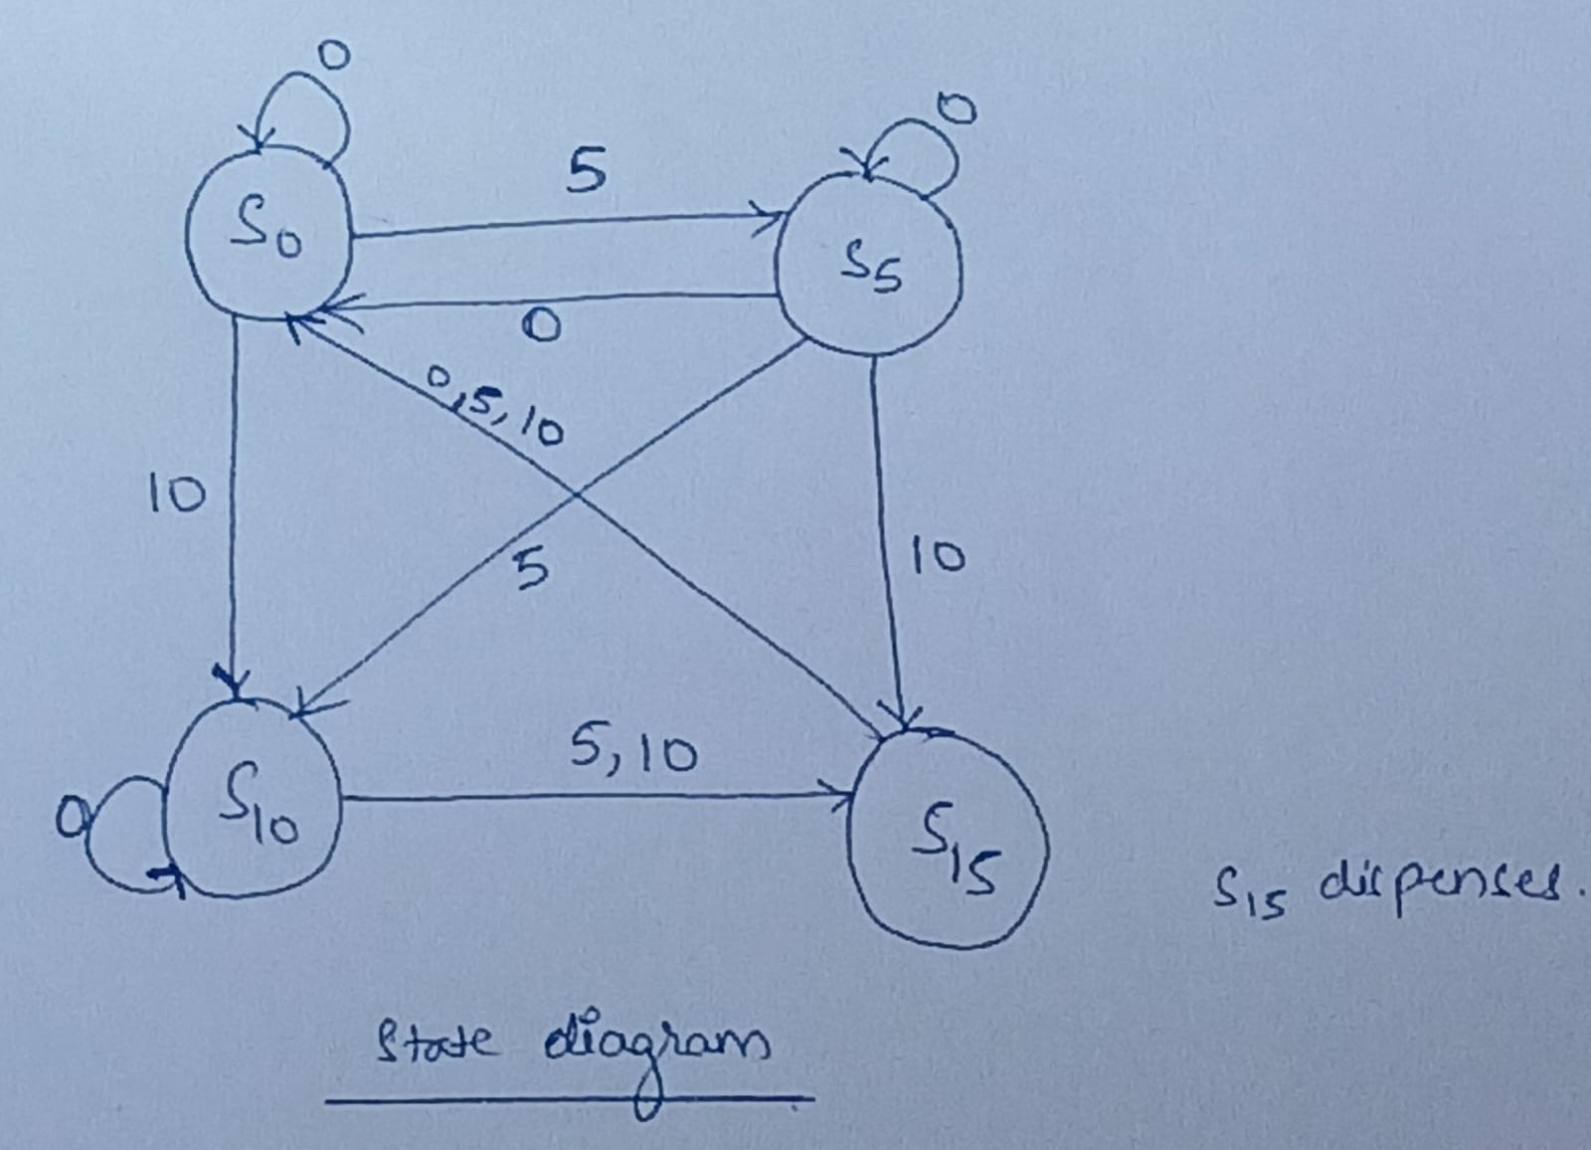

State Table
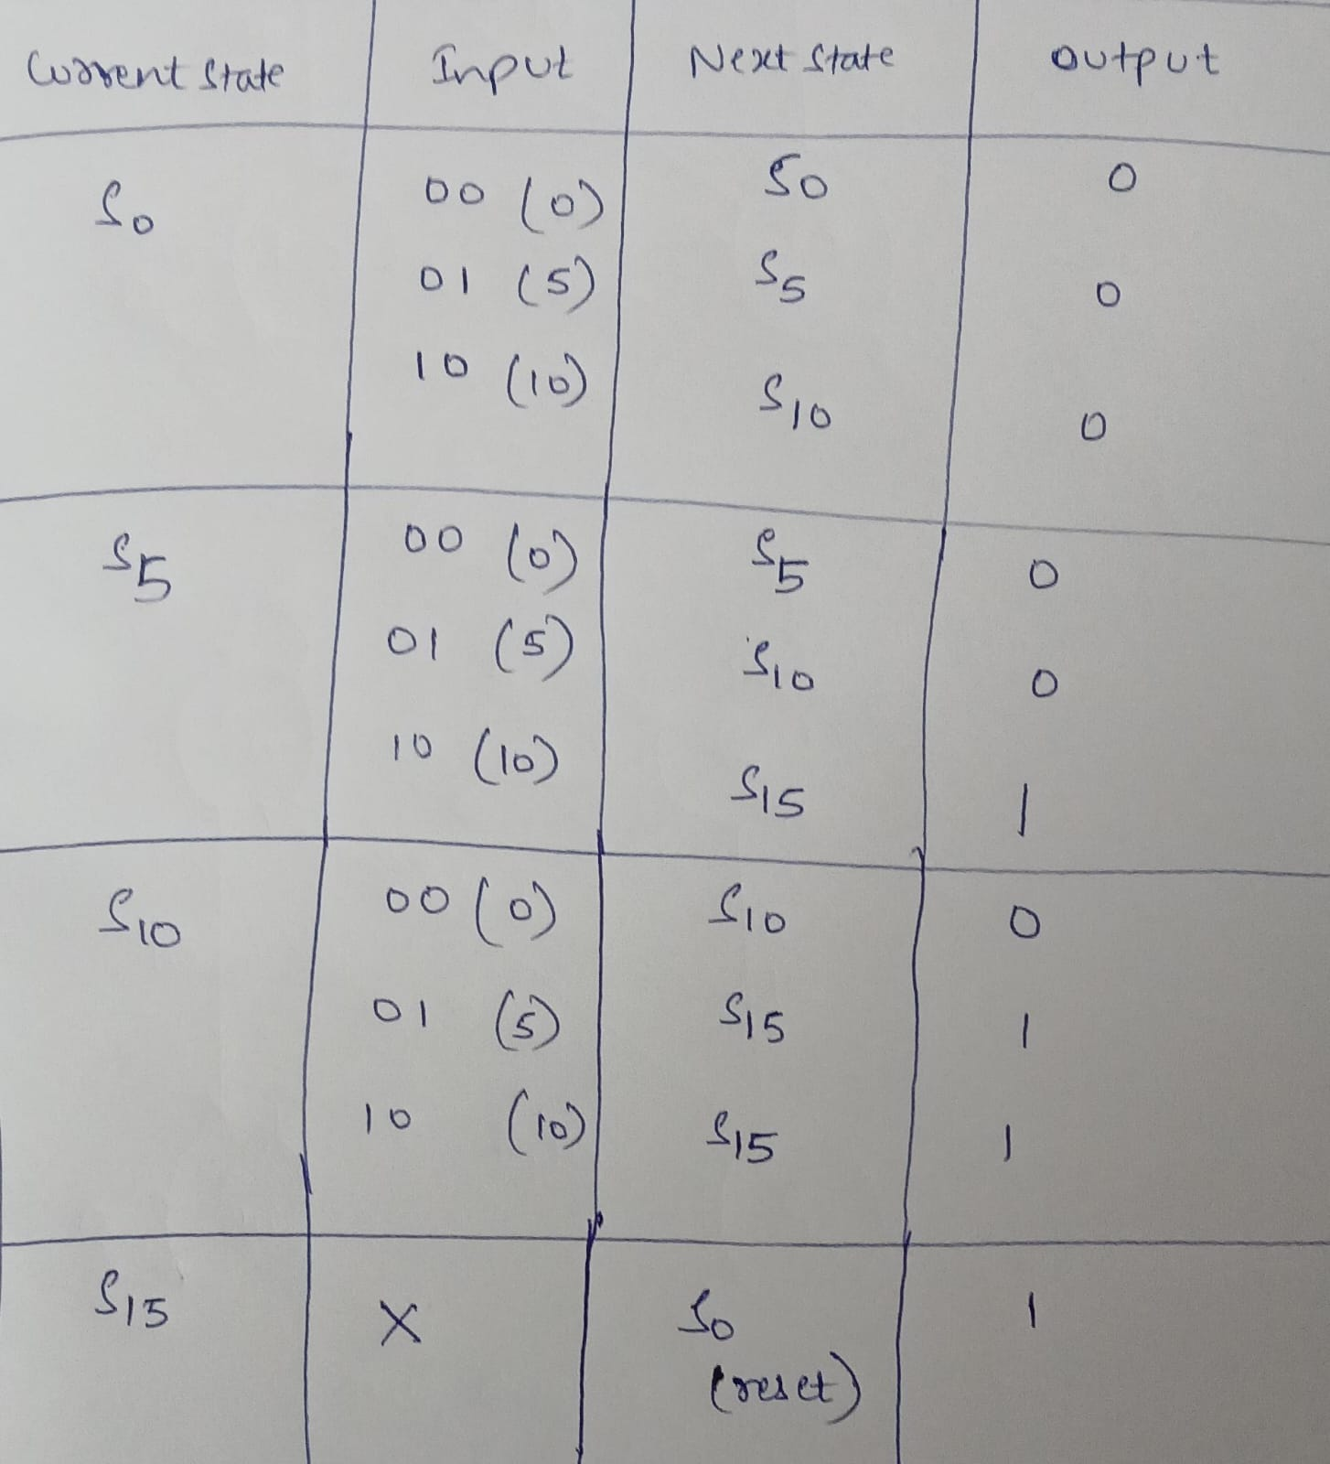

3. Individual Contribution of team members
- Tanmayi Nagabhairava - Python code
- Vaishnavi - Verilog code
- Varsha Anil Patil - Testbench
- Kotra Sai Soumya Sri - State Table and Diagram

