PES UNIVERSITY, Bangalore
Established under Karnataka Act No. 16 of 2013)
Department of Computer Science & Engineering
UE24CS251A: DIGITAL DESIGN AND COMPUTER ORGANIZATION
Orange Problem 2

Student 1:
Name: Tanmayi Nagabhairava
SRN: PES1UG24CS493

Student 2:
Name: Vaishnavi
SRN:PES1UG24CS514

Student 3:
Name: Varsha Anil Patil
SRN: PES1UG24CS516

Student 4:
Name: Kotra Sai Soumya Sri
SRN: PES1UG24CS911

Solution:
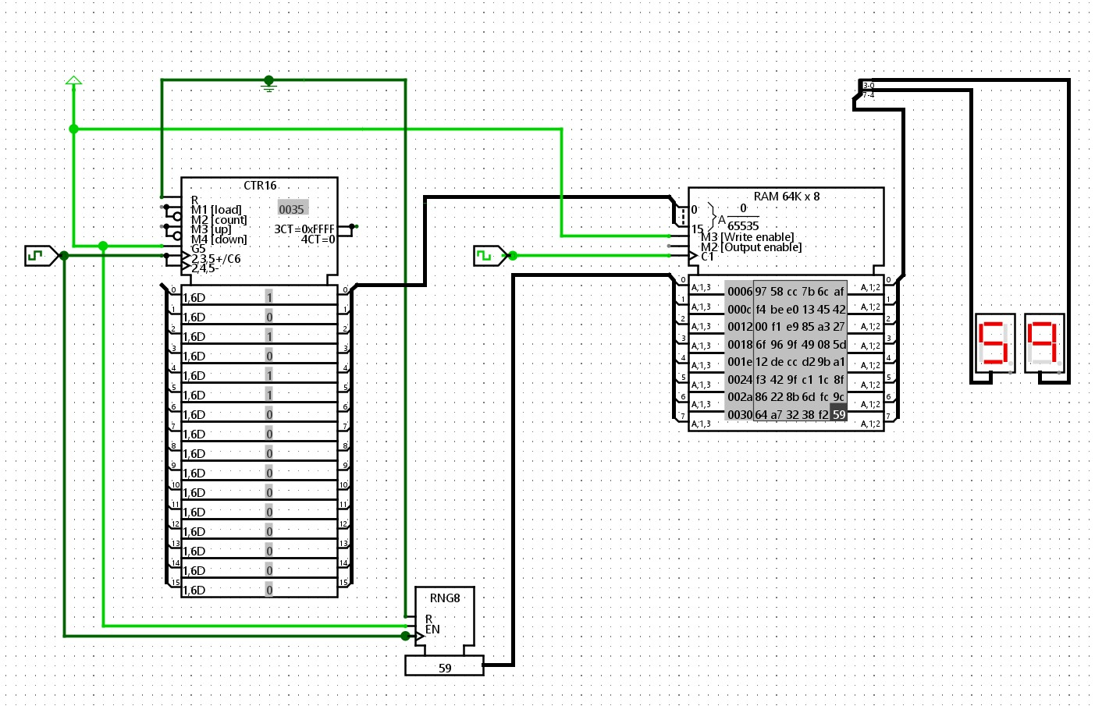

Answers to questions:
- When you start the simulation, which RAM addresses are written first?
The first addresses written are 0, 1, 2, … in ascending order since the counter usually powers up at 0. (The default is 0 → upward, but if you explicitly preload the counter or use a reset value, the sequence will begin from that value.)

- How many bits wide is the RAM data word and why did you set the Random Generator to that width?
According to the lab, the RAM data width is 8 bits. In order to avoid truncation or undefined bits and to ensure that every RAM byte receives a complete 8-bit random value, the Random Generator is set to 8 bits so that its output precisely matches the RAM data bus width.

- What happens if you tie the RAM st pin to Ground instead of 1?
In Logisim's RAM, the st (store/write enable) is set to active-high. By tying it to Ground (0), writes are disabled. As a result, the RAM won't store new values (no writes occur), leaving the contents of the memory unaltered and preventing the hex displays from displaying the memory being filled.

- Experiment: change Clock A to run at the same speed as Clock B. What happens to the stored values?
The Random Generator might not update a stable, new value before the RAM's write edge if Clocks A and B are phase-aligned and run at the same speed. This frequently leads to many addresses receiving the same value or other unexpected/repeated values. This is a timing/race problem; the data needs to be stable prior to the clock edge of the RAM that executes the store.

- Why is the frequency of Clock A ticks set to be twice the rate (or 2 ticks per RAM cycle) of Clock B?
The Random Generator (and counter) can update and settle the data before the RAM's write edge occurs when Clock A is run at twice the rate. When Clock B triggers the actual write, the RAM sees a stable, freshly generated data word because, practically speaking, one of Clock A's ticks enables the Random Generator to change output and settle. The second tick coincides with this. This guarantees that every address receives a unique random value and prevents race conditions.

