Digital Design and Computer Organization Laboratory UE24CS251A
3rd Semester, Academic Year 2025
Mini Project Report
Name:Tanmayi Nagabhairava | SRN:  PES1UG24CS493 | Section: I
Name  Vaishnavi | SRN: PES1UG24CS514 | Section: I
Name  Varsha Anil Patil | SRN:  PES1UG24CS516 | Section: I
Name: Kotra Sai Soumya  Sri | SRN:  PES1UG24CS911 | Section: I

- Problem Statement:

Design and implement a Ring and Johnson Counter with logic circuit.

- Circuit Diagram/Block Diagram

JOHNSON COUNTER:--

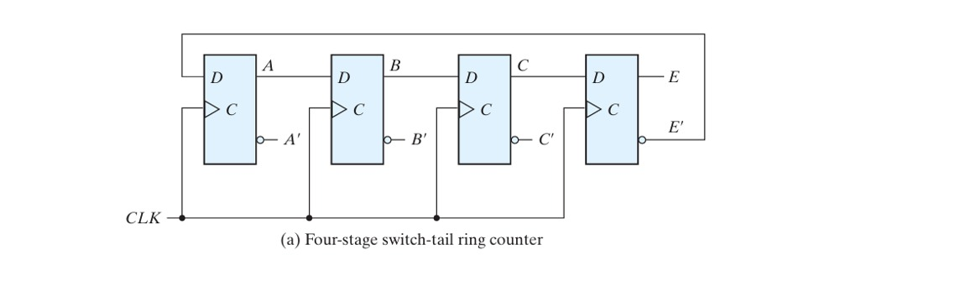

RING COUNTER:--

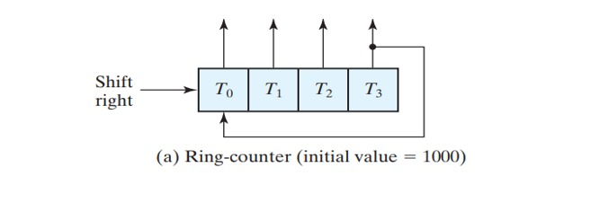
- Verilog Code Screenshot
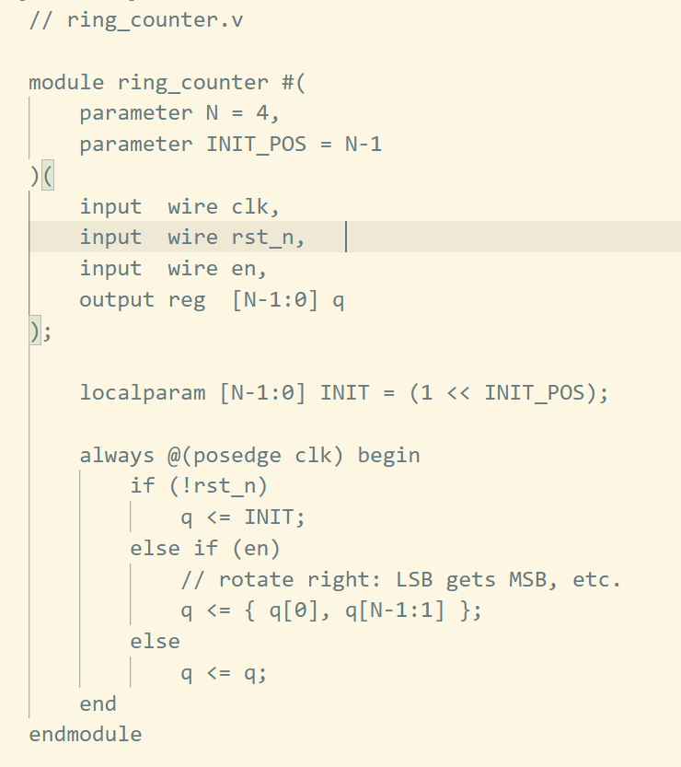

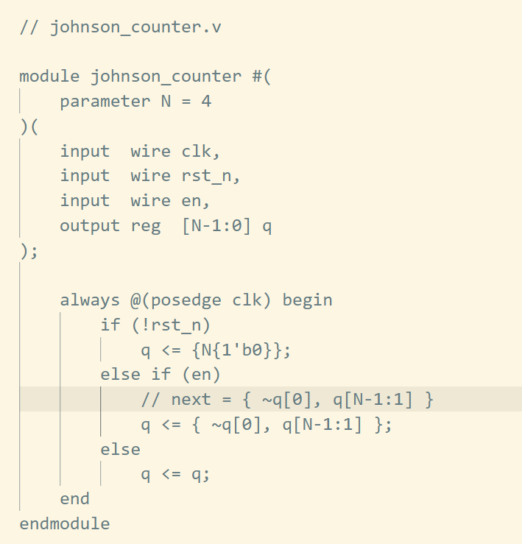

4.VVP Output Screen Shot
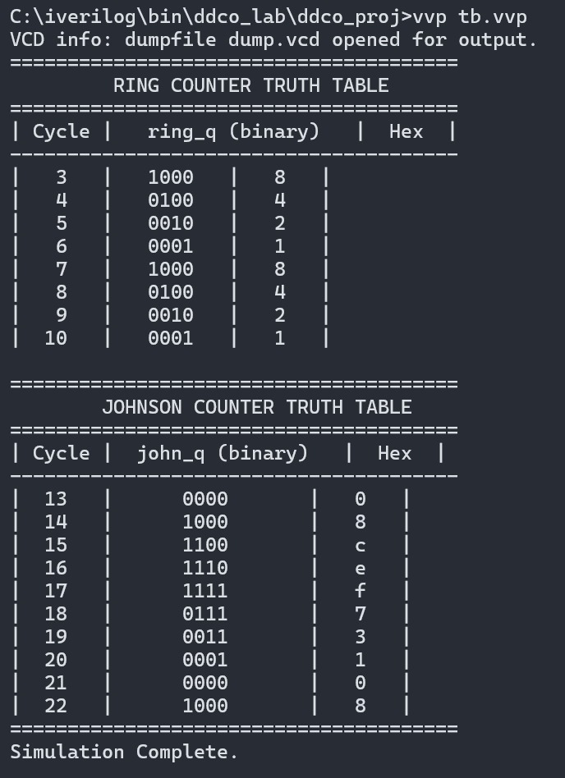
- GTKWAVE Screenshot


