
PES UNIVERSITY
(Established under Karnataka Act No. 16 of 2013)
100 Feet Ring Road, BSK III Stage, Bengaluru-560 085
Department of Computer Science and Engineering
UE24MA241B - Linear Algebra and its Applications
Prepared by: Yash Michael Tharappan
Anchor: Dr. Gayathri T, Department of Computer Science and Engineering
UNIT 3 LINEAR ALGEBRA LIBRARY FUNCTIONS APPENDIX
Gram-Schmidt & Signal Processing (Program 1)
● np.array(): Used to define signal vectors v₁ and v₂ as numerical arrays. ● np.dot(a, b): Calculates the dot product (scalar product) of two vectors. In this program, it is used to find the projection of one vector onto another to determine how much of the signals overlap.
● np.linalg.norm(x): Computes the vector L₂ norm (magnitude). This is used during the Normalization step to ensure basis vectors have a length of 1.
Least Squares Temperature Prediction (Program 2)
● np.vstack(tup): Stacks arrays vertically. Here, it combines the days array with an array of ones to create the design matrix A.
● .T (Transpose): Flips the matrix over its diagonal. This is applied to the stacked arrays to ensure matrix A has the correct dimensions (rows for observations, columns for variables) for the linear system.
● np.linalg.lstsq(a, b): The core function for the Least Squares method. It returns the values for slope (m) and intercept (c) that minimize the squared Euclidean 2-norm |b - Ax|², providing the best-fit line for the temperature data.
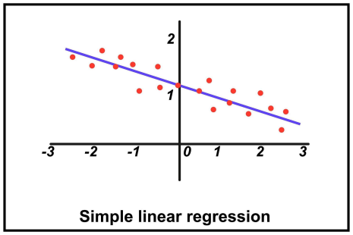

Mechanical Vibrations (Program 3)
● np.linalg.eig(a): Computes the eigenvalues and right eigenvectors of a square matrix. ○ The eigenvalues represent the natural frequencies of the spring-mass system. ○ The eigenvectors represent the mode shapes, showing the physical pattern of the vibration.
Google PageRank (Program 4)
● A.sum(axis=0): Sums the elements of the adjacency matrix along the columns. This is used to determine how many outbound links each web page has.
● np.argmax(a): Returns the indices of the maximum values along an axis. In PageRank, it identifies which eigenvalue is the "dominant" one (closest to 1).
● np.real(val): Extracts the real part of a complex number. Since transition matrices can sometimes yield complex eigenvalues/vectors, this ensures the PageRank scores are real-valued.
● np.argsort(a): Performs an indirect sort, returning the indices that would sort the array. It is used here with a negative sign (-pagerank) to rank the web pages from highest to lowest score.
Image Compression / PCA (Program 5)
● np.mean(a, axis=0): Calculates the arithmetic mean. In Principal Component Analysis (PCA), this is used to "center" the data by subtracting the average pixel value from each column.
● np.cov(m): Estimates the covariance matrix of the data. This matrix describes how different pixels or dimensions in the image vary together.
● @ (Matrix Multiplication): Used to project the centered image data onto the top k eigenvectors (Principal Components) and then reconstruct it. This achieves compression by ignoring vectors with low eigenvalues.

