Department of Computer Science & Engineering

Microprocessor & Computer Architecture
UE24CS251B

MPCA Lab Programs - 6

Name: Tanmayi Nagabhairava |  | SRN: PES1UG24CS493 | Section: I
1 | Write an ARM7TDMI assembly program using nested procedure calls to compute the sum of squares of two numbers. The main program calls a procedure SUM_SQ, which in turn calls another procedure SQUARE to compute the square of a number.  MOV R0,#3  MOV R1,#4  BL SUM_SQ  SWI 0x11  SUM_SQ:  STMFD SP!,{R1, LR}  BL SQUARE  MOV R2,R0  LDMFD SP!,{R1}  MOV R0,R1  BL SQUARE  ADD R0,R0,R2  LDMFD SP!,{PC}  SQUARE:  STMFD SP!,{LR}  MOV R3,R0  MUL R0,R3,R3  LDMFD SP!,{LR}  BX LR  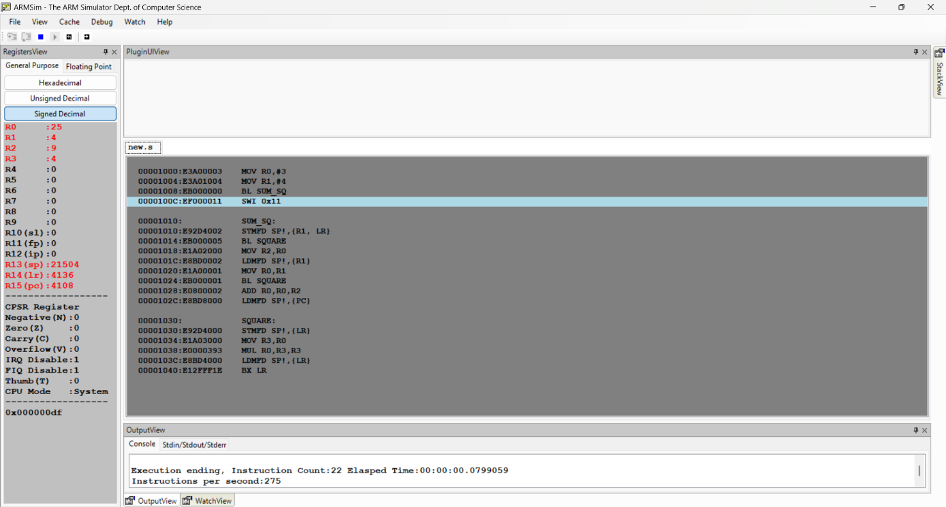
2 | Write an ARM7TDMI assembly language program to multiply two matrices of suitable order and store the result in a separate memory location.  LDR R0,=A  LDR R1,=B  LDR R2,=C  LDR R3,[R0]  LDR R4,[R0,#4]  LDR R5,[R0,#8]  LDR R6,[R0,#12]  LDR R7,[R1]  LDR R8,[R1,#4]  LDR R9,[R1,#8]  LDR R10,[R1,#12]  MUL R11,R3,R7  MUL R12,R4,R9  ADD R11,R11,R12  STR R11,[R2]  MUL R11,R3,R8  MUL R12,R4,R10  ADD R11,R11,R12  STR R11,[R2,#4]  MUL R11,R5,R7  MUL R12,R6,R9  ADD R11,R11,R12  STR R11,[R2,#8]  MUL R11,R5,R8  MUL R12,R6,R10  ADD R11,R11,R12  STR R11,[R2,#12]  SWI 0x11  A: .WORD 1,2,3,4  B: .WORD 5,6,7,8  C: .WORD 0,0,0,0  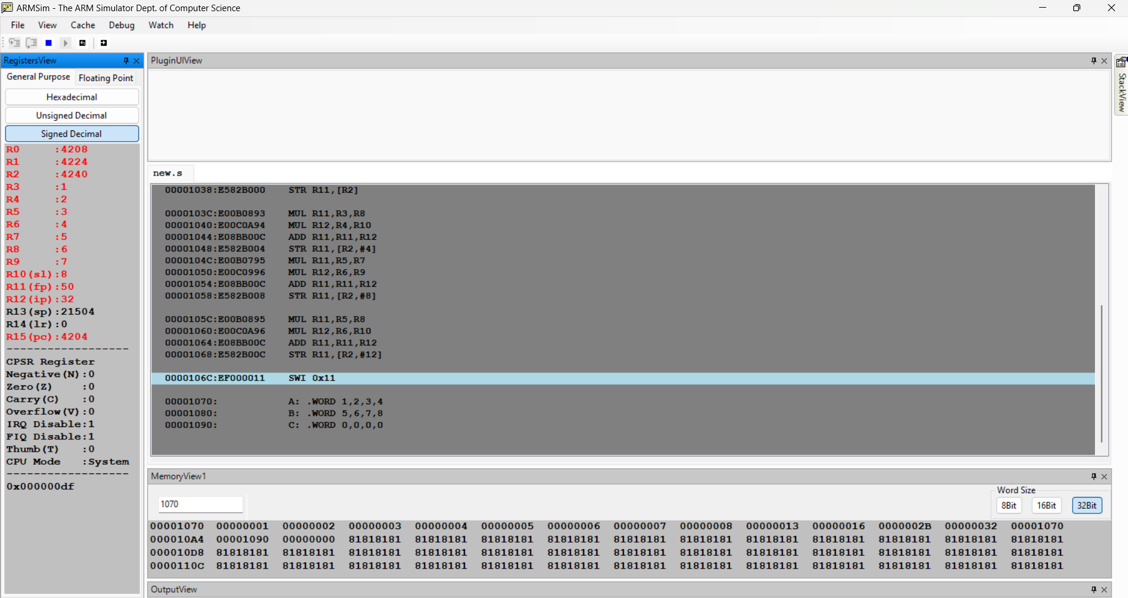
3 | Write an ARM7TDMI assembly language program to generate the first N terms of an arithmetic progression and store them in memory.  LDR R0,=N  LDR R1,[R0]  LDR R2,=A  LDR R3,[R2]  LDR R4,=D  LDR R5,[R4]  LDR R6,=AP  LOOP:  STR R3,[R6],#4  ADD R3,R3,R5  SUBS R1,R1,#1  BNE LOOP  SWI 0x11  N: .WORD 5  A: .WORD 2  D: .WORD 3  AP:.WORD 0,0,0,0,0  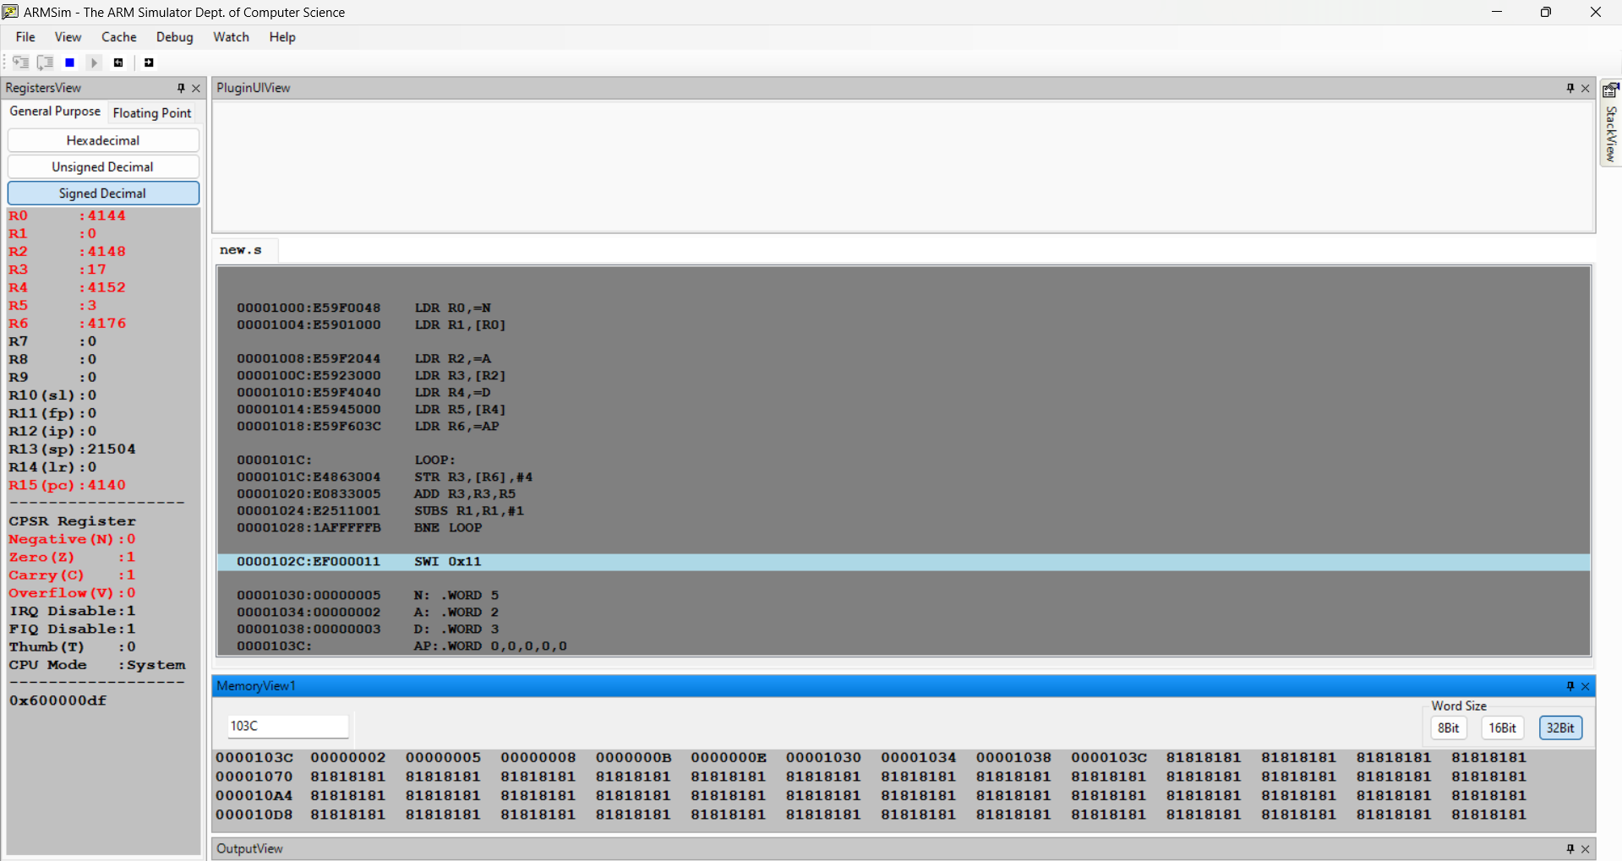
4 | Write an ARM7TDMI assembly language program to concatenate two strings and store the result and displays the string.  LDR R0,=STR1  LDR R1,=STR2  LDR R2,=RES  L1:  LDRB R3,[R0],#1  CMP R3,#0  BEQ L2  STRB R3,[R2],#1  B L1  L2:  LDRB R3,[R1],#1  CMP R3,#0  BEQ L3  STRB R3,[R2],#1  B L2  L3:  MOV R3,#0  STRB R3,[R2]  SWI 0x11  STR1: .ASCIZ "HELLO "  STR2: .ASCIZ "WORLD"  RES: .SPACE 20  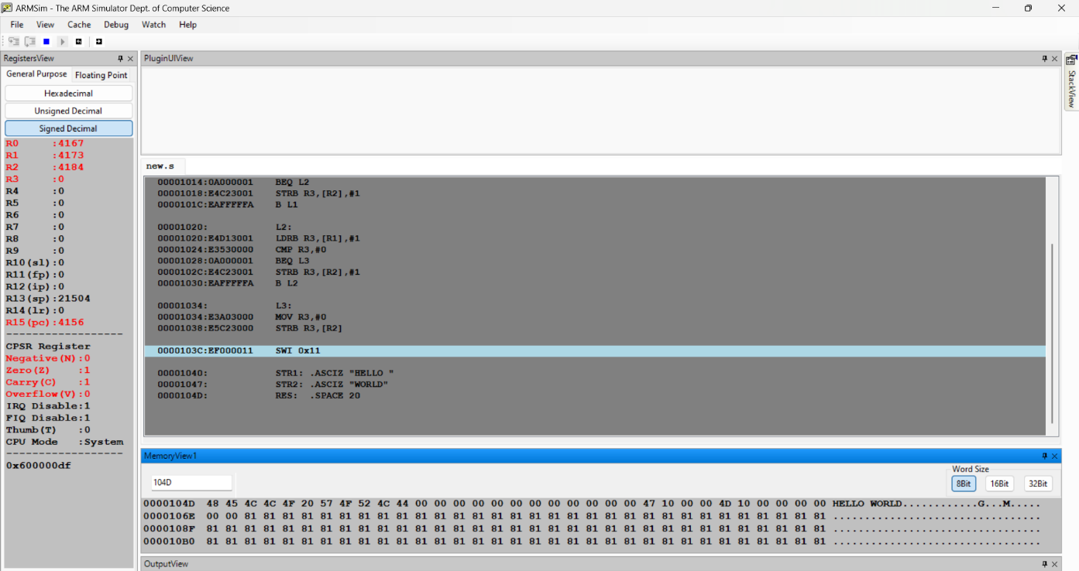
5 | ASSIGNMENT QUESTIONS:  - Write a program to swap the first and last character of a given string.  LDR R0,=STR  MOV R1,R0  FIND:  LDRB R2,[R1],#1  CMP R2,#0  BNE FIND  SUB R1,R1,#2  LDRB R3,[R0]  LDRB R4,[R1]  STRB R4,[R0]  STRB R3,[R1]  SWI 0x11  STR: .ASCIZ "HELLO"  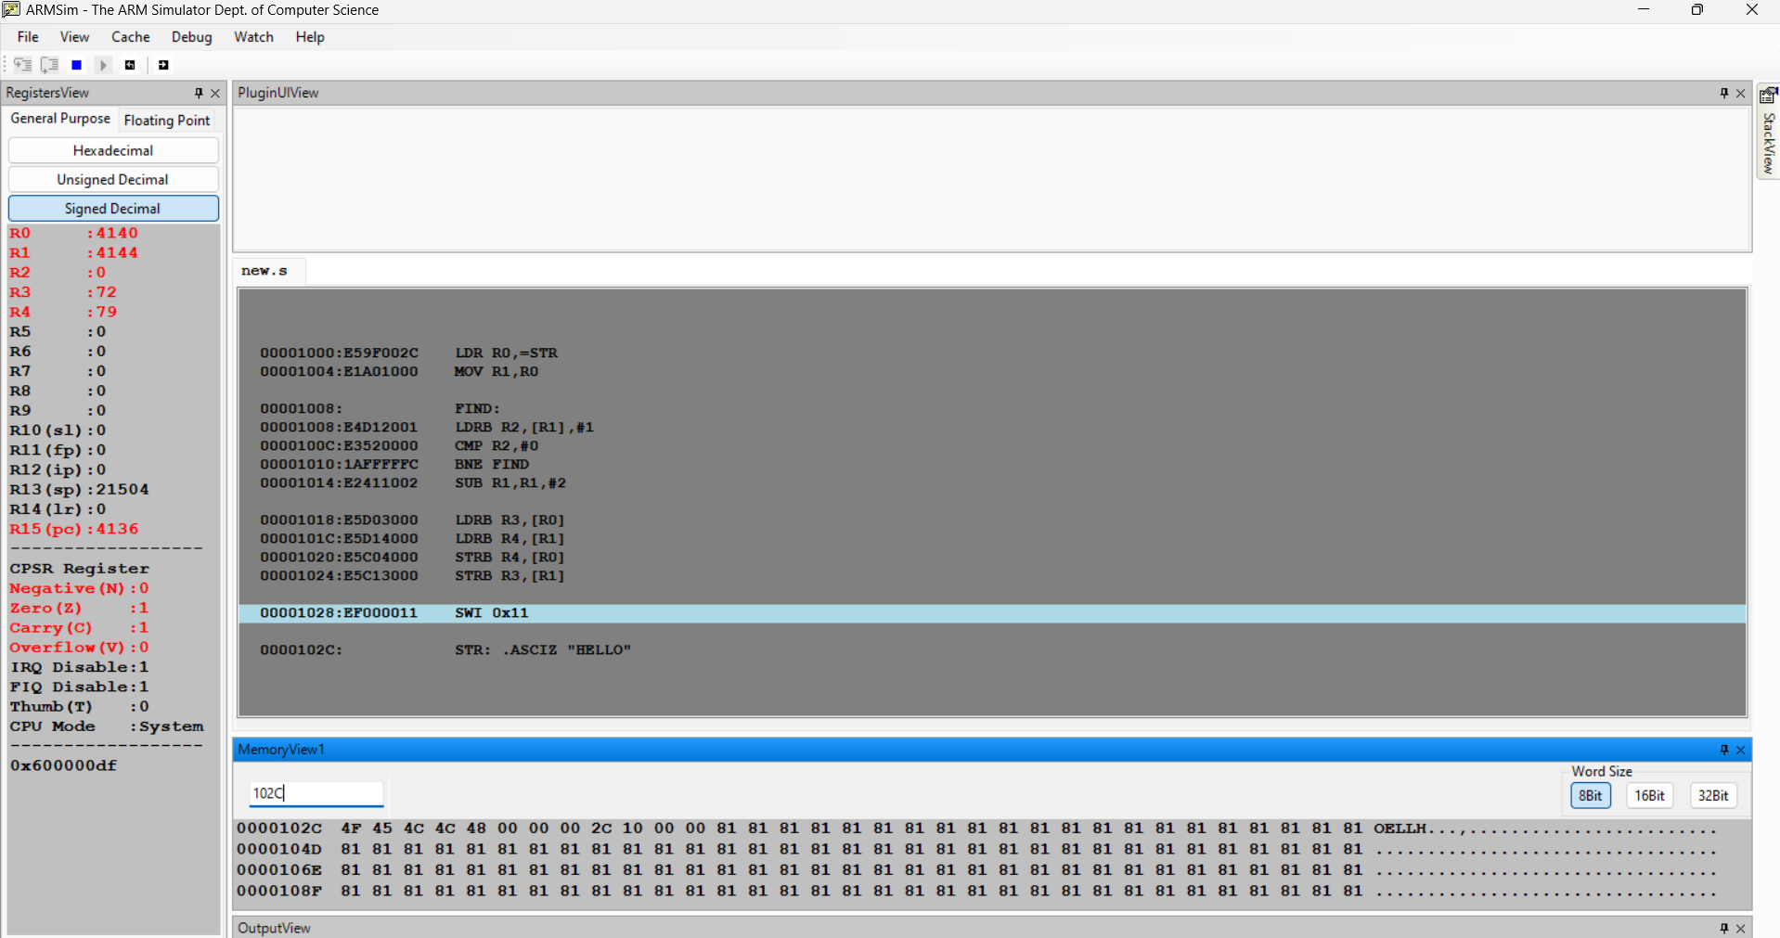  - Given a c Code convert it in its equivalent Arm Code : z = (a << 2) |(b & 15);  LDR R0,=A  LDR R1,[R0]  LDR R2,=B  LDR R3,[R2]  MOV R1,R1,LSL #2  AND R3,R3,#15  ORR R4,R1,R3  LDR R5,=Z  STR R4,[R5]  SWI 0x11  A: .WORD 5  B: .WORD 10  Z: .WORD 0  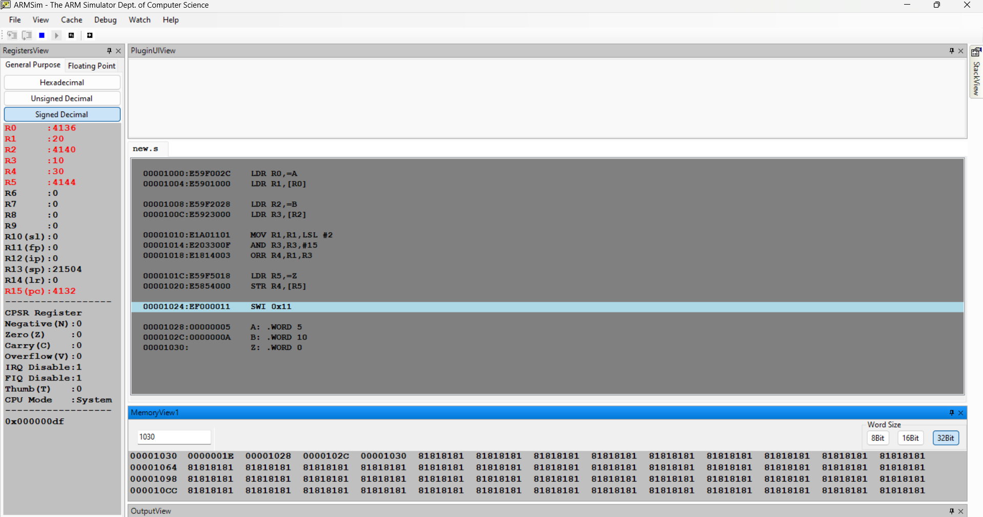
6 | Write an ARM7TDMI assembly language program in which the main program calls a procedure STRING_PROC. The procedure STRING_PROC calls separate procedures LENGTH to find the length of a string and REVERSE to reverse the string. The reversed string must be stored in a separate memory location.  LDR R0,=STR  LDR R1,=REV  BL STRING_PROC  SWI 0x11  STRING_PROC:  STMFD SP!,{R4,R5,LR}  MOV R4,R0  MOV R5,R1  BL LENGTH  MOV R2,R0  MOV R0,R4  MOV R1,R5  BL REVERSE  LDMFD SP!,{R4,R5,PC}  LENGTH:  MOV R3,#0  L1:  LDRB R2,[R0],#1  CMP R2,#0  BEQ L2  ADD R3,R3,#1  B L1  L2:  MOV R0,R3  BX LR  REVERSE:  CMP R2,#0  BXEQ LR  ADD R0,R0,R2  SUB R0,R0,#1  L3:  CMP R2,#0  BEQ L4  LDRB R3,[R0],#-1  STRB R3,[R1],#1  SUB R2,R2,#1  B L3  L4:  MOV R3,#0  STRB R3,[R1]  BX LR  STR: .ASCIZ "HELLO"  REV: .SPACE 20  

