Department of Computer Science & Engineering

Microprocessor & Computer Architecture
UE24CS251B

MPCA Lab Programs – 7
Plug-in Programs

Name: Tanmayi Nagabhairava |  | SRN: PES1UG24CS493 | Section: I
1 | LED Light Up  MOV R0, #1  SWI 0x201  BL DELAY  MOV R0, #2  SWI 0x201  BL DELAY  MOV R0, #3  SWI 0x201  SWI 0x11  DELAY:  LDR R6, =a  LDR R7, [R6]  LOOP:  SUB R7, R7, #1  CMP R7, #0  BNE LOOP  MOV PC, LR  a: .word 1000000  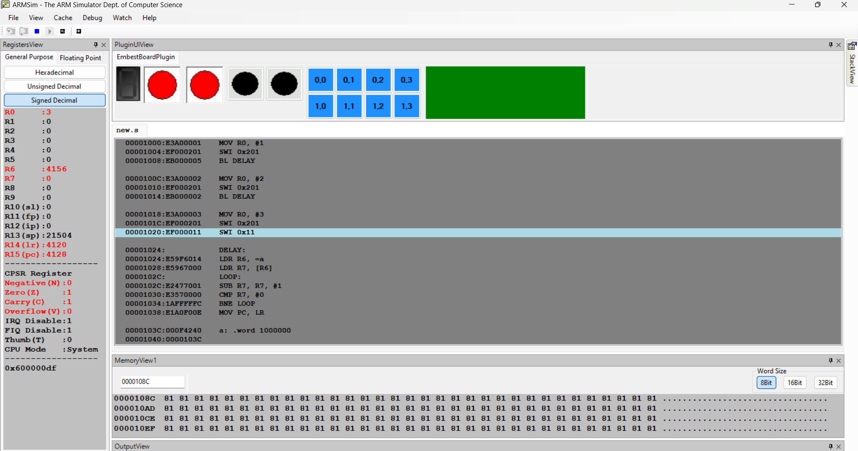
2 | Seven Segment Display  UPCOUNTER  a: .word 1000000  .EQU A, 0X80  .EQU B, 0X40  .EQU C, 0X20  .EQU P, 0X10  .EQU D, 0X08  .EQU E, 0X04  .EQU F, 0X02  .EQU G, 0X01  TAB:  .WORD A|B|C|D|E|G ;0  .WORD B|C ;1  .WORD A|B|F|E|D ;2  .WORD A|B|F|C|D ;3  .WORD G|F|C|B ;4  .WORD A|G|F|C|D ;5  .WORD A|G|E|D|C|F ;6  .WORD A|B|C ;7  .WORD A|B|C|D|E|F|G ;8  .WORD A|B|G|F|C ;9  .WORD A|G|E|C|B|F ;A  .WORD A|B|C|D|E|F|G|P ;B  .WORD A|G|E|D ;C  .WORD A|C|D|E|G|P|B ;D  .WORD A|G|F|E|D ;E  .WORD A|G|F|E ;F  LDR R5, =TAB  MOV R2, #16  UPCOUNT:  LDR R0, [R5], #4  SWI 0X200  BL DELAY  SUB R2, R2, #1  CMP R2, #0  BEQ EXIT  B UPCOUNT  DELAY:  LDR R6, =a  LDR R7, [R6]  LOOP:  SUB R7, R7, #1  CMP R7, #0  BNE LOOP  MOV PC, LR  EXIT:  SWI 0X11  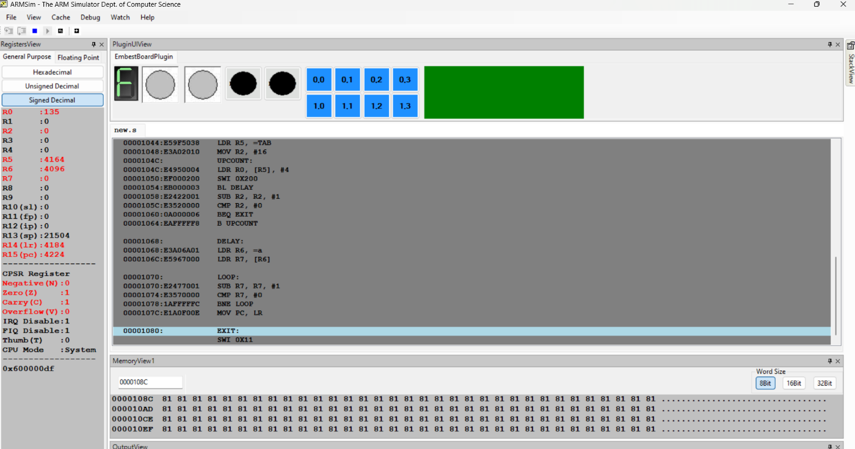  DOWNCOUNTER  a: .word 1000000  .EQU A, 0X80  .EQU B, 0X40  .EQU C, 0X20  .EQU P, 0X10  .EQU D, 0X08  .EQU E, 0X04  .EQU F, 0X02  .EQU G, 0X01  TAB:  .WORD A|B|C|D|E|G ;0  .WORD B|C ;1  .WORD A|B|F|E|D ;2  .WORD A|B|F|C|D ;3  .WORD G|F|C|B ;4  .WORD A|G|F|C|D ;5  .WORD A|G|E|D|C|F ;6  .WORD A|B|C ;7  .WORD A|B|C|D|E|F|G ;8  .WORD A|B|G|F|C ;9  .WORD A|G|E|C|B|F ;A  .WORD A|B|C|D|E|F|G|P ;B  .WORD A|G|E|D ;C  .WORD A|C|D|E|G|P|B ;D  .WORD A|G|F|E|D ;E  .WORD A|G|F|E ;F  LDR R5, =TAB  ADD R5, R5, #60  MOV R2, #16  DOWNCOUNT:  LDR R0, [R5], #-4  SWI 0X200  BL DELAY  SUB R2, R2, #1  CMP R2, #0  BEQ EXIT  B DOWNCOUNT  DELAY:  LDR R6, =a  LDR R7, [R6]  LOOP:  SUB R7, R7, #1  CMP R7, #0  BNE LOOP  MOV PC, LR  EXIT:  SWI 0X11  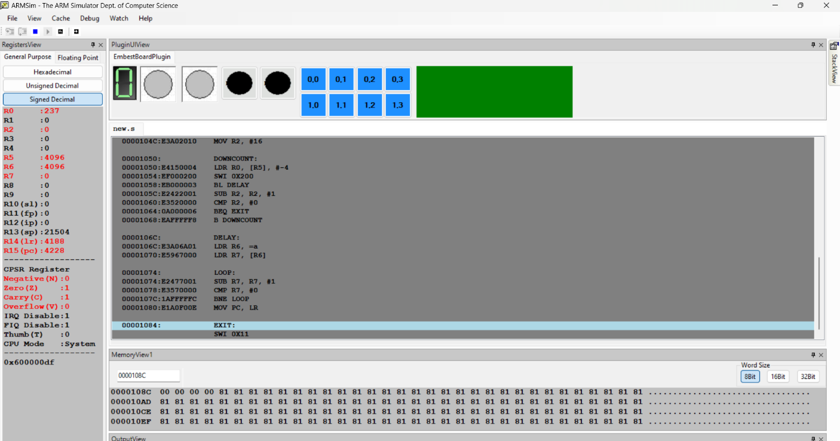  UP AND DOWN COUNTER  a: .word 1000000  .EQU A, 0X80  .EQU B, 0X40  .EQU C, 0X20  .EQU P, 0X10  .EQU D, 0X08  .EQU E, 0X04  .EQU F, 0X02  .EQU G, 0X01  TAB:  .WORD A|B|C|D|E|G  .WORD B|C  .WORD A|B|F|E|D  .WORD A|B|F|C|D  .WORD G|F|C|B  .WORD A|G|F|C|D  .WORD A|G|E|D|C|F  .WORD A|B|C  .WORD A|B|C|D|E|F|G  .WORD A|B|G|F|C  .WORD A|G|E|C|B|F  .WORD A|B|C|D|E|F|G|P  .WORD A|G|E|D  .WORD A|C|D|E|G|P|B  .WORD A|G|F|E|D  .WORD A|G|F|E  LDR R5, =TAB  MOV R2, #16  UPCOUNT:  LDR R0, [R5], #4  SWI 0X200  BL DELAY  SUBS R2, R2, #1  BNE UPCOUNT  LDR R5, =TAB  ADD R5, R5, #56  MOV R2, #15  DOWNCOUNT:  LDR R0, [R5], #-4  SWI 0X200  BL DELAY  SUBS R2, R2, #1  BNE DOWNCOUNT  SWI 0X11  DELAY:  LDR R6, =a  LDR R7, [R6]  LOOP:  SUBS R7, R7, #1  BNE LOOP  MOV PC, LR  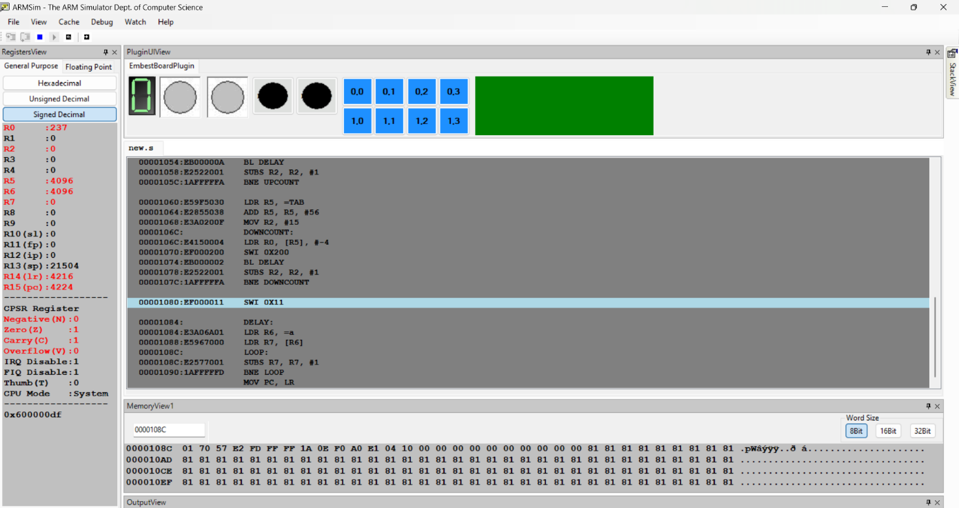
3 | Move a string from Right to Left on LCD (40 columns by 15 rows)  .TEXT  MOV R0 , #30 ; R0 = X  MOV R1 , #7 ; R1 = Y  MOV R7 , #0  LDR R8 , =NUM  LDR R8 , [R8]  LDR R2 , =STR  LOOP:  SWI 0X204  BL SUM  CMP R0 , #0  SUBNE R0 , R0 , #1  SWIEQ 0X11  B LOOP  SUM:  CMP R7 , R8  ADDNE R7 , R7 , #1  BNE SUM  SWI 0X206  MOV R7 , #0  MOV PC , LR  .DATA  STR: .ASCIZ "HELLO WORLD"  NUM: .WORD 15000  

