Department of Computer Science & Engineering

Microprocessor & Computer Architecture
UE24CS251B

MPCA Orange Problem

Name: Tanmayi Nagabhairava |  | SRN: PES1UG24CS493 | Section: I
A | Question A:  Code with comments:  .data  signal: .word 5, -3, 12, 7, 9, 0, -2, 15 # Given data  n: .word 8 # N=8  stable_cnt: .word 0  net_dev: .word 0  drop_cnt: .word 0  spike_idx: .word -1  .text  main:  la x10, signal # Load base address  lw x11, n # Load N  li x12, 0 # Loop counter (i)  li x13, 0 # stable_cnt accumulator  li x14, 0 # net_dev accumulator  li x15, 0 # drop_cnt accumulator  li x16, -1 # spike_idx (default -1)  li x17, 0 # Found spike flag (0 = no, 1 = yes)  loop:  beq x12, x11, end_loop # If i == N, exit  slli x18, x12, 2 # Offset = i * 4  add x18, x18, x10 # Address of signal[i]  lw x19, 0(x18) # x19 = current value  # 1. Stability Check (-5 to +5)  li x20, -5  li x21, 5  blt x19, x20, check_net  bge x21, x19, is_stable  j check_net  is_stable:  addi x13, x13, 1  check_net:  # 2. Net Deviation & 3. Drop Events  blt x19, x0, is_negative  add x14, x14, x19 # Sum positive values  j check_spike  is_negative:  sub x14, x14, x19 # Subtract negative values (Net = Pos - Neg)  addi x15, x15, 1 # Increment drop count  check_spike:  # 4. First Spike Index (> 10)  li x22, 10  ble x19, x22, next_iter  bne x17, x0, next_iter # If already found, don't update  addi x16, x12, 0 # Store current index  li x17, 1 # Set found flag  next_iter:  addi x12, x12, 1 # i++  j loop  end_loop:  # Store results in memory  la x23, stable_cnt  sw x13, 0(x23)  la x23, net_dev  sw x14, 0(x23)  la x23, drop_cnt  sw x15, 0(x23)  la x23, spike_idx  sw x16, 0(x23)  # Exit program  li a7, 10  ecall  Screenshot of the output:  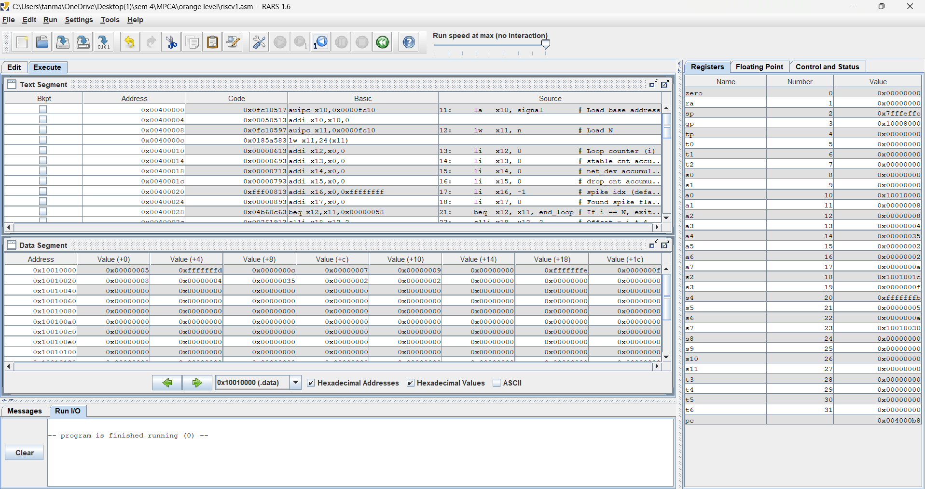  Explanation of code:  The program starts by loading the base address of the signal array and the value N=8 into the register. It sets the accumulators for the stable count, net deviation, and signal drop count while setting the default spike index to -1. It then goes through the loop that iterates through the array using pointer arithmetic. It checks each value in the array to determine if the value is within the stable range of -5 to +5. It branches based on the condition and adds the value if it is within the stable range. It adds positive values to the accumulator while subtracting the negative values from the accumulator to determine the net deviation. It has a counter for signal drop if the value is less than zero. It then goes through the array to determine the first index of the signal spike if the value is greater than 10. It stores the index while avoiding pseudo-instruction usage and stores the results in the memory.
B | Question B:  Code with comments:  .data  n_val: .word 7 # Input value N  is_even: .word 0 # Result: 1 if even  is_prime: .word 0 # Result: 1 if prime  is_fact: .word 0 # Result: 1 if factorial  .text  main:  lw x10, n_val # Load N into x10  # --- 1. Even/Odd Check ---  andi x11, x10, 1 # Extract LSB; if LSB is 0, number is even  beq x11, x0, set_even  li x12, 0 # It is odd  j prime_check  set_even:  li x12, 1 # It is even  prime_check:  la x13, is_even  sw x12, 0(x13) # Store even/odd result  # --- 2. Prime Check ---  li x14, 1  ble x10, x14, not_prime # N <= 1 is not prime  li x14, 2 # Divisor d = 2  prime_loop:  mul x15, x14, x14 # x15 = d * d  blt x10, x15, set_prime # If N < d*d, then N is prime  rem x16, x10, x14 # x16 = N % d  beq x16, x0, not_prime # If N % d == 0, not prime  addi x14, x14, 1 # d++  j prime_loop  set_prime:  li x17, 1  j store_prime  not_prime:  li x17, 0  store_prime:  la x13, is_prime  sw x17, 0(x13)  # --- 3. Factorial Check ---  li x18, 1 # Current factorial product  li x19, 1 # Multiplier counter  fact_loop:  beq x18, x10, set_fact # If product == N, N is a factorial  blt x10, x18, not_fact # If product > N, N is not a factorial  addi x19, x19, 1 # counter++  mul x18, x18, x19 # product = product * counter  j fact_loop  set_fact:  li x20, 1  j store_fact  not_fact:  li x20, 0  store_fact:  la x13, is_fact  sw x20, 0(x13)  li a7, 10 # Exit  ecall  Screenshot of the output:  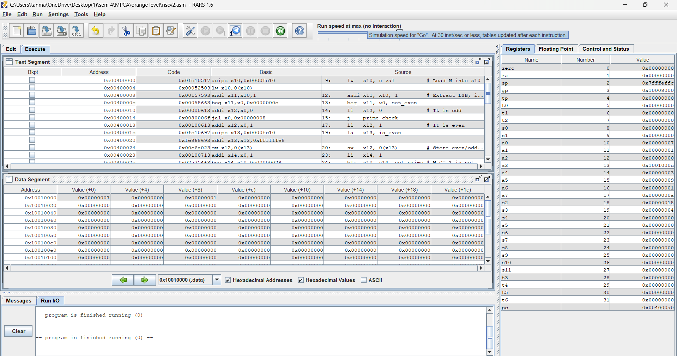  Explanation of code:  This program will check three properties of the positive integer N stored in the memory. It will check if the number is even or odd by using the bitwise AND instruction with the number 1. If the result is 0, the number is even. It will check if the number is prime by looping through the division of the number by integers from 2 up to the square root of the number. If the remainder is 0 at any point during the division, the number is not prime. It will check if the number is a factorial number by looping through the multiplication of consecutive integers from 1 through the number. If the result is equal to the number, the number is a factorial number; if the result is larger than the number, the number is not a factorial number. This program is designed to be compatible with RARS using only RISC-V arithmetic and branch instructions without the use of pseudo-instructions.

