Ideation Phase

Empathize & Discover

Date - 19 September 2022

Team ID- PNT2022TMID592924

Project Name - Project – MARINE MASTERPIECES: IMAGE CLASSIFICATION OF EXQUISITE

Maximum Marks - 4 Marks

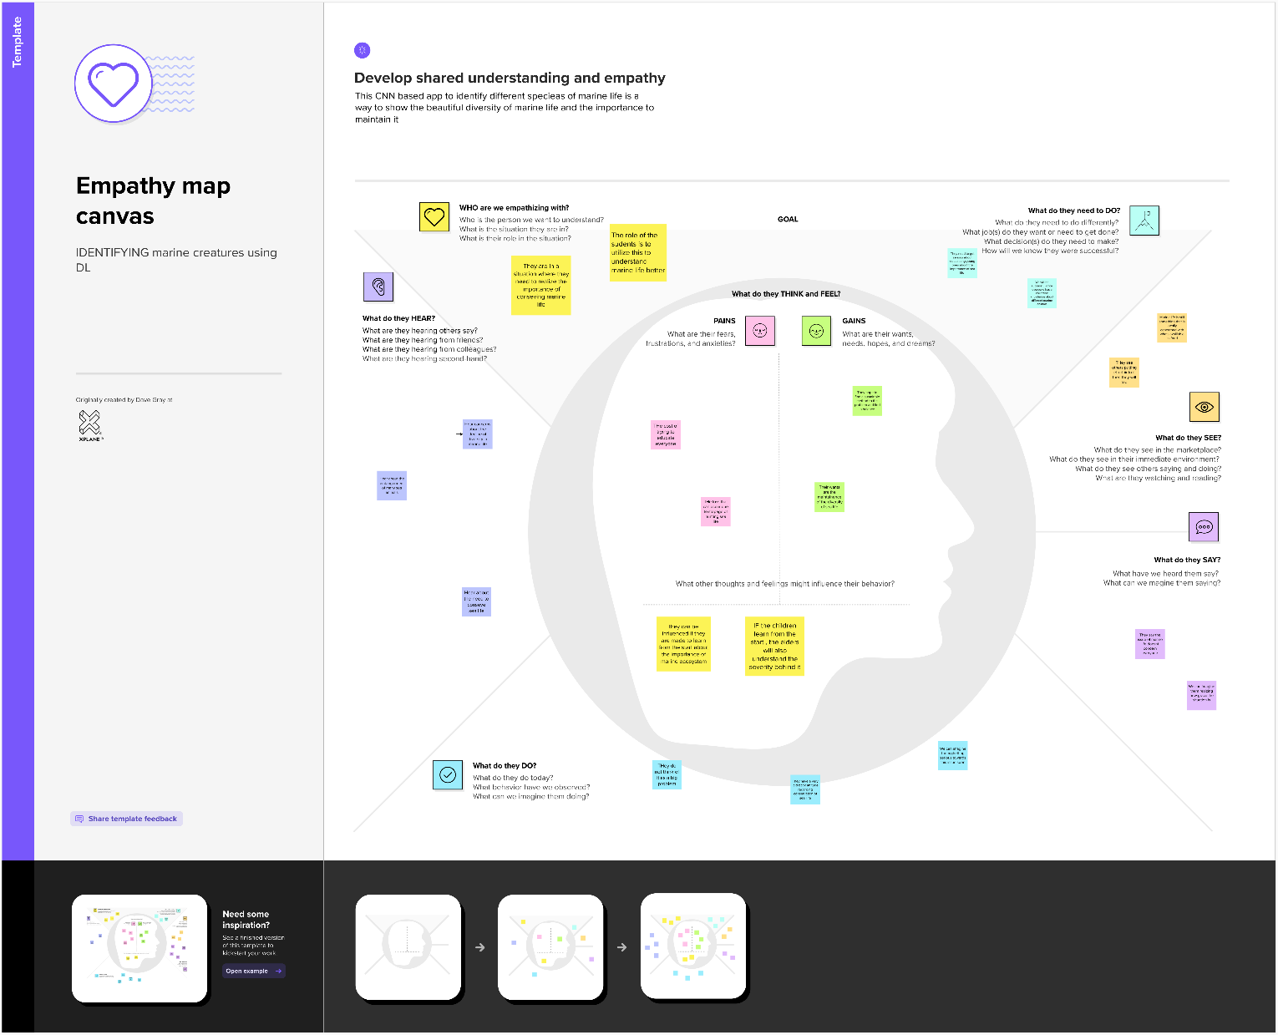\

Brainstorming

