Technologies

Backend :nodejs

Frontend : ejs

For run this app:

Install nodejs (if not)

In cmd write command “**npm i**” to download all modeules

And then write “**node controller.js**”

Web app started on localhost on port 8000 so go on browser and write “**localhost:8000**”

Working:

Web app is for employee and manager.It is start from

**Index.js** – there are option for sign in and sign up

They can sign in if they are registerd

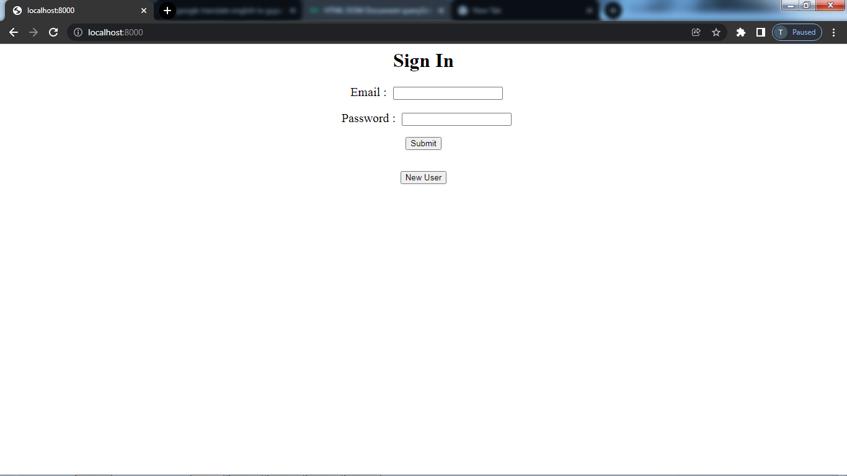

Employee and manager can register them selves by click new user

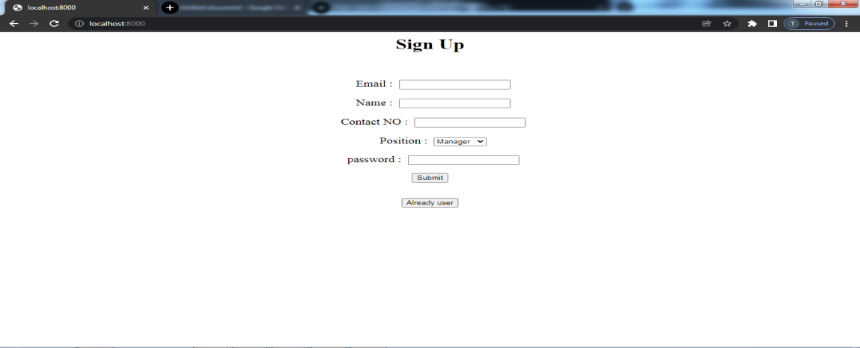

There are validation for sign up

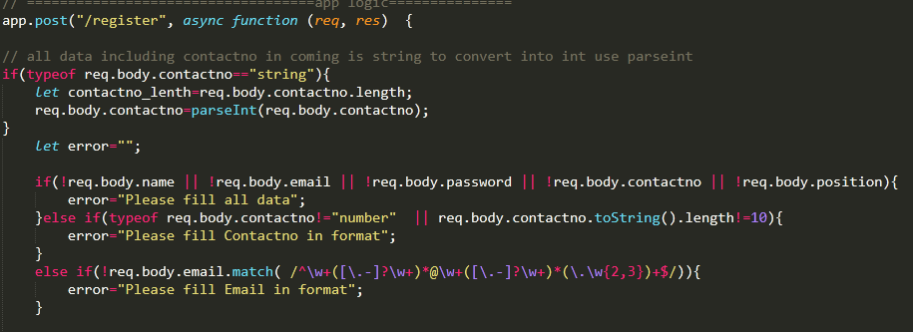

After successfully Signup Or sign in They go to

**employee.ejs** – they can see there registered details and also can edit then by click on I want to update button

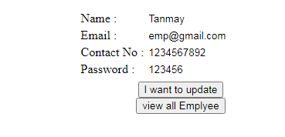

Button of View all emplyee is only visible for manager

And by clicking on that button they will go to

**manager.ejs** – there are available all emplyee details and also manager can remove any employee from this page

