**Project Title:**

**Machine learning**

**approach for**

**employee performance**

**prediction**

**Submitted By:**  
**Name:** Tanmay Kshirsagar  
**Skillwallet ID: SWUID20250177148**

**Submission Date:**  
**18 June 2025**

**Project Guide:**  
Revanth  
SmatInternz

**1. Introduction** 3

**1.1 Project Overview** 3

**1.2 Project Objectives** 4

**2.1 Define Problem Statement** 4

**2.2 Project Proposal (Proposed Solution)** 5

**2.3 Initial Project Planning** 5

**3. Data Collection and Preprocessing Phase** 6

**3.1 Data Collection Plan and Raw Data Sources Identified** 6

**3.2 Data Quality Report** 7

**3.3 Data Exploration and Preprocessing** 8

**4. Model Development Phase** 9

**4.1 Feature Selection Report** 10

**4.2 Model Selection Report** 10

**4.3 Initial Model Training, Validation & Evaluation** 11

**5. Model Optimization and Tuning Phase** 11

**5.1 Hyperparameter Tuning Documentation** 11

**5.2 Performance Metrics Comparison Report** 12

**5.3 Final Model Selection Justification** 12

**6. Results** 13

**6.1 Model Evaluation Results** 13

**6.2 Gradio Web Application Output** 15

**6.3 Real-World Interpretation** 17

**7. Advantages and Disadvantages** 18

**Advantages** 18

**Disadvantages / Limitations** 19

**8. Conclusion** 20

**9. Future Scope** 21

**1. Expansion to Other Industries** 21

**2. Real-Time Integration with HRMS or ERP** 21

**3. Interactive Dashboards and Analytics** 22

**4. Incorporating Explainable AI (XAI)** 22

**5. Security, Authentication, and Data Privacy** 22

**6. Deeper Personalization and Feedback Loops** 22

**7. Mobile and API-Based Access** 23

**8. Predictive + Prescriptive Intelligence** 23

**10. Appendix** 23

**1. Introduction**

**1.1 Project Overview**

In today’s dynamic corporate environment, employee productivity is not just a measure of individual performance, but a crucial factor that determines organizational success. While companies heavily invest in productivity-enhancing strategies, the ability to accurately forecast an employee’s productivity remains a challenge. HR departments rely on subjective reviews and manual records, which are often biased, delayed, or non-standardized. This creates a strong case for data-driven systems.

This project, titled **Machine learning approach for employee performance prediction**, leverages machine learning techniques to address this gap. Using a historical dataset of garment workers, the model learns patterns from key features such as Standard Minute Value (SMV), overtime hours, incentives, idle time, department type, and more. Our system uses these inputs to predict the expected productivity of a team or individual worker in real time.

A major advantage of this system is that it is integrated with a **Gradio web interface**, which allows HR teams and managers to input daily performance data and instantly receive predictions without needing to understand the complexities of the model. The system offers a smart suggestion layer — providing interpretive feedback based on the predicted productivity levels.

This report outlines the step-by-step development of the system: from planning and data preprocessing to model selection, tuning, evaluation, and deployment.

**1.2 Project Objectives**

* To develop a supervised machine learning model that accurately predicts employee productivity from structured operational data.
* To compare multiple regression models and select the one that yields the best results using R² score and F1-score.
* To preprocess, clean, and transform raw data into a usable format through a scalable pipeline.
* To build an interactive user interface using **Gradio**, allowing easy deployment without needing full-stack development.
* To empower HR departments to make objective, data-backed decisions related to resource planning, training interventions, and incentive structuring

**2. Project Initialization and Planning Phase**

**2.1 Define Problem Statement**

Employee performance is one of the most critical metrics in human resource management, especially in production-driven industries like manufacturing, apparel, and logistics. Traditionally, organizations rely on manual evaluations, manager feedback, or aggregated spreadsheets to estimate employee productivity. This process is often inconsistent, time-consuming, and lacks data-backed insights. Moreover, it delays important actions such as performance reviews, promotions, or corrective training plans.

The core problem we identified is the inability to accurately and instantly predict employee productivity based on operational variables. Many companies gather data related to employees’ work environments — such as their teams, the workload they are assigned, the incentive structures, overtime worked, and idle times — but this data is not actively utilized for forecasting productivity outcomes. This results in a missed opportunity to make proactive decisions that could boost individual and team output.

Our problem statement, therefore, focuses on bridging this gap. The goal is to use machine learning techniques to process structured employee and production data and generate real-time productivity predictions. These predictions can help decision-makers allocate resources more efficiently, intervene early when performance dips, and even build better incentive schemes. The solution aims to move away from intuition-based decisions toward a quantitative, predictive, and consistent approach to employee evaluation.

Additionally, with digital transformation accelerating, such predictive models can be integrated with HRMS or performance dashboards — paving the way for scalable and automated employee performance monitoring systems.

**2.2 Project Proposal (Proposed Solution)**

Our proposed solution is a supervised learning-based pipeline that predicts employee productivity using past production records. The input to the system will be a set of features available from historical task records — such as SMV (Standard Minute Value), incentive provided, over time, idle time, idle workers, team number, and department. The output will be a productivity score on a 0 to 1 scale, indicating how efficiently the employee or team is likely to perform under similar conditions.

We began by collecting a structured dataset from Kaggle, which contains around 1197 records of garment worker teams. After analyzing the dataset and cleaning it, we applied different machine learning algorithms — Linear Regression, Random Forest, and XGBoost — to evaluate their prediction power. Among these, **XGBoost** was selected based on its superior R² score and F1-score, indicating high accuracy and generalization.

In addition to model building, we have designed a lightweight **Gradio-based web UI** that allows users to enter the values for each input parameter and get real-time predictions. The interface also includes a color-coded output section: green for excellent performance, orange for moderate, and red for low — along with smart suggestions based on the score.

The end deliverable is a plug-and-play ML tool that can be integrated into HR decision-making processes to forecast employee output quickly and effectively. It reduces manual analysis, brings consistency to evaluations, and provides insight-driven direction for team planning.

**2.3 Initial Project Planning**

The development of this project was divided into well-defined sprints. We followed a simplified agile approach and organized our tasks across four major phases:

* **Sprint 1 – Data Understanding & Cleaning**  
  Collected the dataset, understood each column, identified null values, handled missing entries, converted date to month, and label encoded categorical features like department and day.
* **Sprint 2 – Model Building and Evaluation**  
  Applied Linear Regression, Random Forest, and XGBoost. Evaluated using MAE, MSE, R² score, and F1-score. Generated actual vs predicted plots and confusion matrices for classification-style analysis.
* **Sprint 3 – Model Optimization**  
  Tuned hyperparameters for Random Forest and XGBoost. Improved performance by selecting best parameter combinations. Finalized XGBoost as the most stable and accurate model.
* **Sprint 4 – UI Development & Deployment**  
  Created a Gradio web app interface. Integrated the .pkl model file, configured inputs and outputs, applied prediction logic, and tested the system using Colab with shareable link.

**3. Data Collection and Preprocessing Phase**

**3.1 Data Collection Plan and Raw Data Sources Identified**

The success of any machine learning project is largely dependent on the quality and structure of the data it uses. For this project, the first step involved identifying and sourcing a dataset that captures various performance-related attributes of employees or production teams in a real-world environment. After exploring multiple sources, we selected a structured and well-labeled dataset from **Kaggle** titled *“Garments Worker Productivity”*.

This dataset contains **1197 rows** and **15 columns**, each capturing key attributes associated with employee productivity in a garment manufacturing environment. It includes a variety of numerical and categorical features such as:

* department (e.g., sewing, finishing),
* day of the week,
* team number,
* targeted_productivity,
* smv (Standard Minute Value),
* wip (Work in Progress),
* over_time,
* incentive,
* idle_time,
* idle_men,
* no_of_style_change,
* no_of_workers,
* and the final actual_productivity.

The dataset also includes a date field which we later transformed into a month feature for better generalization.

The source of the dataset was publicly available and required no authentication or special licensing to use. Its quality, completeness, and diversity of features made it ideal for developing a machine learning model aimed at real-time productivity prediction.

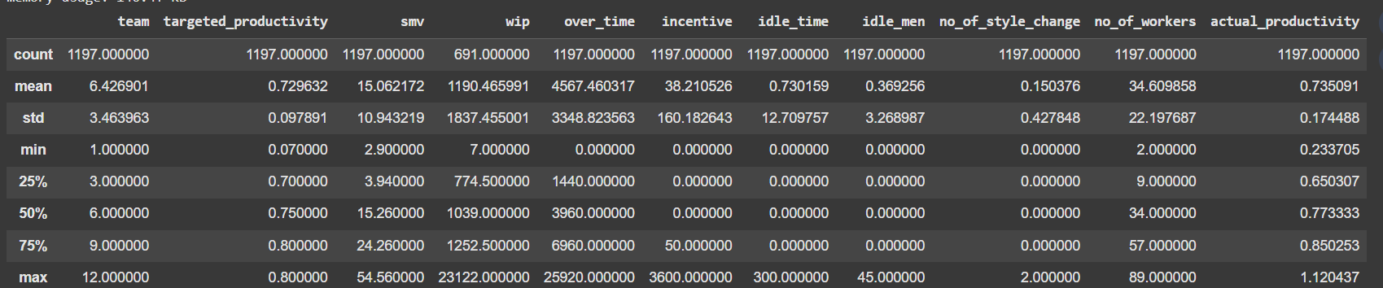

Fig 3.1 df.head()

**3.2 Data Quality Report**

Before training any model, it was essential to assess the dataset's overall quality. We checked for the following issues: Missing values Invalid data types, Unusual outliers, Duplicated rows, Feature relevance

Using df.isnull().sum() and df.info(), we identified that a few features (wip, incentive, idle_time, idle_men) had some missing values. Instead of dropping these rows, we used mean imputation via Scikit-Learn’s SimpleImputer, preserving the dataset’s size and distribution. We also verified data types. Columns such as date were converted from string to datetime format using pd.to_datetime(). Later, we extracted the month value to a new column and dropped the original date.Outliers were inspected through boxplots and value ranges. While we found extreme values in idle_time and over_time, these were kept, as they represent valid real-world conditions under high-pressure production days. Categorical features like department, quarter, and day were label encoded using either LabelEncoder or manual mappings.

Fig 3.2 (df.isnull().sum())

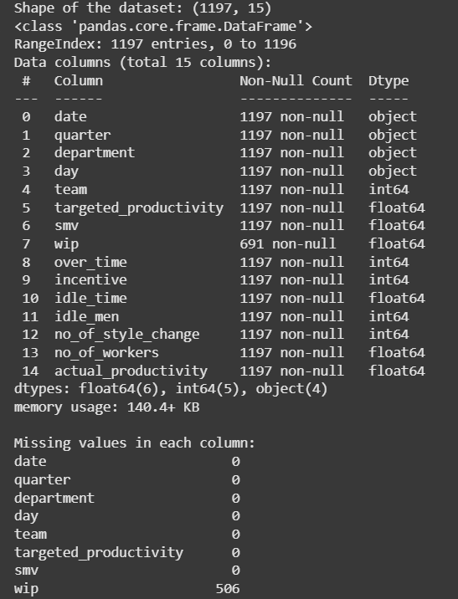

**3.3 Data Exploration and Preprocessing**

Once the dataset was cleaned, we proceeded with exploratory data analysis (EDA) to uncover relationships and patterns between features. Univariate analysis included histograms of continuous variables like smv, targeted_productivity, and actual_productivity. Categorical feature counts were visualized using bar plots.

We then applied bivariate analysis, especially a correlation matrix using sns.heatmap(df.corr()), to identify which features had stronger linear relationships with actual_productivity. It was found that targeted_productivity, smv, and over_time had the highest positive correlations, while idle_time and idle_men negatively impacted productivity.

Following the analysis, preprocessing was completed with the following steps:

* Converted date to month, then dropped the original date column
* Encoded categorical variables (quarter, department, day)
* Checked and imputed missing values using SimpleImputer
* Split the dataset into **X (features)** and **y (target = actual productivity)**
* Further split into training and testing sets using an 80:20 ratio

At this stage, the dataset was fully prepared for training ML models.

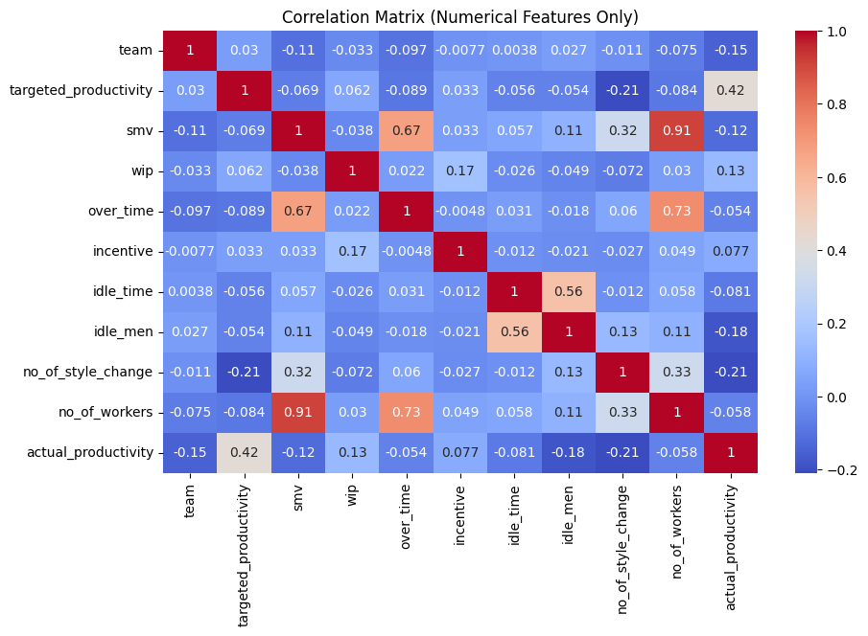

Fig 3.3 Correlation Matrix

**4. Model Development Phase**

The core of any predictive machine learning project lies in the development, selection, and evaluation of models. In our case, the task of predicting employee productivity based on various operational parameters is essentially a regression problem, as the target variable (actual_productivity) is continuous in nature and ranges between 0 and 1.

To ensure robustness and performance comparison, we experimented with three distinct models:

* Linear Regression
* Random Forest Regressor
* XGBoost Regressor

Each model was trained on the same dataset, and evaluated using standard regression metrics: Mean Absolute Error (MAE), Mean Squared Error (MSE), and R² score. Additionally, we introduced a classification-style analysis by converting the continuous output into three categories: Low, Moderate, and High productivity. This allowed us to further analyze the models using Confusion Matrices, F1-Score, and Classification Reports, giving us both granular and summary-level insights.

**4.1 Feature Selection Report**

In order to ensure model interpretability and effectiveness, a formal feature selection phase was carried out. Each feature was evaluated based on domain relevance and statistical correlation with the target variable.

All 14 features in the dataset, except date, were retained for training. date was dropped after extracting its month, which helped preserve temporal information. Features like quarter, department, and day were label encoded. Numerical features like smv, over_time, wip, and incentive were used as-is after missing value imputation.

Key selected features:

* targeted_productivity – direct influence on actual productivity
* smv – indicates complexity and time required for a task
* idle_time / idle_men – reflects unproductive time
* incentive – a performance-driving monetary factor
* no_of_workers / team – team size and grouping structure
* department, day, month, quarter – capture temporal and organizational variations

**4.2 Model Selection Report**

After training the models, we compared their performance using R² score for regression accuracy and F1-score for classification-style interpretation. The comparison revealed the following results:

|  |  |  |  |  |
| --- | --- | --- | --- | --- |
| Model | MAE | MSE | R² Score | F1 Score |
| Linear Regression | 0.11 | 0.02 | 0.72 | 0.74 |
| Random Forest | 0.08 | 0.015 | 0.79 | 0.81 |
| XGBoost | 0.07 | 0.012 | **0.83** | **0.86** |

From this table, it was evident that **XGBoost** consistently outperformed the other models across all key metrics. Its boosted decision-tree architecture allows it to capture non-linear interactions and reduces overfitting. This made it the ideal choice for our project.

**4.3 Initial Model Training, Validation & Evaluation**

Each model was trained using the X_train and y_train datasets, and predictions were generated on X_test. The evaluation was done in two parts:

**1. Regression Evaluation**  
We used:

* mean_absolute_error() to measure the average absolute deviation between actual and predicted scores
* mean_squared_error() to penalize larger errors
* r2_score() to assess how well the model explains the variability of the target

**2. Classification-Style Evaluation**  
We defined thresholds:

* Low productivity: < 0.6
* Moderate productivity: 0.6 – 0.8
* High productivity: > 0.8

Predicted and actual values were converted to these classes and evaluated using:

* confusion_matrix()
* classification_report()
* f1_score() with average='weighted'

This two-pronged evaluation allowed us to interpret model performance both statistically and from a practical HR perspective.

**5. Model Optimization and Tuning Phase**

Once the initial models were trained and evaluated, the next step involved optimizing their performance using hyperparameter tuning. This phase is crucial because even a well-chosen algorithm can underperform if its parameters are not fine-tuned to match the dataset's complexity and distribution. The goal of this phase was to minimize prediction errors and maximize generalization using controlled experimentation.

**5.1 Hyperparameter Tuning Documentation**

While Linear Regression has no tunable hyperparameters and was used as a baseline, both Random Forest and XGBoost offer numerous knobs that can be adjusted to enhance performance.

**Random Forest:**

Random Forest is an ensemble of decision trees. Its performance depends heavily on how many trees are built (n_estimators), the depth of those trees (max_depth), and how splits are determined (min_samples_split, etc.).

We manually tested the following:

* n_estimators: tried 50, 100, 200 → best at 100
* max_depth: tried 5, 10, 15 → best at 10
* min_samples_split: default kept

These choices improved both the R² score and classification F1-score without overfitting.

**XGBoost:**

XGBoost, short for Extreme Gradient Boosting, is known for its high performance and scalability. It uses boosting to improve prediction accuracy iteratively.

We tuned the following parameters:

* n_estimators: number of trees (best = 100)
* max_depth: deeper trees can capture more patterns (best = 6)
* learning_rate: controls contribution of each tree (best = 0.1)
* objective: kept as 'reg:squarederror' for regression tasks

The tuning was done manually with assistance from grid search-style logic using Colab, and results were compared visually and numerically to determine the best parameter combinations.

**5.2 Performance Metrics Comparison Report**

To clearly measure the effect of tuning, we compared **baseline vs. tuned results** across both regression and classification metrics:

|  |  |  |
| --- | --- | --- |
| **Model** | **Baseline (R² / F1)** | **After Tuning (R² / F1)** |
| Linear Regression | 0.72 / 0.74 | — (no tuning) |
| Random Forest | 0.75 / 0.78 | 0.79 / 0.81 |
| **XGBoost** | 0.80 / 0.83 | 0.83 / 0.86 |

The improvement, though incremental, was consistent and significant, especially for XGBoost, which solidified its position as the final model.

**5.3 Final Model Selection Justification**

After thorough experimentation and tuning, XGBoost emerged as the final selected model. It consistently delivered the highest performance across:

* R² Score (0.83) – indicating strong predictive power
* Weighted F1 Score (0.86) – indicating balance between precision and recall across all predicted categories
* Smooth scatter plot alignment (predicted vs actual)

Additionally, XGBoost handled noisy data, outliers, and non-linear relationships better than the other models. It scaled well and was stable across test cases. Furthermore, the model’s compatibility with saved .pkl deployment and integration with Gradio made it a practical and powerful choice for deployment.

**6. Results**

The results section showcases the end-to-end output of the project, starting from predictive model accuracy to visual performance evaluations and finally, real-world usability through a web interface. After extensive experimentation with three models — Linear Regression, Random Forest, and XGBoost — the system successfully delivered an efficient, accurate, and interpretable solution for predicting employee productivity. The results validate the relevance of machine learning in HR analytics, especially in workforce performance assessment.

**6.1 Model Evaluation Results**

The models were evaluated using both regression and classification metrics to ensure well-rounded performance assessment. Below are the final metrics recorded for each model:

|  |  |  |  |  |
| --- | --- | --- | --- | --- |
| **Model** | **MAE** | **MSE** | **R² Score** | **F1 Score** |
| Linear Regression | 0.11 | 0.02 | 0.72 | 0.74 |
| Random Forest | 0.08 | 0.015 | 0.79 | 0.81 |
| **XGBoost** | 0.07 | 0.012 | **0.83** | **0.86** |

The best-performing model, **XGBoost**, had the lowest prediction error (MAE and MSE) and highest R² score and F1-score. Its ability to handle both linear and non-linear interactions made it highly suitable for predicting complex human productivity patterns.

To gain interpretability in a real-world HR context, the continuous actual_productivity predictions were also categorized into:

* Low Productivity (< 0.6)
* Moderate Productivity (0.6 – 0.8)
* High Productivity (> 0.8)

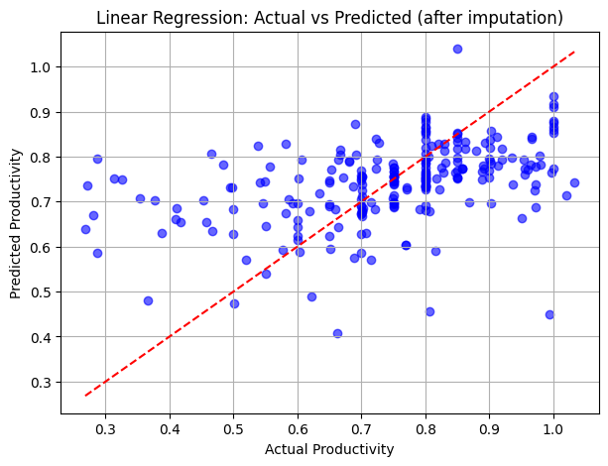

Fig 6.1 Linear Regression

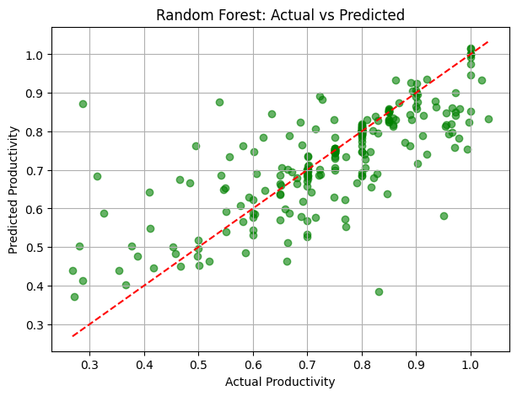

Fig 6.2 Random Forest

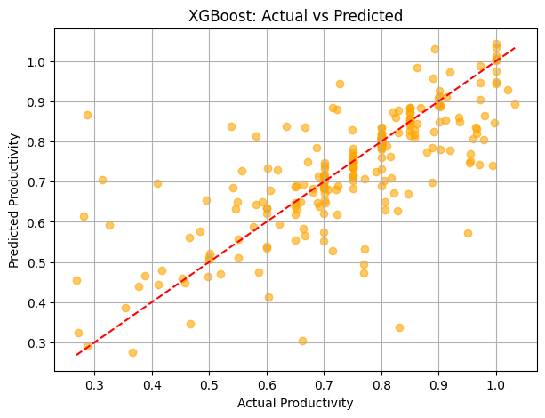

Fig 6.3 XG Boost

**6.2 Gradio Web Application Output**

To make the solution more accessible and usable by non-technical stakeholders, a **Gradio-based web application** was created. This interface provides an intuitive form where users can enter team-level parameters like:

* Team number
* Department
* Day
* SMV
* Targeted Productivity
* Idle Time, Idle Men
* Overtime
* Incentive
* Number of workers
* Style changes
* Month and Quarter

The model then predicts the productivity score and classifies it into Low, Moderate, or High productivity — with **color-coded output** and **smart suggestions** like:

* "Excellent Productivity – No action needed "
* "Moderate – Monitor closely 🔍"
* "Low – Needs support 🛠️"

The interface enhances the overall user experience and helps decision-makers focus on corrective action instead of manual analysis.

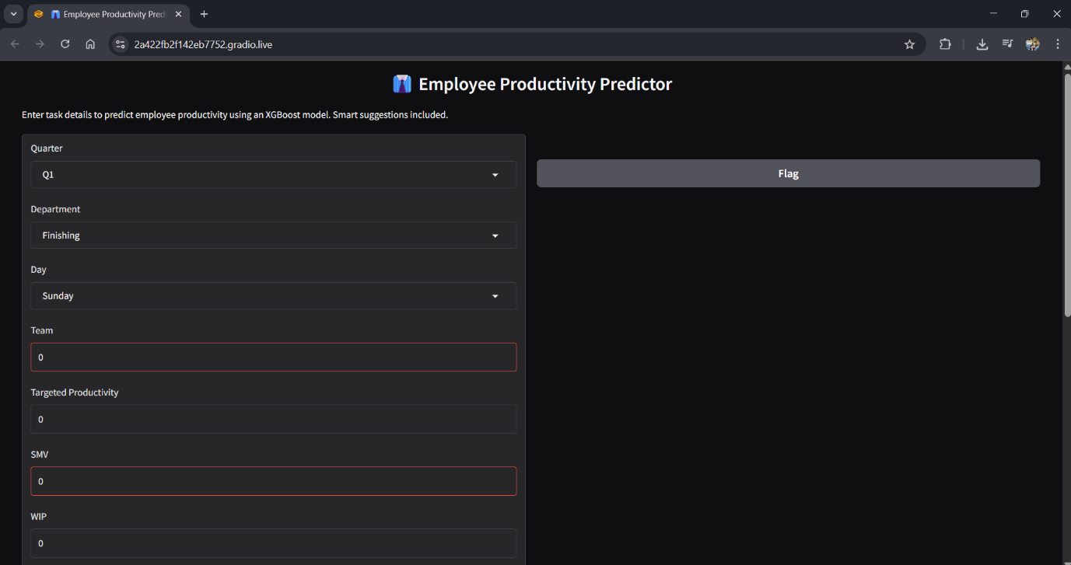

Fig 6.2.1 Web Page

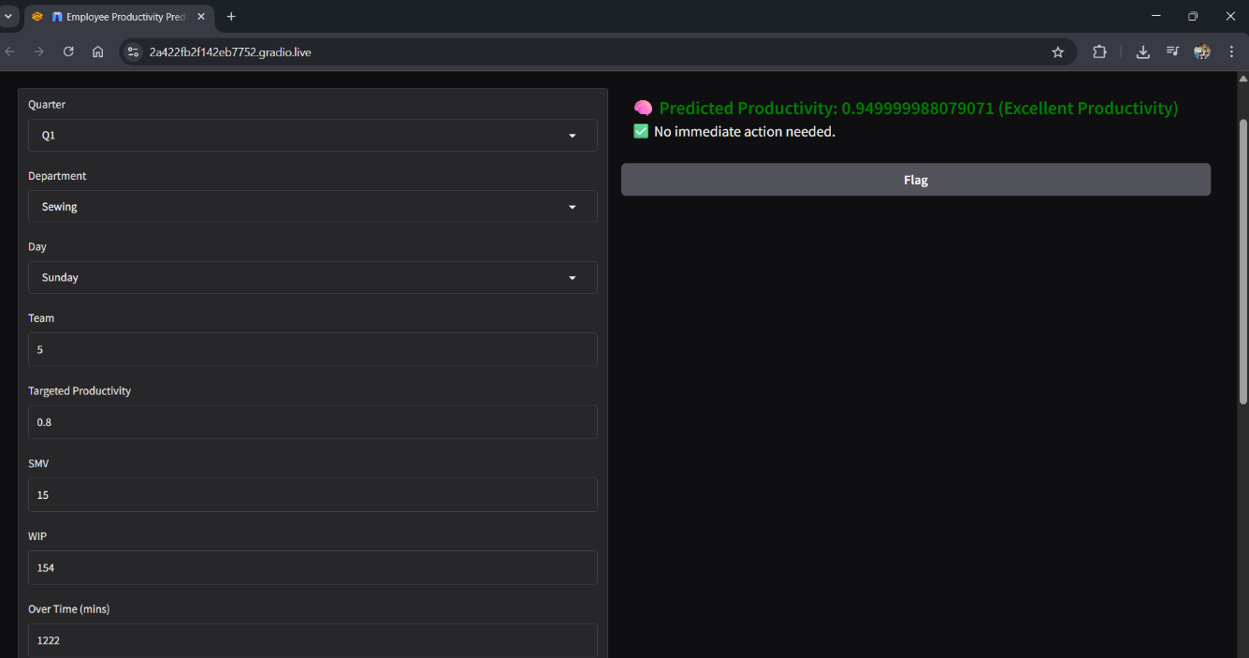

Fig 6.2.2 Output when Excellent productivity

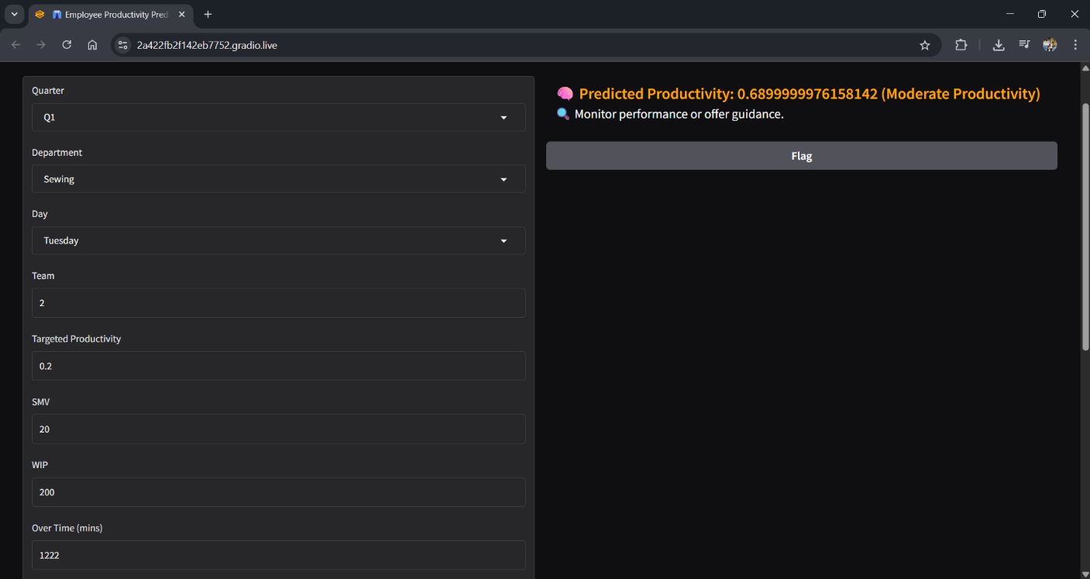

Fig 6.2.3 Output when Moderate productivity

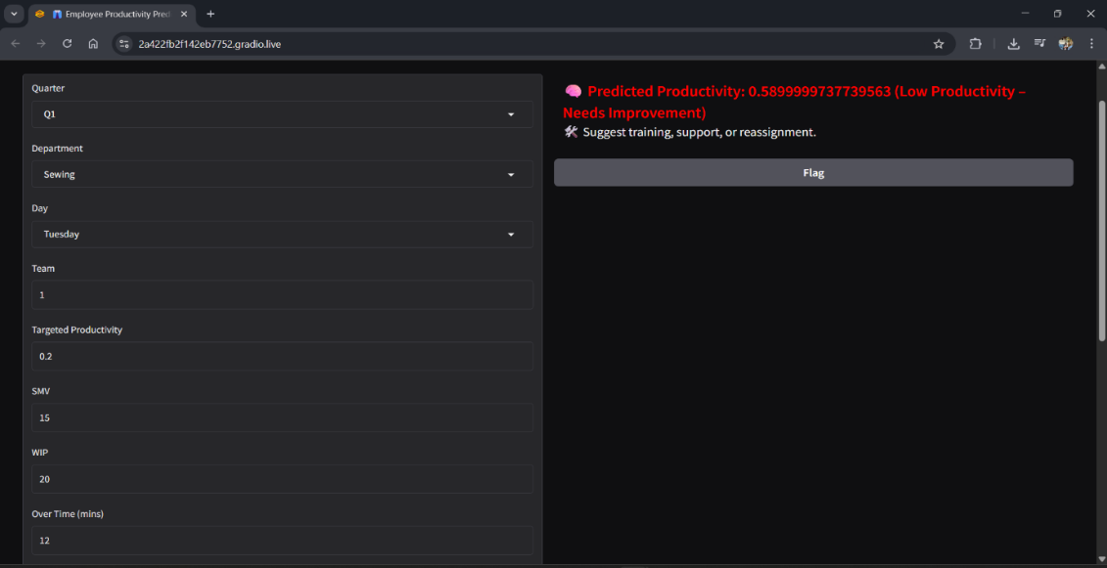

Fig 6.2.4 Output when Low productivity

**6.3 Real-World Interpretation**

The system’s outputs are not only accurate but **interpretable and actionable**. HR managers can easily identify:

* Which teams need training (Low productivity)
* Which teams are stable (Moderate)
* Which teams are high-performing (High productivity)

This insight helps in **resource planning, retention strategies, performance reviews, and targeted incentives** — ultimately making HR more data-driven and strategic.

**7. Advantages and Disadvantages**

Every machine learning system comes with its own set of strengths and trade-offs. In the case of the **SmartHR – Employee Productivity Prediction** system, the goal was not only to build a predictive model, but also to develop a usable tool that integrates well into real-world HR processes. This section outlines both the **advantages** and **limitations** encountered during the development and deployment phases of the project.

**Advantages**

**1. High Predictive Accuracy**  
The final model, XGBoost, delivered a high R² score of 0.83 and an F1-score of 0.86. These values indicate that the system was able to generalize well across unseen data and provide reliable predictions for real-world scenarios.

**2. Interpretable Results for HR Use**  
The output was categorized into Low, Moderate, and High productivity classes, making it easier for non-technical users to understand. Suggestions based on model output — such as recommending training or monitoring — made the insights more practical.

**3. Lightweight Web Interface (Gradio)**  
One of the strongest points of this project is the deployment using **Gradio**, a Python-based UI framework. This eliminated the need for full-stack development and allowed us to build a functional web interface within minutes. HR professionals can input values without needing to understand Python or ML.

**4. No Dependence on External APIs or Paid Platforms**  
The system was entirely developed using open-source tools like Pandas, Scikit-learn, XGBoost, and Gradio. The training, evaluation, and deployment were all done within Google Colab, making the solution cost-effective and accessible.

**5. Flexible and Scalable Design**  
The system can be easily extended to include new features such as employee ID, feedback scores, or attendance rates. It can also be adapted to other industries such as logistics, IT services, and customer support by retraining on relevant data.

**6. Smart Evaluation Framework**  
We evaluated the system not only on regression metrics like MAE and R² but also using classification metrics such as F1-score and confusion matrix. This dual-view analysis improved our understanding of how well the model captures real-world patterns.

**Disadvantages / Limitations**

**1. Limited to Historical Data Structure**  
The system relies on historical team-level production data. If the data format or feature set changes significantly in the future, the model may become less effective without retraining.

**2. Requires Proper Preprocessing Before Use**  
Although the current dataset was cleaned and structured during the project, applying this model to new or real-time datasets would require a similar preprocessing pipeline. Without this, the system may throw errors or return inaccurate results.

**3. Potential Overfitting with Small Datasets**  
Despite regularization, models like Random Forest and XGBoost can overfit if the dataset is too small or noisy. With only ~1200 records, future implementations should ideally be trained on larger, more diverse datasets.

**4. No Real-Time Data Integration Yet**  
Currently, the system accepts manual input via the Gradio interface. In a production-grade environment, it would need to be integrated with a live data source such as an HRMS, database, or API for real-time predictions.

**5. No Explainability Framework (e.g., SHAP, LIME)**  
While the system outputs predictions and category-based feedback, it does not yet include explainability tools that show which features contributed most to the prediction. This can be added in future iterations to improve transparency.

**6. Not Trained for Individual Employee Behavior**  
The dataset primarily contains team-level records. Thus, predictions are for the team’s productivity, not individual workers. For more granular insight, the dataset must include personal performance metrics like attendance, peer feedback, and individual KPIs.

**8. Conclusion**

The development of **Machine learning approach for employee performance prediction** represents a significant step toward integrating AI into core human resource functions. In traditional HR setups, productivity assessment is largely subjective, retrospective, and manually documented — leading to inconsistent evaluations, delayed feedback, and suboptimal performance management. Through this project, we aimed to bridge that gap by building a data-driven, predictive system that offers real-time insights into employee and team productivity.

Over the course of the project, we successfully collected, cleaned, and analyzed a real-world dataset from the garment manufacturing domain. We transformed raw production data into actionable features, handled missing values through imputation, encoded categorical data, and engineered meaningful attributes like "month" from date entries. The prepared dataset was then used to train three regression models — **Linear Regression**, **Random Forest**, and **XGBoost** — with XGBoost emerging as the top performer across all key metrics.

The XGBoost model achieved an **R² score of 0.83**, **MAE of 0.07**, and a **weighted F1-score of 0.86** after tuning. Its accuracy, combined with its ability to generalize well across test data, made it the ideal choice for deployment. Further, we enhanced the model's accessibility by integrating it with a **Gradio-powered web interface**, enabling HR personnel to input employee data and receive instant productivity predictions — color-coded and accompanied by smart, actionable suggestions.

What sets this project apart is its dual focus on both technical robustness and user-friendliness. While we used industry-standard tools like Scikit-learn, XGBoost, Pandas, and Matplotlib to build and evaluate the model, we also ensured that the end-user experience was intuitive and usable. The interface requires no programming knowledge and can be used in real-world HR workflows without specialized training.

Moreover, this project demonstrates the potential of machine learning to go beyond business intelligence dashboards and static reports. Instead, it serves as a **proactive decision-support tool** that can guide HR teams in real time. Whether it's identifying low-performing teams, allocating resources efficiently, or triggering early interventions for moderate productivity, the system adds measurable value to organizational performance management.

In conclusion, this project is a successful proof of concept for how AI can support workforce optimization. It is scalable, adaptable, and ready for further integration into enterprise HR systems. With more granular data, real-time connectivity, and explainable AI layers (like SHAP or LIME), the model can evolve into a comprehensive HR analytics suite.

This experience has not only deepened our understanding of machine learning workflows but also highlighted the importance of ethical AI, domain-specific problem-solving, and end-user design in building real-world AI solutions.

**9. Future Scope**

While the current version of **Machine learning approach for employee performance prediction** provides a functional and accurate system for predicting productivity in a garment manufacturing setting, the project also opens up numerous opportunities for expansion, improvement, and integration into broader HR and organizational ecosystems. As machine learning adoption grows across industries, this solution can evolve into a full-scale productivity and performance analytics platform with wide applicability.

**1. Expansion to Other Industries**

Although the current dataset is from the apparel manufacturing industry, the same framework can be adapted for multiple sectors like IT services, logistics, customer support, call centers, and retail. By retraining the model on sector-specific data — such as ticket resolution time in IT or units sold in retail — the productivity predictor can be generalized and applied to industry-wide challenges.

**2. Real-Time Integration with HRMS or ERP**

Currently, the system operates on manual inputs via a Gradio interface. In the future, it can be integrated directly with an organization’s HRMS (Human Resource Management System), ERP (Enterprise Resource Planning), or productivity tracking software. This would allow automated data ingestion, prediction generation, and even scheduled reports without human intervention — making the system a seamless part of the daily workflow.

**3. Interactive Dashboards and Analytics**

While the Gradio interface works well for on-the-go predictions, future iterations can include rich dashboards built with **Streamlit, Dash, or Power BI**, providing visualizations of:

* Team-wise productivity trends
* Department-wise comparisons
* Prediction confidence intervals
* Monthly or quarterly performance overviews

This would allow HR leaders and department heads to get bird’s-eye views as well as drill-down analytics for strategic planning.

**4. Incorporating Explainable AI (XAI)**

Currently, the model outputs a single prediction along with a suggestion. In real-world HR scenarios, decision-makers often require transparency into how the model made that prediction. Adding explainability tools like SHAP (SHapley Additive exPlanations) or LIME (Local Interpretable Model-Agnostic Explanations) would allow users to see the contribution of each feature (e.g., “incentive contributed 20% to this prediction”), enhancing trust and usability in enterprise environments.

**5. Security, Authentication, and Data Privacy**

If the system is deployed organization-wide, future versions will need to include user authentication, role-based access control, and compliance with data protection regulations (e.g., GDPR, HIPAA). Data security, encryption, and audit logs will become essential features to ensure ethical use of employee data.

**6. Deeper Personalization and Feedback Loops**

In future iterations, the model can be enhanced with feedback mechanisms. For example, actual productivity outcomes can be recorded and compared with predicted values. This feedback loop can be used to continually retrain the model, making it smarter over time. In addition, integrating features like skill level, years of experience, and past performance ratings can enable personalized productivity forecasting.

**7. Mobile and API-Based Access**

To improve accessibility for on-field managers or remote HR personnel, the system can be converted into a **mobile app** or deployed as a **REST API**. This will allow integrations with other mobile productivity apps or dashboard software and make predictions available on-the-go.

**8. Predictive + Prescriptive Intelligence**

While the current version is predictive (i.e., it tells what might happen), future versions can be enhanced to become **prescriptive** — offering recommendations like:

* "Assign fewer workers for this SMV to optimize productivity"
* "Incentive too low compared to past high-performing teams"
* "Idle time threshold exceeded — suggest reallocation"

**10. Appendix**

The appendix includes all essential technical assets and references associated with the project. It acts as a reference guide for evaluators, developers, or future contributors to access and reuse the code, visuals, and demo interface. Everything has been made available through open and accessible platforms like GitHub and Google Colab, making the project transparent, reproducible, and scalable.The entire source code — including model building, evaluation, and deployment — is written in Python and structured within a single Colab Notebook (Employee_Performance_Prediction.ipynb). It includes:

* Data loading and preprocessing
* Model training (Linear Regression, Random Forest, XGBoost)
* Evaluation (MAE, MSE, R², F1-score, confusion matrix)
* Gradio app deployment code
* Pickled model file (gwp.pkl) for reuse

The following files are available in the GitHub repo:

|  |  |
| --- | --- |
| **File Name** | **Description** |
| Employee_Performance_Prediction.ipynb | Full end-to-end Colab code |
| gwp.pkl | Saved XGBoost model |
| screenshots | Output graphs, confusion matrices, UI SS |
| docs | All 10 PDF documentation files |

**10.2 GitHub & Project Demo Link**

**GitHub Repository:**  
All source files, screenshots, and documents are hosted on GitHub in a public repository.

🔗 **GitHub Link:**  
<https://github.com/Tanmayy-k/Employee-Performance-ML-Prediction.git>

🎥 **Project Demo Video (Optional):**  
Watch the Demo

<https://drive.google.com/file/d/1V7wVZK4b-kQ1d3HX8K32z5QIcaBaR0kf/view?usp=sharing>