Yuva Intern Week 3

Exploratory Data Analysis and Visualization Strategy
Credit Card Default Risk Analysis
A practical analysis using Python, SQL and Excel

Student details | Information
Name | Tanmay Pandey
College | Allenhouse Institute of Technology
Course | B Tech
Branch | Computer Science AI and ML
Semester | 7th Semester Final Year
Internship platform | Yuva Intern
Role | Data Analytics Strategist
Week | Week 3

Prepared for internship submission

Executive Summary
This report presents a complete exploratory data analysis and visualization strategy for credit card default risk. The work uses an open UCI dataset containing 30,000 customer records. Python was used for profiling, cleaning, preprocessing, feature engineering and visualization. SQL was used to answer business questions and validate the main findings. Excel outputs were created for easy review and submission.
The analysis found an overall default rate of 22.12 percent. Repayment delay was the strongest practical indicator of default risk. Customers with no delayed months had an 11.71 percent default rate, while customers delayed in all six observed months had a 70.32 percent default rate. The analytical risk segmentation also separated the population clearly: 10.89 percent default for Low Risk, 24.38 percent for Medium Risk and 46.94 percent for High Risk.

Project Objectives
- Understand the dataset structure, distributions, quality and important variables.
- Identify trends, correlations, outliers and customer groups linked with default risk.
- Create clear visual narratives that can be understood by non-technical reviewers.
- Prepare an analysis-ready dataset and reusable SQL outputs for further decision making.

Key Results at a Glance
Measure | Result
Customer records | 30,000
Default customers | 6,636
Non-default customers | 23,364
Overall default rate | 22.12%
Average credit limit | 167,484.32
Missing values | 0
Exact duplicate rows | 0
Duplicate customer IDs | 0

Scope and Tools
The project is limited to descriptive and diagnostic analytics. It does not claim to predict future defaults. The selected tools were Python for reproducible analysis and charts, SQL for business queries and aggregation, and Excel for portable review files. Power BI was not used in this task.

Dataset and Key Variables
The Default of Credit Card Clients dataset contains customer demographics, credit limits, six months of repayment status, bill statements, previous payments and a binary next-month default outcome. The target value 1 represents default and 0 represents no default.
Variable group | Variables | Purpose
Identifier | ID | Maintains one record per customer
Demographics | SEX, EDUCATION, MARRIAGE, AGE | Supports segment comparisons
Credit exposure | LIMIT BAL | Measures available credit
Repayment status | PAY 0, PAY 2 to PAY 6 | Shows recent payment delay behaviour
Bill amounts | BILL AMT1 to BILL AMT6 | Measures outstanding statements
Payments | PAY AMT1 to PAY AMT6 | Measures previous repayments
Target | Default payment next month | 1 default and 0 no default

EDA Methodology
Stage | Method | Reason
Structure review | Shape, data types, head and column inspection | Confirms dataset size and expected fields
Quality review | Missing values, duplicates and range checks | Prevents unreliable summaries
Univariate analysis | Counts, percentages, histograms and descriptive statistics | Explains individual distributions
Bivariate analysis | Group-wise default rates | Shows how risk differs between segments
Multivariate analysis | Correlation heat map | Highlights relationships across many variables
Anomaly review | IQR lower and upper limits | Flags unusual observations without automatic deletion
SQL validation | Aggregations, CTE and ranking | Rechecks business findings independently

Data Quality Findings
The raw analytical table contained no missing values, exact duplicate rows or repeated customer IDs. Initial education codes 0, 5 and 6 were outside the main documented 1 to 4 categories, and marriage code 0 was also inconsistent. During cleaning, these values were consolidated into the Others category. Final validation found no invalid values for gender, education, marriage, age, credit limit or target status.

Exploratory Findings

Default Distribution
The target is moderately imbalanced. A total of 23,364 customers did not default, compared with 6,636 default customers. This difference is important for any future modelling because accuracy alone could hide weak detection of the smaller default class.
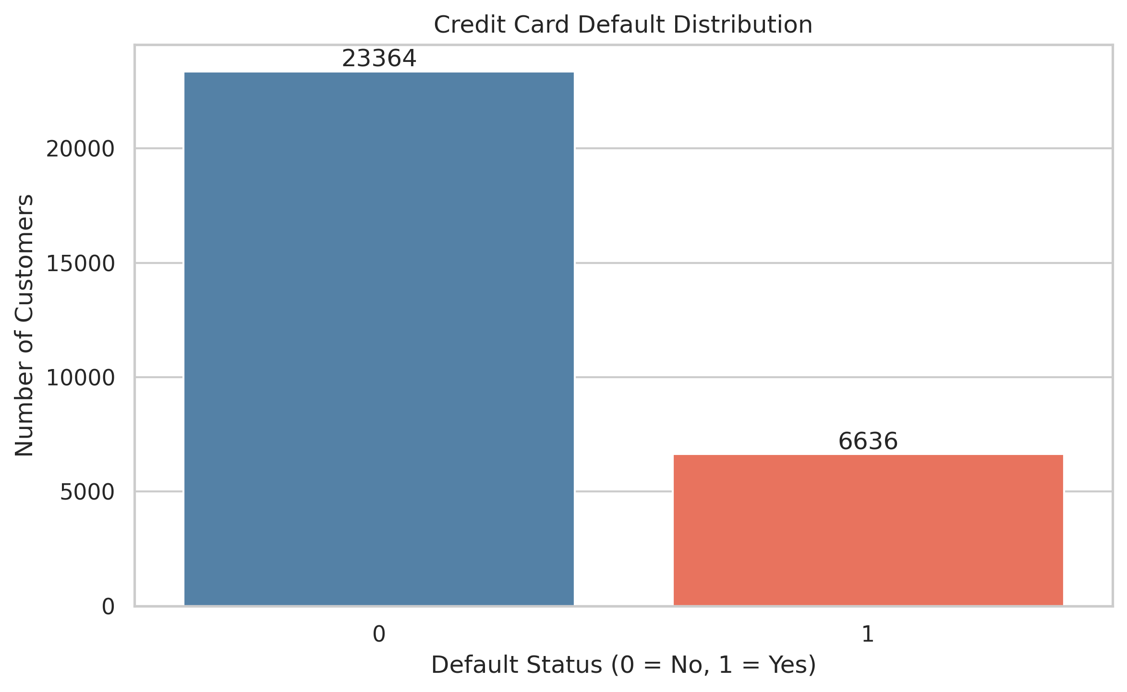
Figure 1 Distribution of next-month default status

Customer and Credit Distributions
Customer age is concentrated in the late twenties through early forties and becomes less common at older ages. Credit limits are right-skewed: many customers have lower or medium limits, while a small number have very high limits. Median-based summaries and IQR checks are therefore useful alongside averages.

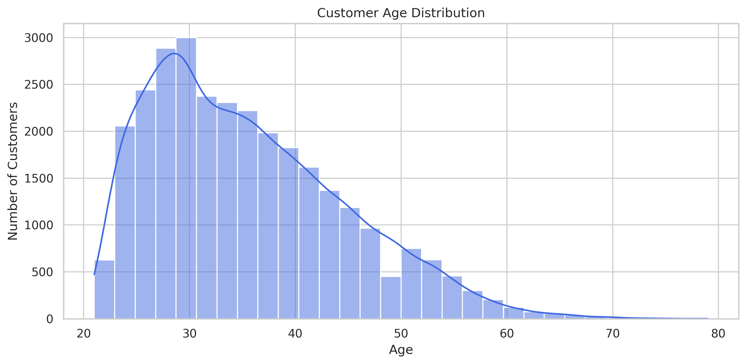
Figure 2 Customer age distribution
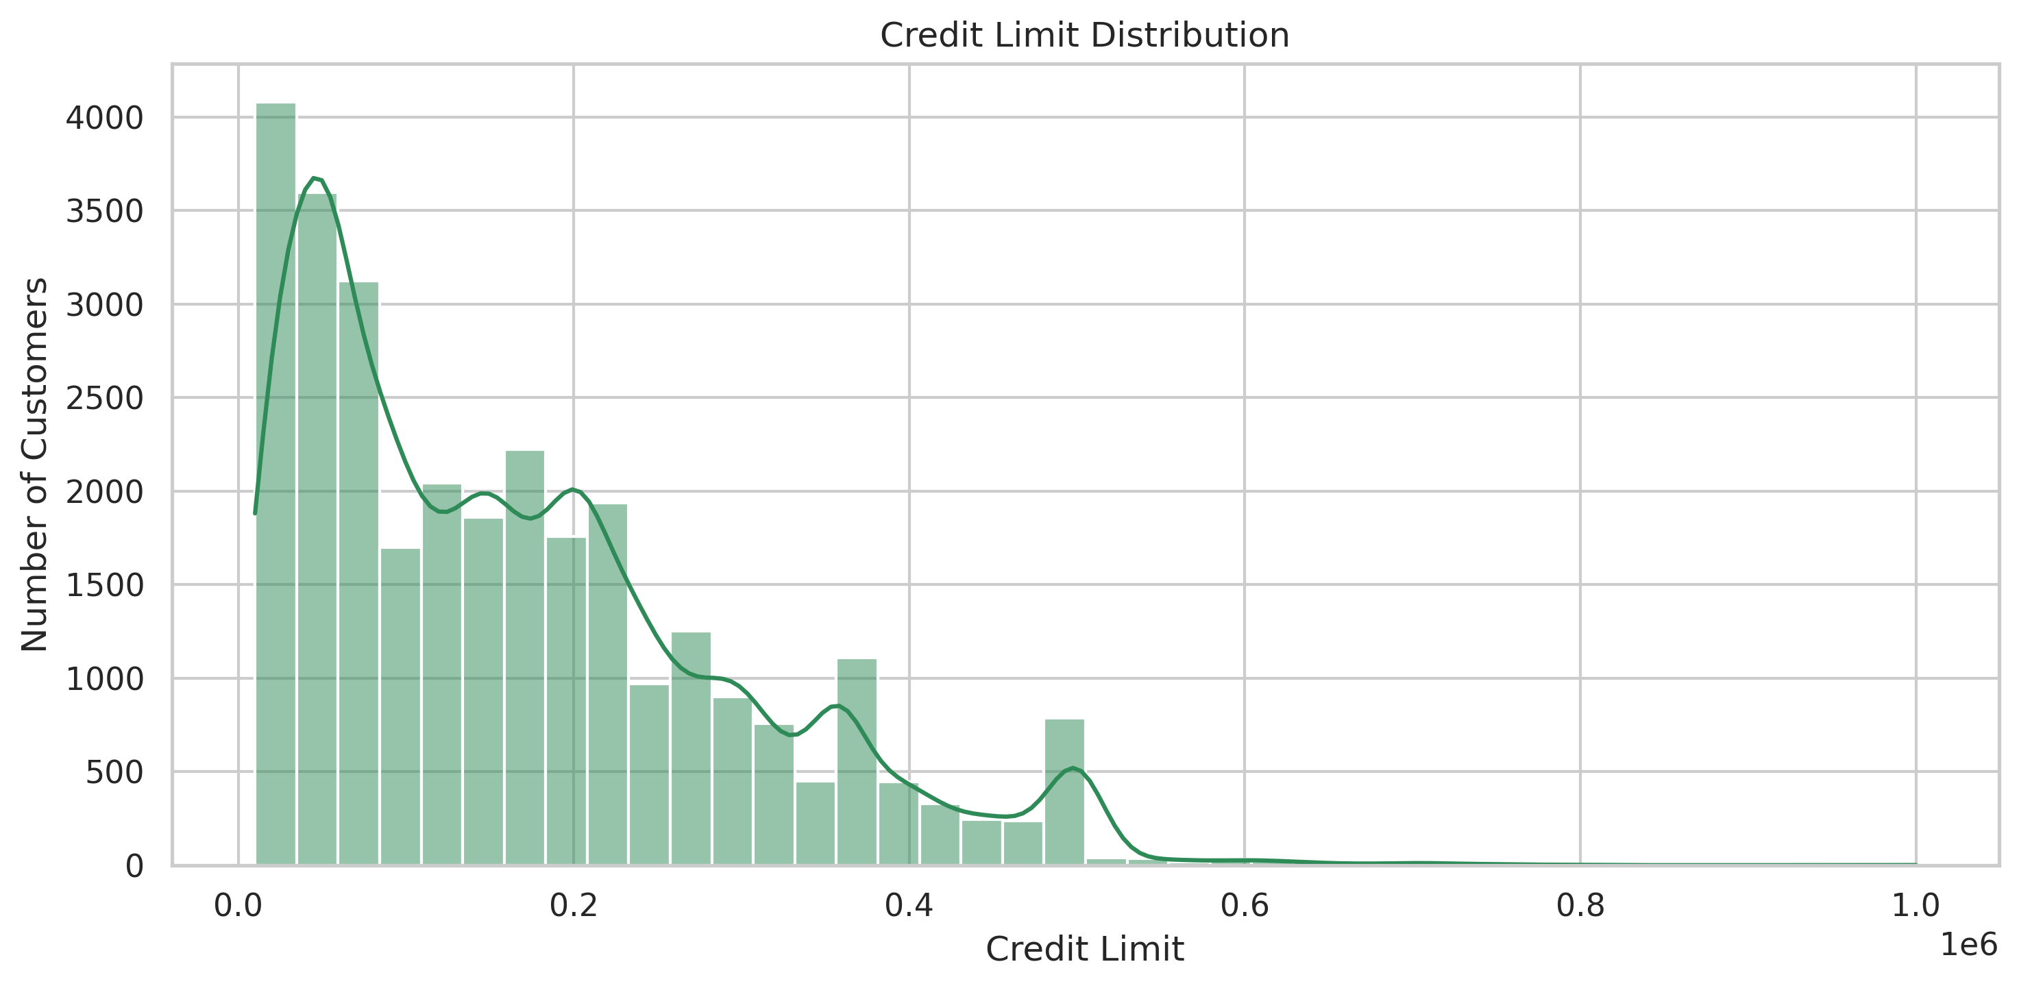
Figure 3 Credit limit distribution

Segment Analysis

Gender and Education
Male customers recorded a 24.17 percent default rate, compared with 20.78 percent for female customers. Education also showed differences after cleaning: High School customers had a 25.16 percent rate, University 23.73 percent, Graduate School 19.23 percent and Others 7.05 percent. The Others group is relatively small, so its lower rate should be interpreted cautiously.
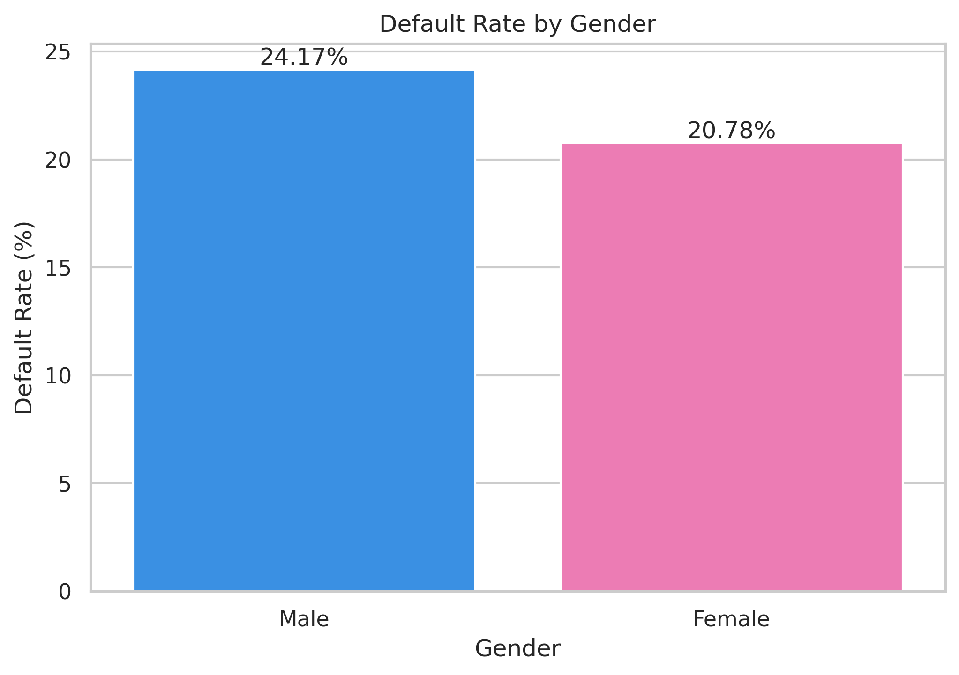
Figure 4 Default rate by gender
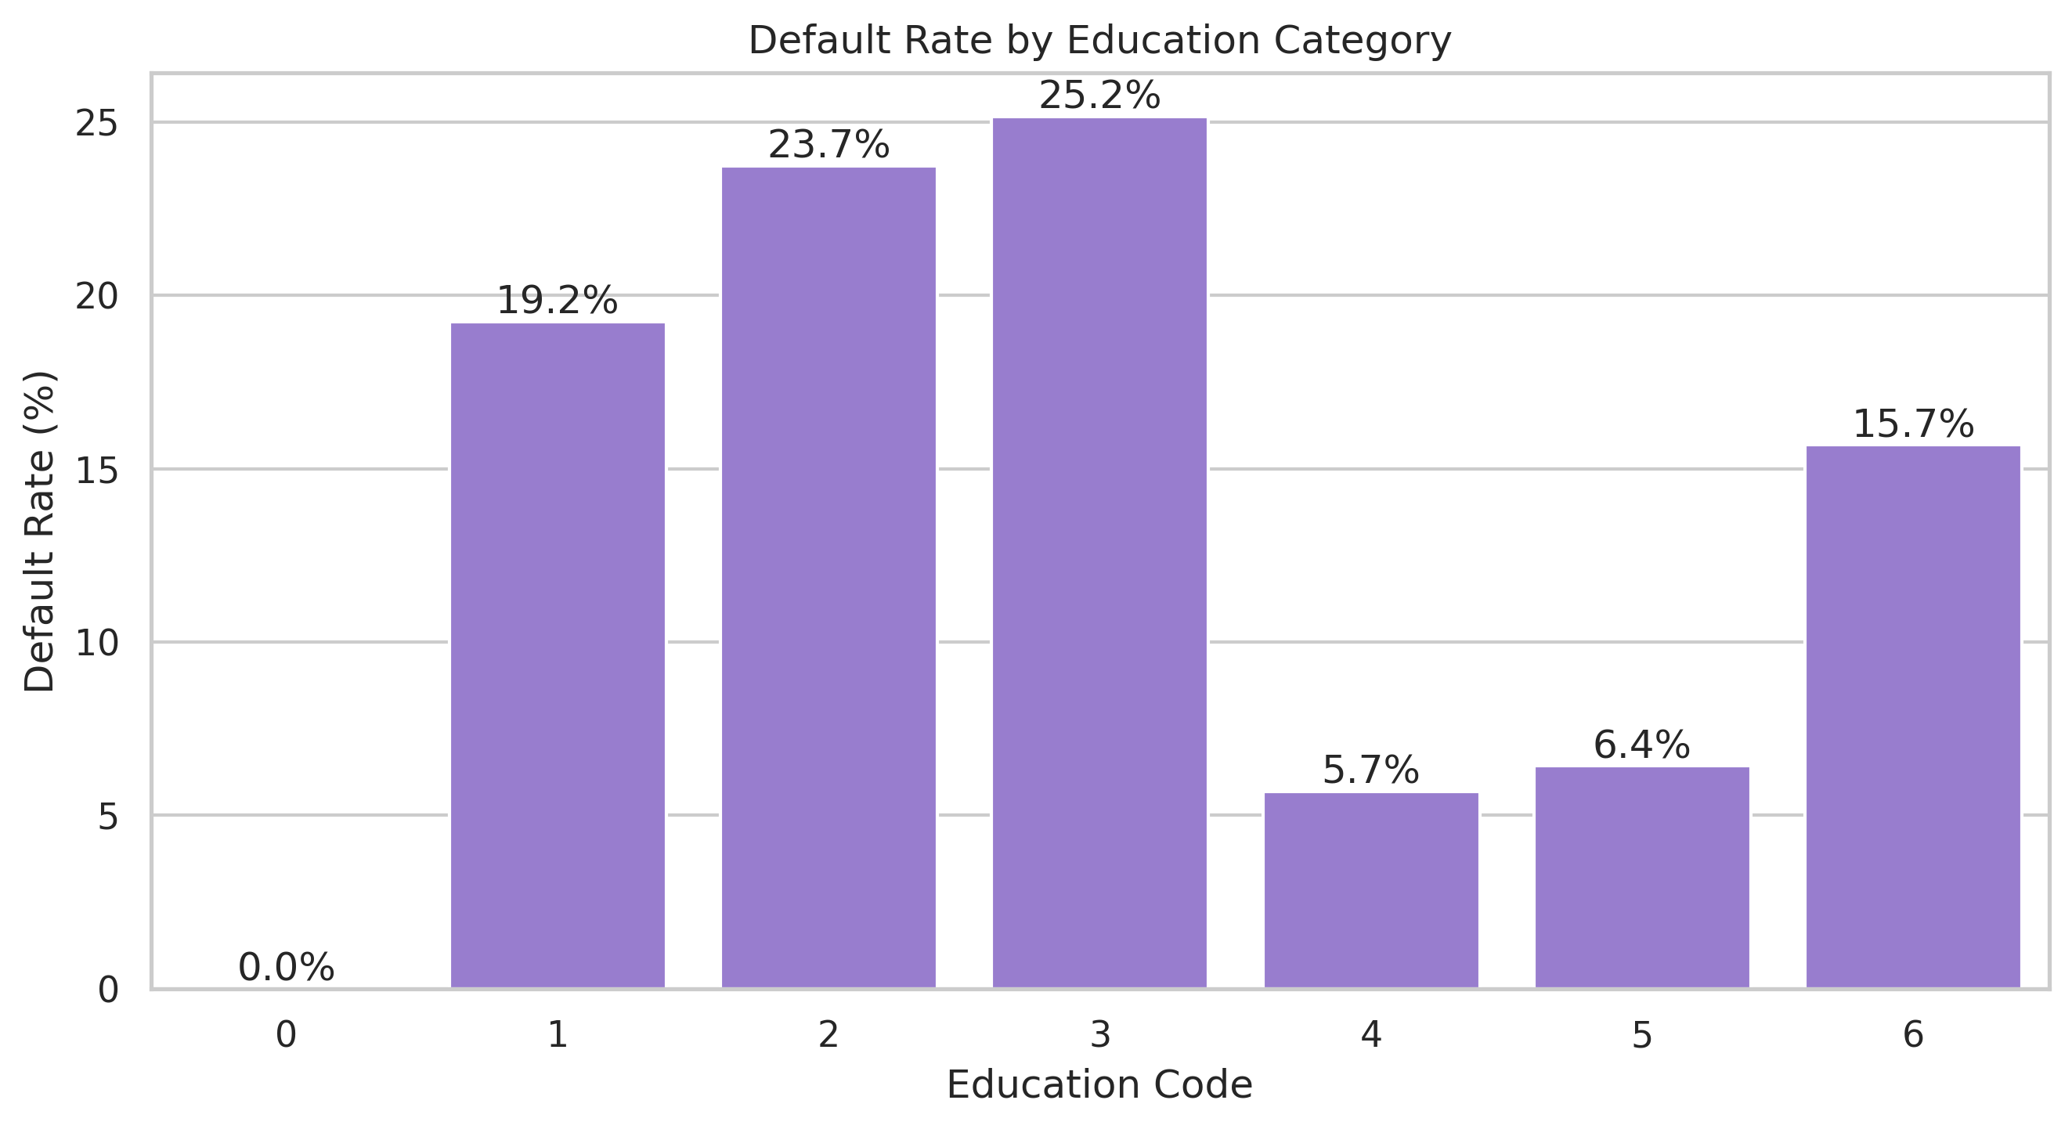
Figure 5 Raw education-code comparison before category consolidation

Age Group
The 26 to 35 group was the largest segment and had the lowest observed age-group default rate at 19.83 percent. Rates were higher for 18 to 25 at 26.66 percent and for 65 plus at 26.74 percent. The oldest group contained only 86 customers, so its percentage is less stable than the larger groups.
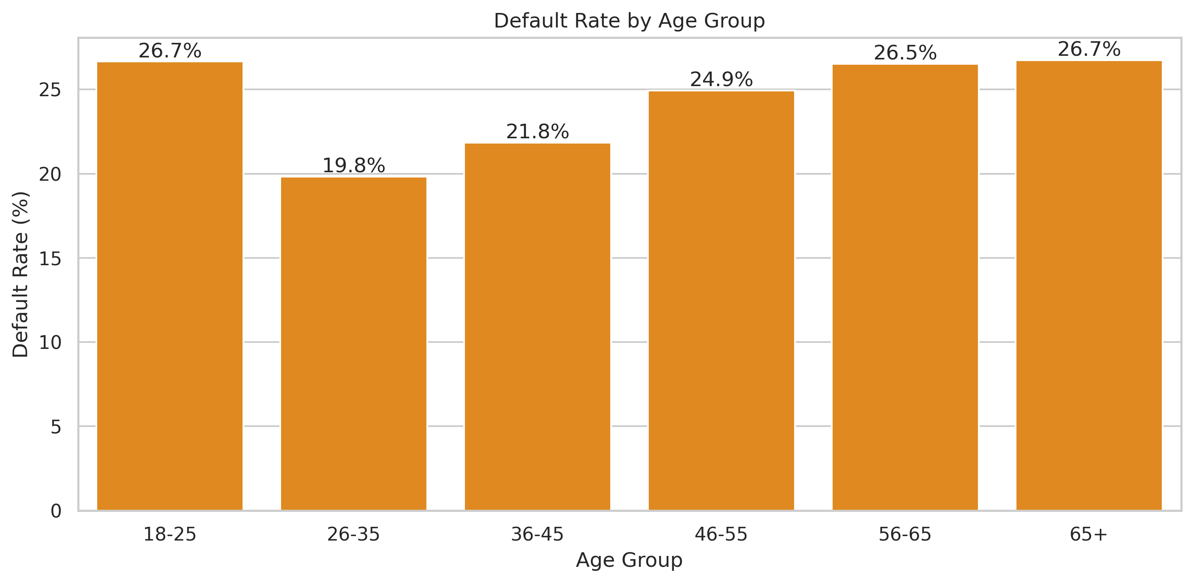
Figure 6 Default rate by age group
Age group | Customers | Defaults | Default rate
18 to 25 | 3,871 | 1,032 | 26.66%
26 to 35 | 12,938 | 2,565 | 19.83%
36 to 45 | 8,522 | 1,861 | 21.84%
46 to 55 | 3,825 | 954 | 24.94%
56 to 65 | 758 | 201 | 26.52%
65 plus | 86 | 23 | 26.74%

Repayment Behaviour and Risk
Repayment delay produced the clearest risk gradient in the analysis. The default rate rose from 11.71 percent with no delayed months to 29.82 percent with one delayed month and reached 70.32 percent for customers delayed in all six observed months. This pattern supports the correlation results: PAY 0 had the strongest positive correlation with default at 0.325, followed by the other repayment-status fields.
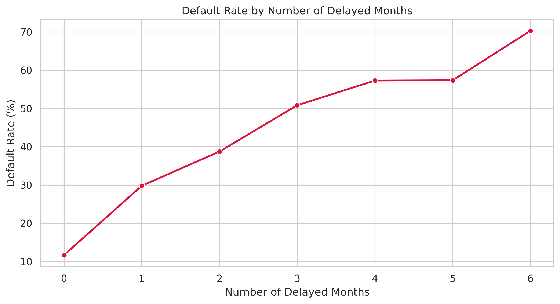
Figure 7 Default rate by number of delayed months
Delayed months | Customers | Default rate
0 | 19,931 | 11.71%
1 | 4,426 | 29.82%
2 | 1,899 | 38.76%
3 | 1,154 | 50.87%
4 | 951 | 57.31%
5 | 298 | 57.38%
6 | 1,341 | 70.32%

Engineered Risk Segments
A transparent rule-based segment was created from delayed-month count and bill-to-limit ratio. It is intended for exploratory prioritisation, not as a production credit-scoring model. High Risk customers had a 46.94 percent default rate, more than four times the Low Risk rate of 10.89 percent.
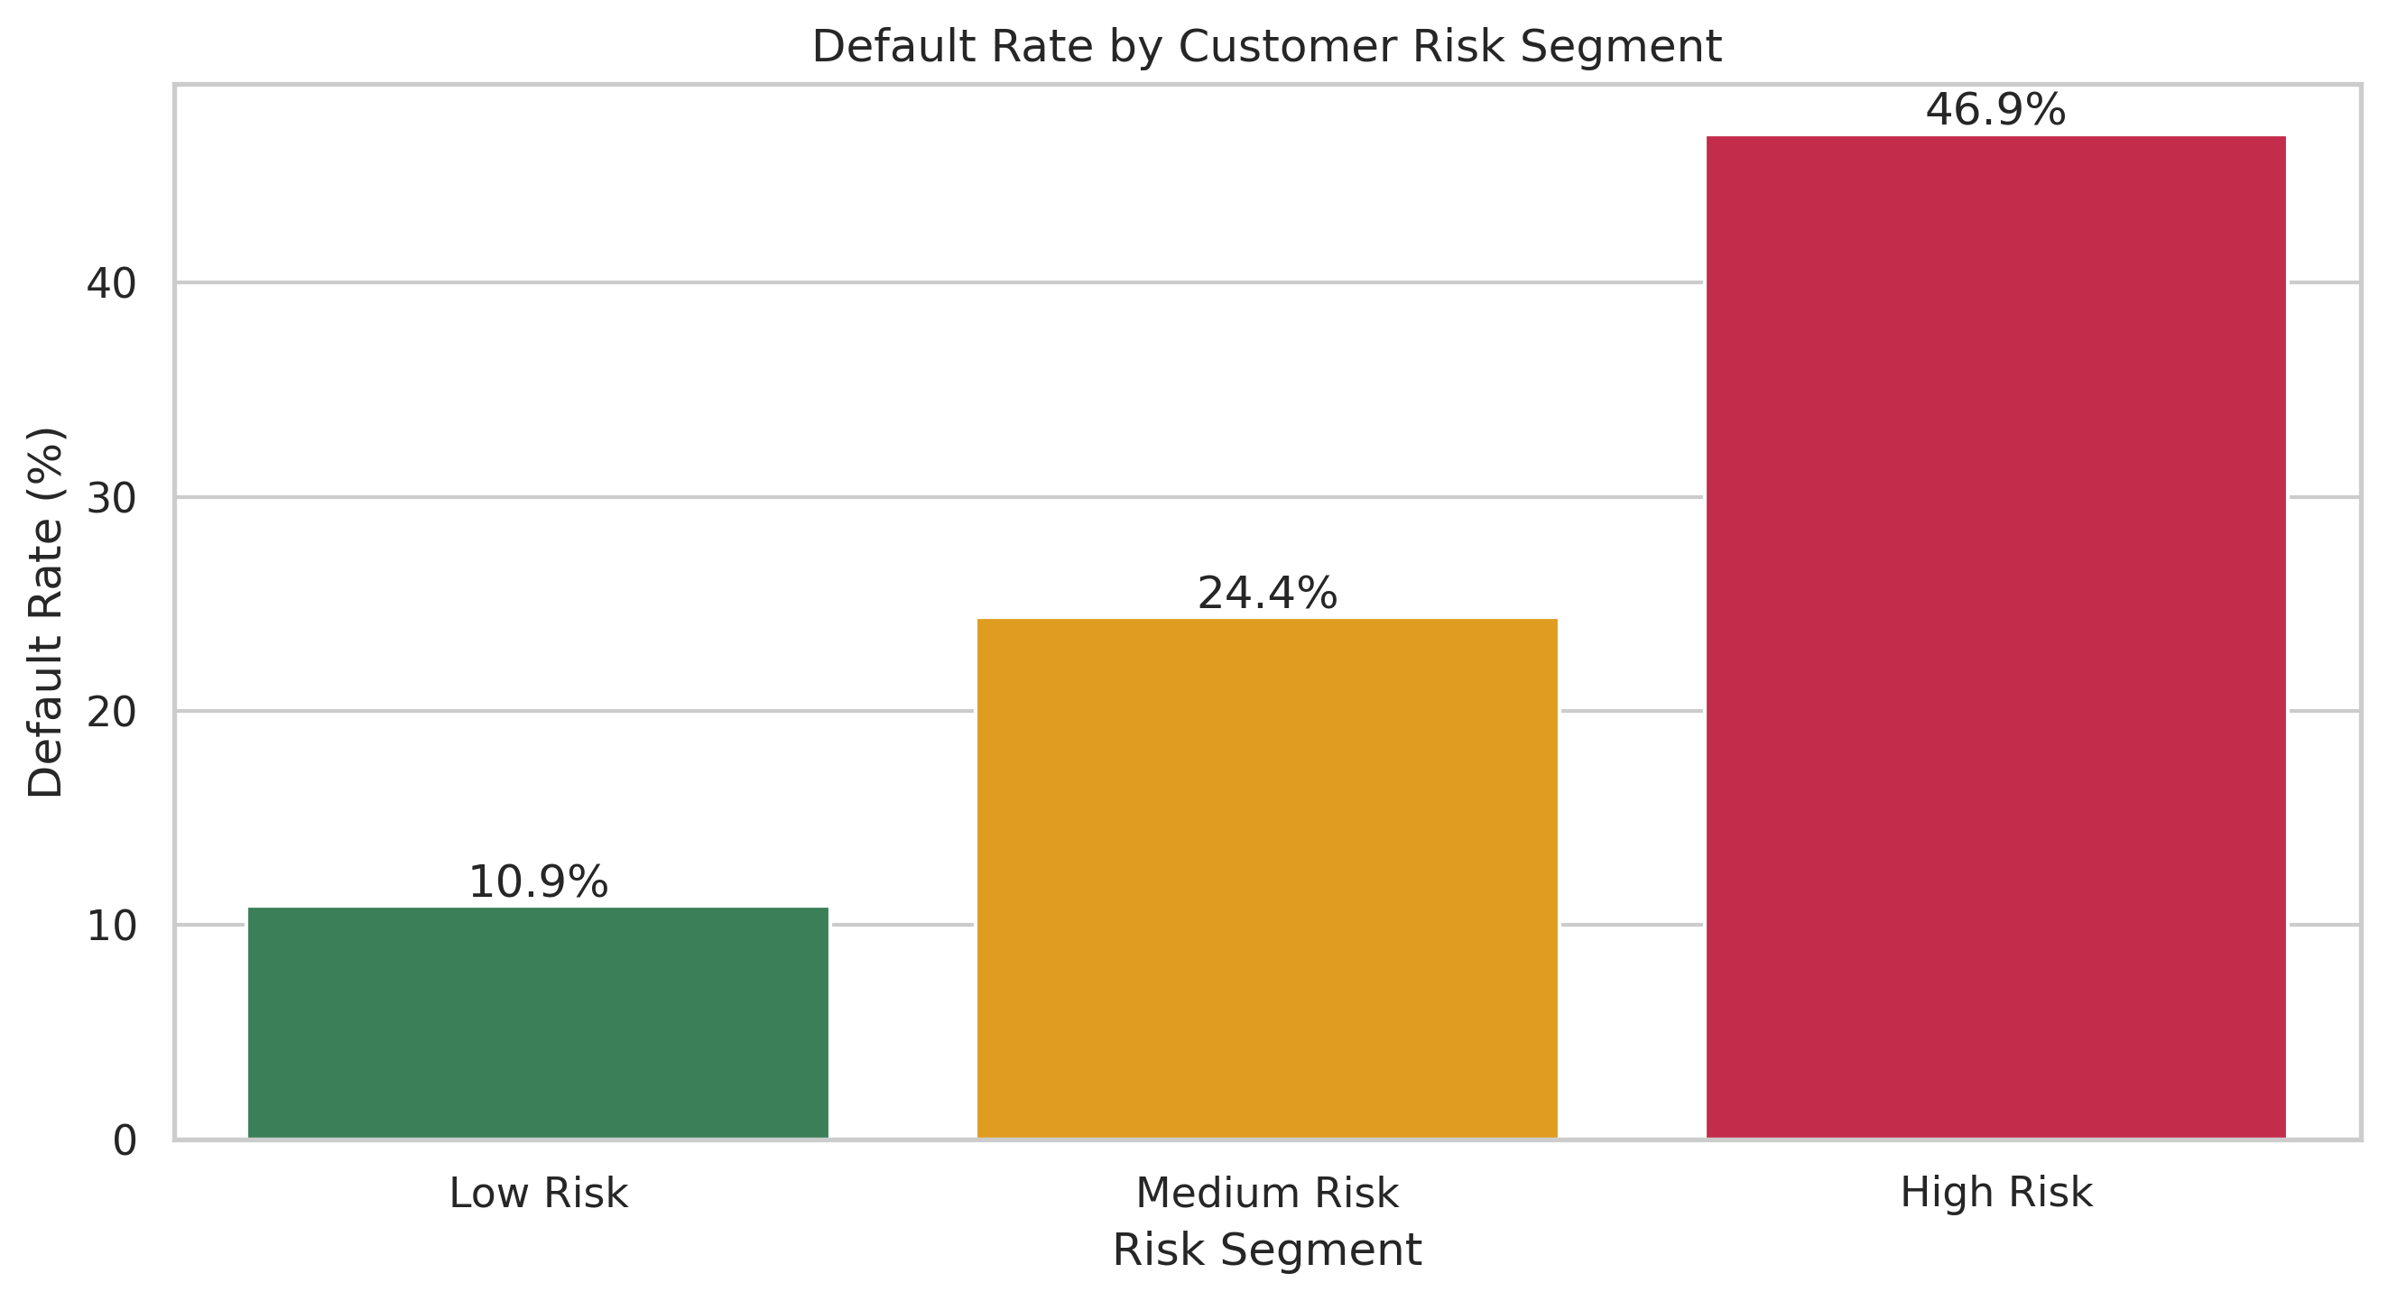
Figure 8 Default rate by engineered risk segment
Risk segment | Customers | Defaults | Default rate | Average delayed months
Low Risk | 14,615 | 1,592 | 10.89% | 0.00
Medium Risk | 9,654 | 2,354 | 24.38% | 0.76
High Risk | 5,731 | 2,690 | 46.94% | 3.09

Payment Behaviour and Credit Exposure

Payment Behaviour Comparison
Group | Average bill | Average payment | Bill to limit | Payment to bill | Delayed months
Default | 43,470.49 | 3,328.22 | 0.449 | 0.213 | 2.00
No Default | 45,404.82 | 5,828.24 | 0.351 | 0.429 | 0.50

Default customers made lower average payments, used more of their available credit and showed four times as many delayed months on average. These differences are more actionable than the small difference in average bill amount.

Credit Limit Groups
Credit limit group | Customers | Defaults | Default rate
Very Low | 7,676 | 2,440 | 31.79%
Low | 4,822 | 1,244 | 25.80%
Medium | 7,880 | 1,535 | 19.48%
High | 9,416 | 1,394 | 14.80%
Very High | 206 | 23 | 11.17%

Observed default rates decreased across the credit-limit groups, from 31.79 percent in Very Low to 11.17 percent in Very High. This is a descriptive association and should not be used alone to approve or reject credit.

Correlation and Outlier Strategy

Correlation Analysis
The heat map shows strong relationships within monthly repayment-status variables and within bill-amount variables. The strongest positive association with default was the latest repayment status PAY 0. Credit limit had a negative correlation of minus 0.154, meaning higher limits were associated with a lower observed default rate, although correlation does not prove causation.
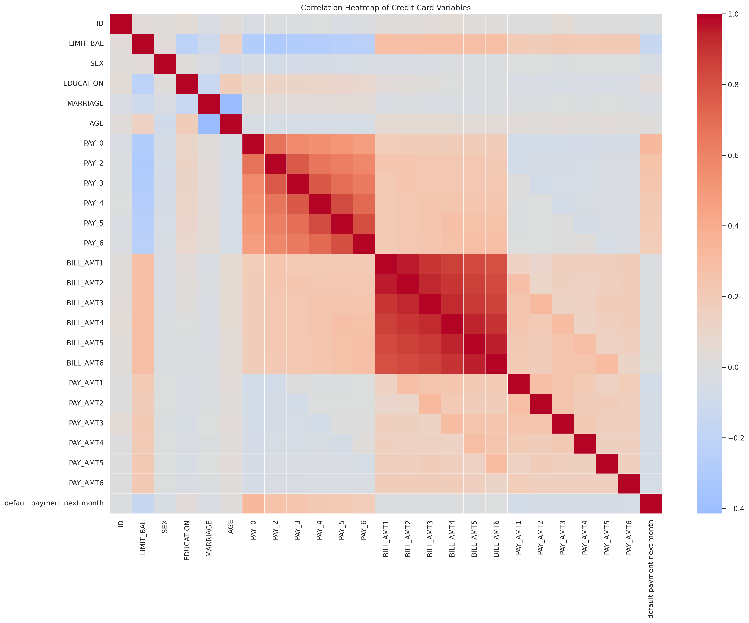
Figure 9 Correlation heat map of numerical variables

Outlier Treatment
The IQR method was applied to age, credit limit, six bill amounts and six payment amounts. Outliers were flagged rather than deleted because unusually high limits, bills or payments can be genuine financial behaviour. For example, 167 credit-limit observations and 272 age observations fell outside the calculated IQR limits; monthly payment outlier counts ranged from 2,598 to 2,994. Keeping flags preserves information while allowing sensitivity checks.

Visualization Strategy
Visual | Use in this project | Why it is effective
Bar chart | Default counts and group default rates | Makes category differences easy to compare
Histogram with density line | Age and credit-limit distributions | Shows shape, concentration and skewness
Line chart | Default rate across delayed-month count | Communicates a clear ordered trend
Heat map | Correlation matrix | Summarises many pairwise relationships in one view
Summary table | SQL results and KPIs | Provides exact values needed for review and decisions

Each visual answers one question and uses direct labels, readable axes and limited colours. Counts are used for population size, while percentages are used for fair comparison between unequal groups. The narrative beside each chart states the practical meaning and any sample-size caution.

SQL Implementation
The analysis-ready dataset was loaded into SQLite as credit_card_customers. Eleven queries were executed to calculate overall KPIs, compare demographic groups, analyse credit-limit groups, rank risk segments, review payment behaviour and list selected high-risk records. A common table expression and window ranking were also used. The SQL results matched the Python summaries, providing an independent validation layer.
- Overall KPI query confirmed 30,000 customers and a 22.12 percent default rate.
- Credit-limit analysis found default rates of 31.79 percent for Very Low limits and 11.17 percent for Very High limits.
- Risk ranking placed High Risk first at 46.94 percent, Medium Risk second at 24.38 percent and Low Risk third at 10.89 percent.
- Payment-behaviour SQL confirmed lower payments and more delayed months among default customers.

Business Insights and Recommendations
Evidence | Interpretation | Recommended use
Default rate rises from 11.71% to 70.32% as delayed months rise from 0 to 6 | Repeated delay is the clearest warning signal | Create early reminders after the first delay and escalate repeated delays
High Risk segment default rate is 46.94% | Rule-based segmentation separates risk meaningfully | Use the segment for review priority, not automatic rejection
Very Low credit-limit group defaults at 31.79% | Lower-limit customers show higher observed risk | Offer suitable repayment support and monitor affordability
Default customers pay 3,328 on average versus 5,828 for non-defaults | Payment capacity or behaviour differs before default | Track payment-to-bill ratio and falling payment amounts
Male default rate is 24.17% versus 20.78% for females | A demographic difference exists in this sample | Report the pattern but avoid discriminatory decisions

Risk Mitigation and Data Governance
- Preserve the original file and perform transformations on a separate copy.
- Document category consolidation, derived formulas and risk-segment rules.
- Keep outlier flags instead of silently deleting genuine high-value records.
- Do not expose customer-level identifiers in public charts or reports.
- Use demographic variables for fairness monitoring, not automatic adverse decisions.
- Validate totals between Python, SQL and Excel before submission or operational use.
- Review segment thresholds periodically because behaviour and portfolios can change.

Limitations
The dataset represents a historical credit-card population from Taiwan and may not reflect current customers, products or regulations in another market. The analysis is observational, so correlations should not be treated as causes. Small categories, especially the 65 plus and Others groups, produce less stable percentages. The engineered risk segment is an explanatory rule and has not been calibrated or validated as a predictive model.

Conclusion
The project demonstrates a complete and reproducible EDA process using Python, SQL and Excel. The strongest result is the consistent rise in default risk with repeated payment delays. The final dataset, charts, SQL database and query workbook provide a practical base for further modelling or business review. For the present task, the evidence supports early intervention, transparent segmentation and careful governance rather than automatic decisions.

Deliverables Produced
- Google Colab notebook containing the Python workflow
- Analysis-ready CSV and Excel datasets
- Nine PNG visualizations
- SQLite database and eleven SQL queries
- Excel workbook containing SQL analysis outputs
- This Week 3 report

