TRF Encoding Model: ASL Signing & EEG
Preliminary Results — Single Participant (MC)
Corina Lab | July 2026
Methods
Participant MC watched 5 continuous ASL narrative videos (~3 min each) while 29-channel EEG was recorded (BioSemi ActiveTwo, 512 Hz; downsampled to 64 Hz; bandpass 0.1–30 Hz). Simultaneous full-body motion capture (Rokoko suit) provided continuous kinematic data. A forward Temporal Response Function (TRF) encoding model was fit via ridge regression (α = 10⁷, window 0–500 ms) using leave-one-video-out cross-validation (5 folds). Model performance is Pearson r between predicted and actual EEG.
Model Performance & Spatial Topography
The 2-feature model (motion energy + velocity stasis) achieves r = 0.107 at F7 (left frontal-temporal), matching the full 7-feature model exactly. 16 of 29 channels show positive prediction accuracy. Unique variance analysis confirmed the remaining 5 features contribute zero independent variance under ridge regularization.
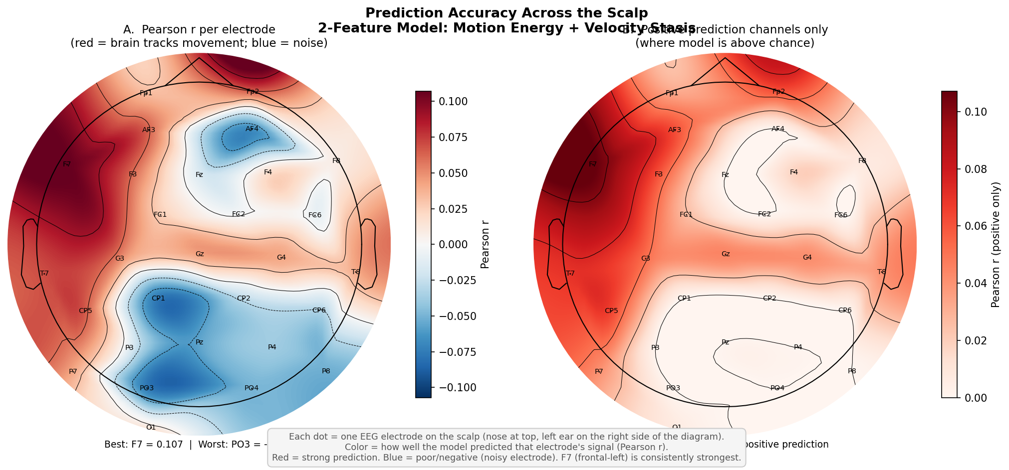
Figure 1. TRF prediction accuracy (Pearson r) across 29 channels. Red = high accuracy; left frontal-temporal cluster is dominant.
Statistical Significance (Permutation Test, n = 200)
Significance was assessed via 200 circular-shift permutations (min. shift 10 s), preserving regressor autocorrelation while destroying temporal alignment. Five channels survive p < 0.01: F7, AF3, F3, T7, CP5 — all left-hemisphere frontal-temporal. C3 and Fp2 are significant at p < 0.05.
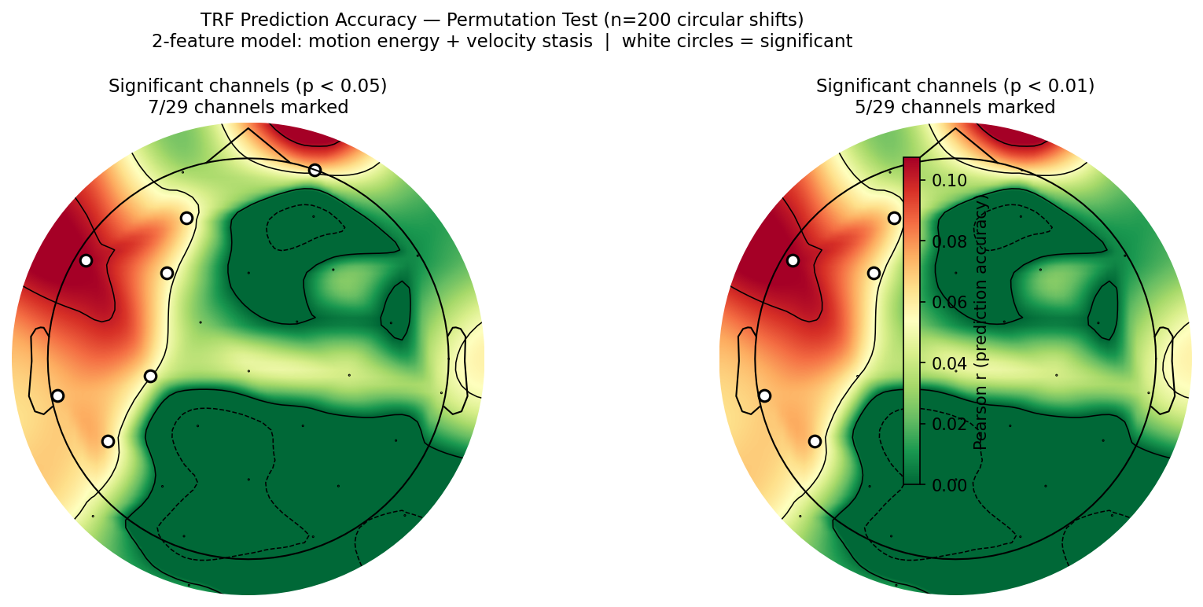
Figure 2. Permutation test (n = 200). White circles mark significant channels at p < 0.05 (left) and p < 0.01 (right).
Feature Contribution — Unique Variance
Of 7 candidate features, only motion energy (overall movement magnitude) and velocity stasis (periods of low velocity / held postures) contribute independently. A stripped 2-feature model matches the full model exactly (F7: r = 0.107). The remaining 5 features are entirely redundant under ridge regularization.
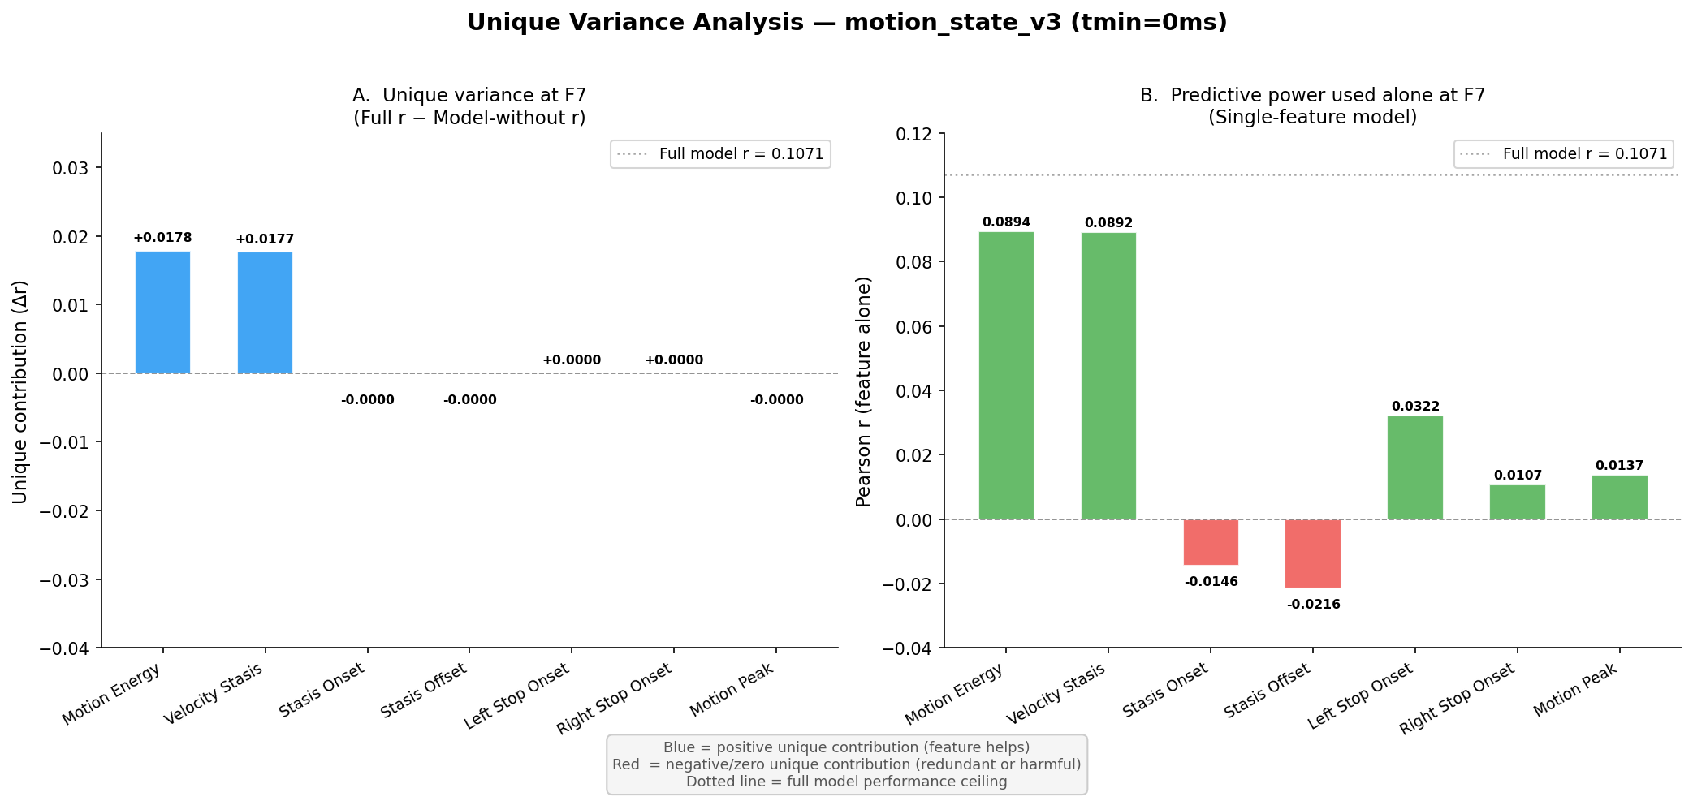
Figure 3. Unique variance analysis. Drop in r when each feature is removed (left) and each feature alone (right). Only motion energy and velocity stasis contribute.
TRF Kernels at F7
TRF kernels at F7 across 0–500 ms are flat for both features: motion energy sustained-positive; velocity stasis sustained-negative. The EEG tracks the ongoing envelope of movement amplitude, not discrete sign-boundary events. The negative stasis coefficient reflects suppressed activity during held postures.
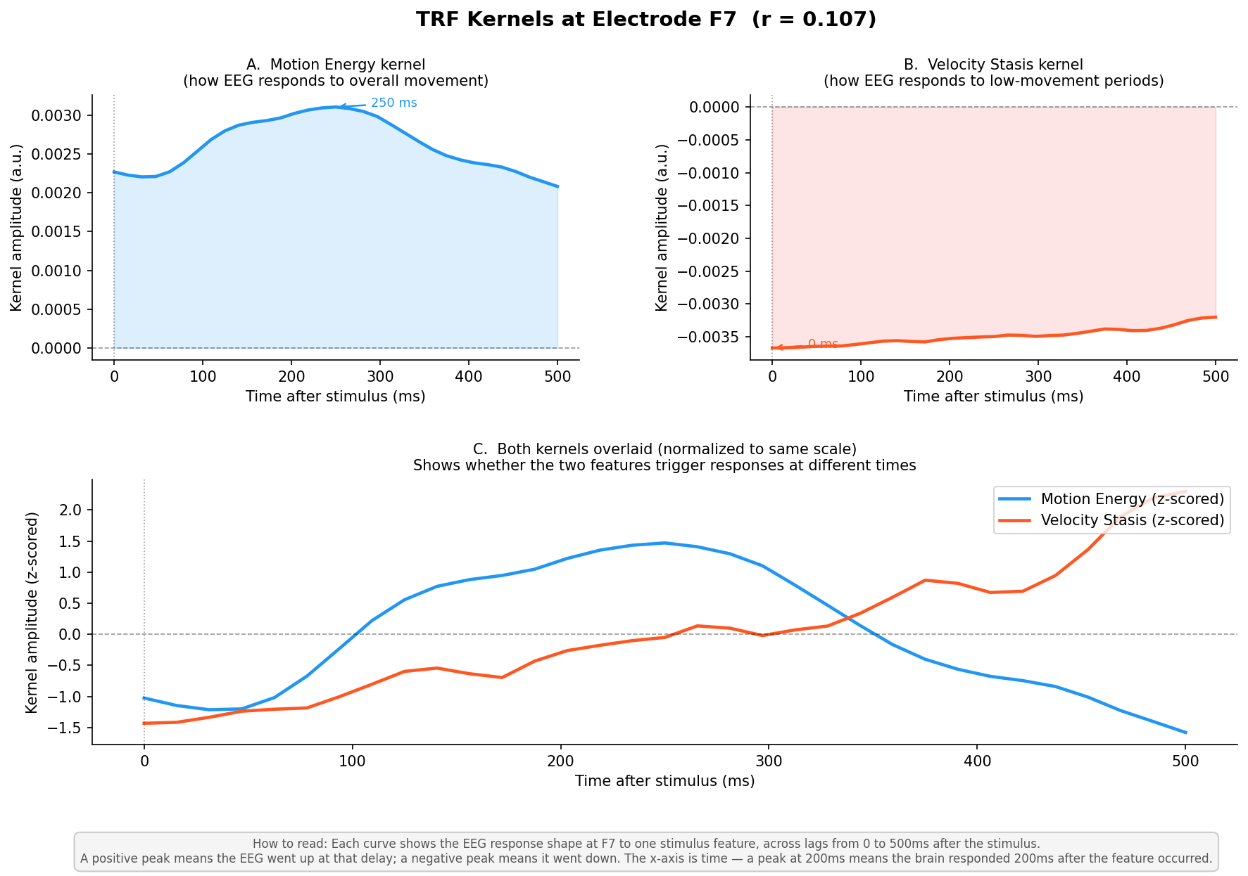
Figure 4. TRF kernels at F7 for motion energy (positive) and velocity stasis (negative). Window: 0–500 ms.
Hand Lateralization
Separate models using left-hand-only and right-hand-only velocity features reveal clear dominance of the right hand (F7: right = 0.094 vs. left = 0.057), consistent with the signer being right-hand dominant. The left frontal-temporal spatial pattern holds for both hands, but is substantially stronger for the dominant hand.
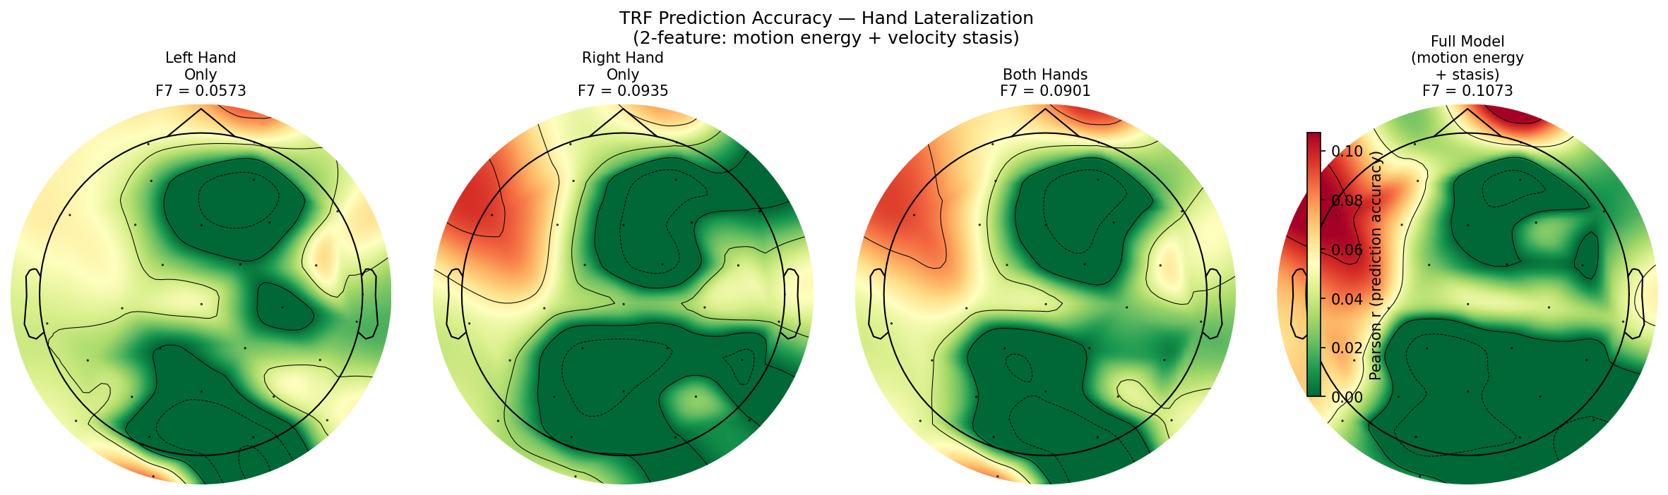
Figure 5. Topographic maps for left-hand-only, right-hand-only, both hands, and the full 2-feature model.
Frequency Band Analysis
The 2-feature model was run on EEG filtered to four bands. Broadband prediction (r = 0.107 at F7) far exceeds any single band. Delta (1–4 Hz) leads among individual bands (r = 0.019), consistent with the ~1–3 signs/second signing rate. The movement-EEG relationship is wideband, not confined to a single oscillatory band.
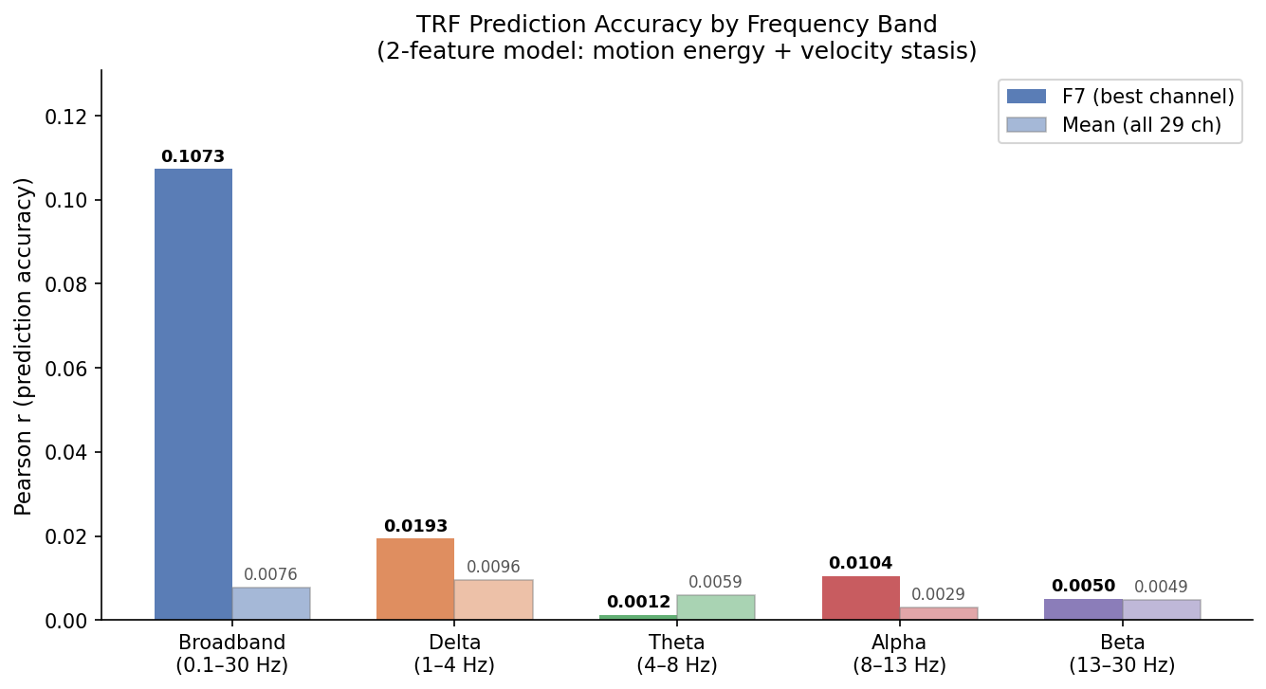
Figure 6. Prediction accuracy by frequency band. Broadband carries ~5× more prediction than the best individual band (delta).
Summary of Key Findings
• Motion energy + velocity stasis are the only features with independent predictive value; 5 others contribute zero unique variance.
• Prediction is strongest at left frontal-temporal sites (F7 cluster), significant at p < 0.01 for 5 channels after 200-permutation testing.
• Right hand dominates over left hand in predicting EEG, consistent with dominant-hand signing.
• TRF kernels are flat across 0–500 ms — EEG tracks movement amplitude continuously, not discrete sign onsets.
• Response is broadband; delta carries the most band-specific signal but captures only ~18% of broadband prediction.

