**Implementation of Mobile Notice Board**

**By**

**Priyabrota Sen**

Roll:1207024

**Tanmoy Ghosh**

Roll:1207028



**Department of Computer Science and Engineering**

**Khulna University of Engineering & Technology**

**Khulna 9203,Bangladesh**

**17 February,2016**

**Implementation of Mobile Notice Board**

**By**

**Priyabrota Sen**

Roll:1207024

**Tanmoy Ghosh**

Roll:1207028

**Supervisor:**

**Dr. Pintu Chandra Shill**

**Associate Professor**

**Department of Computer Science and Engineering**

**Khulna University of Engineering & Technology**

**Department of Computer Science and Engineering**

**Khulna University of Engineering & Technology**

**Khulna 9203,Bangladesh**

**17 February,2016**

**Abstract**

Online notice board helps you access online notices on your android based mobile phone. It is an online notice board maker where a group of people can easily communicate with each other by sticking virtual notes. These note can be only in the form of text.

The notice board has always been the place where students gathers to get their latest release of corporate news. Online notice brings the notice to a virtual location where students can not only read notices but immediately react and respond to them from their account. By using this notice board anyone can change their posted notice.

**Acknowledgment**

All precises goes to Almighty God for his kindness and blessing .Without his desire we would not be here as we are today.

Thanks to our project supervisor **Dr. Pintu Chandra Shill,Assocaite Professor,** **Department of Computer Science and Engineering**, **KUET** for his untiring effort as well as strong support.He truly helped through the entire project with his correct decision and necessary advice we are able to complete this software development project.

We also acknowledgment to our respected seniors for their help to accomplish this project.

Any suggestion,comment from teachers as well as seniors will be highly appreciated.

**INDEX**

**Chapter – 1**

**Introduction to ANDROID…………………………………….. 01-04**

**Chapter -2**

**Project Overview………………………………………………...05-11**

**Chapter – 3**

**Result and Discussions ..……………………………………….12-17**

**Chapter – 4**

**Conclusion……………………………………………………….18-19**

**CHAPTER – 1**

**INTRODUCTION TO ANDROID**

1. **Objectives:**

The objective of this particular course is to make us known with the process of developing software, to adapt with the systematic way of development. Basically, we were to use our previous programming knowledge specially, object oriented programming to develop the chosen software. We were encouraged to develop the software on ANDROID platform which use JAVA programming, is an object oriented programming language. We know JAVA being a programming language with rich library. Its features help us a great deal to accomplish our project in the systematic way within a short period of time although the whole software was a bit complex and stretched itself. In such a short period of time, it was impossible to cover all the features of ANDROID. So, necessary topics related to the software were given priority as the course required.

1. **Introduction to ANDROID:**

Android is an open source and Linux-based Operating System for mobile devices such as smartphones and tablet computers. Android was developed by the *Open Handset Alliance*, led by Google, and other companies.

Android offers a unified approach to application development for mobile devices which means developers need only develop for Android, and their applications should be able to run on different devices powered by Android.

The first beta version of the Android Software Development Kit (SDK) was released by Google in 2007 where as the first commercial version, Android 1.0, was released in September 2008.

On June 25, 2014, at the Google I/O conference, Google announced the next Android version, 5.0 and 5.1 Lollipop. Lollipop is an incremental update, with the primary aim of improving the user interface, both in terms of functionality and performance.

The source code for Android is available under free and open source software licenses. Google publishes most of the code under the Apache License version 2.0 and the rest, Linux kernel changes, under the GNU General Public License version 2.

1. **Why Android?:**

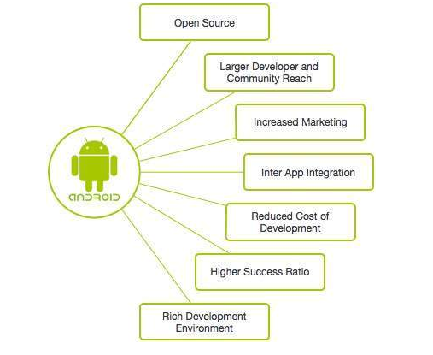

1. **Advantages of Android:**

* **Low Investment and High ROI:**

Android comparatively has a low barrier to entry. Android provides freely its Software Development Kit (SDK) to the developer community which minimizes the development and licensing costs.

* **Open Source:**

Get the open source advantage from licensing, royalty-free, and the best technology framework offered by the Android community. The architecture of the Android SDK is open-source which means you can actually interact with the community for the upcoming expansions of android mobile application development. This is what makes the Android mobile application development platform very attractive for handset manufacturers & wireless operators, which results in a faster development of Android based phones, and better opportunities for developers to earn more. That’s the magic of Android.

* **Easy To Integrate:**

Are you looking for complex technical customization and integration of a web application or just a smartphone application you already have? Yes. Then an android app can be the right solution for you. The entire platform is ready for customization. You can integrate and tweak the mobile app according to your business need. Android is the best mobile platform between the application and processes architecture. Most of the platforms allow background processes helping you to integrate the apps.

* **Multiple Sales Channels:**

Unlike other mobile platforms, Android applications can be deployed in different ways. You do not have to rely on a single market to distribute your applications. You can use third-party application marketplace (especially in Google Android Market), but you can also form your own distribution and sales channel: applications for vertical markets, to develop new application stores, and also place it on your website. You build it, you publish it. With your choice of promotional strategy, you can reach your end users through multiple channels.

* **Easy Adoption:**

Android applications are scripted in Java language with the help of a rich set of libraries. Anyone can build Android applications with the knowledge of Java. According to a recent survey, a lot of Java programmers find it easy to adopt and script code for mobile applications in the Android OS. It is now very beneficial for Java developers to transition the code script into a mobile application, and can also implement android application development services in the app.

**CHAPTER – 2**

**PROJECT OVERVIEW**

**1** .**Introduction To Project:**

Online notice board helps you access online notices on your android based mobile phone. It is an online notice board maker where a group of people can easily communicate with each other by sticking virtual notes. These note can be only in the form of text.

The notice board has always been the place where students gathers to get their latest release of corporate news. Online notice brings the notice to a virtual location where students can not only read notices but immediately react and respond to them from their account.

The interface of the application is straightforward and takes you a little moment to get started. You have to login the account using your id and password. And then you have to show the message which are allowed to show to you. If you want to post a text you have to select the post button from the menu and type your text and click the post button you also have to update your posted message. At the time of post you can tag the person whom you want to show the message. Whom you tag only he can show the message others doesn’t access the message.

**2** .**Objective:**

The proposed system’s objectives are to overcome all the limitations and drawbacks of the existing system. The online notice board application is user friendly android application. The main objective of the application is its simplicity of design and ease of implementation that shows and helps to collect most of the information about events going in university premises. The interface will be very user friendly.

* Faster dissemination of notices regarding education, technical events, cultural events.
* Any lost/found going out in university.
* Easy way to broadcast your message.
* Helps you to be updated with what going on your university.
* Good way to publish exam date ,time ,place.

**3** .**Problem Formulation:**

To develop a mobile application that will help you receiving the notices from the university anywhere and anytime. Earlier their was problem that notices were pasted on notice board. If there is holiday on the next day nobody will be able to read it. Moreover any update on website is also very difficult and any student have no access to update any notice on the website. The more easy way is just type in message sitting wherever and post a button . It will notify all the teachers and students, department head and administrator level with that application.

**3** .**Identification of Need:**

* As we discussed earlier that manual maintenance of a notices is a tedious job. So to enhance the ease of working, we go for this package.
* Giving the facility to convey messages to all students anytime and anywhere.
* Making students updated about all the events and activities going on in the college.
* The student will not require to stand in the crowd to see the notice. There will be no issue of fighting in order to see the notice first. Everyone is first to see that notice inside their own mobile phone anywhere and anytime.
* It saves time.
* Utilizing less man power. As there are many persons involved in circulating the message. With this application, only one person is required to post the notice. Rest of human power is saved in the entire process.

**4** .**Existing System:**

Currently our university has manual system of putting notices on notice board. Its outdated now. As nobody has a time to stand in rush in order to read the notices on noticeboard.

**Limitation of Existing System:**

* **Order of Data**:

Notice can get out of order in traditional notice board system. If someone accidentally puts some data in the wrong place, it can lead to lost data. Automated notice management systems allow users to quickly check whether information already exists somewhere in the system, which helps avoid problems like redundant data.

* **Complexity:**

Automated system is less complex than manual system of handling notices, which can make it easier for untrained people to access and manipulate data. Anyone having the basic knowledge of mobiles can work on the automated system.

* **Inconsistency of data:**

There will be an unavailability for future use, since notice might get misplaced during manual notices management. So notice won’t be preserved properly for future use.

* **Damage:**

Manual notices stack are vulnerable to damage, destruction and theft in ways that digital databases are not. A company may back up its digital data both on site and at offsite locations, ensuring its security if the office building suffered a fire or similar disaster. A manual database, however, may only exist in one place without any copies. As a result, a manual database would be very vulnerable to a fire or other natural disaster. In addition, while access time in a manual database system, information must be found by hand rather than electronically. While a digital database will typically allow users to search the entire database for specific information in seconds, someone looking for information in a manual system may have to spend hours searching for a particular piece of data.

* **Editing and Communication:**

Manual notices do not allow users to easily edit data or information .Manual notices often cannot be edited directly, forcing users to make new copies. To circulate notice on paper, users must require peons and other staff. Online Notice Board app allow users to edit information fields directly, and because data is stored digitally, it is already in a form that can be easily transmitted.

**5.Proposed System:**

Proposed System will be able to do the following:

* **To eliminate wastage of time and energy:**

Online Notice Board app will be able to save lot of paper and time. It directs both teacher and pupils energy and attention to one thing at a time by placing proper persons at their proper places at the proper time. Everything will be fast.

* **To avoid duplication and overlapping:**

This application will help to remove the duplicacy of notices. If anyone find that if a notice has already been published then he will not publish it again.

* **Prevent Crowd in University:**

As you can see, there is always a crowd at notice board. As notice board is one, and people to see notice are more. With this application there will be no more crowd. Everyone will be well informed even at their homes. So they are free to do there other work.

* **Anytime Anywhere Service:**

With this application, notices will be delivered anytime and at any place. There is no restriction of time to send a notice.

* **Keeping Notices at one place:**

This application allow you to have notices in one place only. If there is an attachment with that, all will be placed in a separate folder dedicated to that application. So there will be no here and there of notices.

**6** .**Pre-Requisition For The Project:**

To run the project successfully we needed the help of some prerequisite elements like

1. MySQL Database.
2. ADT bundle.
3. Android Developers Tool.
4. Jdk1.8.0_05
5. Android device with (Minimum API level 10)

**6** .**Use Case Diagram:**

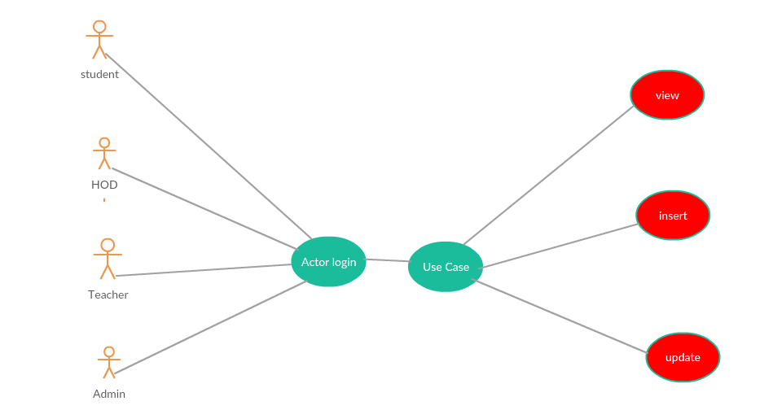

**6** .**Database Design:**

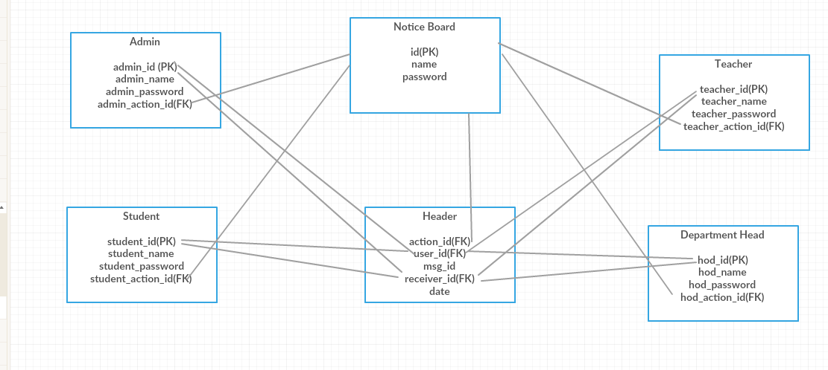

**6** .**System Analysis of Online Notice Board:**

Analysis is the detailed study of the various operations performed by a system and their relationships within and outside of the system. A key question is: What must be done to solve the problem? One aspect of analysis is defining the boundaries of the system and determining whether or not candidate system should consider other related systems. During analysis, data are collected on the available files, decision points, and transactions handled by the present system.

**7**.**Module Description:**

This section attempts to describe each module of the project in brief, and the detailed description of each of these modules is spread throughout this document.

* At first in my project I have to create a login screen for the user I have to catagoires my apps for four level of users. They are:

1. Admin.
2. Head of The Department
3. Teacher
4. Student

* For each four level I have to create a id and a password for every level. That means if one person is in admin he must have the admin password.
* Then in each level there might be many user. That means in a class there are many students. So every students are user but everyone are in the student level. In this case I have to keep a password for every users. So every user must have two password one for his action level and another for his own. If ensure that two correct password then he have to enter the notice board and can see the notice board.
* Using one’s own account anyone post message. If one want that his message should not shown by other then he can tag only whom he want to show his message. By using this features one can not access to other messages. One can also update his/her posted message he can also change his taglist when he update his or her message.
* When one logout from his/her account he/she has to go back to the login screen.
* For my project I have to create my database in MySQL and use the 000webhost server to host my database.

**CHAPTER – 3**

**Result and Discussions**

**User Interface Representation:**

In order to make user interface, many controls are used. Some of which are as follow:

* **TextView:**

Text View displays text to the user and optionally allows them to edit it. A TextView is a completetext editor, however the basic class is configured to not allow editing.

* **EditText:**

EditText is a thin veneer over TextView that configures itself to be editable.

* **Button**:

A button consists of text or an icon (or both text and an icon) that communicates what action occurs when the user touches it.

* **List View:**

ListView is a view group that displays a list of scrollable items. The list items are automatically inserted to the list using an Adapter that pulls content from a source such as an array or database query and converts each item result into a view that’s placed into the list.

* **Check Boxes:**

Checkbox is a control or widget that can be activated with a finger touch and can be polled in the application’s code for a checked and unchecked state.

**Snapshots of System:**

**Start Screen:**

Here you have to insert the action user name and the password. If the password is wrong then it will show an error message.

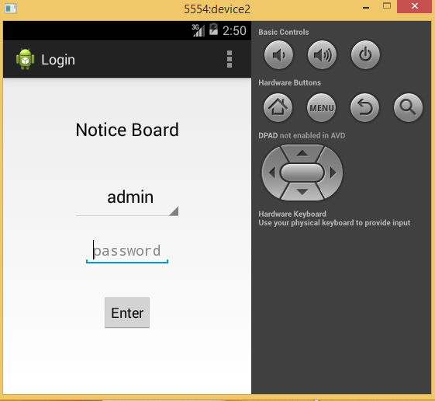

Fig 1: start screen

**Login Screen:**

Each must user have a password . In here the user have to put the user id and user password.

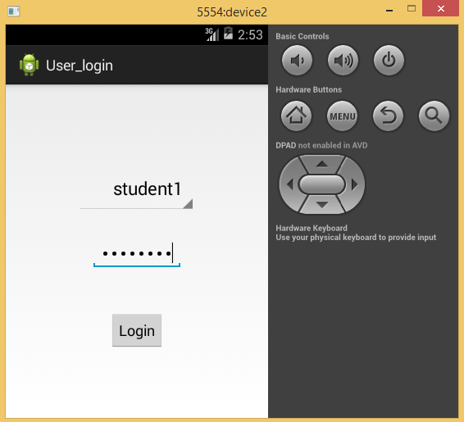

Fig : Login screen

**Notice Screen:**

This the notice board where everyone share the notice. Every notice is showed by who published the notice and whom he want to show the notice and the date and time when the notice was published.



Fig 3: Notice Board screen

**Post Screen:**

To post a notice one have to click the post button and then type the message in the text box and tag the person whom he want to show his/her message then click the post button. Then the message will post.

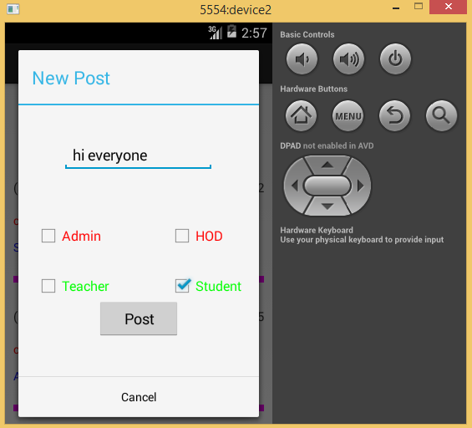

Fig 4: Post Notice screen

**Backend Representation:**

The database used at the Back-end is MySQL database. Web Server used is Apache. Server side scripting language used is PHP.

Database design used at backend server has the following tables:

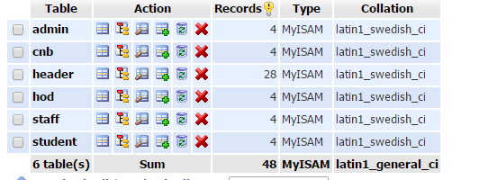

Fig 5: Table for the Database

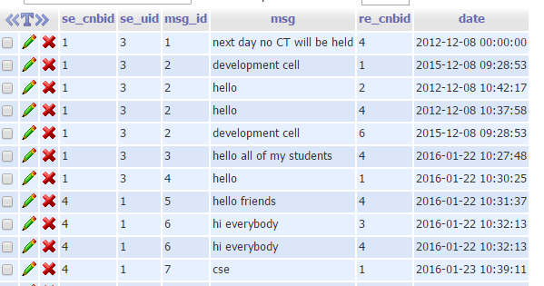

Fig 6: Database for storing message

**CHAPTER – 4**

**Conclusion**

**Limitations:**

* In our project we have to use the free web hosting server. The sever is very slow and when the data size becomes huge then sometimes it does not work. So file transformation is quite difficult in this server.
* Notification is not set in this project. So without notification it is very difficult to user to notify when a new message is posted.
* Sometimes the application fall due to server. And the project always need the network.

**Future Scope:**

* **Categorization of Notice:**

Notices can be categorized in different categories, so that its possible for user to easily manage the notices. Categorization can also be done by making groups. Defining the notice to be circulated in a particular group can make it more secure.

* **Documents and PDF files:**

The attachments can be further improved to include PDF files or Doc files. Then there will not be much need to send images with the notices. A single file would serve all the purposes.

* **Notifications:**

The application can be further improved to include notification in the application icon.

* **Feedback:**

Feedback on the notices can also be taken. It can increase communication among connected members and any issue can be easily sorted out on the spot.

**Conclusion:**

During this project I learned about Android, PHP. Before this project, I had no idea about Android for making application. But now I learned a lot about Android and Java for developing mobile application and PHP for server side scripting. I also learned about the webhosting and how to host a database on the live server. To do this project I used stack overflow for any type of help and learn how to question in stack overflow

**References:**

### [Stack Overflow](https://www.google.com/url?sa=t&rct=j&q=&esrc=s&source=web&cd=1&cad=rja&uact=8&ved=0ahUKEwie7qK21_rKAhVFjo4KHZV3CIIQFggcMAA&url=http%3A%2F%2Fstackoverflow.com%2F&usg=AFQjCNERidL9Hb6OvGW93_Y6MRj3aTdMVA&sig2=iXqxGKXHx70cZZ8yp5JM4g)

www.stackoverflow.com/

### 2. [Android Tutorial - TutorialsPoint](http://www.tutorialspoint.com/android/)

www.tutorialspoint.com/android/

### [PHP Tutorial - TutorialsPoint](https://www.google.com/url?sa=t&rct=j&q=&esrc=s&source=web&cd=1&cad=rja&uact=8&ved=0ahUKEwi3h9CM2frKAhXVA44KHX_5BYoQFggcMAA&url=http%3A%2F%2Fwww.tutorialspoint.com%2Fphp%2F&usg=AFQjCNGIg6MjacKgJ0M6vj1zeptEvjfu0w&sig2=SZ-SDflPK1HSgxRsIEv2ag)

[www.tutorialspoint.com/php/](http://www.tutorialspoint.com/php/)

# অ্যান্ড্রয়েড অ্যাপ্লিকেশন ডেভেলপমেন্ট (Android Application Development)

www.shikkhok.com/android-app-development/