

**Heaven's Light is Our Guide**

**RAJSHAHI UNIVERSITY OF ENGINEERING & TECHNOLOGY**

**Department of Computer Science & Engineering**

**Lab Report**

**Course Code :** CSE 1202

**Course Name :** Data Structure Sessional

**Lab No :** 02

**Lab Subject :** Algorithm Conversion & Problem Solve

**Date of Lab :** 17.07.2023

|  |  |
| --- | --- |
| Submitted by  Name : Tanmoy Mridha  Roll : 2103118  Section : B  Series : 21 | Submitted to  Md. Azmain Yakin Srizon  Lecturer  Department of CSE  RUET |

**Date of Submission:** 24.07.2023

**Book Algorithms**

**Algorithm No:** 2.2

**Algorithm Name:** (Quadratic Equation) This algorithm inputs the coefficients A, B, C of a quadratic equation and outputs the real solutions, if any.

**Code:**

#include <iostream>

#include <cmath>

using namespace std;

int main(){

double A, B, C;

cin >> A >> B >> C;

double D = (B * B) - (4 * A * C);

if (D >= 0){

double x1 = (-B + sqrt(D)) / 2 * A;

double x2 = (-B - sqrt(D)) / 2 * A;

cout << "X1 = " << x1 << endl;

cout << "X2 = " << x2 << endl;

}

else{

cout << "No Real answer" << endl;

}

}

**Output:** 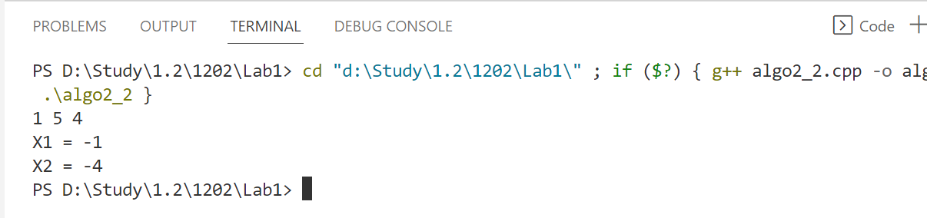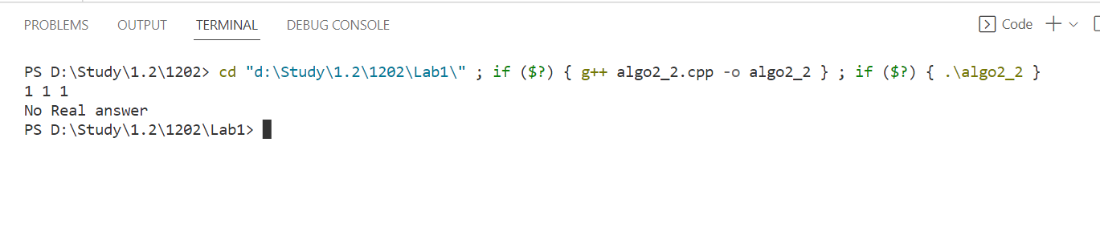

**Algorithm No:** 2.3

**Algorithm Name:** (Largest Element in Array) Given a nonempty array DATA with N

numerical values, this algorithm finds the location LOC and the value MAX

of the largest element of DATA.

**Code:**

#include <iostream>

using namespace std;

int main()

{

    int n;

    cin >> n;

    int array[n];

    for (int i = 0; i < n; i++)

    {

        cin>> array[i];

    }

    int max = array[0], loc = 0;

    for (int i = 0; i < n; i++)

    {

        if (max <= array[i])

        {

            max = array[i];

            loc = i;

        }

    }

    cout <<"Max: "<< max << " LOC: " << loc << endl;

}

**Output:** 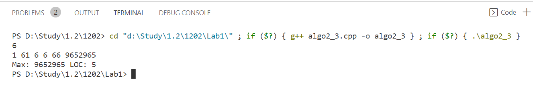

**Algorithm No:** 2.4

**Algorithm Name:** (Linear Search) A linear array DATA with N elements and a specific ITEM

of information are given. This algorithm finds the location LOC of ITEM in

the array DATA or sets LOC = O.

**Code:**

#include <iostream>

using namespace std;

int main()

{

    int n, item;

    cin >> n;

    int array[n];

    for (int i = 0; i < n; i++)

    {

        cin>> array[i];

    }

    cout <<"Item to be searched: ";

    cin >> item;

    int loc = 0, check = 0;

    for (int i = 0; i < n; i++)

    {

        if (item == array[i])

        {

            loc = i;

            check = 1;

            break;

        }

    }

    if (check == 1)

        cout <<"Index of the item: "<< loc << endl;

    else

        cout << "Not found" << endl;

}

**Output:** 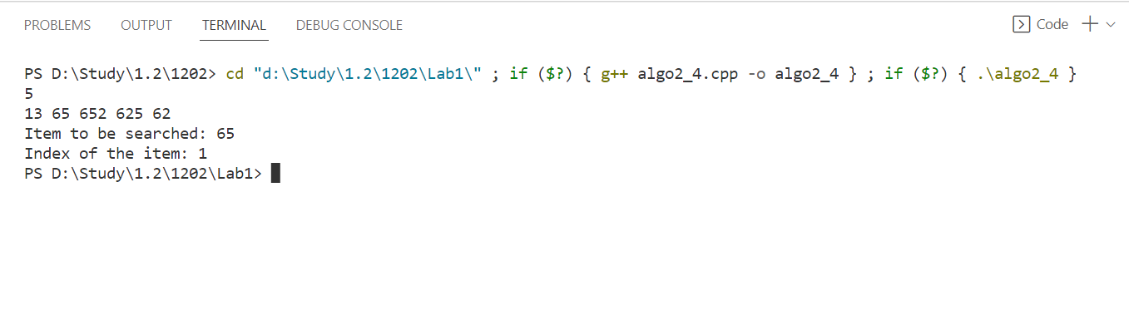

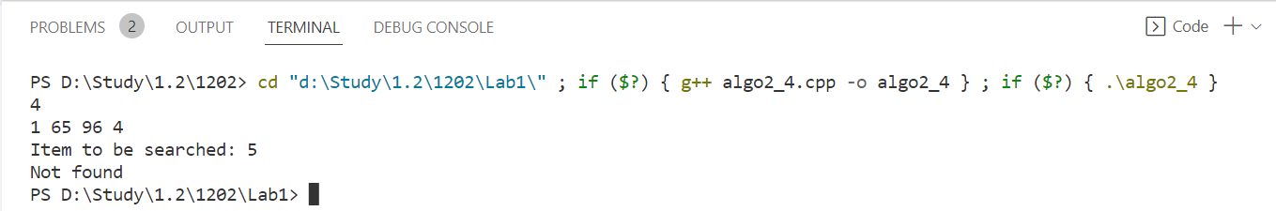

**OJ Problems**

**Problem No:** 1850A

**Problem Name:** To My Critics

**Link:** https://codeforces.com/contest/1850/problem/A

**Code:**

#include <iostream>

using namespace std;

int main()

{

int T;

cin >> T;

while (T--)

{

int A, B, C;

cin >> A >> B >> C;

if (A + B >= 10 || B + C >= 10 || C + A >= 10)

{

cout << "YES" << endl;

}

else

cout << "NO" << endl;

}

}

**Output:** 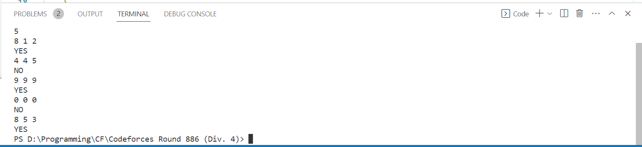

**Problem No:** 1850B

**Problem Name:** Ten Words of Wisdom

**Link:** https://codeforces.com/contest/1850/problem/B

**Code:**

#include <iostream>

using namespace std;

int main()

{

int T;

cin >> T;

while (T--)

{

int N;

cin >> N;

int Amax = 0, Bmax = 0, count = 0;

for (int i = 0; i < N; i++)

{

int A, B;

cin >> A >> B;

if (A <= 10 && B >= Bmax)

{

Amax = A;

Bmax = B;

count = i + 1;

}

}

cout << count << endl;

}

}

**Output:**

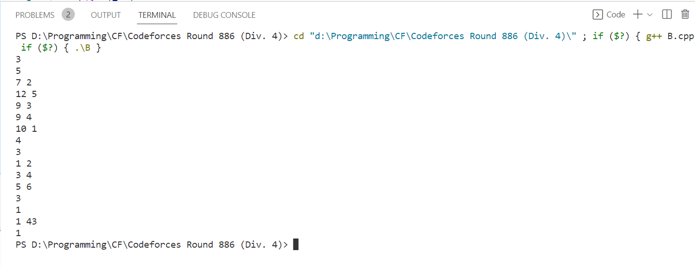

**Problem No:** 1843C

**Problem Name:** Sum in Binary Tree

**Link:** https://codeforces.com/contest/1843/problem/C

**Code:**

#include <bits/stdc++.h>

using namespace std;

int main()

{

int T;

cin >> T;

while (T--)

{

long long int N, sum = 0;

cin >> N;

while (N >= 1)

{

sum += N;

N /= 2;

}

cout << sum << endl;

}

}

**Output:** 