

**Heaven's Light is Our Guide**

**RAJSHAHI UNIVERSITY OF ENGINEERING & TECHNOLOGY**

**Department of Computer Science & Engineering**

**Lab Report**

**Course Code :** CSE 1202

**Course Name :** Data Structure Sessional

**Lab No :** 04

**Lab Subject :** Algorithm Conversion & Problem Solve

**Date of Lab :** 07.08.2023

|  |  |
| --- | --- |
| Submitted by  Name : Tanmoy Mridha  Roll : 2103118  Section : B  Series : 21 | Submitted to  Md. Azmain Yakin Srizon  Lecturer  Department of CSE  RUET |

**Date of Submission:** 14.08.2023

**Problem – 01: Binary Search**

**Code:**

#include <iostream>

#include <iostream>

using namespace std;

int main()

{

    int n, item;

    cin >> n;

    int array[n];

    for (int i = 0; i < n; i++){

        cin >> array[i];    }

    for (int i = 0; i < n - 1; i++){

        for (int j = i + 1; j < n; j++){

            if (array[i] > array[j]) {

                int temp = array[i];

                array[i] = array[j];

                array[j] = temp;

            }        }    }

    cout << "Item to be searched: ";

    cin >> item;

    int UB = n - 1, LB = 0, MID = 0, check = 0;

    while (LB <= UB){

        MID = (UB + LB) / 2;

        if (item == array[MID]) {

            check = 1;

            cout << "LOC: " << MID + 1 << endl;

            break;

        }

        else if (item > array[MID]){

            LB = MID + 1;

        }

        else{

            UB = MID - 1;

        }    }

    if(check == 0){

        cout << "LOC: " << 0 << endl;    } }

**Output:** 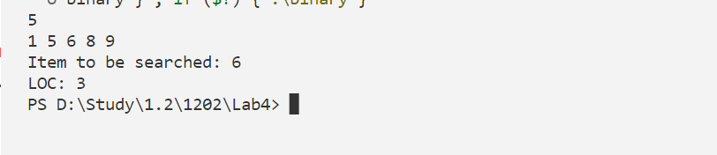 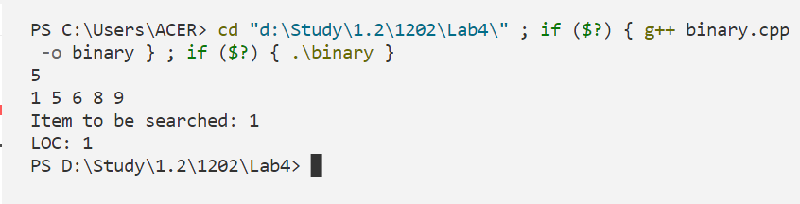 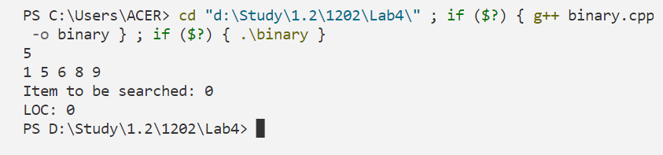

**Problem – 02: Matrix Addition**

**Code:**

#include <iostream>

using namespace std;

int main(){

    int n, m;

    cout << "Rows: ";

    cin >> n;

    cout << "Columns: ";

    cin >> m;

    int matrix1[n][m];

    int matrix2[n][m];

    int add[n][m] = {0};

    cout << "Enter Matrix 1: ";

    for (int i = 0; i < n; i++){

        for (int j = 0; j < m; j++){

            cin >> matrix1[i][j];        }    }

    cout << "Enter Matrix 2: ";

    for (int i = 0; i < n; i++){

        for (int j = 0; j < m; j++){

            cin >> matrix2[i][j];        }    }

    for (int i = 0; i < n; i++){

        for (int j = 0; j < m; j++){

            add[i][j] = matrix1[i][j] + matrix2[i][j];        }    }

    for (int i = 0; i < n; i++){

        for (int j = 0; j < m; j++){

            cout << add[i][j] << "\t";        }

        cout << endl;    } }

**Output:** 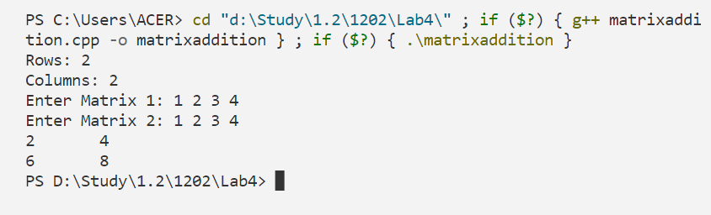

**Problem – 03: Matrix Multiplication**

**Code:**

#include <iostream>

#include <iostream>

using namespace std;

int main(){

    int n, m, x, y;

    cout << "Matrix1 Rows: ";

    cin >> n;

    cout << "Matrix1 Columns: ";

    cin >> m;

    int matrix1[n][m];

    cout << "Matrix2 Rows: ";

    cin >> x;

    cout << "Matrix2 Columns: ";

    cin >> y;

    int matrix2[x][y];

    cout << "Enter Matrix 1: ";

    for (int i = 0; i < n; i++){

        for (int j = 0; j < m; j++){

            cin >> matrix1[i][j];        }    }

    cout << "Enter Matrix 2: ";

    for (int i = 0; i < x; i++){

        for (int j = 0; j < y; j++){

            cin >> matrix2[i][j];        }    }

    int multi[n][y] = {0};

    if (m != x){

        cout << "BYE" << endl;    }

    else{

        int sum = 0;

        for (int i = 0; i < n; i++){

            for (int j = 0; j < y; j++){

                for (int k = 0; k < m; k++){

                    sum += matrix1[i][k] * matrix2[k][j];       }

                multi[i][j] = sum;

                sum = 0;            }        }    }

    for (int i = 0; i < n; i++){

        for (int j = 0; j < y; j++){

            cout << multi[i][j] << "\t";        }

        cout << endl;    } }

**Output:**

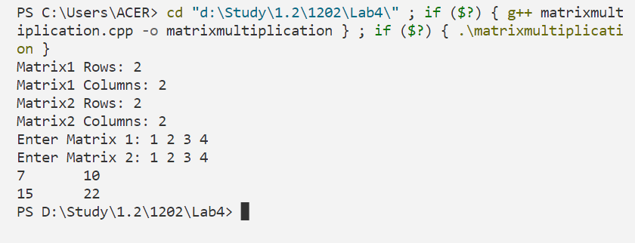

**OJ Problem – 01:**

**Problem Name: Beautiful Matrix**

**Problem No: 263A**

**Link:** **https://codeforces.com/contest/263/problem/A**

**Code:**

#include <iostream>

using namespace std;

#define ll long long int

int main(){

    ll mat[5][5];

    ll checkrow, checkcol;

    for (int i = 0; i < 5; i++)    {

        for (int j = 0; j < 5; j++)        {

            cin >> mat[i][j];

            if(mat[i][j] == 1){

                checkrow = i;

                checkcol = j;            }        }    }

    cout << abs(checkrow - 2) + abs(checkcol - 2)  << endl;}

**Output:**

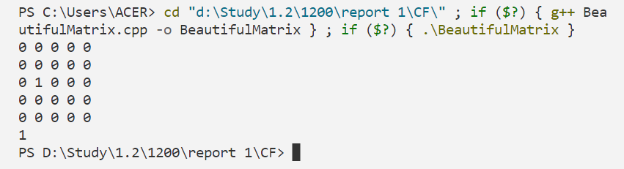

**OJ Problem – 02:**

**Problem Name: OR in Matrix**

**Problem No: 486B**

**Link:** **https://codeforces.com/problemset/problem/486/B**

**Code:**

#include <bits/stdc++.h>

using namespace std;

int main(){

ios::sync_with_stdio(false);

int n, m;

cin >> m >> n;

bool B[m][n], A[m][n], C[m][n];

for (int i = 0; i < m; ++i) {

for (int j = 0; j < n; ++j) {

cin >> B[i][j];

A[i][j] = 1;

C[i][j] = 0; } }

for (int i = 0; i < m; ++i) {

for (int j = 0; j < n; ++j) {

if (B[i][j] == 0) {

for (int k = 0; k < n; ++k) {

A[i][k] = 0; }

for (int k = 0; k < m; ++k) {

A[k][j] = 0; } } } }

for (int i = 0; i < m; ++i) {

for (int j = 0; j < n; ++j) {

if (A[i][j] ) {

for (int k = 0; k < n; ++k) {

C[i][k] = 1; }

for (int k = 0; k < m; ++k) {

C[k][j] = 1; } } } }

for (int i = 0; i < m; ++i) {

for (int j = 0; j < n; ++j) {

if (C[i][j] != B[i][j]) {

cout <<"NO\n";

return 0; } } }

cout <<"YES\n";

for (int i = 0; i < m; ++i) {

for (int j = 0; j < n; ++j) {

cout << A[i][j] <<" "; }

cout << "\n"; }

return 0;}

**Output:**

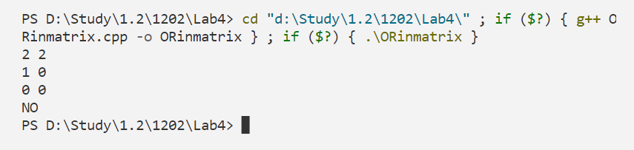

**OJ Problem – 03:**

**Problem Name: Missing Number**

**Problem No: 1083**

**Link:** **https://cses.fi/problemset/task/1083**

**Code:**

#include <iostream>

using namespace std;

int main(){

    int j, k;

    cin >> j;

    int ara[j + 1] = {0};

    for (int i = 1; i < j; i++)    {

        cin >> k;

        ara[k]++;    }

    for (int i = 1; i <= j; i++)    {

        if (ara[i] == 0)        {

            cout << i << endl;        }    } }

**Output:**

