A MICRO PROJECT REPORT
ON
"AQI-Based Respiratory Health Risk Analysis and Prediction Using R"
Subject: ____________________________
(Course Code: ______________)
Submitted in partial fulfilment of the requirement for
The award of the Degree in B.Tech. (Artificial Intelligence and Data Science)
SUBMITTED BY
1. Tanmay Arjun Salunkhe Roll No. 3032
UNDER THE GUIDANCE OF
Prof. / Mr. / Ms. ______________________________
ANNASAHEB DANGE COLLEGE OF ENGINEERING & TECHNOLOGY, ASHTA
Department of Artificial Intelligence and Data Science
Academic Year: 20____ – 20____


MICROPROJECT REPORT
AQI-Based Respiratory Health Risk Analysis and Prediction Using R

1. Abstract
This microproject demonstrates the use of R for exploring an air-quality and health-impact dataset. The work includes importing CSV data, inspecting and cleaning records, descriptive analysis, data visualization, correlation analysis, and a multiple linear regression model. AQI and selected pollutant measurements are used as predictors of respiratory-case counts. The model is evaluated on a held-out test set using Mean Absolute Error (MAE), Root Mean Squared Error (RMSE), and test R-squared. The dataset used for this project is synthetic, so the results demonstrate analytical techniques and must not be interpreted as real-world medical evidence.

2. Introduction
Air quality is an important environmental topic because pollutants such as PM2.5, PM10, nitrogen dioxide, sulfur dioxide, and ozone are commonly studied in environmental-health research. Data analysis can help summarize measurements and explore whether air-quality indicators are associated with health-related variables. R provides functions for data manipulation, visualization, statistical analysis, and predictive modelling.
This project uses R in Posit Cloud, so the analysis can be completed in a browser without installing R locally.

3. Aim
To analyze air-quality indicators and respiratory-health-related variables using R, visualize patterns in the dataset, and demonstrate a linear regression model for predicting respiratory-case counts.

4. Objectives
- Import and inspect the CSV dataset in R.
- Check missing values and duplicate records and prepare the data for analysis.
- Calculate descriptive statistics and examine health-impact categories.
- Visualize AQI, PM2.5, and respiratory-case relationships.
- Train a multiple linear regression model using a training subset.
- Evaluate predictions using MAE, RMSE, and test R-squared.
- Communicate findings and limitations clearly.

5. Tools and Technologies
- R programming language
- Posit Cloud (browser-based RStudio environment)
- CSV dataset: air_quality_health_impact_data.csv
- Base R functions for data cleaning, plots, correlation, and linear regression

6. Dataset Description
The project uses the file air_quality_health_impact_data.csv. The dataset contains 15 columns according to the initial inspection. Variables used in the analysis include AQI, PM2_5, PM10, NO2, SO2, O3, RespiratoryCases, HealthImpactClass, HealthImpactScore, and HospitalAdmissions. After data preparation, 5,811 complete records were used for modelling, of which 4,648 were used for training and 1,163 for testing.
Important limitation: the selected dataset is synthetic. It is suitable for practicing data analysis and model-building steps, but not for making medical claims, estimating actual disease burden, or advising individuals.

7. Methodology
Step 1 – Data import: Imported the CSV file into R as the data frame aqi_data.
Step 2 – Initial inspection: Used head(), str(), names(), dim(), and summary() to inspect records, columns, dimensions, and summary statistics.
Step 3 – Data preparation: Checked missing values and duplicate rows, removed duplicate records, and omitted rows with missing values. Model data was also checked for complete and finite numeric values.
Step 4 – Exploratory analysis: Calculated averages and category counts for respiratory cases and health-impact variables.
Step 5 – Visualization: Created an AQI histogram, scatter plots, a bar chart by health-impact class, and a plot comparing actual and predicted cases.
Step 6 – Correlation: Calculated correlation values to describe linear associations between selected variables.
Step 7 – Model training: Used multiple linear regression with AQI, PM2_5, PM10, NO2, SO2, and O3 to predict RespiratoryCases. The data was divided into approximately 80% training and 20% testing records.
Step 8 – Model evaluation: Generated predictions for the test set and calculated MAE, RMSE, and test R-squared.

8. Visualizations and Results
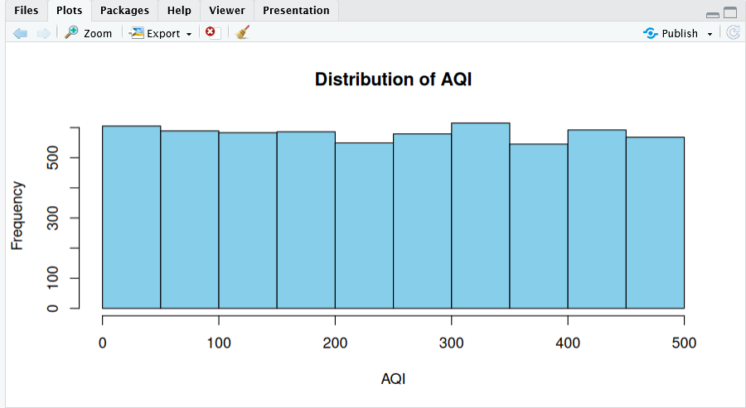
Figure 1: Distribution of AQI
The histogram shows AQI values spread fairly evenly across the 0–500 range, with each 50-unit bin holding roughly 550–600 records. There is no strong concentration at any level, which is consistent with a synthetic dataset.
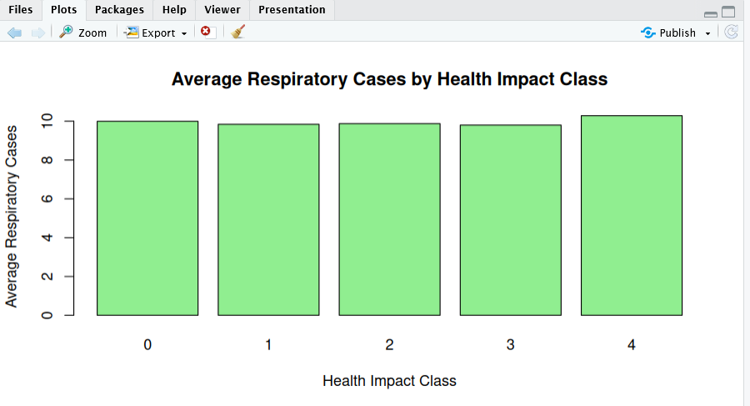
Figure 2: Average Respiratory Cases by Health Impact Class
The average number of respiratory cases is close to 10 in every health-impact class (0 to 4). Class 4 is marginally higher, but the differences between classes are very small.
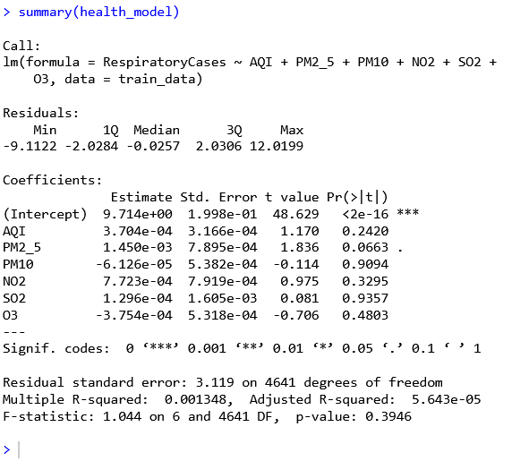
Figure 3: Regression Model Summary (summary(health_model))
The model predicts RespiratoryCases from AQI, PM2_5, PM10, NO2, SO2, and O3. No predictor is statistically significant at the 0.05 level; PM2_5 is the closest (p = 0.0663). Multiple R-squared is 0.001348, adjusted R-squared is 5.643e-05, and the overall F-test is not significant (F = 1.044, p = 0.3946), so the predictors explain almost none of the variation in respiratory cases.
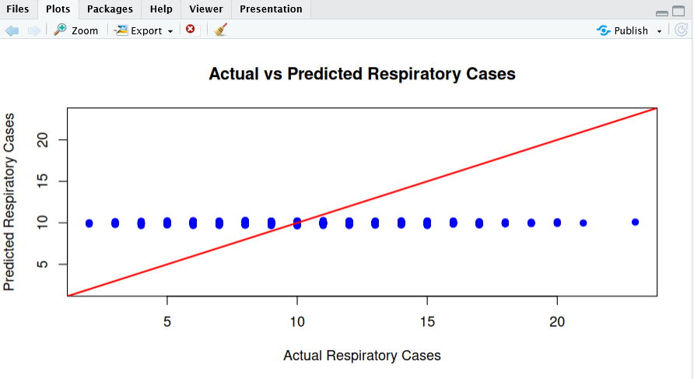
Figure 4: Actual vs Predicted Respiratory Cases
Predicted values stay almost flat at about 10 regardless of the actual count, which ranges from about 2 to 23. If predictions were accurate, the points would follow the red reference line, but they do not, so the model has very little predictive power on this dataset.
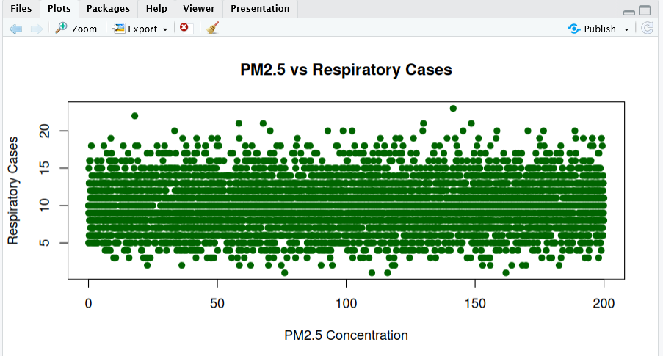
Figure 5: PM2.5 vs Respiratory Cases
Respiratory cases are scattered across the full PM2.5 range of 0–200 with no visible upward or downward trend. The graph does not show a clear relationship between PM2.5 concentration and respiratory cases.

9. Model Evaluation
The table below lists the actual values obtained from the R output in Posit Cloud.
Table 1: Model Evaluation Results
Metric | Actual result from Posit Cloud
Mean Absolute Error (MAE) | 2.47
Root Mean Squared Error (RMSE) | 3.17
Test R-squared | 0.0003
Training records | 4,648
Testing records | 1,163

MAE and RMSE summarize prediction error; smaller values are generally preferable when comparing models on the same target and scale. Test R-squared measures performance relative to variation in the test target and can be negative. It is not classification accuracy.
Here, the model has an MAE of 2.47 and an RMSE of 3.17 respiratory cases, while the test R-squared of 0.0003 is essentially zero. This means the model does no better than predicting the average number of cases for every record, which agrees with the flat pattern in Figure 4.

10. Key Observations
- The dataset was split into 4,648 training records and 1,163 testing records for model building and evaluation.
- AQI values are spread roughly uniformly between 0 and 500 (Figure 1).
- Average respiratory cases are nearly identical, at about 10, across all five health-impact classes (Figure 2).
- None of the six predictors was statistically significant in the regression, and the overall model was not significant (p = 0.3946) (Figure 3).
- The model predicts values close to 10 for almost every record, so predicted and actual cases do not line up (Figure 4).
- No clear pattern appears between PM2.5 and respiratory cases (Figure 5).
- The test R-squared of 0.0003 indicates that the model has almost no explanatory power on this dataset.

11. Conclusion
This microproject demonstrated a complete introductory data-analysis workflow in R, including CSV import, data preparation, descriptive analysis, visualization, correlation, multiple linear regression, and test-set evaluation. Posit Cloud made it possible to complete the work in a browser-based environment. The project provides practical experience in analyzing data and assessing a basic predictive model. The model achieved an MAE of 2.47, an RMSE of 3.17, and a test R-squared of 0.0003, showing that AQI and the pollutant variables explain almost none of the variation in respiratory cases in this dataset. Because the dataset is synthetic, results are educational and do not establish real-world medical risk or causation.

12. Limitations and Future Scope
- The dataset is synthetic and may not represent real populations or real clinical outcomes.
- Associations in the dataset do not prove that air pollution caused a health outcome.
- A random train/test split and one regression model provide only a basic evaluation.
- Future work could use verified real-world environmental and health data, document data provenance, compare additional models, and use cross-validation.

13. Viva Preparation
What is AQI? AQI is an index used to communicate air-quality conditions.
Why did you use R? R provides built-in tools for data analysis, visualization, statistics, and regression.
What is linear regression? It models the relationship between a numeric outcome and one or more predictor variables.
Why split training and test data? Training data fits the model; test data checks how it performs on records not used for fitting.
What is MAE? The mean absolute difference between actual and predicted values.
What is RMSE? The square root of the average squared prediction error; larger errors receive more weight.
What does R-squared mean? It summarizes model performance relative to the variation in the target values; test R-squared can be negative.
Can this model diagnose respiratory disease? No. The dataset is synthetic and this model is an educational demonstration, not a medical tool.

