Aaaaa

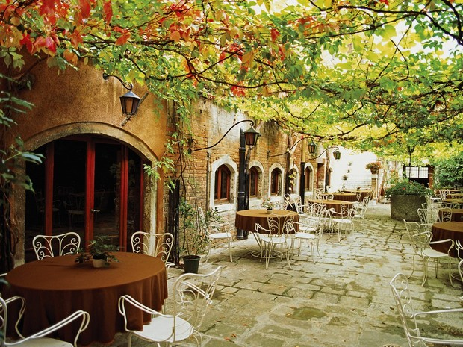

Aadssdsadf

Fsfsdfsdfdsf

|  |  |  |
| --- | --- | --- |
| dsdsd | fdsdfs | fdsfsd |
| sfdfsdfs | dsffsdf | dfsf |