Is it really just a picture?

Problem: Sometimes a file is used to hide other files. Is there anything in this image?
Hint: Try comparing it to the original
Given: Spurs.jpg

Notes: You can easily search for the original image with google’s search by image feature. This is not necessary to solve this problem, but is useful when competing.

Steps:
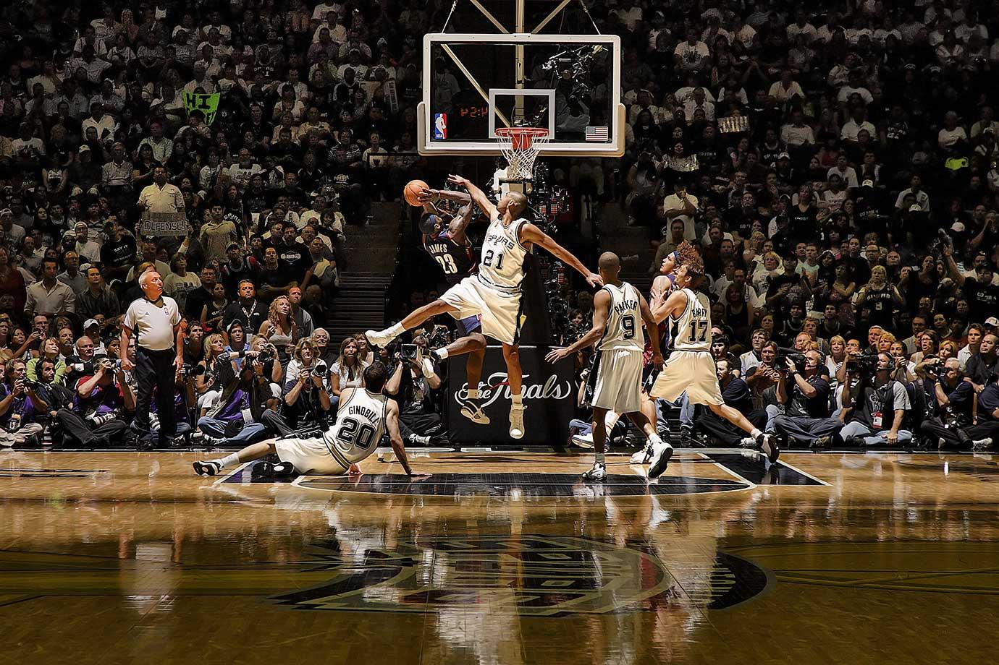
1) If compared to the original it is easy to see that the given image is larger than the original image. 294.9kB for the given and 281.6kB for the original. Something has been added to this file.

2) There are several forensics tools that can be used to search for hidden files. Foremost File Carver will work for this problem.

Note: “Foremost is a console program to recover files based on their headers, footers, and internal data structures. This process is commonly referred to as data carving. Foremost can work on image files, such as those generated by dd, Safeback, Encase, etc, or directly on a drive. The headers and footers can be specified by a configuration file or you can use command line switches to specify built-in file types. These built-in types look at the data structures of a given file format allowing for a more reliable and faster recovery.” http://foremost.sourceforge.net/

3) From the command line inside of the directory where Spurs.jpg is loacted, enter
user@localhost:~$ foremost -v -i Spurs.jpg’

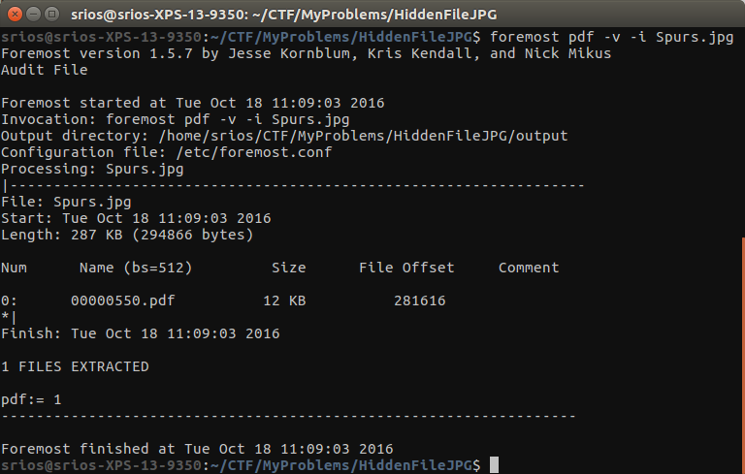
Note: Foremost format
foremost [-v|-V|-h|-T|-Q|-q|-a|-w-d] [-t <type>] [-s <blocks>] [-k <size>]
[-b <size>] [-c <file>] [-o <dir>] [-i <file]

-V - display copyright information and exit
-t - specify file type. (-t jpeg,pdf ...)
-d - turn on indirect block detection (for UNIX file-systems)
-i - specify input file (default is stdin)
-a - Write all headers, perform no error detection (corrupted files)
-w - Only write the audit file, do not write any detected files to the disk
-o - set output directory (defaults to output)
-c - set configuration file to use (defaults to foremost.conf)
-q - enables quick mode. Search are performed on 512 byte boundaries.
-Q - enables quiet mode. Suppress output messages.
-v - verbose mode. Logs all messages to screen

4) The hidden pdf will be placed in a directory labeled ‘output’ by default. Inside will be pdf. Notice that only some words have capital letters. Write them down.

Elaborate

FLAG{OUTTSYOPHNDERHIN}

