Can you crack the password

Problem: Just because there is a password doesnt't mean its secure.
Hint: dictionary.txt
Given: encrypted.pdf

Note: Cracking pdf password can be accomplished with PDFCrack and a dictionary containing password. This tool uses brute-force to crack the password.
http://pdfcrack.sourceforge.net/

Steps:
1) When file is opened you will be prompted to enter the password.
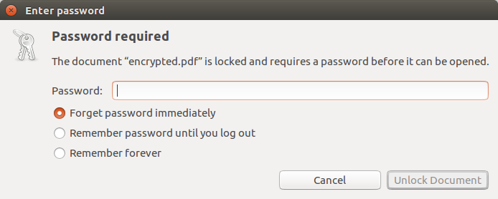
Since the password is not given a tool will be needed to try and crack the password.

Note: This method of cracking the password will only work in certain cases and is dependent on having a word list containing possible passwords.

2) A dictionary with a password list is provided for the problem. Use the word list with PDFCrack to find the password. In the command line enter ‘pdfcrack --wordlist=dictionary.txt encrypted.pdf’

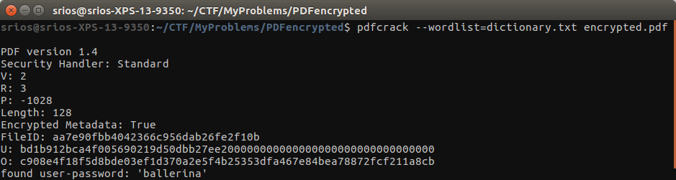
3) The output from running PDFCrack with return the matched password. Enter the password into the pdf and retrieve the flag.

FLAG{*/?_T03_kn1f3_@[\}

