PDFmessage

Problem: The pdf file signatures seem odd in this
Hint: Hex edit
Given: Fall-of-Roman-Empire.pdf

Note: Recommended hex editor ‘Bless Hex Editor’
http://home.gna.org/bless/

Add link for magic number
‘file’ command

Steps:
1) Given a pdf that seems to be just any ordinary pdf. It opens and displays just like any other pdf. Pdf files have the structure shown bellow.

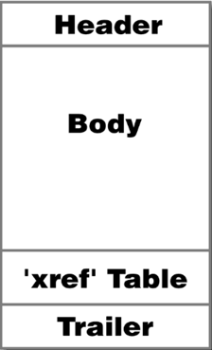

The header is the first line of a pdf and identifies the type of file. For a pdf the beginning marker is ‘%PDF-1.4’
The trailer contains the end of file marker, for this file it is ‘%%EOF’

2) When looking at only the very beginning and very end of the document inside of the hex editor, nothing looks out of the ordinary. A header and trailer are present.

3) Notice that there is more information after the trailer. Copy and paste everything after the trailer into another file.

4)This data happens to be a jpg and when opened reveals the flag.
FLAG{<_Tr3e_$_f1dDy_+1^$<}

