Captured packets

Problem: Search through the web traffic.
Hint: Use Wireshark. The key is the flag. Change this
Given: dump.pcap

Note: Wireshark is a network packet analyzer. Wireshark will intercept and log traffic that passes over a digital network or part of a network. A network packet is a formatted unit of data carried by a network.

Example IP packet from Wikipedia:
IP packets are composed of a header and payload. The IPv4 packet header consists of:
00 | 01 | 02 | 03 | 04 | 05 | 06 | 07 | 08 | 09 | 10 | 11 | 12 | 13 | 14 | 15 | 16 | 17 | 18 | 19 | 20 | 21 | 22 | 23 | 24 | 25 | 26 | 27 | 28 | 29 | 30 | 31 | (bit position)
Version |  |  |  | IHL |  |  |  | QoS |  |  |  |  |  |  |  | Length
ID |  |  |  |  |  |  |  |  |  |  |  |  |  |  |  | 0 | DF | MF | Fragment Offset
TTL |  |  |  |  |  |  |  | Protocol |  |  |  |  |  |  |  | Checksum
Source IP
Destination IP

Further reading: https://en.wikipedia.org/wiki/Network_packet

Steps:
1) Given a pcap dump that will need to be opened in Wireshark
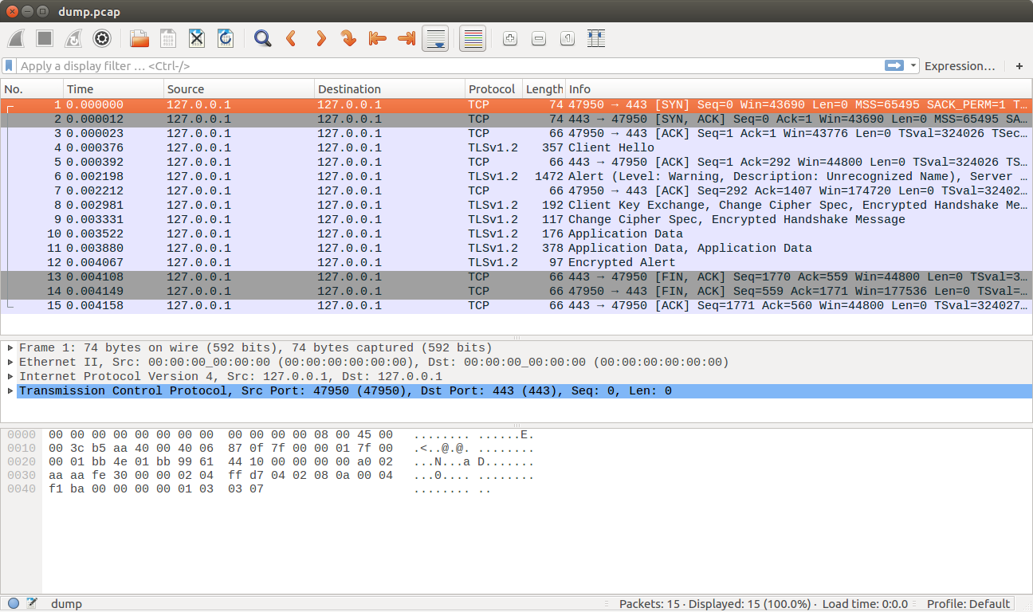
Inside of the packet dump are TCP and TLS packets. TCP is transmission control protocol and is a delivery stream between host applications communicating on an IP network. TLS is transport layer security and is a cryptographic protocol to provide communication security over a network.

2) The given communication is a tcpdump capture that has an SSL encrypted conversation. Search through the TLS packets.

3) Inside of one of the TLS packets data stream is a uTF8String containing the key.
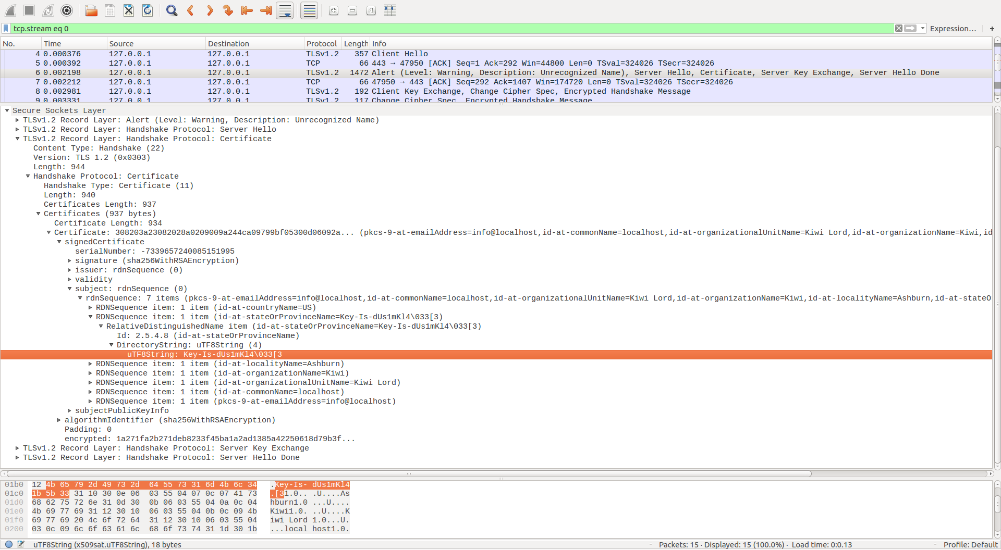
FLAG{Key-Is-dUs1mKl4}

Second way to solve:
$ tcpdump -qns 0 -A -r dump.pcap

