Tabs and spaces

Problem: You should always check your whitespace. Compile the code and see the results. Modify as needed. Turn on hidden characters or use a text editor that displays them like sublimetext.
Hint: TBD
Given: secret.c

Steps:
1) Given a C file that after compilation and execution outputs
‘y?[6c6pg>sfost_e`:[{cahf’ which is meaningless.

2) With hidden characters turned on notice that most lines have spaces in the whitespace but a few have tabs within the whitespace.

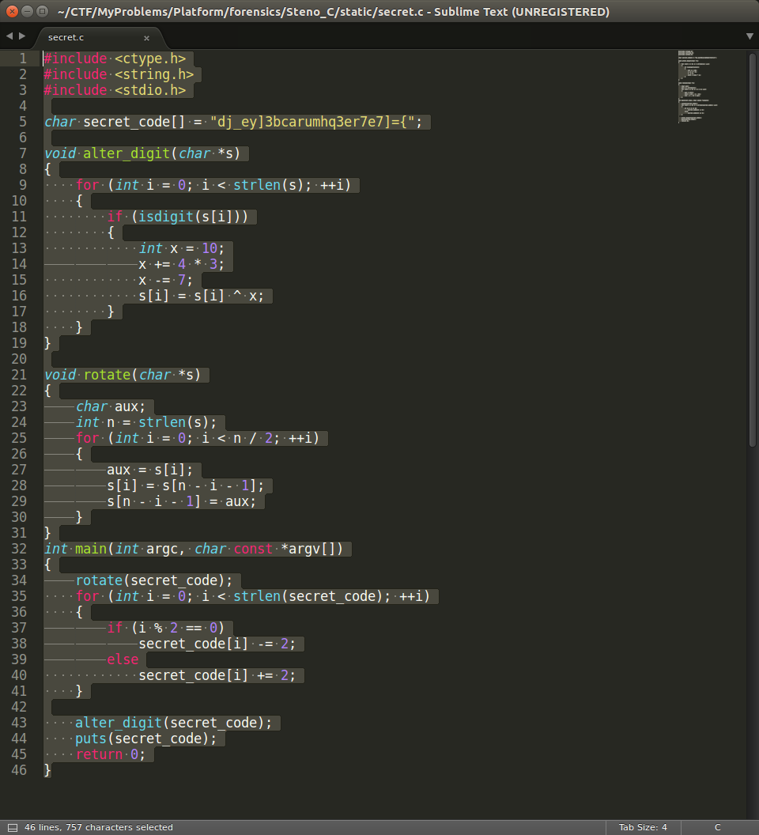

When viewed in sublimetext, spaces appear as dots when highlighted and tabs are represented by lines.

3) Comment out or delete the lines with tabs. Re-compile the code and execute.
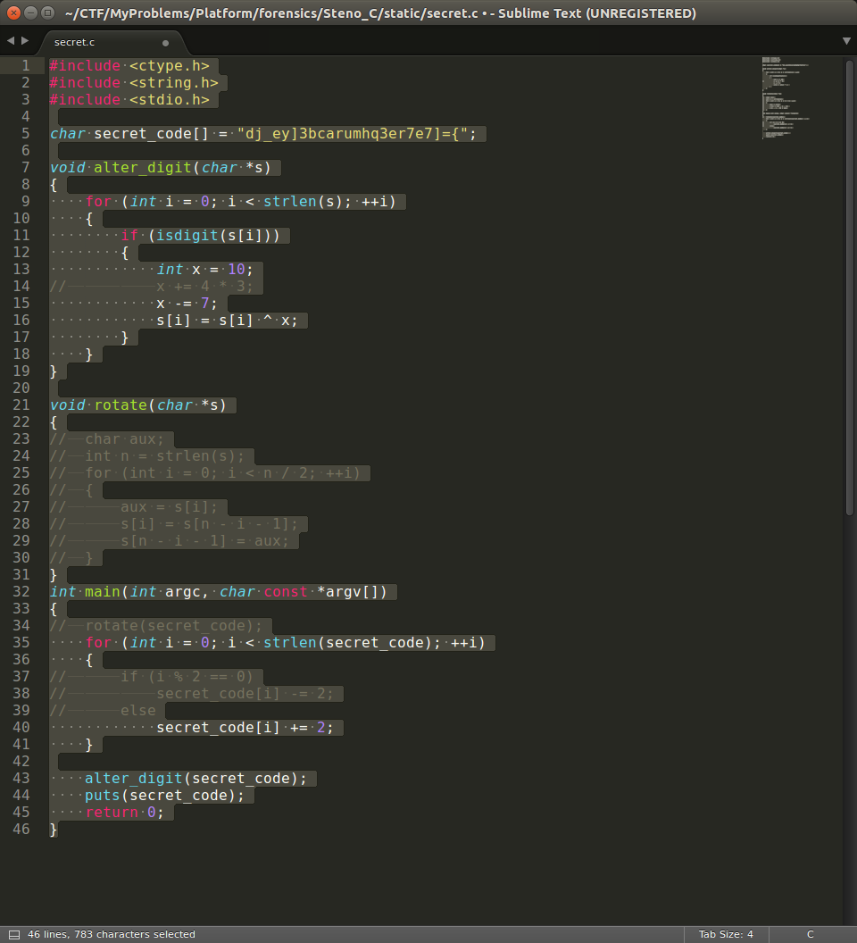

4) Output of the new program is the flag.

FLAG{y?[6c6pg>sfost_e`:[{cahf}

