Message in sound

Problem: Is there anything inside of this sounds file
Hint: Use Sonic Visualizer of Audacity
Given: Rolled.wav

Note: Recommended to use Sonic Visualizer for ease of use. Audacity has more features for advanced users.

Steps:
1) Given a wav format sound file. When opened it plays like any other sound file.

2) Open the file with Sonic Visualizer and notice that there are two distinct audio channels.
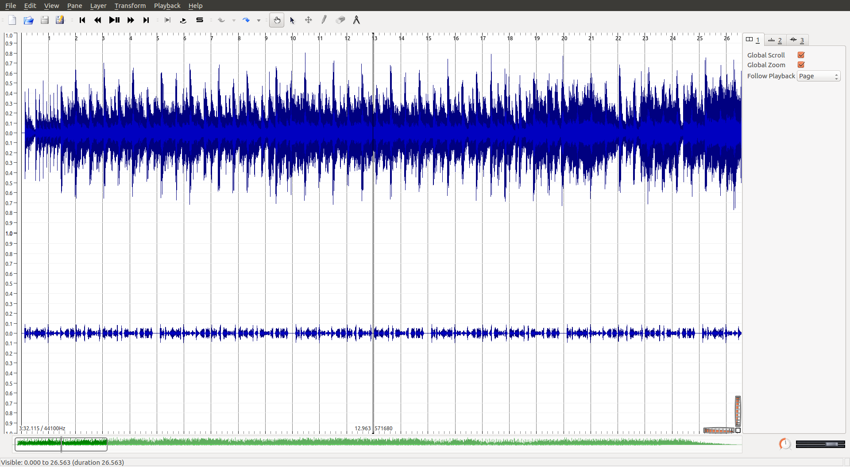
The two audio channels look very different from each other. If you look closely on the second channel the waves are repeating.

3) From the menu select Layer -> Add Spectrogram -> Channel2
Adjust the zoom and position of the spectrogram to find the flag.
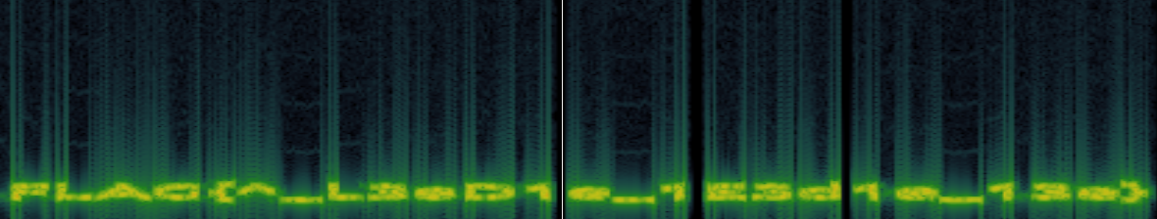
FLAG{^_L3eD1e_1E3d1e_13e}

