HTML inspection I

Problem: Inspection
Hint: Browser tools
Given: home.html

Note: HTML comments are in form <!-- Write your comments here -->

Steps:
1) Open the file in browser and use developer tools to view the source code.

2)
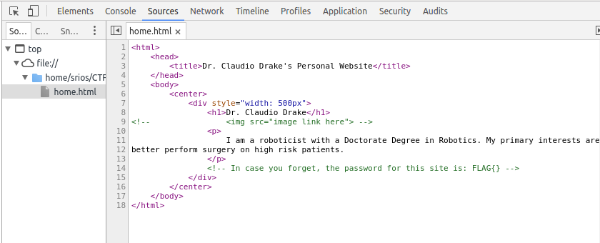
The second set of comments holds the flag

FLAG{}

