HTML inspection II

Problem: Can you correct this html?
Hint: You will need to write a script
Given: inspection.html

Note:

Steps:
1) Opening the html file in browser will show a basic web page filled with text. Notice that some of the words are italics. View the source code in a text editor instead of browser.

2) Try cutting out all of the italics word using grep. Open a terminal in the directory where inpection.html is located.
Enter: grep -o -e "<em>[^/]*</em>" inspection.html
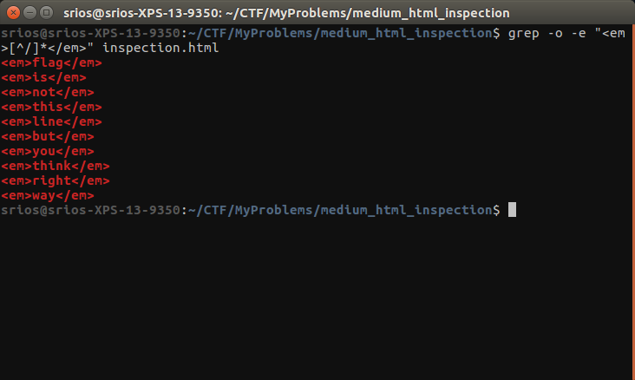

3) The result is not the flag we’re on the right track. Now try removing words within the <e> tag. Again, use grep inside a terminal.
WHY?
Enter: grep -o -e "<e>[^/]*</e>" inspection.html
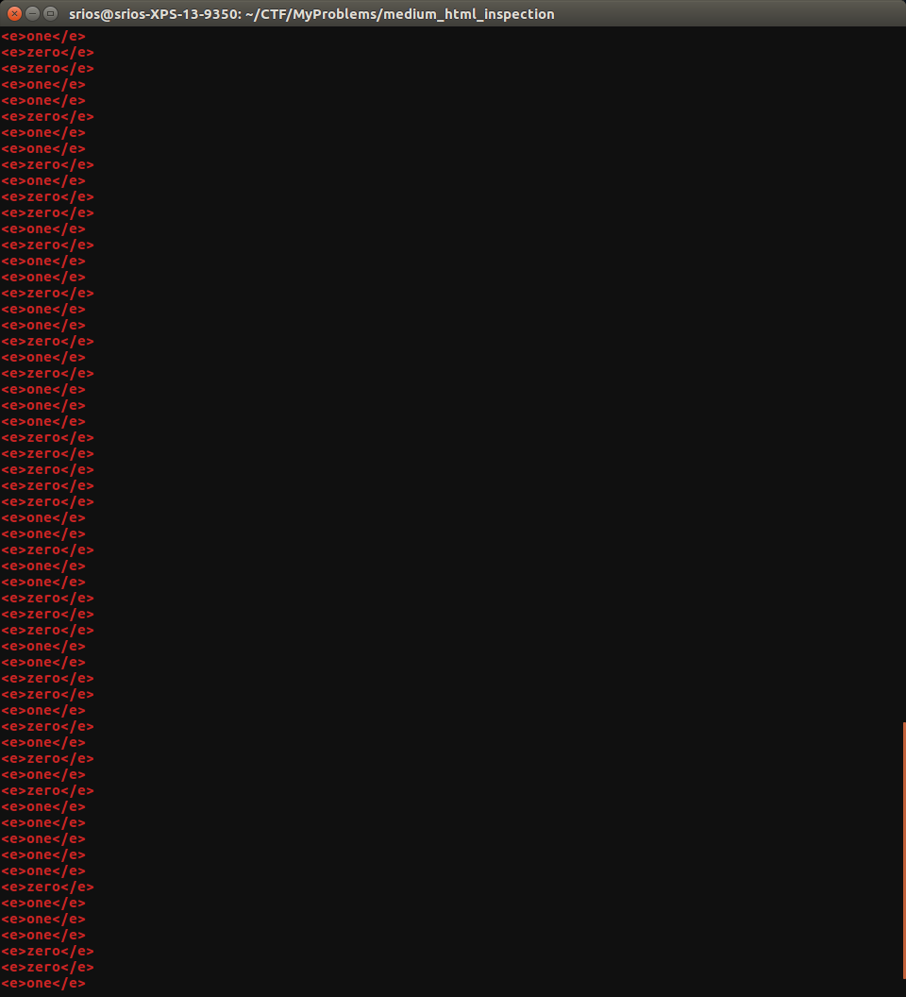

4) The output for the previous step contains only zero and one written explicitly. Write a python script to substitute the word zero with 0 and the word one with 1, then translate it to ASCII byte by byte.

Solution:
#!/usr/bin/env python
import re
import sys
f = open(sys.argv[1])
a = f.read()
b = ''.join(re.findall("<e>([^/]*)</e>", a))
b = b.replace('zero', '0')
b = b.replace('one', '1')
print ''.join(map(lambda x: chr(int(x, 2)), [b[i:i+8] for i in xrange(0, len(b), 8)]))
f.close()

FLAG{flag_is_this_is_a_simple}

