JS can be confusing

Problem: %96 7=28 7@C E9:D 492= :D iQx>A6C2E@C xF=:FD r26D2C s:GFDQ]
Hint: Go to http://www.richmond.com/news/local/central-virginia/a-pow-son-s--year-quest-finally-unfurls/article_3693659c-4788-516c-8c73-1c8defc13efa.html?mode=jqm
Second Hint: This is a tncms packet.

Note:

Steps:
1) Open developer tools in your browser and search the sources.
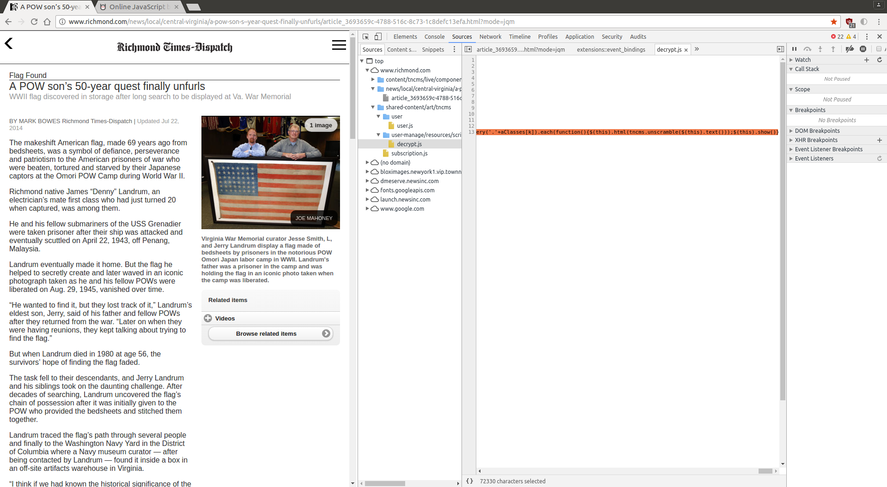
Notice a source titled decrypt.js

2) Line 13 containes the obfuscated code. Visit http://jsbeautifier.org/ and enter the code from line 13. Displayed will be an unobfuscated view of the js code.

3) The hint states this is a tncms packet so a good place to start is to search ‘tncms’ This yields a few results for tncms but only section has what we need. Search around the file and try and determine which part we need.

4) The part we need is
tncms.unscramble = function(sInput) {
var sOutput = '';
for (var i = 0, c = sInput.length; i < c; i++) {
var nChar = sInput.charCodeAt(i);
if (nChar >= 33 && nChar <= 126) {
sTmp = String.fromCharCode(33 + (((nChar - 33) + 47) % 94));
sOutput += sTmp
} else {
sOutput += sInput.charAt(i)
}
}
return sOutput
};

5) This part appears to unscramble tncms packets. You could isolate this section of code and run it with the given message. The easier route is to copy and paste the entire js code into the developer console. Press enter. Call the function to unscramble the tncms with
tncms.unscramble('%96 7=28 7@C E9:D 492= :D iQx>A6C2E@C xF=:FD r26D2C s:GFDQ]')

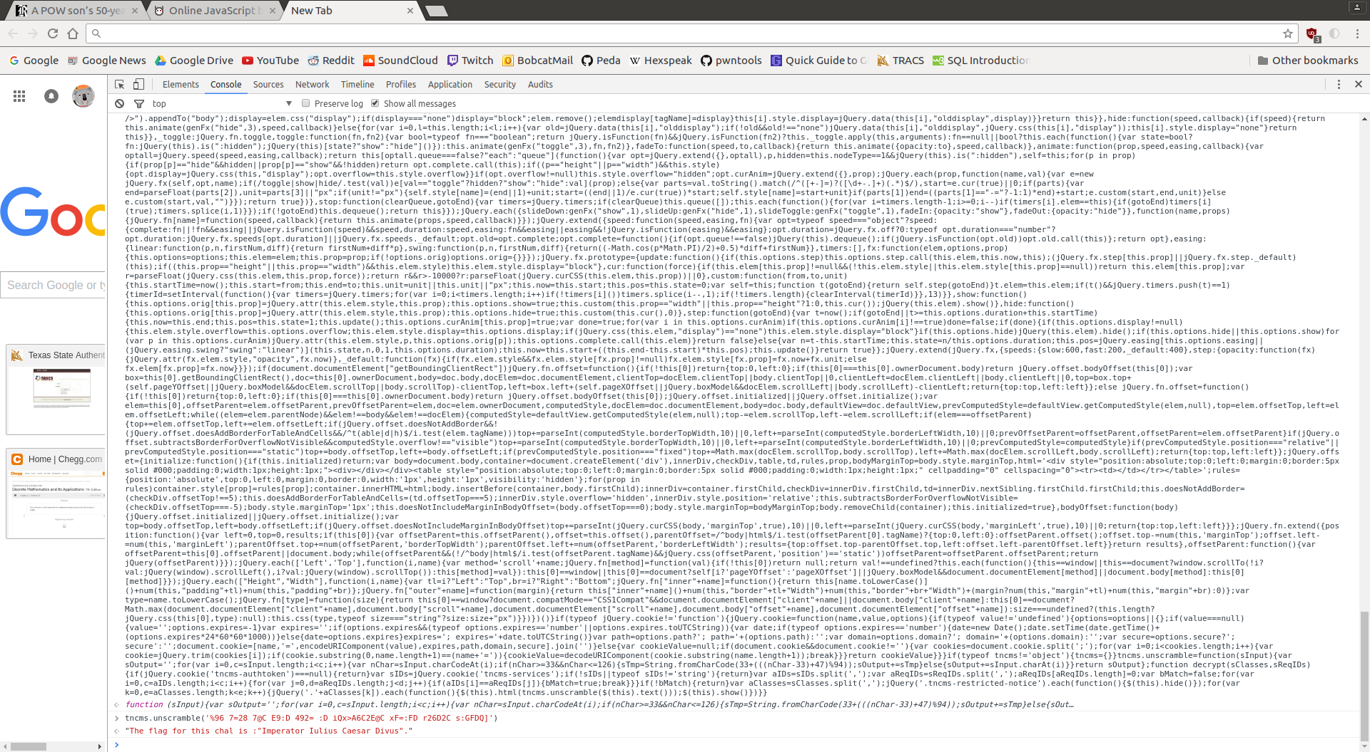
Replace the spaces with underscores to enter the flag.

FLAG{Imperator_Iulius_Caesar_Divus}

