PHP execute

Problem: Search and replace complex terms with regular expressions
Hint: preg_replace()
Given: index.php

Note: PHP preg_replace() will perform a regular expression search and replace
More info can be found http://php.net/manual/en/function.preg-replace.php

Steps:
1) Follow the given link to the site.
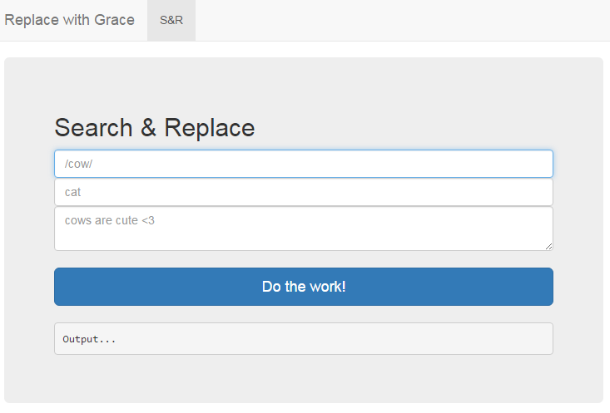
There are three input fields. With only the input fields visible, we assume it looks like the parameters are being sent with the preg_replace function.

Note: preg_replace falls under a PCRE function which can be modified.
According to the manual “If this deprecated modifier is set, preg_replace() does normal substitution of backreferences in the replacement string, evaluates it as PHP code, and uses the result for replacing the search string. Single quotes, double quotes, backslashes (\) and NULL chars will be escaped by backslashes in substituted backreferences”
If we add the e modifier we should be able to execute our own code on the second input.

More information can be found here http://php.net/manual/en/reference.pcre.pattern.modifiers.php

2) Try a few commands to see what the output is. In this case we tried ‘ls’
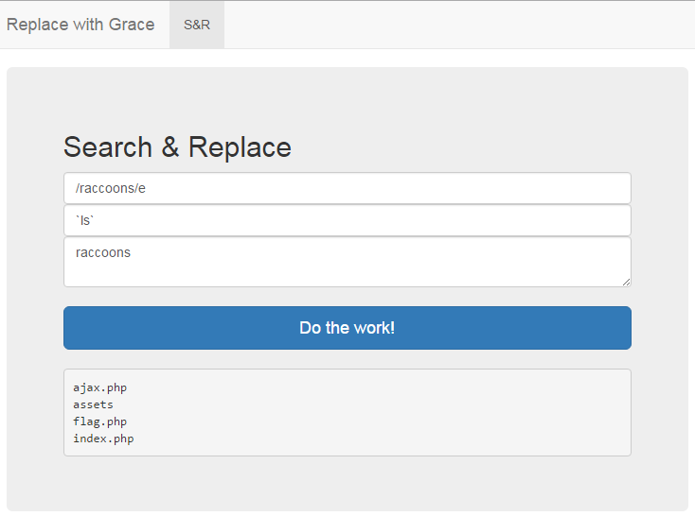

‘flag.php’ seems very suspicious.

3) Use the cat command with flag.php to try and view the contents of flag.php.
