V-Cipher(Vigenere ^ Cipher)

Problem: We encrypted a file using a vigenere xor cipher. Can you get the flag?

Given: vfile.enc

Hint: Frequency

Info: A vegenere cipher is a repeating key cipher, in this case it was xored with the plain text.

To learn more about how a vegenere cipher works visit this [link](https://en.wikipedia.org/wiki/Vigenère_cipher).

Steps:

1) First thing to start with is opening the given file and reading it into a variable. Then you want to make sure it is an even length so that you can decode the hex version. Most likely there will be a new line which is the reason you want to strip the last character from the file. The following is a screenshot of how it would look. You also want to save the length of the text.

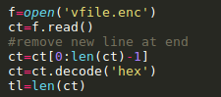

2) The second part and most important is finding the max repeating patterns in the cipher text and finding the largest shifting point. This can be done in many ways, but the rough idea is to take a pattern of a string such as ‘abc’ and see if ‘abc’ is repeated again later in the cipher text. You want to repeat this for strings from length 2 to roughly 16. This is also known as calculating the frequency of the text which is based on the frequency of the English alphabet which can be found easily online. After you have done this part of your script you should know a rough keysize. The following screenshots show the code for analyzing the patterns and the output of the patterns.

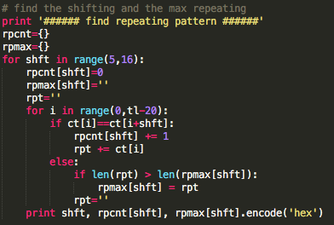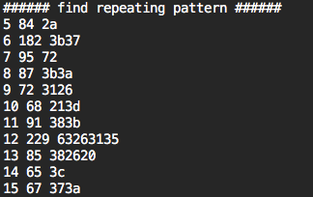

3) It can easily be seen that 12 and 6 have the most repeating patterns, meaning one of these is most likely the key length. Usually it is better to start at the lowest factor number, meaning try 6 first. Then you will want to guess the key size is equal to 6. Then you want to regroup the cipher text based on the key size. Which puts the cipher text into smaller sections(columns) of the cipher text with the length of 6. Then you want to use the 1 gram frequency for the alphabet and swap the characters accordingly to the English alphabet frequency. Normally in a frequency chart. The most used character is not a space because the normal frequency is only 0-25 which is A-Z. In our cipher text we want to assume that the most used character is a space(‘ ‘). We then analyze the cipher text blocks that we created to swap the character based on their high frequencies. This can be seen in the following screenshot.

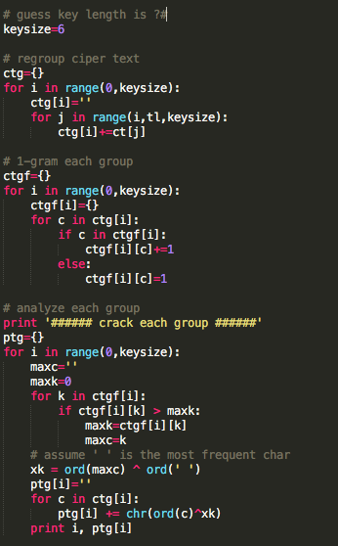

4) Now after we have analyzed each group with our guessed key length as 6. We can now begin to put the cipher text back together which will now be converted into our plain text. Since we had our blocks of text we need to merge them back together which will become our plain text. This can be done like the following:

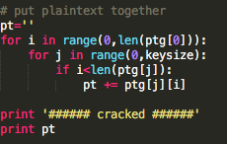

5) When you run the full script you should get some output like the following:

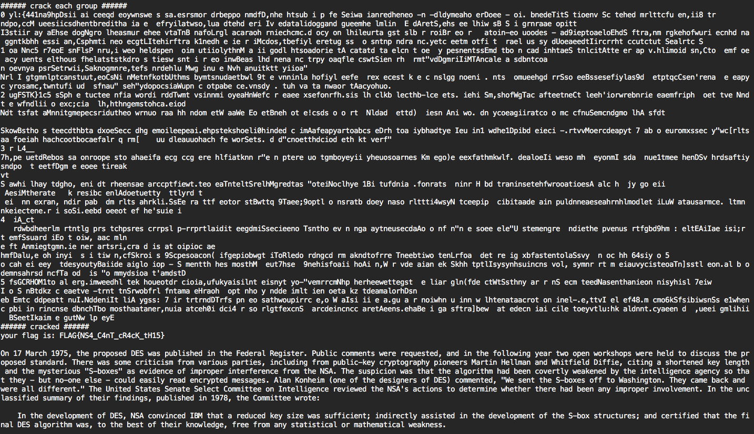

Sample Script:

#!/usr/bin/python

# -*- coding: utf-8 -*-

f=open('vfile.enc')

ct=f.read()

# remove new line at end

ct=ct[0:len(ct)-1]

ct=ct.decode('hex')

tl=len(ct)

# find the shifting and the max repeating

print '###### find repeating pattern ######'

rpcnt={}

rpmax={}

for shft in range(5,16):

rpcnt[shft]=0

rpmax[shft]=''

rpt=''

for i in range(0,tl-20):

if ct[i]==ct[i+shft]:

rpcnt[shft] += 1

rpt += ct[i]

else:

if len(rpt) > len(rpmax[shft]):

rpmax[shft] = rpt

rpt=''

print shft, rpcnt[shft], rpmax[shft].encode('hex')

# guess key length is ?#

keysize=6

# regroup ciper text

ctg={}

for i in range(0,keysize):

ctg[i]=''

for j in range(i,tl,keysize):

ctg[i]+=ct[j]

# 1-gram each group

ctgf={}

for i in range(0,keysize):

ctgf[i]={}

for c in ctg[i]:

if c in ctgf[i]:

ctgf[i][c]+=1

else:

ctgf[i][c]=1

# analyze each group

print '###### crack each group ######'

ptg={}

for i in range(0,keysize):

maxc=''

maxk=0

for k in ctgf[i]:

if ctgf[i][k] > maxk:

maxk=ctgf[i][k]

maxc=k

# assume ' ' is the most frequent char

xk = ord(maxc) ^ ord(' ')

ptg[i]=''

for c in ctg[i]:

ptg[i] += chr(ord(c)^xk)

print i, ptg[i]

# put plaintext together

pt=''

for i in range(0,len(ptg[0])):

for j in range(0,keysize):

if i<len(ptg[j]):

pt += ptg[j][i]

print '###### cracked ######'

print pt