Coding-SuperEasy-Decoding

Problem: I have encoded a string; can you turn it into a flag?

Hint: Hex -> Ascii

Given: 464c41477b336e436f64316e475f346e445f6433633044316e477d

Notes: Encoding and decoding are an easy way to convert strings to a certain encoded type of text or to turn an encoded type of text back to another form of text by decoding it. Simple examples would be if I encode “s” with hex, I am given ‘73’. Now if I decode ‘73’ with hex I am given “s”. This can be seen in the following screenshot.

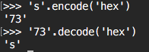

Steps:

1) We are given a string that we know is encoded. When looking at this string you can see a pattern of characters such as c, e, f, and d. Hopefully these stick out as the letters that are used when counting in hex. Therefore, we know we have a string that was encoded with hex.

2) Next we can easily use python to decode this string for us. First just open the terminal. Then, go to the python interpreter by typing ‘python’ in your command line. It should look like the following:

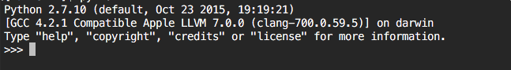

3) Now enter the command to decode the given string with the argument as hex. The command should look as: (do not copy and paste from Microsoft word, command will not work)

‘464c41477b336e436f64316e475f346e445f6433633044316e477d’.decode(‘hex’)

Then the string that was encoded with hex will be returned to you. This can be seen in the following screenshot.

