Easy – Hash

Problem: Can you crack a password for me, if I can log on I will give you the flag. Connect here: nc 127.0.0.1 20202

Hint: It looks like an md5 but who knows.

Given: nc 127.0.0.1 20202

Steps:

1) Connect to the server and get the hash.

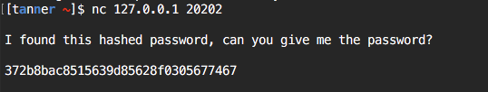

Note: This is an unsalted md5 hash. To learn more about md5 hashing visit this [link](https://en.wikipedia.org/wiki/MD5).

2) Now that we have the hash, we need to figure out the password and send it back to the server. There are many sites to crack a simple md5 hash. Such as this [link](https://hashkiller.co.uk/md5-decrypter.aspx). Copy and paste the hash into this website and it will give you the password.



Note: An md5 hash can easily be cracked nowadays. There are many sites that have databases stored with md5 hashes to easily determine what the hash was before the encryption.

3) Now that we have the password, we can give it to the server and receive the flag.

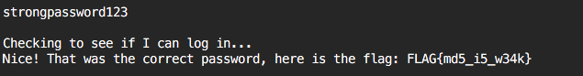

Flag = FLAG{md5_i5_w34k}