Messy Aes

Problem: We were playing around with AES encryption. We seem to have lost our flag. Can you find it?

Given: po6vko2hb574zjwxurkayebnio33mnmuhwhhvtwk2tlqsghnasyb2kfmzu7ckz7lrvcabdsmisereryubq

Hint:

Solution)

This problem has a very easy solution. It is simply a lot of encrypted flags and you just have to find the correct one.

Simple way:

Ctr-f and search for the first 8 bytes: po6vko2hb574zjwx

This leads to the flag : FLAG{sorts_gross_spoon_programmers_exchangers_heap}

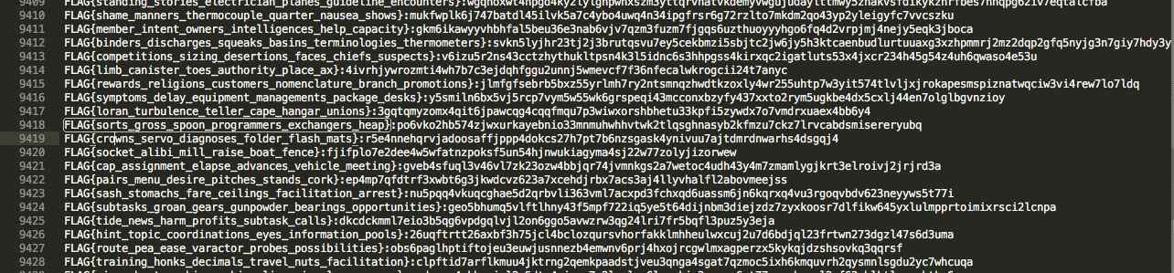

Longer but simple way: make a short script to search the file.

##needed string##

#po6vko2hb574zjwxurkayebnio33mnmuhwhhvtwk2tlqsghnasyb2kfmzu7ckz7lrvcabdsmisereryubq

##first 8bytes

fsb='po6vko2hb574zjwx'

lines=[]

with open('given.txt') as f:

for line in f:

if fsb in line:

print "Found flag:\n"

print line

This also gets the flag: FLAG{sorts_gross_spoon_programmers_exchangers_heap}