* Snowbuffs
* Group Members
  + Tanner Coon
  + Brett Milliken
  + Taylor Nguyen
  + Brandon Pedrianes
  + Xuan Zhou
* Project Tracker: Trello
  + [Link to Trello Page](https://trello.com/b/8KZFp8SF/project)
  + 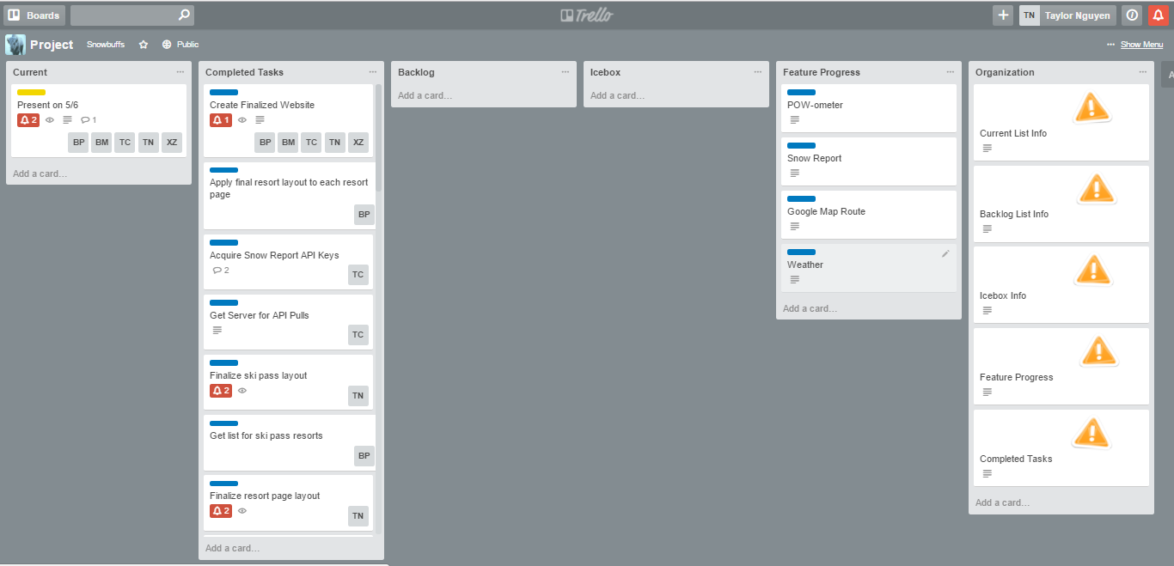
* VCS: Heroku
  + [Link to Repository](https://git.heroku.com/snowbuffspretty.git)
* Proof of Brandon Pedrianes’s contributions to Heroku
  + 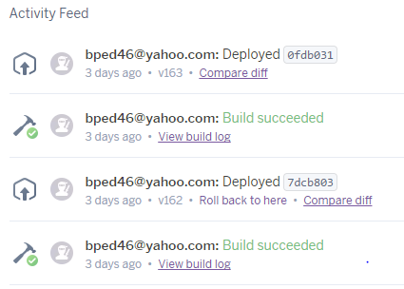
* Proof of Tanner Coon’s contributions to Heroku
  + 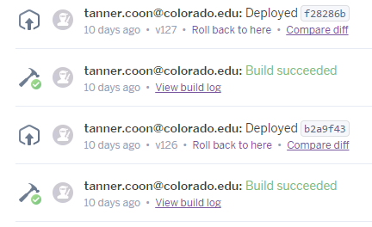
* Proof of Taylor Nguyen’s contributions to Heroku
  + 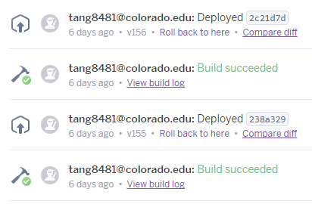
* Proof of Brett Milliken’s contributions to Heroku
  + 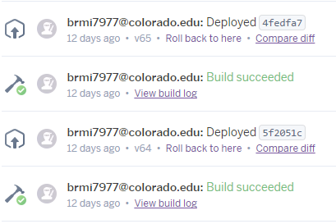
* [Deployment Link](http://snowbuffspretty.herokuapp.com/)