REALKEY

Technical Architecture
& Maintainer Handbook
  - Browser-based parametric CAD for 3D-printable keys and plug followers

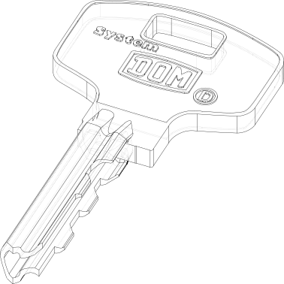
Repository version 0.2.0 | Snapshot 68595bb | Prepared 13 July 2026
Architecture / Data flow / Domain model / Supported systems / Operations / Extension guide

DOCUMENT CONTROL
About this handbook
Purpose This is a code-derived engineering reference for maintainers, contributors, reviewers, deployment owners, and technically sophisticated users. It explains the repository as inspected; it is not a manufacturing certification, locksmith authorization, or guarantee that a generated model is suitable for a particular lock or printer.
Field | Value
Document | realkey - Technical Architecture & Maintainer Handbook
Repository | https://github.com/smgoldade/realkey
Code baseline | main @ 68595bb; latest inspected commit dated 12 July 2026
Package metadata | realkey 0.2.0; Python >=3.13,<3.15; build123d 0.11.0
Prepared | 13 July 2026
Primary audience | Maintainers, contributors, reviewers, deployment owners, advanced users
License | GNU Affero General Public License v3 (repository LICENSE)
Evidence basis | All tracked source/configuration/assets in the supplied workspace; no runtime behavior was assumed where the source was ambiguous

How to read this document
The opening sections establish system intent and architecture. Sections 5-9 are the implementation reference. Sections 10-14 are the operator and maintainer handbook. Section 16 is designed for quick lookup during development or incident diagnosis.
- Verified fact: directly observable in source, configuration, asset metadata, or repository history.
- Observed risk: a source pattern that should be covered by a targeted test or code review before being treated as a defect.
- Recommendation: a proposed hardening or maintainability action, not a claim about current behavior.

Snapshot limitations
The repository contains no automated test directory and no CI workflow. The local documentation build therefore validates syntax/structure and the document itself, but it does not certify CAD dimensional accuracy, print performance, browser compatibility, or operation against physical locks. Those require fixture models, known bittings, browser integration tests, and physical acceptance criteria.

NAVIGATION
Contents
1. Executive overview
What realkey does, its boundaries, and its core architectural proposition.
2. Repository profile
Codebase composition, directory structure, technology choices, and ownership map.
3. System architecture
Runtime boundaries, component responsibilities, registries, and design decisions.
4. Runtime lifecycle and interactions
Startup, validation, generation, preview, download, and sharing flows.
5. Core domain model and geometry services
Key/Follower contracts, cutters, SVG helpers, and resource loading.
6. Supported key systems
Complete catalog of ten registered key generators and their modeling strategies.
7. Plug follower generator
Preset catalog, end-type plug-ins, configuration schema, and assembly algorithm.
8. Browser application and user experience
DOM structure, PyScript state layer, Three.js viewer, and responsive styling.
9. Assets and resource pipeline
SVG/STEP/STL/PNG inventory, label contracts, lazy fetching, and file lifecycle.
10. Build, run, packaging, and deployment
Local use, Python package use, static hosting, versions, and dependencies.
11. Extension and contribution guide
How to add a key family, follower end, preset, asset, or UI feature safely.
12. Security, privacy, safety, and licensing
Trust boundaries, share-link exposure, supply chain, responsible use, and AGPL.
13. Quality assessment and technical debt
Current assurance posture, observed risks, and recommended tests.
14. Operations and troubleshooting
Symptom-based diagnosis for startup, validation, geometry, preview, and export.
15. Recommended roadmap
Prioritized hardening, maintainability, performance, and documentation work.
16. Reference appendices
Module catalog, worker API, URL schema, DOM IDs, assets, glossary, and checklists.
Use Word's Navigation Pane to jump through the complete Heading 1-3 hierarchy.

1. Executive overview
realkey is a browser-hosted parametric CAD system that turns lock-specific configuration and bitting data into local STL and STEP models for keys and plug followers.

1.1 Mission and value
The project began to address key blanks that are difficult to obtain because of geography, availability, or restriction. Its central contribution is not a single model: it is a reusable modeling framework in which each lock family describes its profiles, keyways, bitting grammar, blank construction, and cutting algorithm behind a common interface.
The browser application makes that framework accessible without a conventional server-side CAD service. Heavy geometry runs in a PyScript Web Worker; the foreground remains responsive, supplies selectors and validation, and presents the resulting STL through Three.js. STEP is retained for downstream CAD work, while STL targets slicing and printing workflows.

1.2 System at a glance
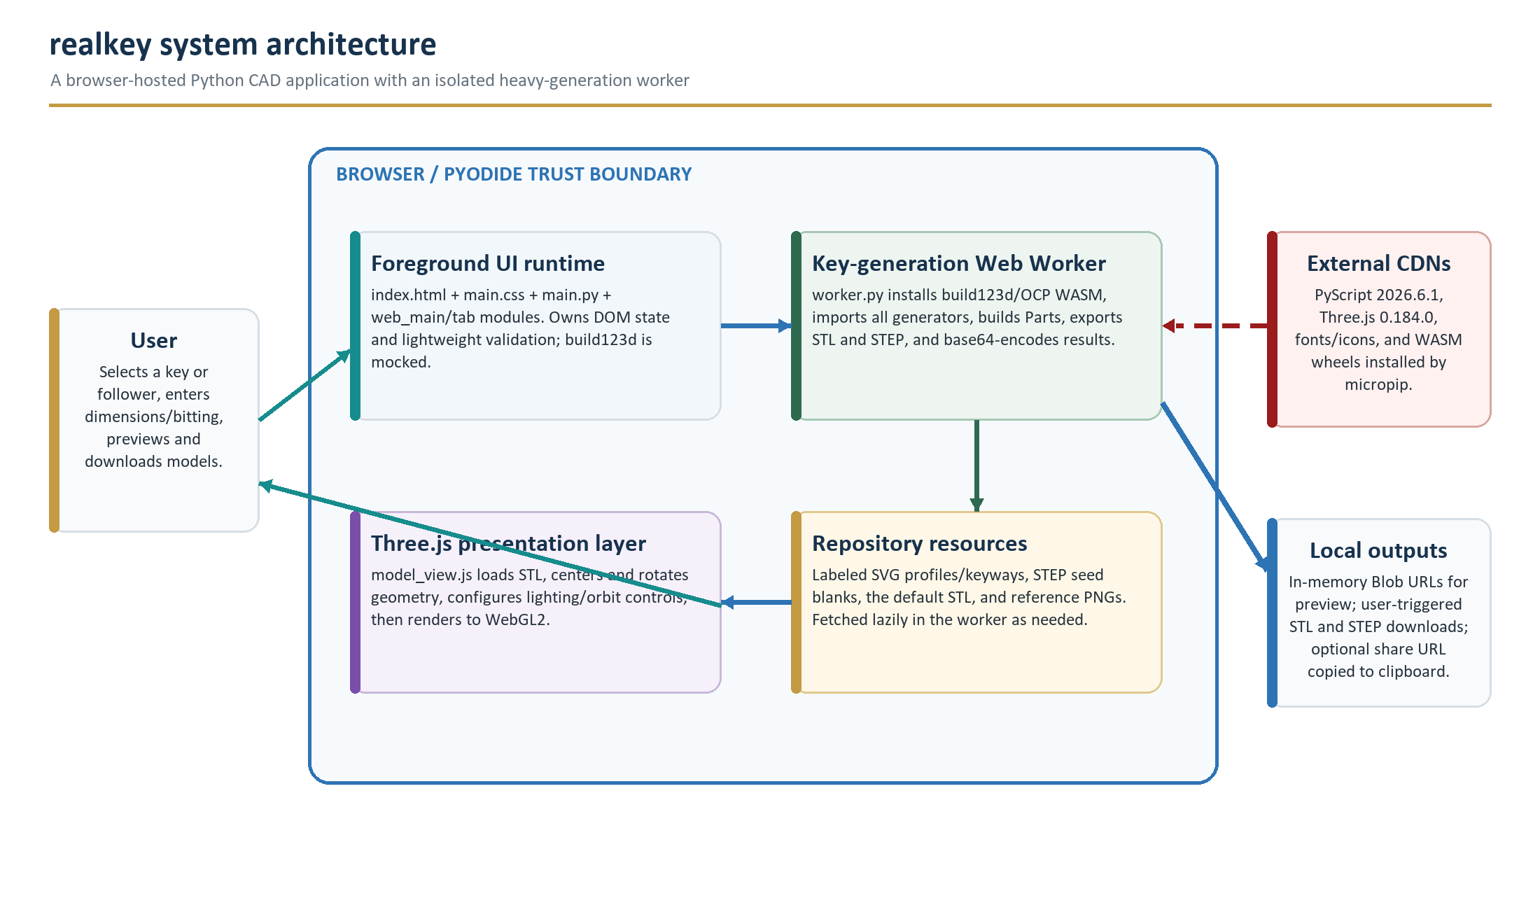
Figure 1. The foreground and CAD worker are separate Python runtimes inside the browser. External packages enter at startup; repository assets and generated files remain within the browser execution environment unless the user downloads or shares them.

1.3 Primary capabilities
- Parametric key generation. Ten registered generators cover ASSA, DOM, MIWA, Opnus, Paclock, Sargent & Greenleaf, three Schlage Everest variants, and VSR.
- Blank generation. An empty bitting requests a printable blank while preserving the selected profile and keyway.
- Plug follower generation. Eleven selector entries (Custom plus ten presets) combine a cylindrical body with any of nine registered end types.
- Dual CAD outputs. Each successful production generation returns both STL and STEP data.
- Interactive preview. Three.js supplies WebGL2 rendering, orbit/pan/zoom controls, automatic rotation, lighting, and model framing.
- Reproducible sharing. Optional query parameters encode the active tab and its settings; an additional flag can trigger generation after load.
- Client-side execution. The repository contains no application server; static hosting serves files while browser runtimes perform geometry.

1.4 Explicit boundaries
Not a server product No API server, database, account system, or telemetry implementation appears in this repository. Static hosting and external package/CDN delivery are still network dependencies.
- No command-line interface is declared in pyproject.toml. The source can be imported as a Python package, and several modules contain maintainer-only __main__ examples for ocp_vscode.
- No slicer profiles, printer calibration artifacts, dimensional validation fixtures, or physical acceptance records are versioned with the code.
- Bitting metadata can be sensitive. Share links are convenient but may place settings in browser history, clipboard contents, screenshots, chat systems, reverse-proxy logs, or analytics outside this repository.
- Generation success means build123d produced exportable geometry; it does not establish authorization, lock compatibility, strength, safe use, or print accuracy.

1.5 Architectural strengths
The codebase has a clear extension seam: Key and FollowerEnd subclasses self-register when imported. UI discovery and worker dispatch use the same registries, reducing duplicate catalogs. Heavy dependencies are intentionally isolated in the worker, while metadata and validation remain available to the foreground through a lightweight build123d mock. Resource loading is also abstracted so the same generator modules can operate against a normal filesystem or a lazy-populated Pyodide filesystem.

2. Repository profile
This snapshot is a compact, domain-heavy repository: 53 tracked files, 4,521 inspected source lines, 22 Python modules, three web assets, and 19 geometry/reference assets totaling approximately 5.24 MiB.

2.1 Top-level structure
realkey/
|-- index.html, main.css, model_view.js # Static application shell and viewer
|-- main.py, worker.py, config.json # Foreground/worker boot and PyScript map
|-- pyproject.toml # Python package metadata
|-- src/realkey/ # Domain, CAD, UI controllers, web adapters
| |-- key.py, key_cutters.py # Key contract and reusable cutter sketches
| |-- follower.py # Follower contract, presets, and CAD assembly
| |-- web_*.py, tab*.py # Browser state and UI orchestration
| `-- assa.py ... vsr.py # Lock-family implementations
`-- resources/ # SVG, STEP, STL, and PNG inputs
Packaging uses a src layout, but the browser does not install the wheel. config.json copies selected modules from src/realkey into a /realkey path inside each PyScript runtime.

2.2 Composition
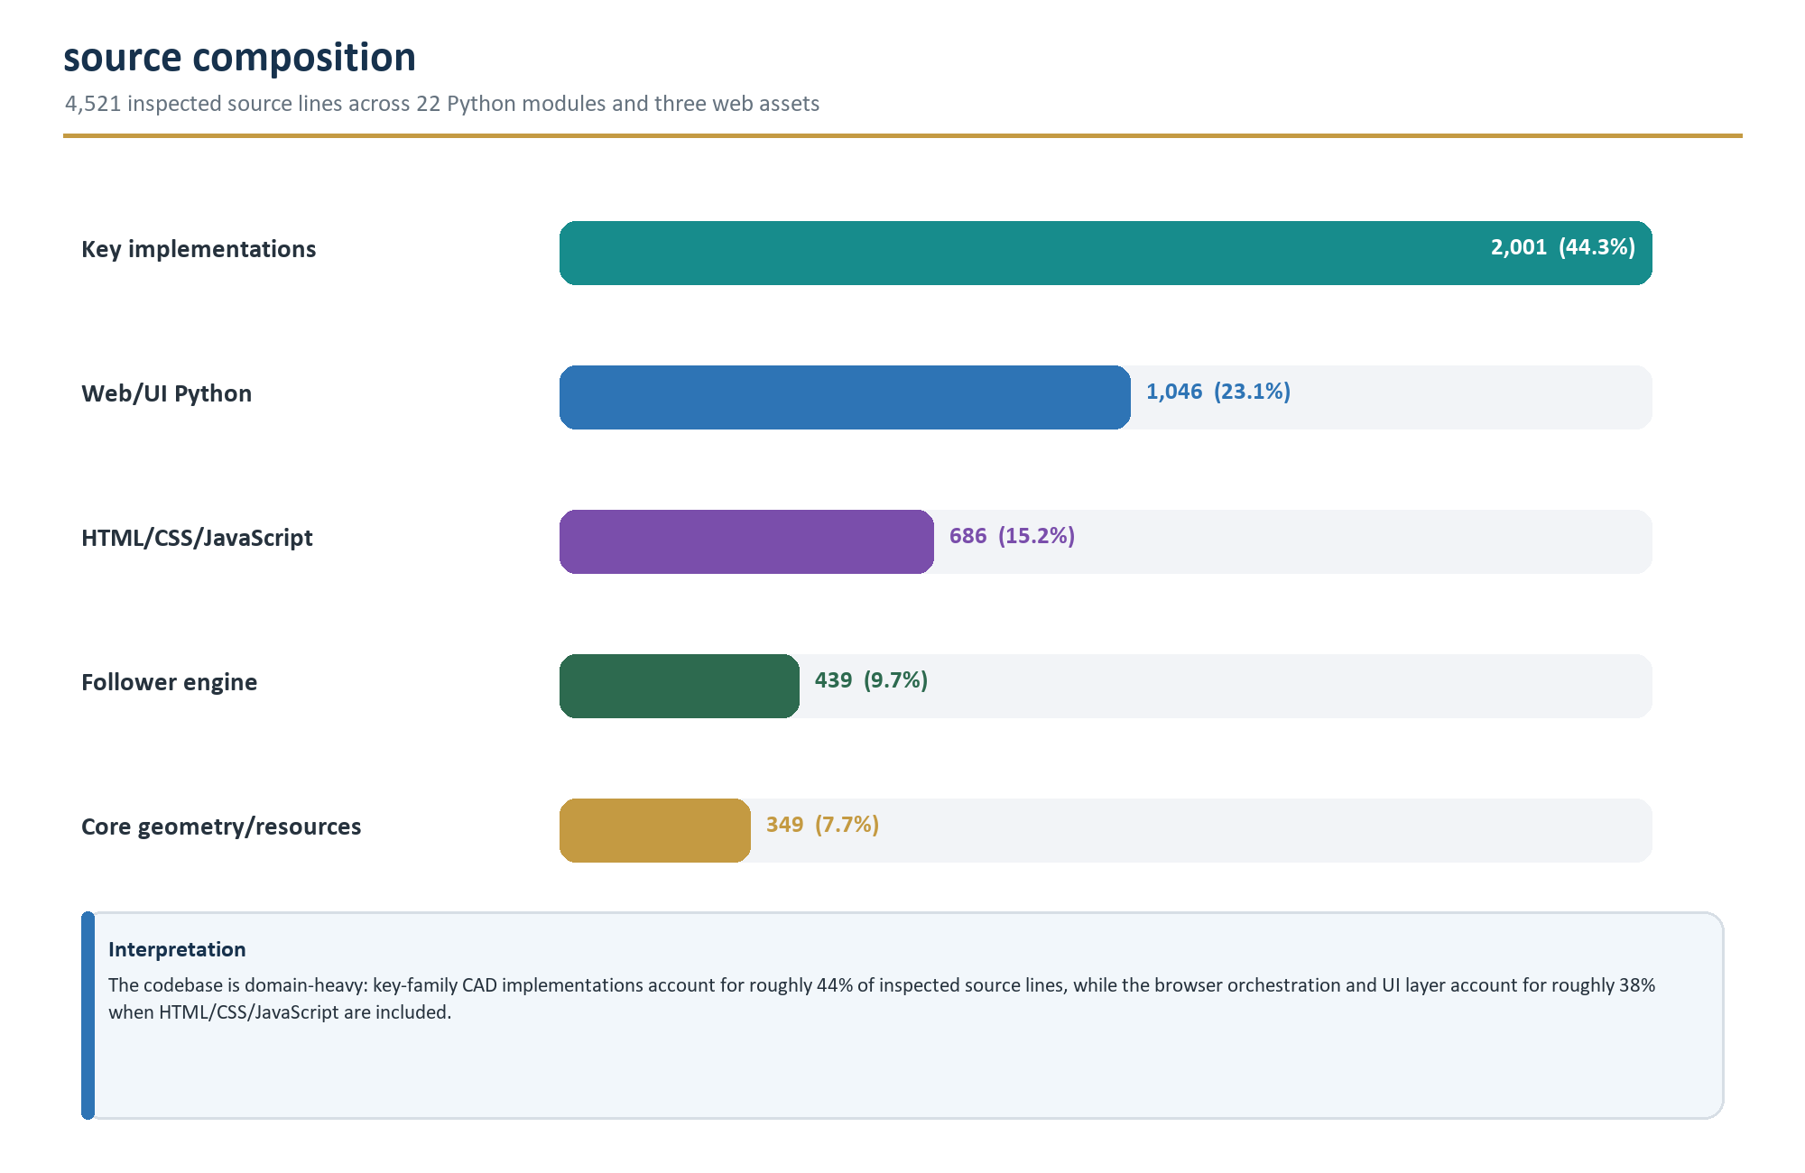
Figure 2. Inspected source-line composition. Counts include blank and comment lines so that the chart matches physical file size rather than executable statements.
Measure | Observed value | Interpretation
Tracked files | 53 | Small repository; all tracked files can be reviewed as one system.
Python modules | 22 | Includes two top-level browser entry scripts and 20 package modules.
Python lines | 3,835 | AST parsing succeeded under the documentation runtime; execution was not implied.
Web lines | 686 | index.html, main.css, and model_view.js.
Classes | 37 | Includes 10 Key subclasses, 9 FollowerEnd subclasses, web wrappers, and helper types.
Resource assets | 19 / 5,492,680 bytes | Eight SVG, seven STEP, three PNG, one STL.
Automated tests | 0 tracked | No test/test_* path was present.
CI workflows | 0 tracked | No .github/workflows files were present.

2.3 Technology stack
Layer | Technology / version | Role
Language | Python >=3.13,<3.15 | Domain model, validation, CAD generation, and browser control.
CAD | build123d 0.11.0 | Parametric boundary-representation modeling and STL/STEP/SVG export.
Browser Python | PyScript 2026.6.1 | Foreground interpreter, named Web Worker, DOM APIs, JS module bridge.
CAD runtime | Pyodide + OCP WASM wheels | Browser-compatible OpenCascade and lib3mf dependencies installed by worker.py.
3D view | Three.js 0.184.0 | STLLoader, PerspectiveCamera, OrbitControls, WebGL2 rendering.
UI | HTML5 + CSS | Native controls, Popover API dialogs, responsive flex layout, dark theme.
Development | ocp_vscode 3.4.0 (optional) | Interactive local CAD inspection for module __main__ examples.
Packaging | setuptools >=77.0.3 | Build backend; no console script entry point is declared.
License | AGPL-3.0 | Strong copyleft including source-availability obligations for network interaction.

2.4 Ownership map
Source area | Primary responsibility | Change impact
main.py | Foreground boot | Wait for worker, mock heavy CAD symbols, install typing extensions, call web_main.main().
worker.py | CAD worker API | Install WASM CAD dependencies, dispatch generators, export STL/STEP, return base64.
index.html | Application shell | DOM, PyScript/worker declarations, dialogs, inputs, preview canvas, CDN declarations.
model_view.js | 3D viewer | Three.js scene, WebGL2 check, camera/orbit controls, lighting, STL loading, disposal.
main.css | Presentation | Dark responsive layout, tabs, buttons, inputs, dialogs, loader, mobile breakpoint.
config.json | PyScript file map | Maps repository Python modules into /realkey for foreground and worker runtimes.
key.py | Domain contract | Abstract Key interface and import-time subclass registry.
key_cutters.py | Reusable cutters | Capped angled, smooth angled/MACS-aware, and lever cutter sketches.
geom_tools.py | Geometry utilities | Bounding extents, tube creation, and swept lifting-cut helper.
svgtools.py | SVG label helpers | Filter and normalize labeled wires/faces or groups around an origin.
resource_fetcher.py | Asset adapter | No-op on CPython; lazy same-origin fetch into Pyodide worker filesystem.
web_core.py | DOM abstraction | Typed wrappers for elements, selects, numeric lengths, options, and checkboxes.
tab.py | UI plug-in contract | Singleton-like tab base, query serialization, parameter loading, async generation.
tab_key.py | Key UI controller | Registry-driven selectors, bitting validation, worker request, presentation metadata.
tab_follower.py | Follower UI controller | Preset loading, dynamic end controls, unit-aware values, worker request.
web_main.py | Application coordinator | Initial state, routing, generation lifecycle, object URLs, downloads, shares.
follower.py | Follower domain/CAD | Preset data, end-type registry, end generators, cylindrical assembly and chamfers.
assa.py ... vsr.py | Key implementations | Ten registered key types, validation rules, blank sources, and CAD cuts.

2.5 Recent repository direction
The inspected history shows active work immediately before this snapshot: Schlage Everest insertion cleanup, West 917 follower updates, B-series keyways, an iNAHO follower, an upgrade to build123d 0.11.0 and PyScript 2026.6.1, VSR 2000 support, and share-link improvements. The design is evolving in both supported hardware and browser runtime infrastructure; regression tests and dependency reproducibility would therefore provide high leverage.

3. System architecture
realkey is a static web application with two Python execution contexts, a JavaScript rendering context, and a shared repository of measured geometry assets.

3.1 Runtime boundaries
Boundary | Owns | Must not own
Static host | HTML, CSS, JavaScript, Python source map, SVG/STEP/STL/PNG assets | CAD state, user accounts, generated model storage
Foreground PyScript | DOM state, selection, validation, query serialization, downloads | BRep construction or heavy CAD imports
Generation worker | Dependency installation, resource cache, build123d Parts, export files | DOM mutation or direct UI state
Three.js | STL decoding, mesh lifecycle, camera, controls, lighting, WebGL rendering | Authoritative CAD model or STEP export
User browser | Ephemeral files, Blob URLs, clipboard, downloaded artifacts | Durable server-side storage in this repo

3.2 Foreground lightweight-CAD strategy
main.py waits for the named keygen worker, provides it with the page base URL, and then places a deliberately incomplete module object into sys.modules['build123d']. Unit constants and geometry type names exist so that Key subclasses can be imported and their class-level metadata can be evaluated. Any real geometry operation is absent by design. This keeps selector population and validate_bitting() available without loading the OCP CAD stack twice.
Invariant Metadata methods and validation paths must remain free of build123d operations that require a real geometry implementation. blank() and key() are the intended heavy boundary.

3.3 Worker CAD environment
worker.py first registers mock packages to prevent incompatible non-WASM distributions from being pulled transitively. It then installs WASM-specific cadquery-ocp-novtk and lib3mf packages, cadquery_ocp_proxy, build123d 0.11.0, and typing-extensions. After installation it imports every Key implementation and follower.py, causing registry population. Export functions write fixed temporary filenames, read the results as bytes, base64-encode them, and return a dictionary to the foreground.
Foreground -> Worker request
generate_key(key_tag, profile, keyway, bitting)
generate_follower(length, diameter, top_tag, top_config, bottom_tag, bottom_config)
Worker -> Foreground success
{"stl": "<base64>", "step": "<base64>"}
Worker -> Foreground failure
{"error": "<exception text>"}

3.4 Registry-driven discovery
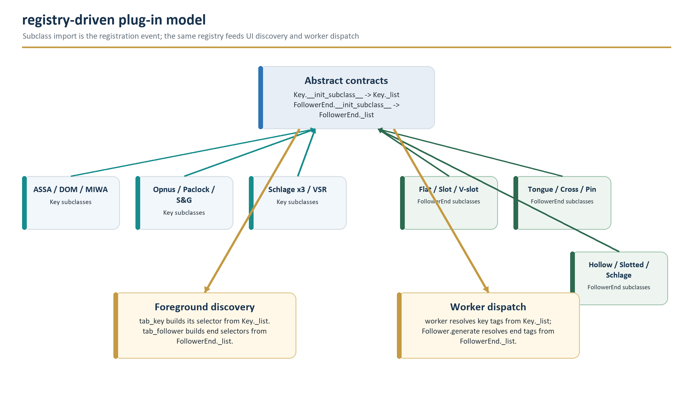
Figure 3. Key and FollowerEnd use import-time subclass registries. Both browser discovery and worker dispatch depend on complete, symmetric imports.
Key.__init_subclass__ stores each subclass in Key._list under cls.tag(). FollowerEnd does the same in FollowerEnd._list. This makes a unique, stable tag part of the public integration contract. Duplicate tags silently overwrite earlier entries, so uniqueness must be covered by tests or an explicit registration guard.

3.5 Architectural decisions and consequences
Decision | Benefit | Consequence / maintenance obligation
Browser-only heavy CAD | No model data must be sent to an application server; static hosting is sufficient. | Startup downloads and WebAssembly memory/CPU usage move to the client.
Two Python runtimes | UI remains light while the worker owns costly CAD imports. | Modules must be importable under both the mock and real build123d surfaces.
Import-time registries | Simple plug-in discovery and uniform dispatch. | A module missing from either import list or config.json is effectively absent.
Asset-assisted modeling | Measured SVG/STEP geometry avoids rebuilding every blank in code. | File paths and SVG labels become API-like contracts that require validation.
Base64 worker payloads | PyScript boundary receives plain serializable dictionaries. | Payload expansion and duplicate in-memory representations matter for large models.
STL preview, STEP download | Fast viewer path plus editable CAD output. | The preview is tessellated and cannot prove STEP/BRep fidelity.
Query-string sharing | Reproducible deep links without persistence service. | Potentially sensitive bitting/dimensions are exposed wherever URLs are recorded.

4. Runtime lifecycle and interactions
The application lifecycle is asynchronous at two critical points: worker dependency installation and Three.js STL loading. UI state is coordinated around those boundaries.

4.1 Startup sequence
- Static parse. index.html loads remote styles, PyScript, the Three.js module, foreground main.py, and a named keygen worker configured by config.json.
- WebGL gate. model_view.js stops with a visible error if WebGL2 is unavailable.
- Worker install. worker.py installs the CAD dependency chain and imports generator modules.
- Foreground handoff. main.py awaits workers['keygen'], sets the worker base URL, installs typing-extensions, installs the build123d mock, and imports web_main.
- UI construction. Importing web_main instantiates KeyTab and FollowerTab. Their module-level element wrappers bind to the existing DOM.
- Initial state. web_main.main removes the loader, loads resources/realkey.stl, and applies any query parameters.

4.2 Generation sequence
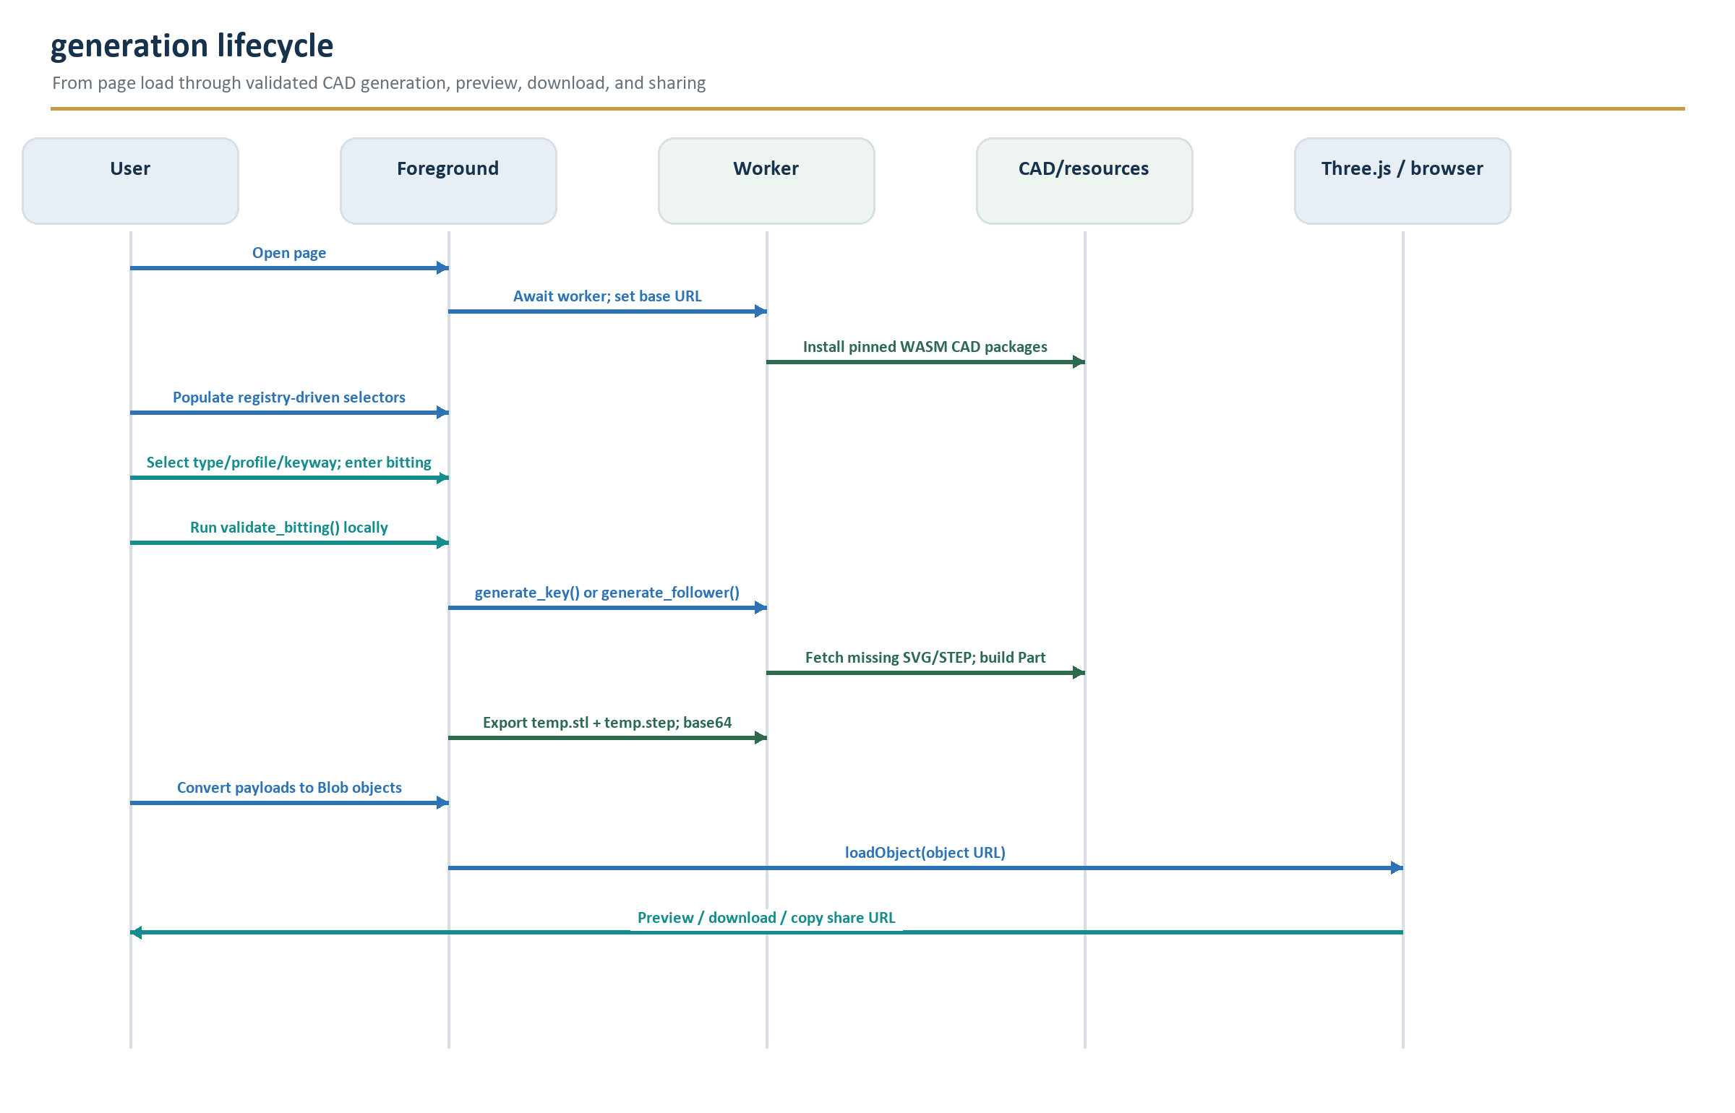
Figure 4. Production generation sequence. Validation occurs in the foreground before the same generator runs in the worker; worker exceptions are flattened into an error string.

4.3 Key-tab interaction
KeyTab populates its top-level selector from Key._list. A key change repopulates profile and keyway options from the selected class, installs basic and optional advanced bitting HTML, clears the previous bitting, and enables inputs. Empty bitting is valid and means blank generation. Non-empty bitting calls the selected class's validate_bitting() in the foreground; a raised exception disables Generate and is shown in the information area.
On Generate, KeyTab calls the worker with the selected tag/profile/keyway/bitting. It augments a successful worker dictionary with a human-readable description and brass-like material parameters (roughness 0.25, metalness 0.95).

4.4 Follower-tab interaction
FollowerTab creates length controls that can display millimeters or inches while returning millimeters to the domain. Selecting a named preset fills length, diameter, top/bottom end tags, and end-specific dimensions. Any manual change switches the preset selector to Custom. Dynamic end controls are generated from FollowerEnd.config(); non-empty configurations also receive a rotation input.
Generation sends numeric values and two configuration dictionaries to the worker. The response is decorated with a descriptive name, high-metalness silver presentation settings, and then follows the same preview/download path as a key.

4.5 Result handling
Stage | Data representation | Lifecycle
Worker export | temp.stl and temp.step | Created in the worker filesystem for each generation; read immediately.
Worker response | Base64 strings | Structured-clone-friendly but ~33% larger than binary.
Foreground decode | Uint8Array-like bytes via to_js | Wrapped in Blob objects with model/stl and model/step MIME types.
Preview | Blob object URL | Passed to asynchronous STLLoader; should remain valid until loading completes.
Download | New object URL | Attached to a synthetic anchor with a description-derived filename, clicked, then revoked.
Share | URL query parameters | Copied to clipboard; settings and auto-generation are opt-in checkboxes, checked by default.

4.6 Error propagation
Worker entry functions catch broad Exception values and return their text under an error key. The foreground treats that key as a generation failure and re-enables Generate. This gives users direct CAD/validation diagnostics but loses structured error types and stack context. Follower errors include the exception class name; key errors do not. A future error contract should add a stable code, user-safe message, diagnostic detail, and retryability flag.

5. Core domain model and geometry services
The domain model separates descriptive metadata and validation from heavy geometry. Shared cutters and resource adapters reduce duplication across lock families.

5.1 Key taxonomy
Term | Repository meaning | Example
Type | A lock/key family implemented by one registered Key subclass. | Schlage Everest Primus
Profile | Overall blank/blade shape, often linked to pin count or control-key form. | e29p_ctrl
Keyway | Cross-sectional warding geometry inserted into the lock. | s123
Bitting | Family-specific compact code describing cut depth/position, sometimes multiple sides/rows. | 326163 23645
Blank | Profile + keyway with no bitting cuts. | Empty bitting requests blank()
Cut key | Blank after family-specific subtractive operations. | key(profile, keyway, bitting)

5.2 Key abstract interface
Method | Foreground-safe? | Contract
tag() | Yes | Unique stable snake_case registry key and worker dispatch identifier.
display_name() | Yes | Human-readable family name used in the selector.
profiles() | Yes | Nested group -> tag -> label mapping for optgroups and options.
keyways() | Yes | Nested group -> tag -> label mapping for keyway selection.
basic_bitting_definition() | Yes | Short trusted HTML displayed beside the input.
advanced_bitting_definition() | Yes | Optional long trusted HTML shown in a popover.
validate_bitting(profile,keyway,bitting) | Yes | Raise an explanatory exception for invalid input; return normally when accepted.
blank(profile,keyway) | Worker only | Return a build123d Part for the uncut blank.
key(profile,keyway,bitting) | Worker only | Validate, obtain blank, apply cuts, return a build123d Part.

5.3 Reusable key cutters

angled_cutter
Builds one closed 2D cutter face per requested cut. Each face has a flat root and two ramps derived from half the included angle. When the theoretical ramp span exceeds max_cutter_width, the cutter adds capped vertical segments so that it remains inside the allowed region. This cutter can undercut between independent cuts.

smooth_angled_cutter
Builds a single continuous outline through ordered cut centers. It preserves the root width, places transitions between adjacent centers, recognizes exact MACS-like spans, and raises when the required slope cannot fit. A neutral entry/exit closes the profile. This is the main reusable top-edge cutter for DOM, MIWA, and Schlage.

lever_cutter
Builds rectangular cutouts from center X, depth Y, and width. S&G adds throat and optional guard-tip entries to the same list before extruding the sketch through the blank.

5.4 Geometry helpers
Helper | Purpose | Consumers
geom_tools.min/center/max | Aggregate bounding-box values across a ShapeList. | SVG group normalization; max is currently unused in tracked source.
geom_tools.Tube | Create an annular cylinder by subtracting two concentric circles and extruding both directions. | Follower end creation and end chamfer tools.
generate_lifting_cut | Sweep a face along a vector that combines forward displacement and lift. | Currently no tracked call site.
svgtools.get_filtered | Select the first imported shape whose label exactly matches a requested label. | All SVG-backed key families.
get_*_starting_at_origin | Translate a shape/group so its minimum bounding corner is the origin. | Blank profile construction.
get_*_centered_around_origin | Translate a shape/group around its aggregate center. | Keyway and decorative element placement.

5.5 Cross-runtime resource adapter
resource_fetcher.pre_fetch_resource() returns immediately on non-Emscripten Python. In the Pyodide worker it requires a base URL, checks whether the path is already present, creates parent directories, requests the same-origin resource, writes the response into the worker filesystem, and returns success/failure. Generator code can therefore use ordinary relative paths with import_svg() or import_step() in both environments.

5.6 Key-family strategy map
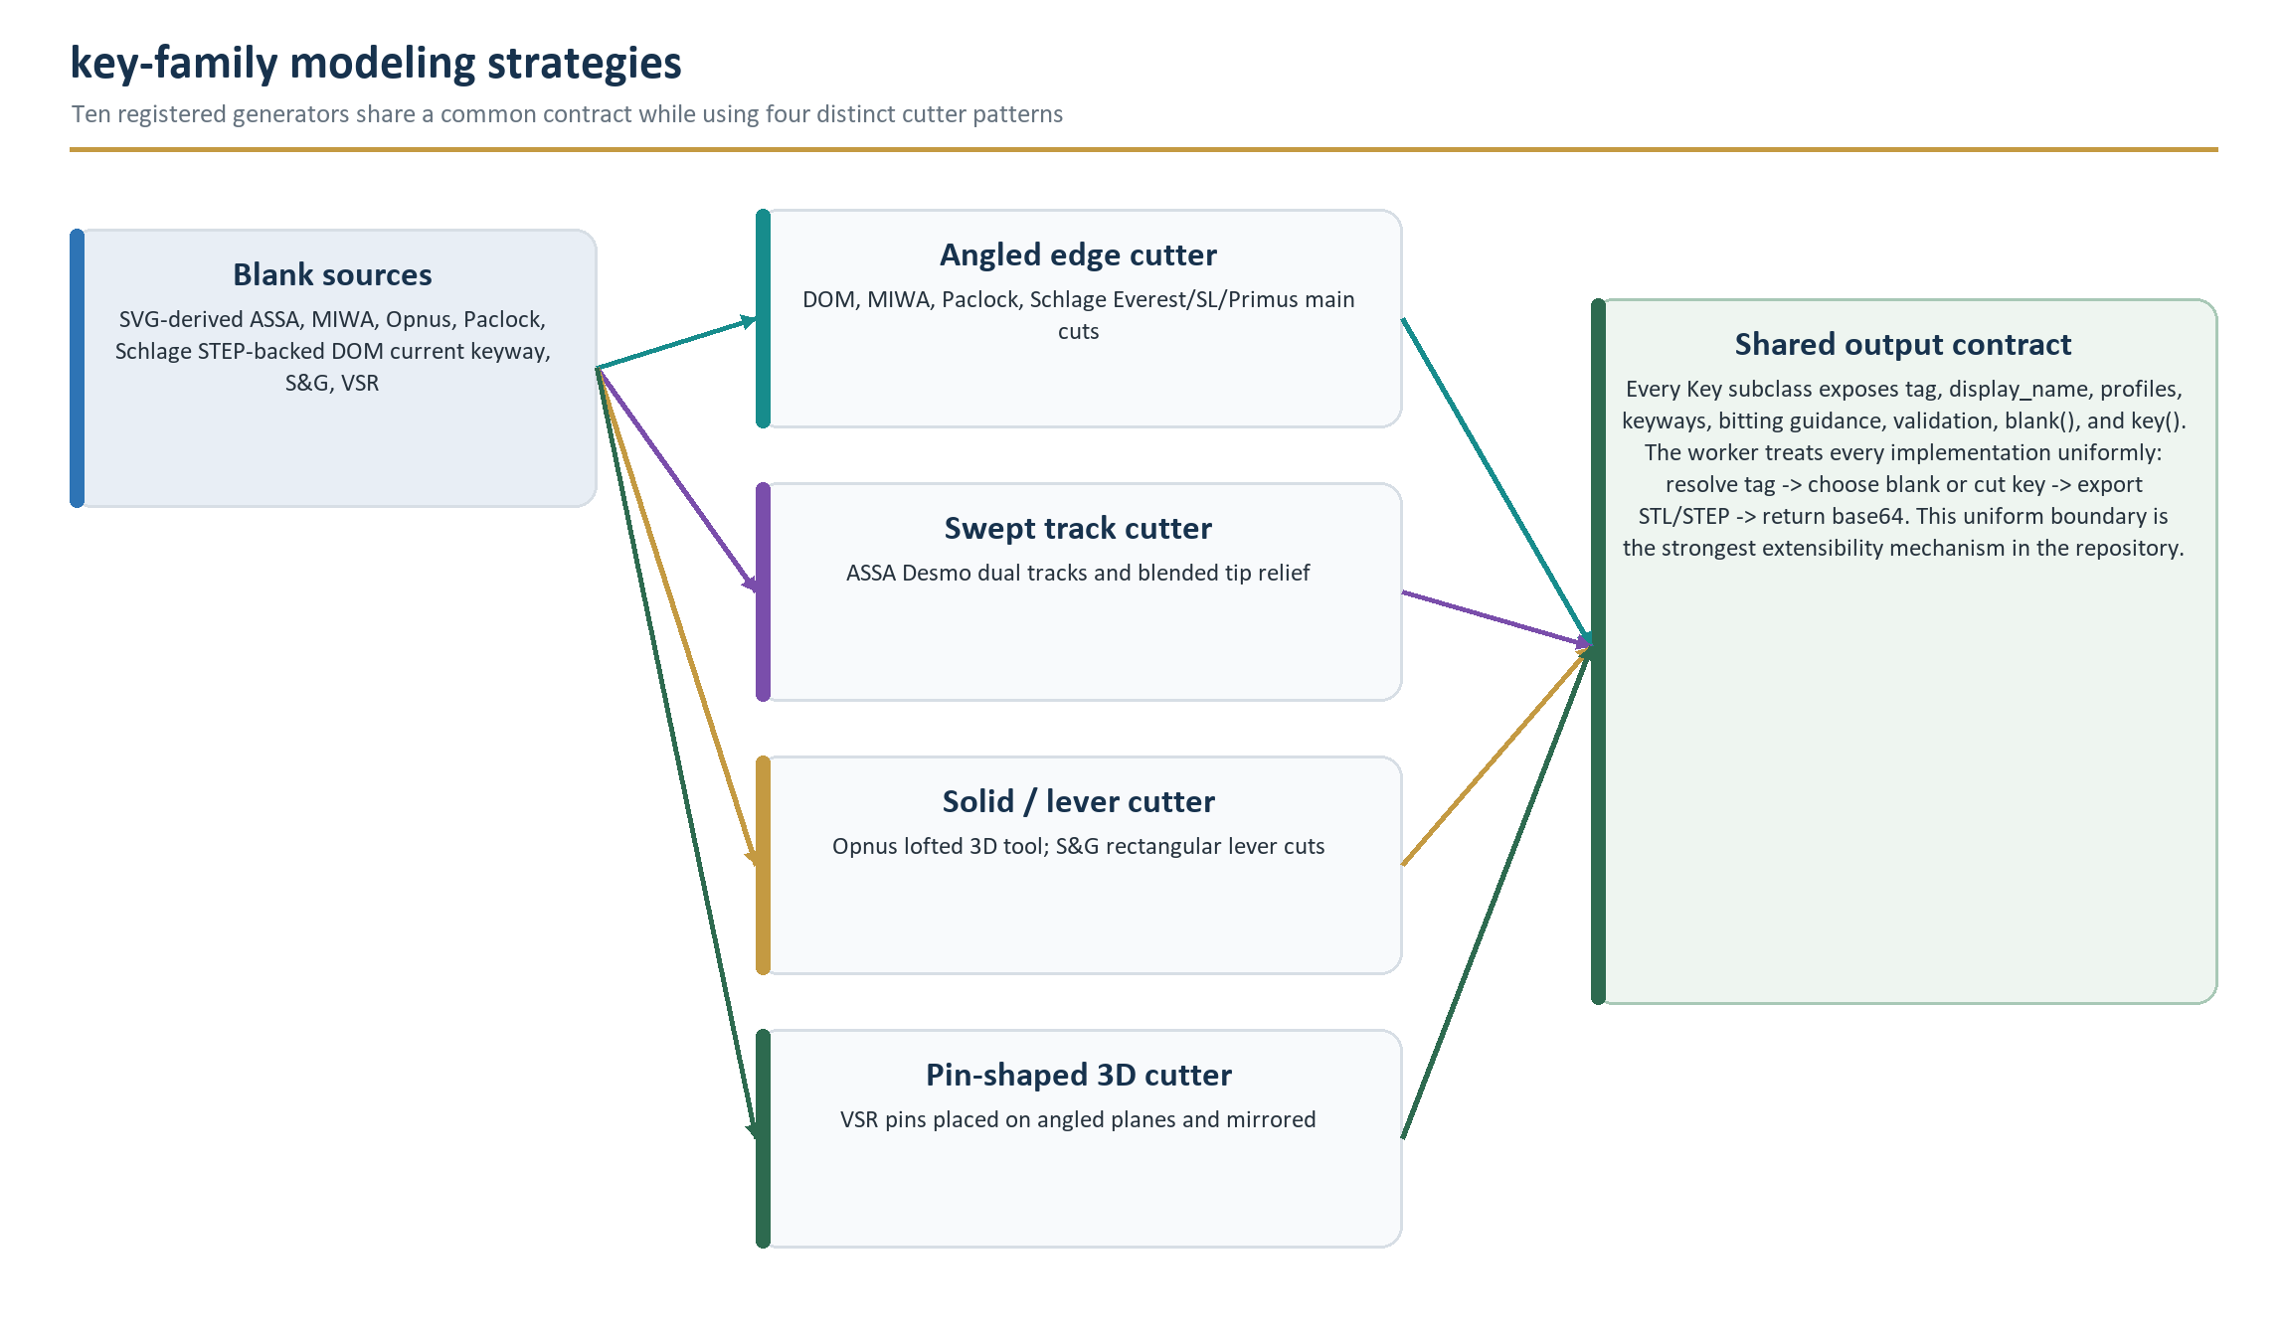
Figure 5. Blank construction and cutter strategy vary by family, but every generator is normalized by the Key contract and worker export path.

6. Supported key systems
The snapshot registers ten Key subclasses spanning edge-cut, dual-track, side-cut, lever, sidebar, and multi-row pin geometries.

6.1 Catalog summary
System | Registry tag | Profiles | Accepted bitting form | Blank source
ASSA Desmo | assa_desmo | 6-, 8-, 10-pin | Even count, up to profile limit; 1-6; right side then left, bow to tip | Labeled SVG profile + keyway extrusion/cut
DOM System D | dom_system_d | Basic | Even count, up to 10; 1-5; right side then left, bow to tip | STEP blank for current keyway; SVG construction path retained for alternatives
MIWA SR | miwa_sr | 10-cut | Up to 10; 0-3; bow to tip; physical spacing skips one inactive position | Labeled SVG profile + offset keyway clearance
Opnus Memolis | opnus_memolis | Operator, change | Up to 14; 0-5; right side then left, bow to tip | Labeled SVG profile, mirrored keyway, and finishing chamfers
Paclock PR1 | paclock_pr1 | PR1 6-pin, PRO 7-pin | Up to 6 or 7 by profile; 1-6; bow to tip | Labeled SVG profile + programmatically rounded keyway
S&G Safe Deposit Box | sg_sdb | Renter: 60, 96, 96 7-cut; Guard: 87H, 87H 7-cut, 9609, SY3B | 5-7 positions by profile; 0-7; tip to bow | Profile-specific STEP models
Schlage Everest | schlage_everest | Everest/29: 6-pin and control | Up to 6; 0-9; bow to tip | SVG profile + programmatic family/species notch keyway
Schlage Everest SL/SFIC | schlage_everest_sl | Everest SL/29SL: 7-pin and control | Up to 7; 0-9; tip to bow | Shared Everest SVG/programmatic keyway blank service
Schlage Everest Primus | schlage_everest_primus | Everest/29 Primus: 6-pin and control | Main: up to 6, 0-9; sidebar: up to 5, 1-7; groups separated by space | Shared Everest blank with Primus sidebar material retained
VSR 2000 | vsr_2000 | 1 | Three groups: right <=6, top <=3, left <=5; accepted range 1-5 | STEP model with programmatic tip relief

Blank convention The production worker calls blank() whenever the bitting string is empty. Per-family validate_bitting() is bypassed for that path.

6.2 ASSA Desmo
Property | Value
Implementation | src/realkey/assa.py :: Desmo
Registry / display | assa_desmo / ASSA Desmo
Profiles / keyway | 6pin, 8pin, 10pin / desmo
Bitting | Even-length numeric string; profile maximum 6/8/10; digits 1-6; right side then left
Primary asset | resources/ASSA/Desmo.svg

Blank pipeline
The SVG is imported with Inkscape labels. A profile face such as #profile_desmo_8pin is translated to the origin and extruded to a 3 mm width. The centered #keyway_desmo face is rotated and used inside a rectangular YZ cutter at the key datum, removing all material that is not the intended keyway along the blade.

Cut algorithm
The input is split into equal right and left strings. Ten possible cut spacings are 3.5 mm apart after a 4.5 mm offset; six track levels use 0.5 mm increments. Each side becomes an 18-point track, with a deliberately skipped retention location and special points inserted around that location. Missing trailing positions repeat the final height toward the tip.
build_track() places enlarged pin-shaped sections and sweeps them through straight or height-changing segments. Sloped segments compensate top and bottom pin paths to maximize printable clearance. The two tracks are subtracted at opposite Z offsets, and tip edges are swept toward the last track height to provide a continuous entry.
Manufacturing intent DESMO_TRACK_TOLERANCE enlarges the nominal 3 mm track by 0.75 mm. The comments explicitly prioritize a printable, working ramp envelope over a visually exact factory track.

6.3 DOM System D
Property | Value
Implementation | src/realkey/dom.py :: SystemD
Registry / display | dom_system_d / DOM System D
Profile / keyway | basic / 1
Bitting | Even-length numeric string up to 10 digits; 1-5; right side then left
Primary assets | SystemD_B1.step is used for keyway 1; SystemD.svg supports a retained construction path

Blank pipeline
The currently exposed keyway loads a pre-modeled STEP blank. The alternate code path demonstrates a fully constructed blank: split SVG profile, separate bow/blade extrusions, bow insets, raised branding, SVG keyway subtraction, and staged tip extrusions. That path is not selected by the only current keyway tag but remains useful design documentation.

Cut algorithm
Right and left halves use different staggered starting offsets: 7.25 mm and 5.0 mm, both on 4 mm centers. Five depth values range from 0.375 to 2.25 mm. Each half is converted to a smooth 90-degree cutter, extended with repeated final-height positions, and extruded from the blade centerline in opposite Z directions.
Input assumption calculate_cuts() indexes the last cut while extending a side. Empty bitting is routed to blank(), but any future grammar that permits an empty half should add an explicit guard.

6.4 MIWA SR
Property | Value
Implementation | src/realkey/miwa.py :: SR
Registry / display | miwa_sr / MIWA SR
Profile / keyway | 10cut / sr
Bitting | Numeric string up to 10 digits; values 0-3; bow to tip
Primary assets | SR.svg, SR_Key_Decode.png, SR_Lock_Decode.png

Blank pipeline
The labeled SR profile is extruded to 2 mm. The keyway face is centered, shifted by 1 mm, offset inward by 0.125 mm, and subtracted through the blade. This creates deliberate clearance around the imported keyway geometry.

Cut algorithm
Logical cuts use four depths: 0, 0.625, 1.575, and 2.0 mm. Physical positions are on 2.25 mm centers after 5.5 mm. Position index 8 is inserted as an uncut/blank station, so later logical digits advance one extra physical spacing. A continuous 120-degree cutter is built from the requested points, mirrored around the blade centerline, and extruded through both sides.
advanced_bitting_definition() embeds measurement tables and the two repository PNGs to explain keyed and keyless decoding. The advanced copy says the inactive station follows the eighth logical bitting; the generation code explicitly inserts that station.
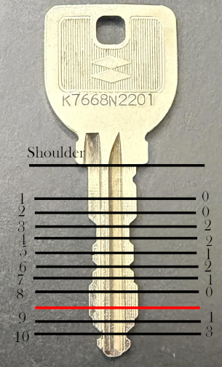
Figure 6. Repository reference image used by the MIWA SR advanced bitting help. The red line marks the inactive physical station that is skipped by the logical bitting sequence.

6.5 Opnus Memolis
Property | Value
Implementation | src/realkey/opnus.py :: Memolis
Registry / display | opnus_memolis / Opnus Memolis
Profiles / keyway | memolis operator, memolis_change / memolis
Bitting | Numeric string up to 14 digits; values 0-5; split into right and left halves
Primary asset | resources/Opnus/Memolis.svg

Blank pipeline
The selected SVG profile is extruded to 3.25 mm, while the keyway is centered and mirrored before being removed along the blade. Tip, secondary, and bitting-surface chamfers are then applied to create the intended insertion and cutting faces.

Cut algorithm
Seven positions per side use 3.75 mm spacing with a 1.875 mm stagger between sides. Six depths advance by 0.35 mm. key_cutter() combines a rounded base, trapezoidal side, lofted transition, and top overcut into a three-dimensional tool. Each depth translates that tool before a +/-45-degree placement; two mirror planes create the opposite face. Right and left tool compounds are subtracted from the blank.
Observed validation gap The generator splits the string into two halves but validate_bitting() does not require an even length. The intended 7+7 grammar should be confirmed and covered by tests before tightening validation.

6.6 Paclock PR1 / PRO
Property | Value
Implementation | src/realkey/paclock.py :: PR1
Registry / display | paclock_pr1 / Paclock PR1
Profiles / keyway | pr1 6-pin, pro 7-pin / pr1
Bitting | Numeric; max 6 for PR1 or 7 for PRO; digits 1-6; bow to tip
Primary asset | resources/Paclock/PR1.svg

Blank pipeline
The selected labeled profile is directly extruded to 2 mm. The keyway shape is centered, its two outer vertex groups are filleted, and the result is rotated. Subtracting the keyway from a surrounding rectangle produces a robust cutter that removes the inverse cross-section through the blade.

Cut algorithm
Positions begin 0.145 inches past the datum on 0.1375-inch centers. Six stored root distances are measured in inches. A generic 90-degree angled cutter with a 0.065-inch root and a 0.25-inch width cap is extruded through the blank.

6.7 Sargent & Greenleaf safe-deposit-box keys
Group | Profiles | Positions
Renter | 60; 96; 96 7-Cut | 6; 6; 7
Guard | 87H; 87H 7-Cut; 9609; SY3B | 5; 7; 5; 5

All profiles use the lever keyway tag and accept depth digits 0-7. The bitting order is tip to bow, unlike most edge-cut families in the repository. Profile-specific dictionaries supply spacing, width, depth, blank width, X/Y datum, throat location/depth/width, and (for guard keys) tip relief.

Blank and cutting pipeline
Each profile maps to one of five STEP assets; 96/96_7cut and 87h/87h_7cut share blank files. For every digit, the generator computes an X position by subtracting profile spacing from the datum and a Y position by adding profile depth. A throat rectangle is always appended. Guard profiles append a wide tip snip. The combined lever_cutter sketch is extruded through twice the profile key width.

Embedded domain documentation
advanced_bitting_definition() contains a lock-series cross-reference table and a list of common guard bittings, including one explicitly marked suspect. That content is operational knowledge, not validated CAD input; it should retain provenance if expanded.
Observed error-path issue When reporting an over-length bitting, validate_bitting() attempts cls.profiles()[profile]. profiles() is grouped under Renter/Guard, so that expression does not address the nested profile tag. A targeted test should verify that the intended ValueError message is reachable.

6.8 Schlage Everest family
schlage.py contains a shared programmatic keyway builder, a shared blank builder, and three registered generators. It is the largest module in the repository (609 lines) and the densest reuse point among key families.

Programmatic keyways
A keyway tag combines a family letter and a three-digit species. The species maps to a subset of five notch rules. A family SVG base face is loaded, the applicable notch polygons are subtracted, and the completed face is centered. Six family methods exist (B, C, D, R, S, T), each exposing the same 16 species: 000, 100, 200, 150, 120, 230, 134, 145, 135, 125, 124, 123, 234, 235, 245, and 345.
Surface area Current registered generators expose C/S for Everest and Primus, and B/R for SL/SFIC. D/T catalog methods are implemented but not returned by the active Key.keyways() methods.

Shared blank construction
EverestBlank maps semantic profiles to one of eight labeled SVG profile paths, selects the standard or SL datum/height, extrudes a 2.75 mm blank, subtracts the programmatic keyway, and creates a sidebar ramp. Non-Primus profiles also receive a sidebar cutout; Primus profiles retain material for sidebar bitting.

Schlage Everest
Property | Value
Tag / profiles | schlage_everest / Everest and Everest 29, each 6-pin or control
Keyways | C-series for Everest; S-series for Everest 29
Bitting | Up to 6 digits, 0-9, bow to tip
Cutter | 100-degree smooth cutter; roots 0.335 in - 0.015 in x depth; 0.231 in + 0.1562 in x position

The final requested cut is duplicated 10 mm farther toward the tip. This ghost cut trims a trailing steeple before the cutter is extruded through the blade.

Schlage Everest SL/SFIC
Property | Value
Tag / profiles | schlage_everest_sl / Everest SL and 29SL, each 7-pin or control
Keyways | B-series for SL; R-series for 29SL
Bitting | Up to 7 digits, 0-9, tip to bow
Cutter | 90-degree smooth cutter; 0.056 in root with SL-specific reverse spacing/depth tables

Schlage Everest Primus
Property | Value
Tag / profiles | schlage_everest_primus / Everest and Everest 29 Primus, 6-pin or control
Keyways | C-series for Everest Primus; S-series for Everest 29 Primus
Bitting | '<main> <sidebar>'; main <=6 digits 0-9; sidebar <=5 digits 1-7
Cutters | Shared 100-degree main cutter plus a shallower independent sidebar cutter

Five sidebar positions sit between adjacent main-cut positions. Seven sidebar codes select precomputed X offsets and root depths. The main cutter crosses the full blade; the sidebar cutter removes only the configured sidebar width.

6.9 VSR 2000
Property | Value
Implementation | src/realkey/vsr.py :: _2000
Registry / display | vsr_2000 / VSR 2000
Profile / keyway | 1 / 1
Bitting | '<right> <top> <left>'; max lengths 6/3/5; accepted digits 1-5
Primary asset | resources/VSR/2000-1-1.step

Blank pipeline
A STEP blank is imported, then a polygonal cutter on the XZ plane removes material near the maximum X coordinate to create tip relief. The unused VSR SVG is retained in resources but is not read by the current blank implementation.

Cut algorithm
Instead of using 2D edge profiles, the generator builds an intentionally widened physical pin model: tapered shaft, cylindrical section, and depth-dependent head height. Right and left rows place those tools on planes rotated around the core center at +/-65 degrees. The top row uses a -90-degree plane, skips one physical station, and adds an unsprung passive top cut on a separate plane. Multiple mirrors reproduce opposite key faces and warding relationships.
Observed rule divergence The advanced help says side rows support depths 2-5 and the active top row appears to use 1 and 3, but validate_bitting() currently accepts 1-5 for every group. Preserve current behavior in documentation, then decide whether code or explanatory text should change after fixture tests.

6.10 Cross-family validation behavior
Every implementation enforces numeric ranges and a maximum length, but exact-length, profile membership, keyway membership, side-balance, and family-specific mechanical restrictions are not uniformly enforced. The UI constrains profile/keyway tags through selectors, but worker functions are callable by tag and should not assume only UI-originated requests if they become a public API.
Rule | Families enforcing it | Notable exceptions
Profile-dependent max length | ASSA, Paclock, S&G | Others use one global maximum or grouped syntax.
Even number of side cuts | ASSA, DOM | Opnus splits halves without an even-length check.
Multi-group delimiter | Schlage Primus, VSR | Both depend on whitespace-separated groups.
Exact physical restrictions | Partly encoded by geometry | VSR explanatory restrictions are not validated.
Profile/keyway tag membership | Implicit through asset/dictionary lookup | No common upfront contract validation.

7. Plug follower generator
Follower generation is a second plug-in domain: a central cylindrical body is composed with independently selected top and bottom end generators.

7.1 Domain schema
FollowerConfigData(
length: float, # total length in millimeters
diameter: float, # outside diameter in millimeters
top_tag: str,
top_config: dict[str,float],
bottom_tag: str,
bottom_config: dict[str,float],
)
FollowerEnd.generate() receives the overall length and diameter plus its configuration, and returns (optional Part, axial length consumed). FlatEnd returns no part and zero length. Every other end returns a part aligned to its local Z axis and the amount that must be subtracted from the central body length.

7.2 Preset catalog
Preset | Length | Diameter | Top | Bottom
Custom | User supplied | User supplied | Any registered end | Any registered end
iNAHO Tierkey Short | 50 mm | 9.45 mm | Tongue | Pin slot
Kaba Ace | 50 mm | 9.95 mm | Cross | Pin slot
Keso 2000S | 50 mm | 10.95 mm | Tongue | Pin slot
Schlage | 70 mm | 0.495 in | Schlage | Slot
West 917 | 60 mm | 11.95 mm | Tongue | Pin slot
Generic 10mm | 70 mm | 10 mm | Slot | Flat
Generic 12.5mm | 70 mm | 12.5 mm | Slot | Flat
Generic 12.7mm | 70 mm | 12.7 mm | Slot | Flat
Generic 12.8mm | 70 mm | 12.8 mm | Slot | Flat
Generic 14mm | 70 mm | 14 mm | Slot | Flat

Preset configuration dictionaries contain end dimensions but do not include rotation. The browser UI creates a rotation control and sends that value along with dimensional fields. Direct library callers should add rotation for any non-empty end configuration until the domain model supplies a default.

7.3 End-type catalog
Tag | Display | Configuration keys | Geometry
flat_end | Flat End | None | No added part; base cylinder receives a chamfer
slot | Slot | depth, width, rotation | Rounded slot subtracted from a cylindrical end
v_slot | V Slot | depth, width, rotation | Three-circle hull forms a V-shaped subtractive opening
tongue | Tongue | depth, width, rotation | Rectangular tongue outside the follower tube profile
cross | Cross | depth, X width, Y width, rotation | Orthogonal box union clipped by the follower tube
pin_slot | Pin Slot | depth, width, rotation | Axial slot with partial-depth relief and filleted edge
hollow | Hollow | depth, wall thickness, rotation | Annular tube extension
slotted_hollow | Slotted Hollow | depth, wall thickness, slot width, rotation | Tube extension with axial slot
schlage | Schlage | None | Fixed annular, lobed Schlage-specific end geometry

7.4 Assembly algorithm
- Resolve ends. Look up top_tag and bottom_tag in FollowerEnd._list.
- Generate ends. Call each generator and collect optional Part plus consumed length.
- Calculate body. remaining_length = total length - top length - bottom length; radius = diameter / 2.
- Place top. Translate the top part above the central cylinder and rotate around Z when its configuration is non-empty.
- Place bottom. Rotate 180 degrees around X, translate below the central cylinder, then apply optional Z rotation.
- Build body. Create the remaining central cylinder and union present ends.
- Blend transitions. Use annular subtractive tools and chamfers at generated ends; use a direct edge chamfer for flat ends.
- Return. Raise if no Part was created; otherwise return the complete build123d Part.

7.5 Browser configuration behavior
Each end change destroys and rebuilds the corresponding dynamic control container. Every configured dimension is rendered through LengthInputElement, so the displayed unit can change without changing the millimeter value sent to the worker. Rotation is a plain floating-point input in degrees. Any dimension or end change marks the preset Custom. Query serialization uses names such as slot_depth-ig-top and rotation-ig-bottom.

7.6 Follower-specific validation gaps
Observed condition | Why it matters | Recommended test or guard
run_validation() unconditionally enables Generate | Negative, zero, or inconsistent dimensions are not rejected by the tab controller. | Validate total length, diameter, every end dimension, and finite numeric values.
remaining_length has no positive guard | Ends can consume more than the total length and cause invalid CAD operations. | Require remaining_length > a documented minimum before Cylinder().
rotation is assumed when config is non-empty | Direct use of FOLLOWER_DEFINITIONS can lack the key even though browser requests include it. | Use config_data.get('rotation',0.0) and test direct preset generation.
chamfer_amount is multiplied during assembly | When both generated ends exist, the later branch can receive a different value. | Test symmetric ends and decide whether both transitions should use the same base chamfer.
Worker checks generate_follower, not generated_follower, for None | The intended postcondition check references the function object and is dead. | Correct the variable and add a worker error-contract test.

8. Browser application and user experience
The browser layer is thin but stateful: HTML declares the interaction surface, Python controllers own state and validation, and JavaScript owns only the 3D scene.

8.1 Application shell
Region | Primary DOM IDs | Responsibility
Loader | loader, status | Covers the page until foreground and worker initialization complete; shows WebGL/package status.
Header | header, share-dialog, about-dialog | Project identity, sharing controls, about/printing guidance.
Tab selector | key-tab-button, follower-tab-button | Switches between key and follower controllers.
Key inputs | key-select, profile-select, keyway-select, bitting | Registry selection, validation, basic/advanced instructions.
Follower inputs | follower-*, follower-top-div, follower-bottom-div | Preset, units, ends, rotations, dynamic dimensions.
Actions | generate, save-stl, save-step | Start worker call and download generated artifacts.
Viewer | canvas, model-description, model-generating | Render default/generated STL and show current lifecycle state.

8.2 Python DOM abstraction
web_core.py wraps PyScript ElementCollection objects to make application code read like a small UI framework. Element standardizes enabled/hidden/active and innerHTML. StringValueElement and FloatValueElement expose values; OptionElement and OptionElementList normalize selection; SelectElement supports optgroups and tag-based selection; CheckboxElement abstracts checked state.

LengthInputElement
A LengthInputElement replaces its host span with a text input plus unit selector. The canonical value is millimeters. Millimeter display uses three decimals; inch display uses five. A regular-expression pattern and custom validity message constrain non-negative decimal input. The unit-change handler converts the displayed value and then validates it.
Observed integration risk unit_change() compares OptionElementList.selected (a wrapper) with self._mm/self._inch (raw PyScript elements). Unless wrapper equality delegates to the underlying element, neither conversion branch will run. This requires a browser-level unit-toggle test; static review alone cannot prove the bridge's equality behavior.

8.3 Tab state model
Tab implements a singleton-like __new__ per subclass, pairs one button with one content region, and uses CSS classes to express active/hidden state. _populate_param() provides fail-soft query loading: malformed or missing values do not crash the entire route, although exceptions are deliberately swallowed and no diagnostic is recorded.
Observed fallback issue web_main.get_selected_tab() falls back to tabs['keys'] even though the dictionary keys are 'key' and 'follower'. Normal UI state should always have one tab selected, but the fallback path should still be corrected and tested.

8.4 Three.js rendering
model_view.js creates a PerspectiveCamera, WebGLRenderer with antialiasing, OrbitControls with damping and auto-rotation, ambient light, and ten directional lights distributed on a spherical lattice. Shadows use PCFSoftShadowMap. Resize handling recalculates aspect, renderer size, and device-pixel-ratio backing dimensions.
loadObject() removes and disposes the previous geometry/material, awaits STLLoader.loadAsync(), computes a bounding box, translates the mesh to center X/Y, rotates it -90 degrees around Z, enables shadows, and places the camera at 75% of the bounding-box diagonal. The current implementation does not reset OrbitControls target/state between differently shaped models.
Asynchronous lifecycle risk web_main.start_generation() calls model_view.loadObject(stl_url) without awaiting its Promise and then immediately revokes stl_url. Browsers often retain in-flight Blob data, but this ordering can race STLLoader. Await the load or revoke in a completion/finally callback.

8.5 Presentation and responsive behavior
main.css implements a dark Alexandria-font interface with blue Generate, red download, and icon-style information controls. The desktop main region uses a 1:2 input/view flex ratio. At 768 px or below it switches to a single column. The canvas has a 30 em minimum height, the page body is capped at 75 em, and dialogs are capped and scrollable.

8.6 Accessibility review
Area | Current evidence | Recommended improvement
Document language | html lang='en' and viewport metadata are present. | Retain during template changes.
Inputs | Most primary inputs have visible labels and for/id associations. | Fix share-dialog labels that point to share-values rather than the actual checkbox IDs.
Icon buttons | title attributes provide hover text. | Add aria-label; do not rely on title alone.
Follower tab icon | img has no alt text. | Use alt='' when decorative or meaningful alt text when informative.
Status | Generation/loading text is updated visually. | Add aria-live regions for status and error messages.
Canvas | Interaction instructions are visible. | Provide an accessible textual model summary and download-first alternative.
Color | Errors and disabled states use color changes. | Verify contrast and add non-color indicators where state is important.
Keyboard/dialogs | Native buttons, selects, and popover-enabled dialogs are used. | Test focus entry/return, Escape behavior, and tab containment across target browsers.

9. Assets and resource pipeline
Asset paths, SVG labels, and coordinate conventions are executable contracts: a rename or label drift can break model generation even when Python source remains unchanged.

9.1 Asset inventory summary
Extension | Count | Bytes | Primary use
SVG | 8 | 252,487 | Parametric 2D profiles, keyways, branding, and the follower tab icon.
STEP | 7 | 3,695,693 | Seed blanks for DOM, S&G, and VSR.
PNG | 3 | 1,523,016 | OpenGraph/System D art and MIWA decoding references.
STL | 1 | 21,484 | Default viewer model shown after startup.
Total | 19 | 5,492,680 | Approximately 5.24 MiB of resource inputs.

9.2 Pipeline
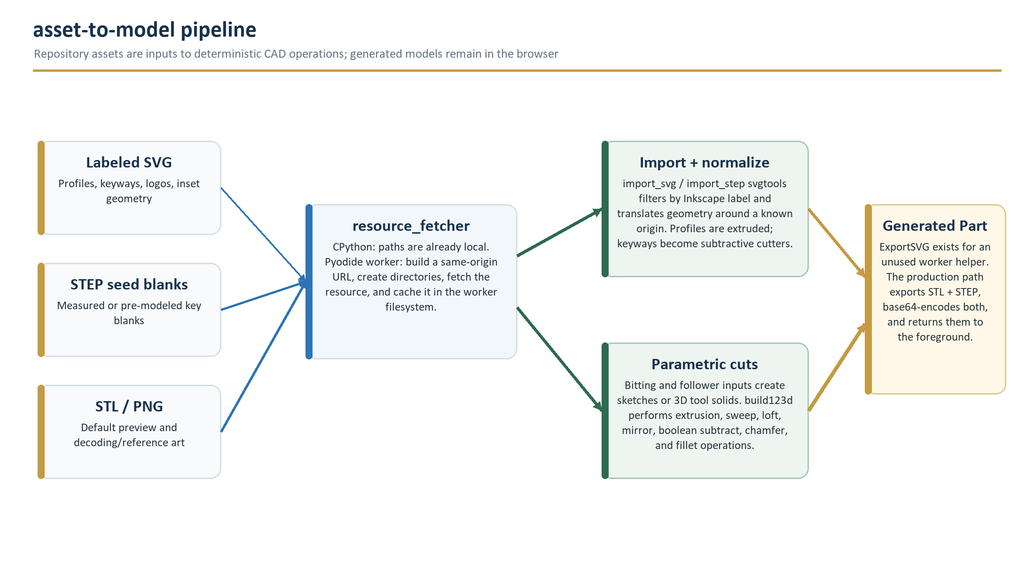
Figure 7. Static assets become local worker files, are normalized into build123d geometry, and feed blank construction or reference presentation. Generated models leave the browser only through explicit user actions.

9.3 SVG authoring contract
SVG-backed generators call import_svg(..., label_by='inkscape:label') and then perform exact string matching. Labels commonly begin with #, for example #profile_desmo_8pin, #keyway_sr, or #profile_e29sl_ctrl. Imported geometry must resolve to the expected Face/Wire type, have usable bounding boxes, and be positioned so translation to the minimum corner or center produces the datum assumed by code.
- Preserve Inkscape labels during optimization or editor conversion; id alone is not the selector used by the code.
- Do not embed raster-only profile geometry when the generator expects a path; Opnus/Memolis.svg contains a reference image but generation selects labeled path geometry.
- Verify flip_y choices. ASSA, MIWA, Opnus, Paclock, and Schlage explicitly import with flip_y=False; DOM uses the build123d default.
- Keep grouped decorative elements and single profile/keyway faces distinct. svgtools has separate group and single-shape normalization functions.
- Run blank generation for every profile/keyway combination after label or coordinate changes.

9.4 STEP asset contract
STEP files are imported as authoritative starting solids. Python code assumes their units, orientation, and datums already match the family constants. S&G and VSR immediately subtract cutters relative to stored coordinates; DOM keyway 1 directly uses the imported blank before applying bilateral cuts. A visually plausible STEP replacement can still be dimensionally incompatible.

9.5 Browser fetching and caching
The worker base URL is window.location.origin + window.location.pathname. pre_fetch_resource() appends the relative resource path, downloads only when the worker-local path is absent, and then reuses that file for subsequent generations in the same worker lifetime. A deployment must therefore preserve the repository-relative resources tree beneath the application base path.
Deployment implication Static-host rewrite rules, case sensitivity, and base-path placement are part of the runtime contract. Test every STEP/SVG path on the target host; Windows development can hide case mismatches that fail on Linux-backed hosting.

9.6 Generated-file lifecycle
Production exports use temp.stl and temp.step inside the single named worker. The files are overwritten on the next generation and are not explicitly removed. The current UI serializes user actions by disabling Generate while a request is active, limiting collision risk. Any future concurrent API or worker pool must allocate unique filenames or export to memory.

10. Build, run, packaging, and deployment
The repository supports two execution modes: normal CPython for library/development use and a static browser application whose heavy dependencies are installed into a PyScript worker at runtime.

10.1 Prerequisites
Mode | Required | Optional / environmental
Python library | Python 3.13 or 3.14; build123d 0.11.0 | ocp_vscode 3.4.0 for interactive development
Browser application | Modern browser with WebGL2, Web Workers, WebAssembly, ES modules, Blob URLs, Clipboard API | Network access to configured CDNs and package hosts on first uncached load
Static host | Correct MIME types and repository-relative file paths | HTTPS for clipboard behavior and production security

10.2 Local Python installation
# From the repository root with Python 3.13 or 3.14
python -m venv .venv
.venv\Scripts\activate
python -m pip install -e .
# Optional interactive CAD viewer
python -m pip install -e .[dev]
pyproject.toml declares only build123d as a runtime dependency. There are no console_scripts entry points; consumers import realkey modules or execute an implementation's maintainer-only __main__ block. Those blocks are examples, may write local STEP files, and are not a stable CLI.

10.3 Local browser application
# Serve over HTTP; do not open index.html directly with file://
python -m http.server 8000
# Then open
http://localhost:8000/
A simple static server is sufficient because the application has no backend. The browser must still fetch PyScript, Three.js, Font Awesome, Bunny Fonts, and worker-installed packages from external origins unless those dependencies are vendored or already cached.

10.4 Worker dependency sequence
Order | Package declaration | Purpose
1 | Mock cadquery-ocp-novtk 7.9.3.1 and lib3mf 2.4.1 | Prevent incompatible dependency resolution while WASM substitutes are installed.
2 | cadquery-ocp-novtk-OCP.wasm==7.9.3.1.post202606201016 | OpenCascade/OCP browser runtime.
3 | lib3mf-OCP.wasm==2.5.0.post202606200901 | 3MF/export-related WASM library used by CAD stack.
4 | cadquery_ocp_proxy==7.9.3.1.1 | Proxy integration for OCP in Pyodide.
5 | build123d==0.11.0 | Parametric CAD API used by all generators.
6 | typing-extensions (unversioned) | Compatibility typing support; also installed in the foreground.

Reproducibility Most CAD packages are pinned, but typing-extensions and remote CSS/font assets are not fully integrity-locked. Record a known-good dependency manifest and consider vendoring or applying subresource integrity where supported.

10.5 Static deployment
- Preserve paths. Deploy index.html, main.css, model_view.js, main.py, worker.py, config.json, src/realkey, and resources with their relative layout.
- Serve ES modules correctly. JavaScript and PyScript assets need appropriate content types; CDN and worker requests must not be blocked by host policy.
- Use HTTPS. Clipboard APIs and modern browser security features are most reliable in a secure context.
- Test base paths. Verify both root hosting and subdirectory hosting because the worker derives resource URLs from origin + pathname.
- Set a content security policy deliberately. The current page references several external origins and uses PyScript/ES modules; a CSP must enumerate the required sources or dependencies must be self-hosted.
- Cache immutable dependencies. Versioned Three.js and PyScript assets can be cached aggressively; application source/assets should use a release-aware invalidation strategy.
- Verify large first load. Measure worker install time, WebAssembly download size, memory use, and failure behavior on the target device class.

10.6 Deployment acceptance checklist
- Loader progresses to Loaded and disappears on a clean-cache browser session.
- WebGL2 preview displays resources/realkey.stl and orbit/pan/zoom work.
- Every key family populates profiles/keyways; at least one blank and one cut key generate per family.
- Every named follower preset generates; custom top/bottom ends and unit switching are verified.
- STL preview, STL download, and STEP download all complete with non-empty files.
- Share URLs restore key and follower settings; optional auto-generation behaves as selected.
- SVG/STEP resources return 200 under the production base path with correct case.
- CSP/CORS/worker console has no blocked dependencies or mixed-content warnings.
- Mobile layout at <=768 px remains usable and dialogs are keyboard accessible.

11. Extension and contribution guide
A feature is complete only when the domain contract, geometry assets, foreground registry, worker registry, PyScript file map, export path, and documentation agree.

11.1 End-to-end workflow
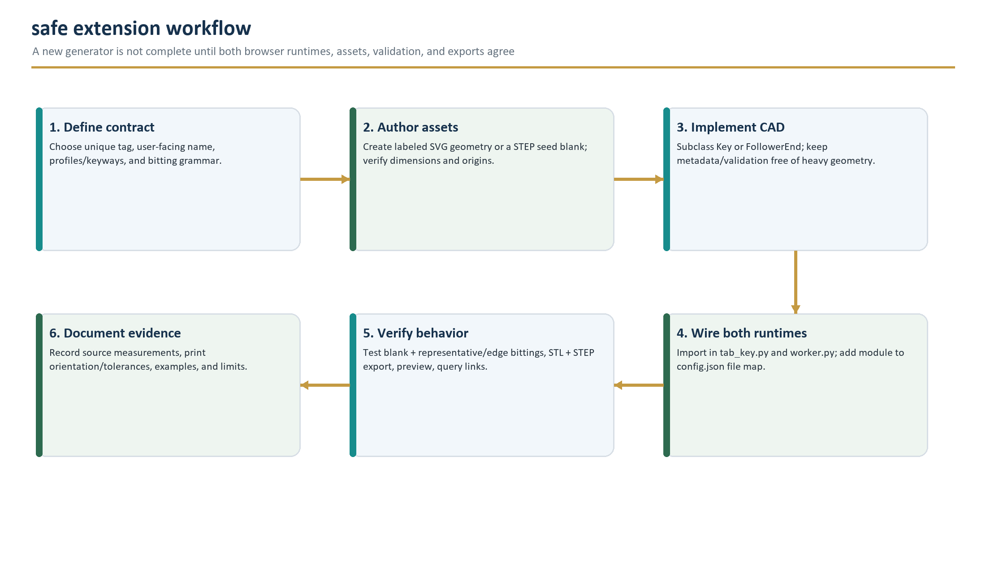
Figure 8. Recommended extension sequence. Wiring and verification are first-class implementation steps because two Python runtimes must load the same plug-in.

11.2 Adding a key family

Step 1 - establish the public grammar
Choose a unique snake_case tag, stable display name, profile tags, keyway tags, bitting order, maximum/exact lengths, allowed depth symbols, delimiter rules, and authoritative measurement source. Tag changes break saved URLs; profile/keyway changes can break asset labels and downstream integrations.

Step 2 - implement the contract
from build123d import *
from realkey import key, resource_fetcher
class Example(key.Key):
@classmethod
def tag(cls) -> str: return "vendor_family"
@classmethod
def display_name(cls) -> str: return "Vendor Family"
@classmethod
def profiles(cls): return {"": {"p1": "Profile 1"}}
@classmethod
def keyways(cls): return {"": {"k1": "Keyway 1"}}
# basic_bitting_definition, advanced_bitting_definition,
# validate_bitting, blank, and key are also required.
Keep tag/display/profile/keyway/bitting metadata and validate_bitting() safe under the foreground's build123d mock. Heavy imports beyond build123d, file reads, and geometry creation belong in blank()/key() or worker-only helpers.

Step 3 - author and verify assets
Use repository-relative paths and resource_fetcher.pre_fetch_resource() before every worker-read asset. For SVG, label every selected path/group with the exact Inkscape label referenced by code. For STEP, record units and coordinate datums. Generate the blank before implementing bitting so profile/keyway and cut failures remain separable.

Step 4 - wire every load path
Location | Required change | Failure symptom if omitted
src/realkey/<module>.py | Add the new subclass and assets/constants. | No implementation exists.
src/realkey/tab_key.py | Import the module. | Key is absent from the selector because foreground registry is empty for it.
worker.py | Import the module. | Selector works, but worker Key._list cannot resolve the tag.
config.json | Map the module from src/realkey to /realkey. | One or both PyScript runtimes cannot import the module.
resources/ | Add exact path/case assets. | Generation fails during prefetch/import, often only on case-sensitive hosting.
CONTRIBUTING.md / handbook | Document bitting and source evidence. | Future maintainers cannot validate intent or measurements.

Step 5 - validation and geometry acceptance
- Registry tag is unique in both runtimes and appears once in the UI.
- Every profile x keyway combination generates a non-empty, valid blank.
- Minimum, maximum, alternating, and representative known bittings generate valid Parts.
- Too long, too short (when applicable), invalid characters, invalid ranges, malformed groups, and unknown tags fail with user-safe messages.
- No requested cut violates root width, maximum adjacent cut, remaining wall thickness, or printable clearance rules.
- STL and STEP exports are non-empty; STEP re-import and STL manifold/watertight checks pass.
- Three.js centers and frames the result; old mesh resources are disposed; the object URL remains valid until load completion.
- Share URL round-trips every setting and auto-generation behavior.
- At least one print/measurement fixture records expected dimensions and tolerance.

11.3 Adding a follower end
Subclass FollowerEnd and implement tag(), display_name(), config(), and generate(). config() maps stable machine tags to labels; the UI automatically creates a rotation field plus one LengthInputElement per entry. generate() must return geometry aligned along local Z and the exact axial length consumed. A flat/no-geometry end returns (None, 0).
Naming contract Dynamic URL keys are built from config tags, for example hollow_depth-ig-top. Renaming a configuration key breaks existing share URLs.

11.4 Adding a follower preset
Add a FollowerConfigData row to FOLLOWER_DEFINITIONS with total length, diameter, two registered end tags, and their dimensional dictionaries. Confirm that browser-populated rotation is present in generated requests. A domain-level default rotation is recommended before treating the preset object itself as directly executable.

11.5 Developer feedback loop
Existing key modules use an if __name__ == '__main__' block with ocp_vscode.show_all() and occasional STEP export. This is the fastest geometry-authoring loop, but it should be supplemented with automated assertions. Recommended fixtures serialize key metadata, validate bitting matrices without CAD, generate known Parts under CPython, check bounding boxes/volumes, and re-import exports.

11.6 Contribution review checklist
- Source measurements and assumptions are documented; proprietary or third-party assets have clear redistribution rights.
- New metadata contains no untrusted HTML; advanced help images have accessible descriptions in the UI/documentation.
- No unrelated generator behavior changes without regression evidence.
- All runtime/development dependencies are versioned intentionally.
- No generated binaries, temporary exports, editor state, or credentials are committed accidentally.
- AGPL notices and source links remain visible where required for deployed modifications.

12. Security, privacy, safety, and licensing
Client-side CAD reduces server data collection, but it does not eliminate supply-chain trust, URL disclosure, browser persistence, unsafe model use, or license obligations.

12.1 Trust boundaries
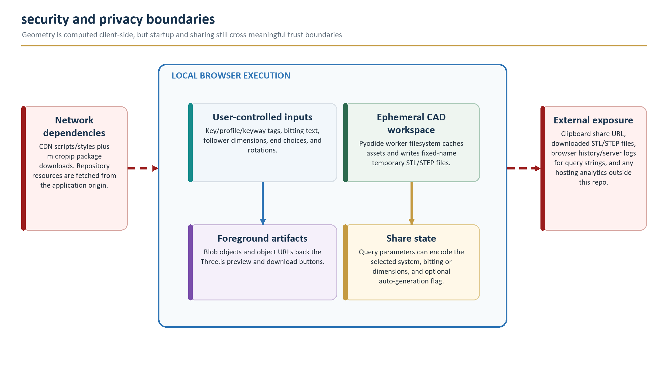
Figure 9. Local execution boundary and external exposure points. The generated model stays local by default, while startup and optional sharing cross network or clipboard boundaries.

12.2 Data handled by the application
Data | Where it exists | Persistence / exposure
Key family/profile/keyway/bitting | DOM state; worker call; optionally query string | Ephemeral unless shared; URLs can persist in history/logs/clipboard.
Follower dimensions/end config | DOM state; worker call; optionally query string | Same exposure as key settings.
Repository CAD assets | Static host and worker filesystem cache | Public to anyone who can load the application.
Generated STL/STEP | Worker temp files, base64 response, foreground Blobs | Ephemeral until explicitly downloaded; subject to browser memory/cache behavior.
Share URL | Clipboard and receiving application | May be stored by browser, chat, email, issue tracker, proxy, or analytics systems.
Console/errors | Browser developer tools | Worker exception text may disclose paths or implementation detail to the local user.

12.3 External supply chain
Origin / mechanism | Material loaded | Control in snapshot
pyscript.net | PyScript 2026.6.1 CSS and core.js | Versioned URL; no SRI attribute in index.html.
cdn.jsdelivr.net | Three.js 0.184.0 and addons via import map | Version pinned; no SRI for ES module imports.
cdnjs.cloudflare.com | Font Awesome 7.0.1 CSS | Versioned URL; no integrity attribute.
fonts.bunny.net | Alexandria font CSS/font files | Family specified; asset URL is not release-locked in repository.
micropip/package host | OCP/lib3mf WASM, proxy, build123d, typing-extensions | CAD packages mostly pinned; typing-extensions unpinned; keep_going=True.
Application origin | Python modules and resources | Exact paths in config.json and source; no content hashes.

Hardening direction Publish a tested lockfile/manifest, self-host critical runtime assets where practical, add CSP and integrity controls compatible with ES modules, and fail startup with a precise dependency-stage diagnostic.

12.4 Input and output security
- Validate at the worker boundary. Foreground controls reduce accidental invalid calls but do not make the exported worker functions trusted. Verify tags, finite numbers, lengths, ranges, and dictionary keys again before CAD operations.
- Do not render arbitrary HTML. Current bitting help is code-authored, but info.html and model descriptions use innerHTML. Future external data or echoed inputs should be escaped or inserted as text.
- Treat filenames as untrusted composition. Download names are derived from model_description.innerHTML. Keep descriptions plain and sanitize filesystem-significant characters.
- Limit resource abuse. CAD generation can be CPU/memory intensive. Cap dimensions and complexity, and provide cancellation/timeouts before exposing a broader API.
- Revoke URLs after use, not before completion. Preview object URLs should be released after the STL loader succeeds or fails; download URLs can be revoked after click dispatch.
- Avoid query secrets. Share only bittings and dimensions the user intends to disclose; provide a prominent warning before copying sensitive settings.

12.5 Responsible and safe use
Use authorization Generated keys and lock-service tools should be created and used only for locks and systems the user owns or is explicitly authorized to service. Maintain local legal, safety, workplace, and site policies.
A model can fail by being dimensionally inaccurate, brittle, sharp, improperly oriented, jammed in a keyway, or strong enough to damage a lock while still too weak for safe removal. Treat all prints as prototypes. Measure critical dimensions, inspect surfaces and warding, use appropriate materials/PPE, and test in a controlled environment before relying on a model.
The in-application print guidance recommends high-detail settings and lists candidate materials, but it is advisory and not a validated process specification. Printer calibration, anisotropy, shrinkage, nozzle condition, slicer version, and post-processing can materially change fit.

12.6 AGPL-3.0 obligations
The repository LICENSE is GNU Affero General Public License version 3. In practical terms, redistributed covered versions must preserve the license and source rights, and modified versions offered for remote network interaction must provide users an opportunity to receive corresponding source. The deployed UI already links to the GitHub repository; downstream operators should ensure that link points to the exact corresponding source for their version and that notices remain appropriate.
Legal note This section is an engineering summary, not legal advice. Review the full LICENSE and obtain counsel for distribution, hosted modifications, third-party assets, patents, trademarks, or commercial use.

13. Quality assessment and technical debt
The architecture is understandable and extensible, but assurance currently depends on manual use. The highest-value next step is a layered automated test system around metadata, validation, assets, CAD fixtures, exports, and browser integration.

13.1 Verified assurance posture
Control | Observed state | Implication
Automated unit/integration tests | No tracked tests | Validation and geometry regressions are not automatically detected.
Continuous integration | No tracked workflow | Supported Python/browser/dependency combinations are not verified on change.
Dependency pins | Core CAD/browser versions mostly pinned | Some assets/packages remain unpinned or lack integrity metadata.
Input validation | Per-key validation; follower validation minimal | Coverage is inconsistent and worker boundary trusts UI-shaped values.
Error contract | Broad exceptions -> string | User gets feedback, but diagnostics are unstructured and difficult to aggregate.
Asset validation | Runtime import only | Missing labels, bad case, invalid STEP, or datum drift fail late.
Documentation audit | All Python files AST-parsed; all tracked files inventoried | Confirms readable syntax/structure, not executable CAD correctness.

13.2 Risk matrix
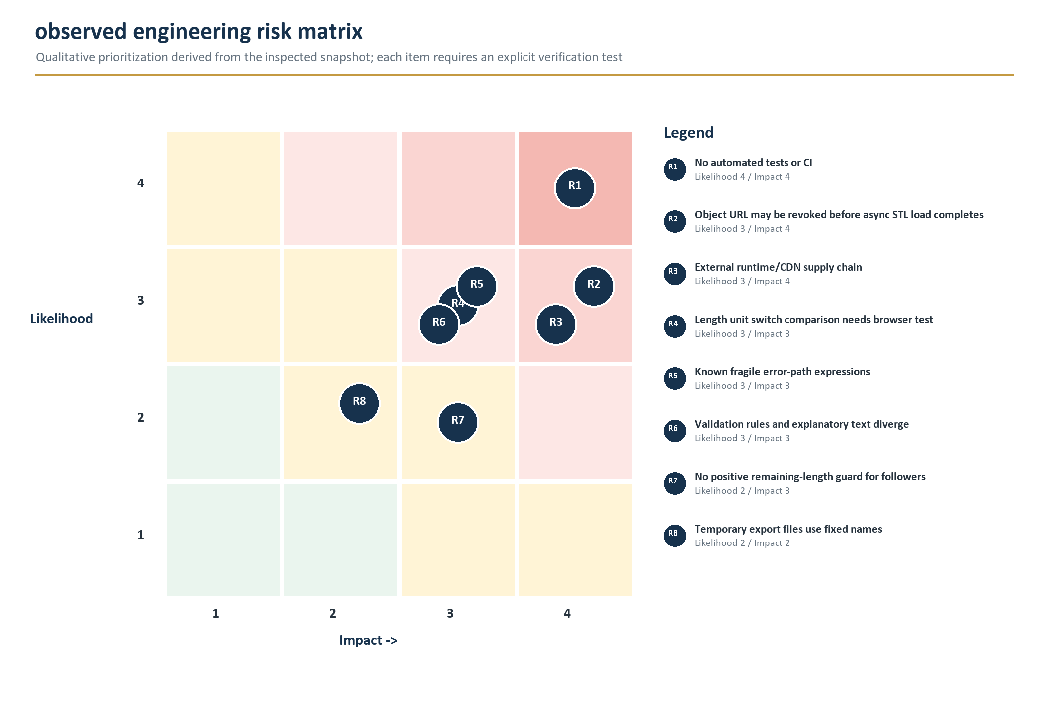
Figure 10. Qualitative prioritization of observed engineering risks. Ratings are review guidance, not measured incident probability.

13.3 Source-review findings
ID | Evidence | Assessment | Recommended verification / change
Q1 | geom_tools.max(): m.Y1 | The Y branch references Y1 while neighboring code uses X/Y/Z. Likely latent defect; no tracked call site. | Call with multiple Shapes; assert max vector; correct attribute if test confirms.
Q2 | web_main.get_selected_tab(): tabs['keys'] | Fallback key is not present in tabs. | Force all tabs hidden and verify deterministic fallback/error.
Q3 | worker.generate_follower(): if generate_follower is None | Checks the function object rather than generated_follower. | Correct variable and test a None-returning/stub generator path.
Q4 | SGSDB.validate_bitting(): cls.profiles()[profile] | Nested profiles mapping is grouped by Renter/Guard, not direct profile tag. | Test every over-length profile and repair message lookup.
Q5 | LengthInputElement.unit_change() equality | Wrapper/raw element equality is runtime-bridge dependent. | Browser test mm -> in -> mm value preservation.
Q6 | start_generation(): loadObject(); revokeObjectURL() | The asynchronous Promise is not awaited before revocation. | Delay revoke until load completion; test large STL and slow device.
Q7 | VSR help vs validate_bitting() | Explanatory row restrictions are narrower than accepted 1-5 ranges. | Use known pinning fixtures to decide authoritative rule.
Q8 | Memolis side split | Odd strings are accepted and split into unequal halves. | Confirm grammar; enforce even/exact side counts if required.
Q9 | Follower.generate() | No remaining-length/dimension guards; rotation assumed for non-empty configs. | Add domain validation and direct preset tests.
Q10 | Fixed temp.stl/temp.step | Safe for current serialized single worker; not safe for future concurrency. | Use unique paths or memory export before parallelization.
Q11 | __export__ excludes generate_key_art | Helper exists but is not exported and is unused by UI. | Remove, expose intentionally, or cover with a purpose-driven test.
Q12 | HTML accessibility metadata | Follower icon lacks alt; some share labels target nonexistent ID; no aria-live. | Run automated a11y scan plus keyboard/screen-reader smoke tests.

13.4 Recommended test architecture
Layer | What to test | Representative tooling / evidence
Contract tests | Unique tags; required class methods; profile/keyway maps; HTML guidance present; config/import symmetry. | pytest without CAD using a robust build123d mock.
Validation tests | Boundary lengths, character sets, groups, depth ranges, profile-specific rules, unknown tags. | Parameterized pytest matrix per family.
Asset tests | All paths exist; SVG labels/types; STEP import; path case; no orphan/missing config files. | XML parser + build123d import smoke tests.
Geometry fixtures | Blank/cut Part validity, volume/bounds, wall thickness, known datum dimensions. | build123d/OCP assertions and golden measurement JSON.
Export tests | STL/STEP non-empty, re-importable, expected bounding boxes, STL manifold status. | Temporary directory exports and mesh/CAD validators.
Worker tests | Success/error dictionary schemas, base64 decoding, resource caching, unique temp lifecycle. | PyScript worker integration or factored pure-Python service functions.
Browser E2E | Startup, unit toggles, all selectors, generation, Blob preview, downloads, query round-trip, dialogs. | Playwright across Chromium/Firefox/WebKit where PyScript support permits.
Physical QA | Printed critical dimensions, insertion, operation, extraction, wear and failure mode. | Versioned fixture plan; authorized locks; measurement records.

13.5 Minimum merge gate
- Formatting/lint and AST/compile checks pass on supported Python versions.
- Contract and validation tests pass without loading heavy CAD where possible.
- Changed families generate all blanks and a representative boundary matrix under build123d 0.11.0.
- All changed STL/STEP outputs re-import and remain within expected geometric tolerances.
- Browser startup and affected user flows pass from a clean cache with console errors treated as failures.
- Asset/config/import symmetry audit passes; no missing or orphaned generator module is introduced.
- Security/a11y review is completed for any new external dependency, HTML content, input, dialog, URL field, or download behavior.

14. Operations and troubleshooting
Troubleshooting should first identify the failing boundary: static hosting, external dependency installation, foreground state, worker CAD, asset import, Three.js preview, or browser download/share APIs.

14.1 Symptom-based guide
Symptom | Likely boundary / causes | Diagnostic and recovery
Loader never disappears | Worker install is slow/failed; PyScript or a package origin is blocked; foreground exception. | Open console/network panels. Identify last [BG]/[FG] message. Verify CDN/package responses, worker creation, and memory. Retry clean cache.
'WebGL issue detected' | WebGL2 unavailable/disabled, GPU/driver policy, headless/remote environment. | Open the emitted WebGL diagnostic; enable hardware acceleration or use a compatible browser/device. Downloads could be exposed without preview as a future fallback.
No keys loaded | Foreground module missing from config.json/import list; import failed under build123d mock. | Check main.py traceback, config file map, tab_key imports, and metadata code for accidental heavy CAD execution.
Key appears but worker reports unknown tag | Module imported in tab_key but not worker.py, or worker import failed. | Compare both import lists and confirm registry contents in worker console.
Generate remains disabled | No key selected or validate_bitting() rejected current value; key selectors not populated. | Read the visible info message; verify bitting grammar and profile/keyway; use empty bitting for a blank.
Unable to load ... SVG/blank | Resource 404, case mismatch, base path issue, or worker filesystem write failure. | Open Network; request the exact resources/... path; verify deployment case and set_base_url.
CAD exception after valid input | Geometry assumptions, impossible adjacent cut slope, invalid asset datum, or OCP failure. | Record family/profile/keyway/bitting and stack detail from worker console; reproduce under CPython/ocp_vscode; add regression fixture.
Follower fails | Missing rotation key, negative remaining body, invalid width/depth/radius, or end boolean/chamfer failure. | Try a named flat-end preset, then isolate each end. Inspect all numeric configs in millimeters and add domain guards.
Generation returns but preview does not change | Blob URL revoked too early; STLLoader error; camera framing/material issue. | Inspect Promise/network/console; delay URL revocation; download and validate STL separately.
STL works; STEP fails | STEP export/read failed or Blob MIME/download path issue. | Decode response sizes in foreground; inspect worker temp.step; re-import with build123d or a CAD tool.
Downloaded filename is odd | model_description contains HTML entities or unsupported filename characters. | Sanitize description and avoid HTML in model-description when composing filenames.
Share link restores wrong state | Unknown/malformed query tag, renamed config key, swallowed _populate_param exception, or fallback path. | Compare generated parameters with current selectors; test percent-decoding and dynamic follower keys.
mm/in switch changes value incorrectly | LengthInputElement selection comparison or repeated conversion issue. | Test known 25.4 mm <-> 1.00000 in round-trip and inspect selected option wrapper behavior.
Mobile view is clipped | Canvas minimum height/dialog width or flex layout interaction. | Test <=768 px, browser zoom, portrait/landscape, dialogs, and device pixel ratio resize handling.

14.2 Diagnostic data to capture
- Repository commit, deployment URL/base path, browser/version/OS, WebGL renderer, and whether the session used a clean cache.
- Last visible loader message plus complete [FG] and [BG] console sequence.
- Selected tab, registry tag, profile, keyway, bitting or follower dimensions/end configs, with sensitive values redacted where appropriate.
- Exact resource/package URL and HTTP status for the first failed request.
- Worker exception class/message and, during development, full traceback.
- Generated STL/STEP byte lengths and whether each file can be opened/re-imported independently of the web viewer.
- For geometry regressions: bounding box, volume, critical measured dimensions, screenshot, and known-good comparison commit.

14.3 Recovery principles
Do not treat repeated refreshes as a fix. Separate environment failures from deterministic geometry failures, preserve the smallest failing input, and add that input to an automated fixture before changing constants or asset coordinates. For physical-fit complaints, record printer/slicer/material/orientation and dimensional measurements before altering the CAD source.

15. Recommended roadmap
The roadmap prioritizes correctness and reproducibility before expanding the catalog. Each stage should end with measurable acceptance evidence.

15.1 Priority plan
Priority | Work item | Outcome / acceptance evidence
P0 | Add contract + validation tests for every Key/FollowerEnd | Unique registries, import symmetry, profile/keyway maps, and complete boundary matrices verified on every change.
P0 | Fix and test Q1-Q9 source-review findings | Known fragile paths have deterministic tests and clear intended behavior.
P0 | Add CAD smoke fixtures and export re-import | At least one blank and cut model per family plus every follower preset produce valid STL/STEP.
P0 | Add browser E2E for startup/generation/download/share | Clean-cache Chromium path passes; Blob URL lifecycle and unit switching are covered.
P0 | Introduce CI on supported Python versions | Lint/format/contract/validation/CAD smoke gates run for pull requests.
P1 | Define structured worker error schema | Stable code, user message, diagnostic detail, phase, and retryability replace raw strings.
P1 | Centralize validation and typed request/response models | Worker boundary rejects unknown tags, non-finite numbers, malformed configs, and complexity abuse.
P1 | Harden dependency delivery | Known-good manifest, predictable cache behavior, CSP, and self-host/integrity decision documented.
P1 | Automate asset-contract audit | All SVG labels, STEP imports, path case, config mappings, and orphan assets checked.
P1 | Add performance budgets and cancellation | Worker install, peak memory, generation duration, payload size, and cancellation behavior measured.
P1 | Improve accessibility | Keyboard, focus, aria-live, labels, canvas alternative, and contrast pass documented tests.
P2 | Create dimensional provenance schema | Each generator records source, units, datums, tolerances, sample/measurement notes, and confidence.
P2 | Version physical print fixtures | Authorized test matrix links model, printer/slicer/material settings, measurements, and result.
P2 | Reduce duplicate in-memory/file payloads | Evaluate transferables, memory export, compression, and STEP-on-demand without losing reliability.
P2 | Expand supported systems | New families use the complete extension and evidence checklist rather than ad hoc wiring.

15.2 Suggested release gates
Release level | Minimum evidence
Patch | All automated gates pass; changed families and affected browser flow have regression tests; no asset/schema break.
Minor | New generator/preset passes full contract, validation, blank/cut/export, UI, sharing, and documentation acceptance.
Runtime/dependency upgrade | Clean-cache install tested; full CAD smoke set; browser E2E; load-time/memory comparison; rollback plan.
Physical-fit claim | Versioned model and print process; authorized lock fixture; critical measurements; repeat trials; documented limitations.

15.3 Definition of a professionally maintainable state
A future maintainer should be able to identify every supported public tag, reproduce the browser and CPython environments, validate every asset contract, generate and re-import representative models, understand why each key constant exists, diagnose a failed request by phase, and verify a physical-fit claim from recorded evidence. This handbook provides the map; automation must make that map continuously true.

16. Reference appendices
The following tables are intended for quick lookup during implementation, review, deployment, and diagnosis.

16.1 Worker API
Function | Parameters | Returns / notes
set_base_url | base_url: str | Sets resource_fetcher base; exported to foreground and called during boot.
generate_key | key_tag, profile, keyway, bitting | Blank for empty bitting, otherwise cut key; success STL/STEP base64 or error string.
generate_follower | length, diameter, top_tag, top_config, bottom_tag, bottom_config | Converts JS proxy dictionaries with to_py(); success STL/STEP or typed-name error string.
shared_generate | part: Part | Internal helper; exports fixed temp.stl and temp.step and encodes contents.
generate_key_art | key_tag, profile, keyway, bitting | Creates projected SVG base64; present in source but not listed in __export__ and unused by UI.

16.2 Foreground generation response
Key | Producer | Meaning
stl | Worker | Base64-encoded binary STL; required on success.
step | Worker | Base64-encoded STEP file; required on success.
error | Worker | Mutually exclusive failure text.
description | Tab controller | Human-readable filename/viewer label.
roughness | Tab controller | Three.js MeshPhysicalMaterial roughness; key/follower set 0.25.
metalness | Tab controller | Three.js material metalness; both set 0.95.
color | Follower tab or default | Follower sets silver 0xC0C0C0; keys use viewer default brass 0xE3BD7A.

16.3 Share-link query schema
Parameter | Applies to | Meaning
tab | All | key or follower; omitted legacy links default to key.
generate | All | Empty or true triggers generation after loading restored settings.
key | Key | Key registry tag.
profile | Key | Selected profile tag.
keyway | Key | Selected keyway tag.
bitting | Key | Raw bitting grammar; empty value represents a blank.
follower | Follower | Named preset label or Custom.
follower_length | Custom follower | Canonical millimeter float serialized as text.
follower_diameter | Custom follower | Canonical millimeter float serialized as text.
follower_top | Custom follower | Top FollowerEnd registry tag.
<config>-ig-top | Custom follower | Top rotation/dimension field, canonical numeric value.
follower_bottom | Custom follower | Bottom FollowerEnd registry tag.
<config>-ig-bottom | Custom follower | Bottom rotation/dimension field, canonical numeric value.

16.4 Key registry quick reference
Tag | Class | Profiles | Keyways / family
assa_desmo | assa.Desmo | 6-, 8-, 10-pin | Desmo
dom_system_d | dom.SystemD | Basic | 1
miwa_sr | miwa.SR | 10-cut | SR
opnus_memolis | opnus.Memolis | Operator, change | Memolis
paclock_pr1 | paclock.PR1 | PR1 6-pin, PRO 7-pin | PR1
sg_sdb | sargentandgreenleaf.SGSDB | Renter: 60, 96, 96 7-cut; Guard: 87H, 87H 7-cut, 9609, SY3B | Lever
schlage_everest | schlage.Everest | Everest/29: 6-pin and control | C-series and S-series families (16 species each)
schlage_everest_sl | schlage.EverestSL | Everest SL/29SL: 7-pin and control | B-series and R-series families (16 species each)
schlage_everest_primus | schlage.EverestPrimus | Everest/29 Primus: 6-pin and control | C-series and S-series families
vsr_2000 | vsr._2000 | 1 | 1

16.5 Follower registry quick reference
Tag | Display | Configuration
flat_end | Flat End | None
slot | Slot | depth, width, rotation
v_slot | V Slot | depth, width, rotation
tongue | Tongue | depth, width, rotation
cross | Cross | depth, X width, Y width, rotation
pin_slot | Pin Slot | depth, width, rotation
hollow | Hollow | depth, wall thickness, rotation
slotted_hollow | Slotted Hollow | depth, wall thickness, slot width, rotation
schlage | Schlage | None

16.6 DOM identifier reference
Area | IDs
Lifecycle | loader, status, content, info, model-generating, model-description
Header/dialogs | header, header-text, header-right, about-dialog, advanced-bitting-dialog, share-dialog
Tabs | key-tab-button, follower-tab-button, key-tab, follower-tab
Key | key-select, profile-select, keyway-select, bitting-instructions, show-advanced, advanced-bitting-info, bitting
Follower | follower-select, follower-length, follower-diameter, follower-top-select, follower-top-div, follower-bottom-select, follower-bottom-div
Actions | generate, save-stl, save-step, copy-link, share-settings, share-generate
Viewer/social | model-view, canvas, meta-image

16.7 Complete resource inventory
Path | Type | Role
resources/ASSA/Desmo.svg | SVG | 6/8/10-pin profiles and Desmo keyway.
resources/DOM/SystemD.svg | SVG | Alternate System D profile/keyway/bow branding geometry.
resources/DOM/SystemD_B1.step | STEP | Current DOM System D keyway 1 blank.
resources/MIWA/SR.svg | SVG | SR 10-cut profile and keyway.
resources/MIWA/SR_Key_Decode.png | PNG | Annotated keyed decoding reference.
resources/MIWA/SR_Lock_Decode.png | PNG | Annotated keyless/core decoding reference.
resources/Opnus/Memolis.svg | SVG | Operator/change profiles, keyway, embedded reference image.
resources/Paclock/PR1.svg | SVG | PR1/PRO profiles and PR1 keyway.
resources/plug_follower.svg | SVG | Follower tab icon; not a CAD source.
resources/realkey.stl | STL | Default Three.js model at application startup.
resources/SargentAndGreenleaf/60.step | STEP | S&G 60 renter blank.
resources/SargentAndGreenleaf/87H.step | STEP | S&G 87H/87H 7-cut guard blank.
resources/SargentAndGreenleaf/96.step | STEP | S&G 96/96 7-cut renter blank.
resources/SargentAndGreenleaf/9609.step | STEP | S&G 9609 guard blank.
resources/SargentAndGreenleaf/SY3B.step | STEP | S&G SY3B guard blank.
resources/Schlage/Everest.svg | SVG | Eight profile paths and B/C/R/S family base keyways.
resources/SystemDArt.png | PNG | OpenGraph/cover-style line art for DOM System D.
resources/VSR/2000-1-1.step | STEP | VSR 2000 profile/keyway 1 blank.
resources/VSR/2000.svg | SVG | Retained VSR profile geometry; unused by current generator.

16.8 SVG label patterns used by generators
Family | Selected labels
ASSA Desmo | #profile_desmo_<6pin|8pin|10pin>; #keyway_desmo
DOM System D | #profile; #keyway; #inset_bow; #dom_logo; #system; #d
MIWA SR | #profile_sr_10cut; #keyway_sr
Opnus Memolis | #profile_memolis; #profile_memolis_change; #keyway_memolis
Paclock | #profile_pr1; #profile_pro; #keyway_pr1
Schlage | #profile_<mapped profile>; #keyway_<b|c|r|s>

16.9 Glossary
Term | Definition in this system
BRep | Boundary representation used internally by OpenCascade/build123d for solid CAD geometry.
Bitting | Compact family-specific cut code that links a key to a lock configuration.
Blank | Profile/keyway model before bitting cuts.
Bow | The handle region of a key.
Control profile | A profile variant intended for a control key form where supported.
Cut datum | Reference coordinate from which spacing or depth is calculated.
Follower | Tool used to follow a plug during cylinder servicing; modeled as a body plus configurable ends.
Keyway | Warded cross-section of the portion entering the lock.
MACS | Maximum adjacent cut relationship; smooth_angled_cutter references an exact slope-fitting case.
Profile | Overall 2D shape/length variant of a blank.
Sidebar | Secondary bitting/control surface, notably modeled for Schlage Primus.
STEP | Editable CAD interchange representation exported by build123d.
STL | Tessellated triangle mesh used for preview and common slicing workflows.
Web Worker | Isolated browser execution context used for dependency installation and heavy CAD.

16.10 Source baseline
This handbook was derived from the supplied workspace on 13 July 2026, main branch, commit 68595bb (12 July 2026). Package metadata reports version 0.2.0. The repository was clean before documentation scratch/output files were introduced. Source claims should be revalidated when the code, assets, dependency versions, or deployment model changes.
Project repository: realkey repository on GitHub

16.11 Final maintainer handoff checklist
- Update the snapshot commit/date/version and rerun repository metrics.
- Regenerate architecture charts if runtime boundaries, registries, or deployment dependencies change.
- Update the key/follower/asset catalogs whenever tags, profiles, keyways, presets, or resource paths change.
- Re-run static, accessibility, table-geometry, metadata-privacy, and visual page audits before publishing the handbook.
- Link deployed modifications to their exact corresponding source and preserve applicable license notices.

