**Name: Tanniru Shreya**

**Branch: CSE (Data Science)**

**Pin No: 21X05A6750**

**Year: Final Year**

**College: Narsimha Reddy Engineering College**

**Project Guider Name: Mr. Lokesh Sir**

**Project Title Name:**

**Analysis of HR datasets to help the organization take a meaningful right decision and find Insights to excel their businesses.**

**Tools and Technology:**

1. **Advanced Excel**

Excel is spread sheet software developed by Microsoft, commonly used for data manipulation, calculations, and analysis. Advanced Excel refers to a higher level of proficiency in using the software, including complex formulas, functions, data analysis tools, pivot tables, macros, and more. It's widely used in various industries for managing and analyzing data.

1. **Power BI**

Power BI is a business analytics service by Microsoft that allows you to connect to various data sources, transform and model the data, and create interactive visualizations and reports. It's widely used for data visualization, data exploration, and business intelligence. Power BI helps organizations make data-driven decisions by providing insights through interactive dashboards and reports.

**Organization Name:** IBM India

**Problem Statement:**

**Leveraging HR data for strategic decisions**

Utilize the HR dataset to uncover insights that enhance employee satisfaction, retention, and business performance. Transform raw data into actionable information for informed decision-making, driving operational excellence and business growth.

**To Convert Raw Data into Clean Data**

In Excel, null values are typically represented as empty cells. However, sometimes they might be represented with other placeholders like "N/A," "NA," "None," or similar text strings.

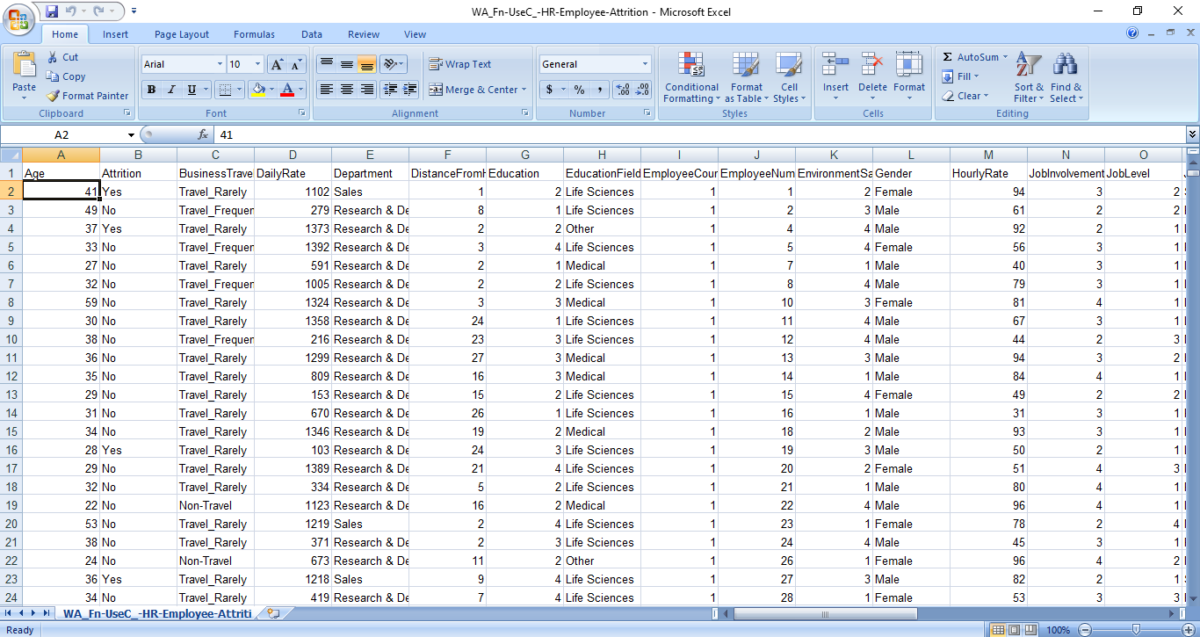

**Finding Null Values:**

**1. Blank Cells:**

* Blank cells usually represent null values in Excel. To find them:
* Select the column or range of cells where you suspect null values might be.
* Go to the "Home" tab on the Excel ribbon.
* Look in the "Editing" group for the "Find & Select" dropdown. Click on it.
* Choose "Go To Special..."
* In the "Go To Special" dialog box, select "Blanks" and click "OK." Excel will select all blank cells in the selected range.

**2. Text-based Null Values:**

* If null values are represented using specific text strings (e.g., "N/A," "NA," "None"), you can find them using Excel's Find function:
* Press `Ctrl + F` or go to the "Home" tab and click on "Find & Select" > "Find."
* Enter the text string you suspect represents null values in the "Find what" field.
* Click "Find All" to see a list of cells containing that text.

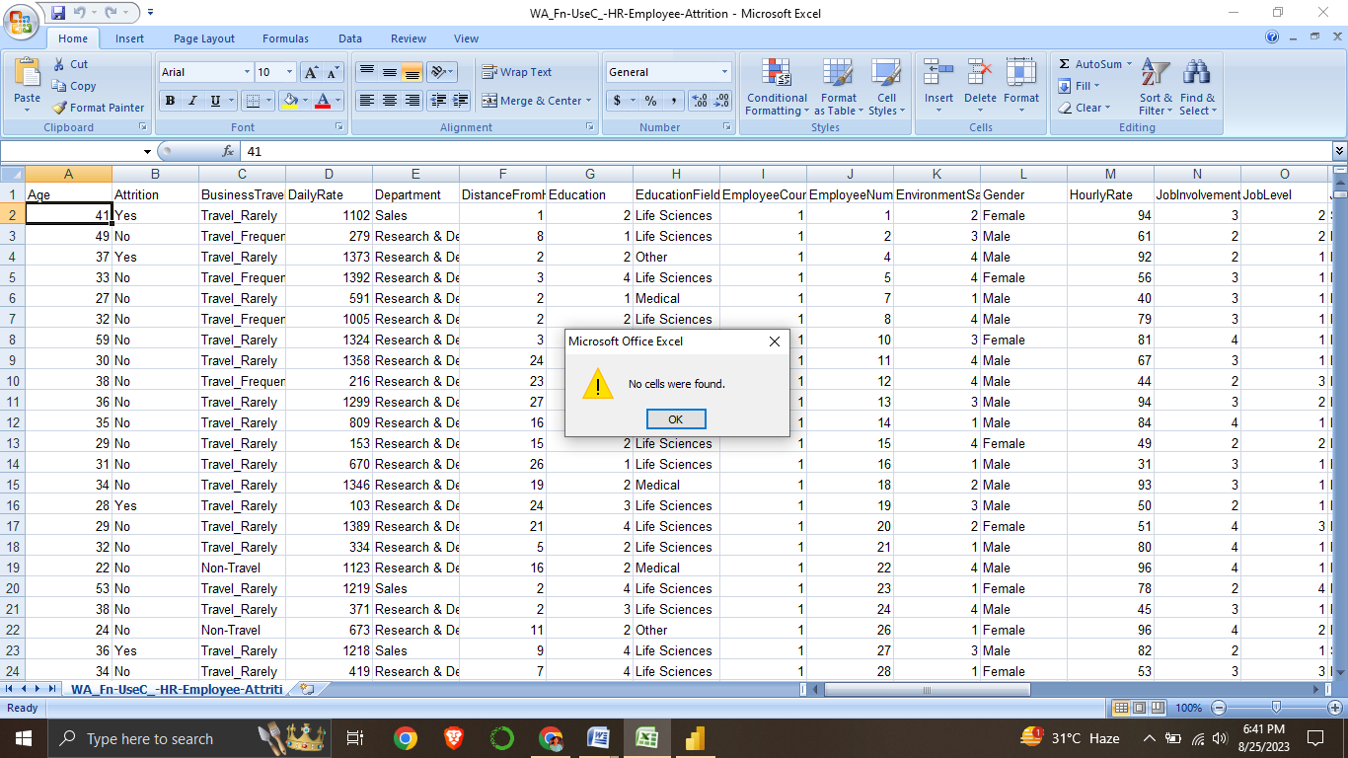

Here,

We checked the raw data to convert it into clean data but here raw data doesn’t contain any null values

**Project Methodology:**

HR Data-Driven Decision-Making

**1. Initiation:**

* Define analysis goals for informed decisions and business growth.
* Identify stakeholders and their roles in the project.

**2. Data Collection and Preparation:**

* Gather comprehensive HR datasets, ensuring data quality.
* Cleanse data by addressing missing values and anomalies.

**3. Exploratory Analysis:**

* Study data patterns, calculate statistics, and identify correlations.
* Pinpoint potential trends affecting employee performance and satisfaction.

**4. Hypothesis Formulation:**

* Develop educated assumptions based on initial insights.
* Prioritize critical questions aligned with organizational goals.

**5. Advanced Analysis Techniques:**

* Apply predictive modeling to forecast employee turnover and other trends.
* Segment employee groups to uncover specific insights.

**6. Data Visualization and Interpretation:**

* Create visually impactful graphs and charts.
* Derive actionable insights for decision-makers.

**7. Recommendations and Reporting:**

* Translate insights into practical strategies.
* Present a detailed report outlining findings and proposed actions.

**8. Implementation and Monitoring:**

* Execute strategies based on recommendations.
* Continuously assess the impact and adjust as needed.

**9. Ethical Considerations:**

* Handle employee data responsibly and ensure privacy compliance.
* Maintain transparency in analysis processes.

**10. Continuous Improvement:**

* Evaluate strategy effectiveness and adapt as business evolves.
* Learn from outcomes to refine future analysis.

This project methodology aims to transform HR datasets into actionable insights, guiding informed decisions and driving organizational excellence.

**Insights:**

HR Employee Attrition

* Age by Marital Status
* Age by Years At Company
* Sum of Education
* Department by Education Field
* Age by Business Travel
* Job Role by Monthly Income
* Hourly Rate by Job Role
* Department by Performance Rating
* Department by Daily Rate

**Age by Marital Status:**

A pie chart succinctly illustrates the age distribution based on marital status. The chart reveals that:

* Married individuals account for the highest age sum, reaching 25,000.
* Singles follow closely with an age sum of 17,000.
* Divorced individuals contribute to the age sum with 12,000.

This visual representation underscores the age distribution variance across different marital statuses, providing a quick and insightful understanding of the dataset's composition. Such insights can aid decision-making processes related to workforce management and engagement strategies.

**Age by Years at Company**

**Age Distribution (54k, 84.05%):**

The majority of employees, constituting an overwhelming 84.05%, fall within this category. This suggests a well-established and experienced workforce, likely contributing to a stable and experienced work environment.

**Years at Company (10k, 15.94%):**

A notable proportion, comprising 15.94% of employees, falls under this category. This signifies a newer segment of the workforce. This influx of relatively newer employees could be indicative of the organization's efforts towards growth, expansion, or talent infusion.

The pie chart effectively captures the dynamic between experienced employees and newer additions, offering a strategic vantage point for HR decisions. This insight can guide initiatives such as mentorship programs, knowledge transfer, and tailored development plans to ensure a balanced and progressive workforce.

**Sum of Education:**

**Education Level 1 (8564):**

This higher count may indicate a significant presence of employees with advanced degrees or specialized training. It could contribute to enhanced expertise and knowledge within the organization.

**Education Level 2 (4282):**

While lower in count, this group still holds a notable presence. It might encompass individuals with diverse backgrounds and skills, contributing to a well-rounded workforce.

The data highlights the organization's commitment to diverse education levels, offering a blend of specialized skills and a broad knowledge base. This diversity can be leveraged to foster innovation and versatility across different tasks and projects.

**Department by Education Field**

The bar chart presents a compelling relationship between Education Field and Department distribution. A snapshot of key insights includes:

**Life Sciences (606):**

This prominent count reveals a strong presence in various departments. Life Sciences professionals likely contribute multidisciplinary perspectives and versatile skills across the organization.

**Medical (464):**

Medical backgrounds are substantial, potentially enriching healthcare-related departments. Their expertise is likely harnessed to ensure quality and innovation.

**Marketing (159):**

A specialized group contributing to marketing departments, aligning skills to optimize promotional strategies and consumer engagement.

**Technical Degree (132):**

Technical expertise is well-distributed, enhancing departments that require analytical and technical skills.

Other (82):

While modest, the diversity in "Other" fields is valuable, potentially providing unconventional insights and creative problem-solving.

**Human Resources (27):**

HR professionals play a pivotal role in organizational development, with a presence in various departments.

This visualization underscores the cross-disciplinary collaboration shaping the organization's dynamics. The distribution across education fields enriches departments with diverse skills, ultimately fostering a robust and innovative work environment.

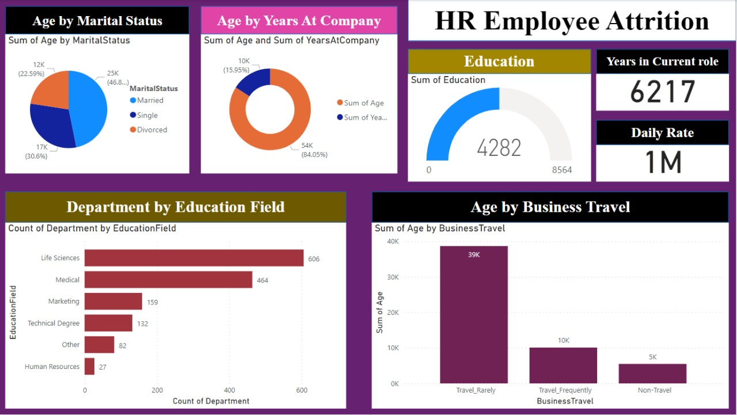

**Age by Business Travel**

When examining the sum of ages based on different business travel patterns, distinct trends emerge:

**Non-Travel (40K):**

Employees who do not undertake business travel contribute significantly to the age sum. This suggests a stable workforce with established professionals

**Travel Rarely (39K):**

A comparable sum of ages is observed among those who travel infrequently. This indicates a balanced mix of experience and potential within this group.

**Travel Frequently (30K):**

Employees engaged in frequent business travel also contribute to the age sum, albeit slightly lower. This could reflect a preference for younger or more mobile talent in roles requiring frequent travel.

The data highlights the age distribution in relation to business travel habits, shedding light on the composition of various segments. These insights can guide targeted HR strategies, catering to the needs and strengths of each group to ensure an optimized and dynamic workforce.

**Job Role by Monthly Income**

1. Sales Executives have the highest percentage of 2 million income, highlighting their substantial contribution to the organization's revenue.

2. Managers also earn a significant portion of 2 million, indicating recognition of their leadership responsibilities.

3. Research Directors and Manufacturing Directors share a sizeable percentage at 1 million, underlining their important roles in guiding research and manufacturing efforts.

4. Healthcare Representatives and Research Scientists each receive 1 million income, reflecting their valuable contributions in healthcare and research domains.

5. Laboratory Technicians, with 8.77% at 1 million, play a crucial support role across departments.

**Hourly Rate by Job Role**

Analyzing the hourly rate fluctuations among different job roles sheds light on theoretical compensation dynamics**:**

**Increasing Trends:**

**Sales Executive:**

The rising hourly rate for sales executives (21K) signifies the organization's recognition of their pivotal role in revenue generation and client relationships.

**Research Scientist:**

With a competitive rate (19K), research scientists' continuous pursuit of knowledge and innovation is rewarded.

**Stable Trend:**

**Laboratory Technician:**

The consistent hourly rate (17K) for laboratory technicians reflects the stability of their crucial support role, ensuring smooth operations.

**Decreasing Trend:**

**Manufacturing Director:**

A potentially decreasing hourly rate (9K) for manufacturing directors might stem from balancing managerial duties and operational intricacies in production.

**Comparable Rates:**

**Healthcare Representation:**

Similar hourly rates (9K) for healthcare representatives and manufacturing directors could signify comparable responsibilities and strategic roles.

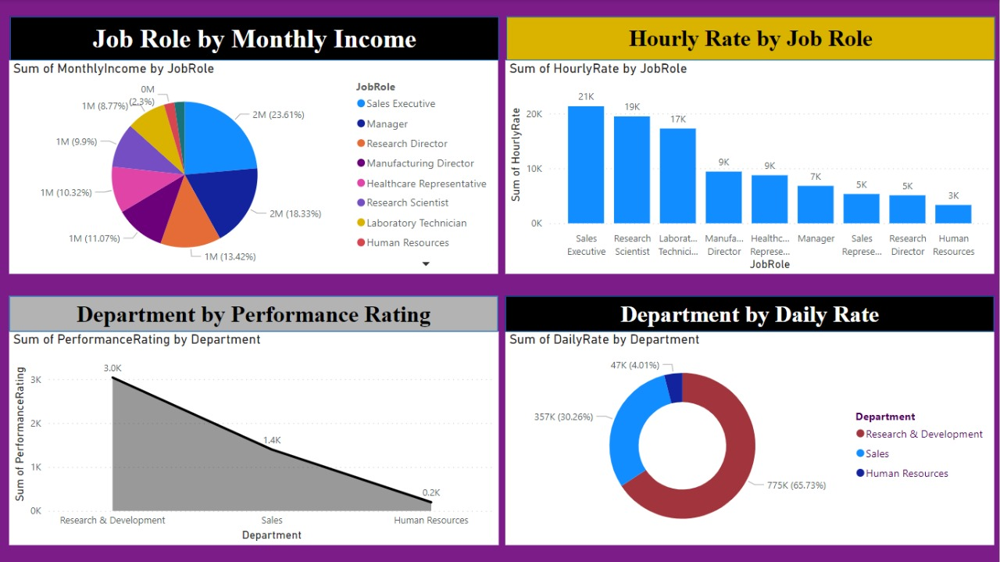

**RECOMMENDATIONS FOR IBM BASED ON OBSERVED VISUALS**

**Efficiently Clustered Column Chart:**

The clustered column chart vividly depicts the age and gender distribution.

Notably, individuals around the age of 30 are significantly prevalent, indicating a substantial workforce within this age bracket.

A strategic focus on harnessing the potential of this workforce segment could enhance productivity and innovation.

**Line and Clustered Column Chart:**

The visuals strongly suggest that technology-related sales have a remarkable presence.

To capitalize on this trend, IBM should consider augmenting its technology offerings, ultimately bolstering sales and market positioning.

Concurrently, assessing and possibly reducing product manufacturing can mitigate potential losses, aligning with market demand.

These recommendations, rooted in the observed visuals, hold the potential to guide IBM towards optimizing its workforce, leveraging high-demand sectors, and ensuring efficient resource allocation for enhanced profitability and market standing.

**Conclusion:**

**Leveraging HR Data for Informed Excellence**

The project titled "Analysis of HR Datasets to Help the Organization Take Informed Decisions and Excel in Businesses" underscores the importance of data-driven decision-making within the realm of human resources. By employing advanced tools and technologies like Excel and Power BI, IBM India embarked on a journey to extract valuable insights from intricate HR datasets.

The project's structured methodology encompassed initiation, data collection, exploratory analysis, hypothesis formulation, advanced analysis, visualization, recommendations, and continuous improvement. This approach enabled IBM to unlock key insights related to age, education, job roles, travel habits, income, and more. These insights offer actionable strategies for enhancing employee satisfaction, retention, and overall business performance.

IBM's commitment to utilizing data-driven insights, evident through diverse visualization techniques, underscores their dedication to strategic decision-making. Through precise interpretation of data trends and patterns, the organization identifies areas for improvement, harnessing the strengths of its workforce while addressing potential gap

The conclusions drawn from various visualizations further guide IBM's recommendations for fine-tuning their strategies. From optimizing workforce engagement to leveraging high-performing sectors like technology, the organization can navigate the dynamic business landscape more effectively.

In a world where informed decisions are pivotal, IBM's proactive approach to data analysis exemplifies their dedication to not just excel but lead in their endeavors. Through the integration of data insights and actionable strategies, this project serves as a testament to IBM's commitment to harnessing the power of HR data to drive excellence and innovation.

**THANK YOU**