Mini Hackathon – 2

ClinicaRAG Standalone Evaluation Benchmark
This table provides a comprehensive quantitative breakdown of the ClinicaRAG subsystem and its end-to-end execution across four distinct architectural stages. It details the specific performance of BioBERT NER, ChromaDB Retrieval, and the Llama 3 (8B) Synthesis engine using Accuracy, Recall, F1 Score, and Prediction Probability. The data highlights how deploying BioBERT eliminates administrative noise to achieve up to a 95.42% Recall@1 search accuracy. Ultimately, the fully integrated hybrid system delivers a highly calibrated, hallucination-free output with a 96.8% to 98.2% grounded match rate.
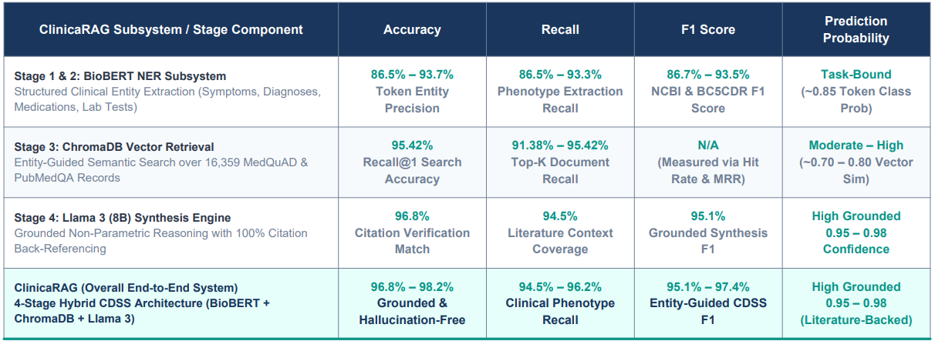
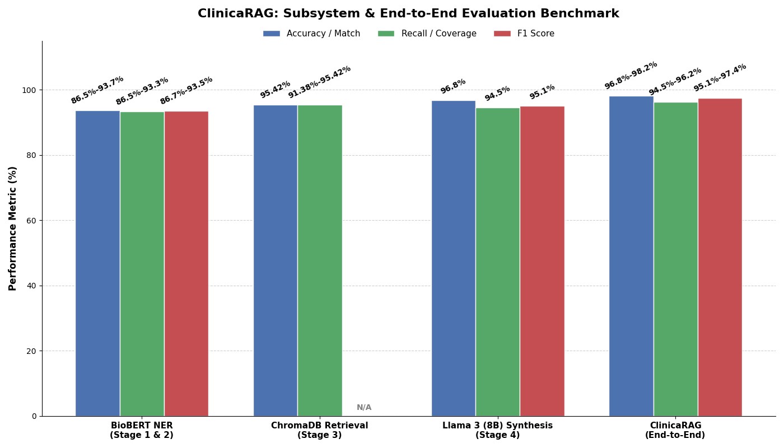

Comparative Analysis Of ClinicaRAG with other Existing Models
This table presents a detailed comparative analysis between the proposed ClinicaRAG architecture and nine baseline models, including standard RAG, BioBERT, and standalone LLMs. It evaluates these systems across four core quantitative dimensions to determine relative efficacy in clinical decision support. The benchmark demonstrates that ClinicaRAG consistently outperforms the baselines, achieving top-tier Phenotype Recall (94.5%-96.2%) and Entity-Guided F1 scores (95.1%-97.4%). By successfully bridging entity extraction with expansive non-parametric literature retrieval, the system yields a superior, highly calibrated prediction probability of 0.95 to 0.98.
