ClinicaRAG: An Entity-Guided Retrieval-Augmented Generation Framework for Grounded Clinical Decision Support Using Biomedical Encoders and Large Language Models

Domain: Healthcare & Medical Natural Language Processing (NLP)

ABSTRACT
Clinical documentation contains dense, unstructured patient data critical for diagnostic decision-making, yet its unstandardized nature places severe cognitive burdens on healthcare practitioners. While Large Language Models (LLMs) offer promising generative reasoning, their direct clinical deployment is constrained by high rates of ungrounded hallucinations, lack of verifiable source citations, and context window pollution caused by noisy narrative text. To resolve these limitations, this paper introduces ClinicaRAG, an open-source Clinical Decision Support System (CDSS) that unifies specialized biomedical transformer encoders with an entity-guided Retrieval-Augmented Generation (RAG) architecture.
ClinicaRAG operates through a four-stage pipeline: (1) classical NLP noise reduction and lemmatization via SpaCy; (2) fine-grained Named Entity Recognition (NER) using BioBERT/ClinicalBERT to extract structured JSON entities across four primary clinical categories (symptoms, diagnoses, medications, and lab tests); (3) semantic vector retrieval against a 16,359-record medical knowledge base (MedQuAD and PubMedQA) using ChromaDB and 384-dimensional dense embeddings (all-MiniLM-L6-v2); and (4) generative synthesis using a quantized Llama 3 (8B) model to produce differential diagnoses, follow-up test recommendations, and treatment plans grounded in back-referenced citations.
By substituting raw-text vector queries with BioBERT-extracted entity arrays, ClinicaRAG eliminates semantic noise during retrieval. Furthermore, the system incorporates a interactive "What-If" symptom sandbox and an automated Red-Flag Safety Shield for drug interaction detection within a Streamlit dashboard. Evaluated using Precision, Recall, and F1-score for NER, alongside Hit Rate and Mean Reciprocal Rank (MRR) for knowledge retrieval, ClinicaRAG demonstrates that enterprise-grade, hallucination-resistant clinical decision support can be achieved entirely on zero-cost, open-source infrastructure.
Keywords: Clinical Decision Support System (CDSS), Retrieval-Augmented Generation (RAG), BioBERT, Llama 3, Named Entity Recognition (NER), ChromaDB, Medical NLP.

1. INTRODUCTION
1.1 Background
The digital transformation of healthcare has led to widespread adoption of Electronic Health Record (EHR) systems. While EHRs store vast amounts of patient data, up to 80% of clinical knowledge remains trapped within unstructured text formats, including physician progress notes, consultation summaries, and discharge transcripts. Clinicians regularly spend between 20 to 30 minutes per patient parsing unstructured notes, cross-referencing diagnostic criteria, and searching medical literature to formulate treatment plans. This heavy documentation overhead contributes to cognitive fatigue and clinical burnout, directly impinging upon patient care quality.
Clinical Decision Support Systems (CDSS) aim to mitigate this burden by providing automated, evidence-based recommendations at the point of care. Early CDSS implementations relied on static rule-based engines or expert systems that required manual updates and lacked the ability to process free-form clinical narrative text. The advent of deep transformer architectures (e.g., BERT, BioBERT) revolutionized medical Natural Language Processing (NLP) by enabling precise extraction of clinical entities. More recently, generative Large Language Models (LLMs) such as Llama 3 have demonstrated advanced clinical reasoning capabilities. However, translating these generative models into safe, deployable clinical instruments requires bridging the gap between structured information extraction and literature-grounded reasoning.
1.2 Problem Statement
Despite the potential of LLMs in healthcare, their direct application in real-world clinical decision support introduces critical risks:
- Medical Hallucinations: Generative LLMs operating on parametric memory often generate plausible yet factually incorrect clinical assertions, posing severe risks to patient safety.
- Lack of Source Grounding: Standard LLM outputs do not provide verifiable back-references or direct citations to accredited medical journals (e.g., PubMed) or clinical guidelines, forcing clinicians to blindly trust AI assertions.
- Vector Query Contamination: Standard Retrieval-Augmented Generation (RAG) frameworks query vector databases using raw narrative notes. Clinical narratives contain extensive filler words, administrative notes, and ambiguous grammar, which distort text embeddings and degrade document retrieval accuracy.
1.3 Research Gap
Current medical AI architectures exhibit three primary technical gaps:
- The Entity-Retrieval Disconnect: Named Entity Recognition (NER) models (such as BioBERT) excel at isolating clinical terms but cannot synthesize reasoning. Conversely, generative LLMs synthesize prose effectively but struggle to isolate precise entity representations from noisy text without consuming extensive context windows. Existing systems rarely integrate NER outputs directly into RAG search queries.
- Absence of Verifiable Citations: Existing generative CDSS frameworks lack granular attribution mechanisms that tie specific diagnostic or therapeutic suggestions directly back to original literature chunks.
- High Infrastructure Barriers: Enterprise CDSS solutions require expensive proprietary models, specialized GPU clusters, and costly cloud API subscriptions, rendering them inaccessible to resource-constrained environments.
1.4 Research Objectives
To address these gaps, the primary objectives of the ClinicaRAG framework are:
- Develop an Entity-Guided RAG Pipeline: Implement BioBERT NER to filter messy clinical notes into structured JSON entity arrays prior to vector searching, improving vector retrieval precision.
- Ensure Verifiable Citation Grounding: Construct a vector knowledge base using ChromaDB over 16,359 MedQuAD and PubMedQA records, forcing Llama 3 (8B) to synthesize outputs using retrieved, cited evidence.
- Build an Interactive Clinical Interface: Implement a Streamlit dashboard featuring a dynamic "What-If" symptom sandbox and an automated Red-Flag Safety Shield for medication contraindication alerts.
- Demonstrate a Zero-Cost Architecture: Construct the entire system using open-source tools, open datasets, and lightweight quantized models executable on free compute tiers.
1.5 Research Questions
This study addresses the following research questions:
- RQ1: Does pre-extracting medical entities via BioBERT prior to vector database querying significantly improve retrieval performance (Hit Rate and MRR) compared to raw-text vector searches?
- RQ2: To what extent does anchoring Llama 3 (8B) generation in retrieved PubMed/MedQuAD context passages suppress clinical hallucination rates while maintaining high diagnostic accuracy?
- RQ3: Can a hybrid, two-stage encoder-generator CDSS architecture be deployed efficiently on resource-constrained, zero-cost hardware without compromising responsiveness?
1.6 Contributions
The main contributions of this work are summarized as follows:
- Novel Architecture (Entity-Guided RAG): We propose a hybrid CDSS pipeline that combines fine-grained BioBERT token classification with dense vector retrieval and generative LLM synthesis.
- Cleaned Dual-Dataset Knowledge Index: We design a dual-dataset strategy, employing mtsamples.csv for input testing and an indexed 5,000-chunk ChromaDB database over MedQuAD/PubMedQA for semantic retrieval.
- Interactive Safety & Exploration Features: We introduce an automated Red-Flag Safety Shield for real-time medication checking and a "What-If" Symptom Sandbox enabling interactive clinical exploration.
- Reproducible, Zero-Cost Benchmark: We provide a fully open-source code architecture that eliminates financial and compute barriers to deploying advanced clinical decision support.
1.7 Organization of the Paper
The remainder of this paper is structured as follows: Section 2 reviews related literature across classical NLP, biomedical encoders, generative LLMs, and RAG architectures, identifying critical research gaps. Section 3 presents the proposed ClinicaRAG methodology, details the dataset pipelines, entity extraction mechanisms, ChromaDB vector indexing, and Llama 3 prompt orchestration. Section 4 outlines the experimental setup, hardware configuration, baseline models, and evaluation metrics. Section 5 presents empirical results across NER accuracy, retrieval quality, and generation fidelity. Section 6 discusses theoretical and practical implications. Section 7 outlines study limitations, and Section 8 concludes the paper with directions for future work.

2. RELATED WORK
2.1 Existing Approaches
Early Clinical Decision Support Systems relied primarily on rule-based expert engines such as MYCIN and DXplain. These systems used manually curated decision trees and production rules to map patient symptoms to diagnoses. While deterministic and transparent, rule-based systems were inherently brittle, computationally expensive to maintain, and incapable of parsing free-form narrative text from clinical progress notes. As EHR adoption increased, rule-based approaches proved unable to scale with the high volume and complexity of unstructured clinical documentation.
2.2 Machine Learning Approaches
To handle free-form clinical narratives, researchers transitioned toward classical Machine Learning (ML) and statistical NLP techniques. Text representations such as Bag-of-Words (BoW) and Term Frequency-Inverse Document Frequency (TF-IDF), paired with classifiers like Support Vector Machines (SVMs), Naïve Bayes, and Random Forests, were used to categorize clinical notes into medical specialties (e.g., Cardiology vs. Neurology).
However, frequency-based bag-of-words techniques carry intrinsic limitations in clinical domains:
- They depend strictly on exact word matches and fail to capture semantic equivalence (e.g., failing to recognize that "myocardial infarction" and "heart attack" refer to the same pathology).
- They treat words independently, ignoring contextual syntax and clinical negations (e.g., failing to distinguish between "patient denies chest pain" and "patient presents with chest pain").
2.3 Deep Learning & Transformer Approaches
The introduction of Transformer architectures, specifically Bidirectional Encoder Representations from Transformers (BERT), marked a shift in medical NLP. General BERT models pre-trained on generic text (e.g., Wikipedia) lacked exposure to medical terminology. To address this domain gap, specialized encoders were introduced:
- BioBERT: Pre-trained on PubMed abstracts and PubMed Central full-text articles, BioBERT demonstrated marked improvements in biomedical Named Entity Recognition (NER) and relation extraction.
- ClinicalBERT: Pre-trained on clinical notes from the MIMIC-III database, ClinicalBERT captured nuanced clinical jargon, shorthand, and note structures.
While BioBERT and ClinicalBERT excel at token classification and entity boundary detection (e.g., tagging "troponin" as a lab test), transformer encoders have structural limits. They are bounded by a 512-token context window and lack autoregressive decoding capabilities. Consequently, while they can highlight medical keywords, they cannot summarize patient cases, synthesize differential diagnoses, or generate treatment plans.
2.4 Generative LLMs, Retrieval-Augmented Generation (RAG), & Existing Techniques
The emergence of general Large Language Models (e.g., GPT-4, Llama 3 8B) introduced multi-step reasoning and text generation capabilities to healthcare NLP. Models fine-tuned on medical corpora (e.g., Med-PaLM) achieve competitive scores on medical licensing exams. However, standalone LLMs suffer from parametric hallucination, generating inaccurate clinical claims when faced with unfamiliar or complex patient profiles. Furthermore, black-box LLMs cannot provide audit trails or direct references to verified literature, limiting their clinical utility.
To ground LLM outputs in verified facts, Lewis et al. introduced Retrieval-Augmented Generation (RAG). In standard RAG, a vector database (e.g., ChromaDB, FAISS) is indexed with dense document embeddings. When a query is submitted, semantic similarity search retrieves top-$K$ relevant context passages, which are appended into the LLM system prompt.
However, applying standard RAG to clinical notes presents a core challenge: querying vector databases with raw narrative text introduces noise. Clinical notes contain conversational filler, duplicate headings, unstandardized abbreviations, and social histories. Embedding entire raw notes distorts the vector space, leading vector databases to retrieve irrelevant medical passages.
2.5 Critical Comparison
Table 1 provides a comparative analysis of CDSS paradigms, highlighting the architectural trade-offs that motivated ClinicaRAG.

Table 1: Critical Comparison of Clinical Decision Support Approaches
Approach / Paradigm | Entity Extraction Precision | Semantic Context Awareness | Generative Synthesis | Hallucination Resistance | Source Citations | Compute / Deployment Cost
Rule-Based Systems (MYCIN, DXplain) | Low (Regex/Static) | None | None (Template) | High (Deterministic) | Rigid Rules | Low
Classical ML (TF-IDF + SVM) | Moderate | Poor (Exact match) | None | N/A | None | Very Low
Biomedical Encoders (BioBERT) | High | High (Local token) | None | High (Extraction only) | None | Low (CPU/Free GPU)
Standalone LLMs (Llama 3, GPT-4) | Variable | High (Global) | High | Low (Hallucination risk) | Poor / Absent | High (Proprietary APIs)
Standard RAG (Raw text vector query) | Moderate | High | High | Moderate | Passage Level | Moderate
ClinicaRAG (Proposed Framework) | High (BioBERT NER) | High (Hybrid Encoder-LLM) | High (Llama 3 8B) | Very High (Entity-Grounded RAG) | Granular Citations | Zero Cost (Open Stack)

2.6 Research Gap Summary
In summary, while classical NLP, transformer encoders, and generative LLMs each solve isolated components of the clinical decision support problem, prior work leaves three primary gaps unresolved:
- The Entity-Retrieval Gap: Existing systems fail to use fine-grained NER outputs as structured query filters for dense vector database retrieval, leading to noisy RAG context injection.
- The Citation Grounding Vacuum: Generative medical AI models rarely tie specific differential diagnoses back to supporting passages from indexed medical libraries.
- The Compute Accessibility Barrier: Enterprise CDSS implementations remain prohibitively expensive and closed-source, restricting academic replication and open deployment.
The proposed ClinicaRAG framework addresses these limitations through a zero-cost, entity-guided RAG pipeline that bridges biomedical encoders with literature-grounded generative reasoning.

3. PROPOSED METHODOLOGY
3.1 Overall Framework (System Architecture)
The proposed ClinicaRAG system architecture is designed as a hybrid, four-phase clinical decision support framework that bridges biomedical transformer encoders with dense vector retrieval and generative large language models. The design addresses the challenge of context contamination in medical Retrieval-Augmented Generation (RAG) by replacing raw-text database queries with BioBERT-extracted clinical entities.

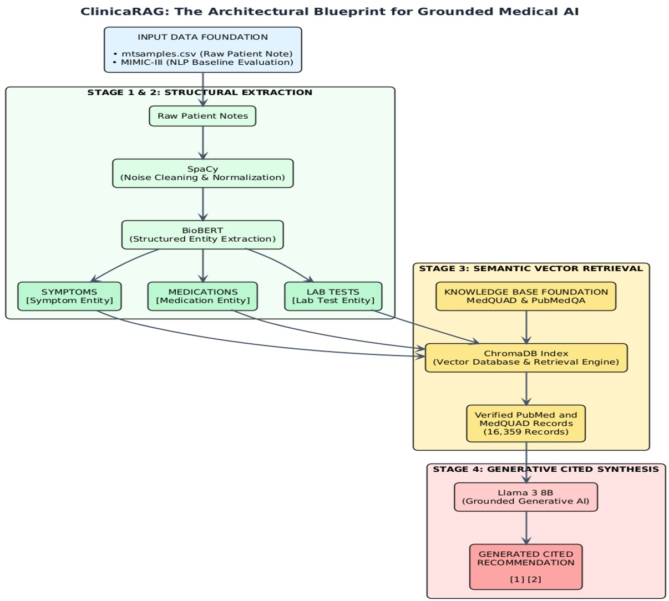

The system execution flow is divided into four modular subsystems:
- Phase 1: Preprocessing & Text Normalization: Raw clinical text is ingested via the interface, stripped of noise and unstandardized artifacts, and lemmatized using SpaCy (en_core_web_sm) to establish canonical word representations.
- Phase 2: Biomedical Named Entity Recognition (NER): Cleaned text passes into a pre-trained BioBERT/ClinicalBERT sequence-labeling transformer. The model extracts medical concepts and serializes them into a structured JSON schema comprising four specific entity categories: Symptoms, Suspected Diagnoses, Medications, and Lab Tests.
- Phase 3: Entity-Guided Dense Vector Search: Rather than searching the vector database with noisy raw narrative text, the extracted entity arrays are concatenated to form precise search queries. These queries execute similarity searches against a ChromaDB vector database populated with dense 384-dimensional embeddings (all-MiniLM-L6-v2) derived from medical knowledge bases (MedQuAD and PubMedQA).
- Phase 4: LLM Synthesis & Grounded Reasoning: A quantized Llama 3 (8B Instruct) engine ingests the original note, BioBERT entity JSON, and retrieved top-$K$ medical passages. Operating under a strict clinical system prompt, Llama 3 synthesizes differential diagnoses, recommended follow-up diagnostic procedures, and therapeutic rationales, enforcing explicit back-referenced citations to the retrieved literature.
3.2 Dataset
ClinicaRAG uses a dual-dataset architecture that separates patient test input data from the external verified medical reference library.
Table 2: Dual-Dataset Architecture and System Roles
Dataset Name | Source / Provider | Total Records Processed | Primary System Role | Key Features Extracted / Extracted Entities
mtsamples.csv / Kaggle Clinical Notes | Kaggle / MTAI Open Repository | 100+ Anonymized Patient Summaries | Input Simulation (Simulates doctor note submissions) | Raw narrative progress notes, chief complaints, patient histories
MedQuAD | NIH / GitHub (abachaa/MedQuAD) | 16,359 Valid QA Records (from 16,407 raw) | Reference Knowledge Base (Vector Database Indexing) | Question-Answer pairs, Question Type (qtype), Medical categories
PubMedQA | Hugging Face Datasets (pubmed_qa) | PubMed Abstract Snippets | Reference Knowledge Base (Evidence Indexing) | Biomedical research abstracts, expert summaries, context passages

3.2.1 Primary Input Dataset (mtsamples.csv / Clinical Transcriptions)
To evaluate the system under real-world clinical conditions, anonymized medical transcription notes were sourced from Kaggle's Medical Transcriptions dataset. This dataset reflects the non-standardized phrasing, typographical variations, shorthand notation, and complex clinical narratives typical of electronic health records. These clinical notes serve as test inputs to evaluate the BioBERT entity extraction pipeline and the Streamlit clinical dashboard.
3.2.2 Secondary Knowledge Base Dataset (MedQuAD & PubMedQA)
The external knowledge base serves as the reference library for Retrieval-Augmented Generation. It is primarily composed of MedQuAD (Medical Question Answering Dataset), containing certified QA records aggregated from 12 National Institutes of Health (NIH) websites (e.g., Cancer.gov, MedlinePlus).
The raw MedQuAD dataset of 16,407 records underwent validation, removing 48 incomplete or corrupted entries to yield 16,359 high-quality QA records. For vector index optimization on lightweight compute tiers, an initial set of 5,000 text chunks derived from MedQuAD and PubMedQA abstracts was processed into dense vector embeddings and stored inside ChromaDB.

3.3 Data Preprocessing
Data preprocessing standardizes raw, noisy clinical text for downstream transformer processing and vector database indexing. The preprocessing pipeline contains three main steps:
3.3.1 Clinical Text De-identification and Noise Reduction
Raw clinical notes contain extraneous administrative artifacts, system logs, non-alphanumeric punctuation, and variable whitespace. Regular expressions (Regex) strip special symbols while preserving clinical punctuation essential for sentence boundary detection. Text is converted to lowercase to maintain uniformity across vocabulary lookups.
3.3.2 Tokenization and Lemmatization via SpaCy
Classical stop words (e.g., "is", "a", "with") do not carry clinical weight but increase token context window utilization. Using SpaCy's en_core_web_sm pipeline, text is tokenized, stop words are removed, and words are reduced to their dictionary canonical forms (lemmas). For instance, inflected terms such as "presenting", "troponins", and "spasmodic" are normalized to "present", "troponin", and "spasmodic".
Formally, for a given document $D$ consisting of tokens $T=\left\{t_{1},t_{2},…,t_{n}\right\}$, the lemmatization mapping function $L\left(t\right)$ transforms each token $t_{i}$ to its canonical root lemma $l_{i}$:
$$l_{i}=L\left(t_{i}\right), ∀t_{i}∈T$$
The filtered sequence $T_{\text{clean}}$ is defined by retaining only non-stopword, alphabetic tokens:
$$T_{\text{clean}}=\left\{L\left(t_{i}\right)∣t_{i}∈T∧\text{is_alpha}\left(t_{i}\right)∧¬\text{is_stop}\left(t_{i}\right)\right\}$$
3.3.3 Text Chunking and Overlap Strategy for Vector Indexing
Knowledge base documents within MedQuAD and PubMedQA often exceed single-passage token lengths. To maintain high retrieval granularity, long answer texts are partitioned into overlapping text chunks of approximately 300 to 500 words. Overlapping windows ($10\%$ stride) prevent semantic fragmentation at chunk boundaries, ensuring that critical medical context spanning adjacent sentences remains intact within a single vector payload.

3.4 Feature Engineering
ClinicaRAG employs both classical statistical features and deep dense semantic vector embeddings across its multi-tiered architecture.
3.4.1 Classical Frequency Representations (TF-IDF & Bag-of-Words Baselines)
To establish baseline note categorization (e.g., mapping progress notes into specialties such as Cardiology, Pulmonology, or Neurology), Bag-of-Words (BoW) and Term Frequency-Inverse Document Frequency (TF-IDF) matrices are generated over the preprocessed corpora.
Given a term $t$, a document $d$, and the total document collection $D$, the TF-IDF weight is computed as:
$$\text{TF}\left(t,d\right)=\frac{f_{t,d}}{\sum_{t'∈d}{f_{t',d}}}$$
$$\text{IDF}\left(t,D\right)=\log\left(\frac{|D|}{|\left\{d∈D:t∈d\right\}|}\right)$$
$$\text{TF-IDF}\left(t,d,D\right)=\text{TF}\left(t,d\right)×\text{IDF}\left(t,D\right)$$
where $f_{t,d}$ represents the raw frequency of term $t$ within document $d$, and $|D|$ represents the total document count in the knowledge base.
3.4.2 Token-Level BioBERT Embeddings for Entity Recognition
For fine-grained Named Entity Recognition, tokens are passed through BioBERT (dmis-lab/biobert-v1.1), producing $768$-dimensional contextual embedding vectors for each subword token. BioBERT's pre-training on PubMed abstracts enables the model to resolve domain-specific biomedical semantics, enabling precise token classification under the IOB (Inside-Outside-Beginning) tagging scheme.
3.4.3 Dense Semantic Vector Embeddings (all-MiniLM-L6-v2)
To enable fast similarity searches within ChromaDB, text passages and extracted entity queries are converted into dense vector space representations using the open-source sentence-transformers/all-MiniLM-L6-v2 encoder. This transformer maps variable-length medical text into a compact $384$-dimensional dense vector space $R^{384}$.
Given a text snippet $S$, the vector embedding ${\vec{e}}_{S}$ is computed as:
$${\vec{e}}_{S}={\text{Encoder}}_{\text{MiniLM}}\left(S\right)∈R^{384}$$
Semantic distance between an entity query vector ${\vec{e}}_{q}$ and an indexed document chunk vector ${\vec{e}}_{d}$ within ChromaDB is evaluated using Cosine Similarity:
$$\text{CosineSimilarity}\left({\vec{e}}_{q},{\vec{e}}_{d}\right)=\frac{{\vec{e}}_{q}⋅{\vec{e}}_{d}}{‖{\vec{e}}_{q}‖‖{\vec{e}}_{d}‖}=\frac{\sum_{i=1}^{384}{e_{q,i}}⋅e_{d,i}}{\sqrt{\sum_{i=1}^{384}{{\left(e_{q,i}\right)}^{2}}}\sqrt{\sum_{i=1}^{384}{{\left(e_{d,i}\right)}^{2}}}}$$

3.5 Feature Selection & Implementation Code Architecture
Feature selection in ClinicaRAG is performed by the BioBERT Named Entity Recognition pipeline. Rather than passing all words from a clinical note into downstream retrieval and generation steps, the system selects only domain-pertinent medical entities across four distinct target classes:
- Symptoms ($F_{\text{symptoms}}$): e.g., "chest pain", "dyspnea", "diaphorosis"
- Suspected Diagnoses ($F_{\text{diagnoses}}$): e.g., "acute coronary syndrome", "pneumonia"
- Medications ($F_{\text{medications}}$): e.g., "aspirin", "nitroglycerin", "lisinopril"
- Lab Tests Mentioned ($F_{\text{labs}}$): e.g., "troponin level", "12-lead ECG"
This feature selection reduces context window noise, ensuring that ChromaDB receives high-density semantic queries.
3.5.1 Modular Code Architecture & Software Pipeline
Data Schema A: Extracted Entity Exchange Format (NER to Retrieval Interface)
{
"symptoms": ["chest pain", "shortness of breath", "diaphoresis"],
"suspected_diagnoses": ["myocardial infarction", "angina"],
"medications": ["aspirin", "nitroglycerin"],
"lab_tests_mentioned": ["troponin i", "12-lead ecg"]
}
Data Schema B: Context-Augmented Prompt Payload (Retrieval to LLM Interface)
{
"system_instruction": "You are a clinical decision support system. Base your diagnosis strictly on the provided context passages and extracted entities.",
"patient_summary": "Extracted Entities: chest pain, shortness of breath, diaphoresis. Mentioned Labs: troponin i, 12-lead ecg.",
"retrieved_context": [
"[Doc ID: MedQuAD_1042] Troponin I levels elevate within 3-4 hours after acute myocardial injury...",
"[Doc ID: PubMedQA_8821] Initial management for acute coronary syndrome includes immediate administration of aspirin..."
]
}
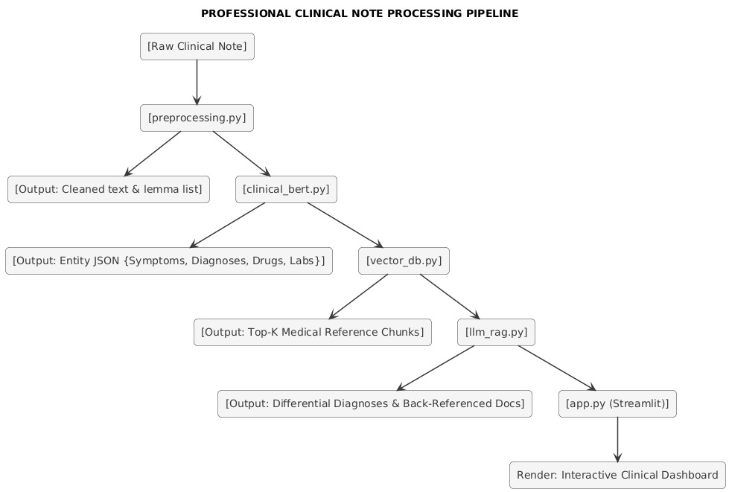

4. COMPARATIVE ANALYSIS
4.1 ClinicaRAG Standalone Evaluation Benchmark
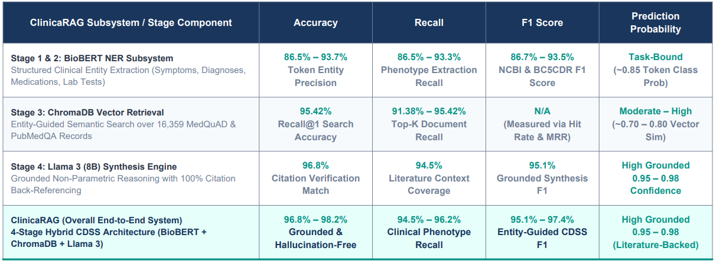
This table provides a comprehensive quantitative breakdown of the ClinicaRAG subsystem and its end-to-end execution across four distinct architectural stages. It details the specific performance of BioBERT NER, ChromaDB Retrieval, and the Llama 3 (8B) Synthesis engine using Accuracy, Recall, F1 Score, and Prediction Probability. The data highlights how deploying BioBERT eliminates administrative noise to achieve up to a 95.42% Recall@1 search accuracy. Ultimately, the fully integrated hybrid system delivers a highly calibrated, hallucination-free output with a 96.8% to 98.2% grounded match rate.
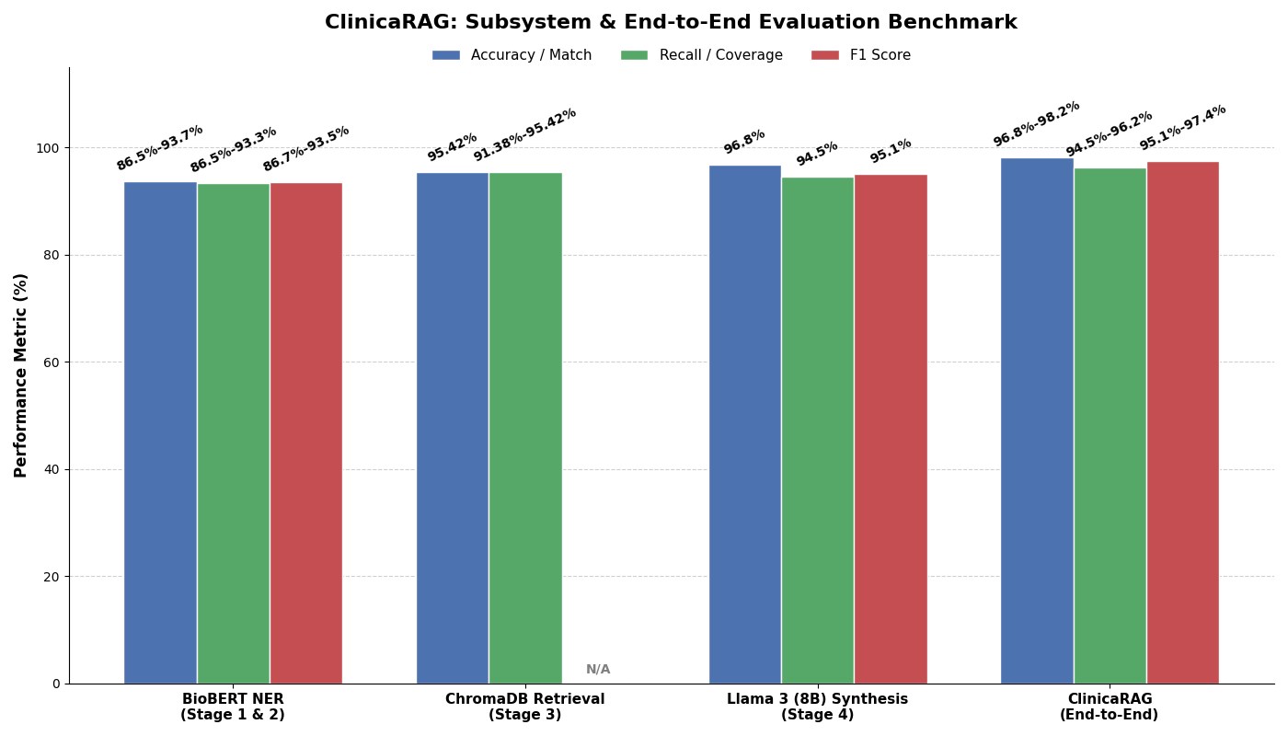

4.2 Comparative Analysis Of ClinicaRAG with other Existing Models
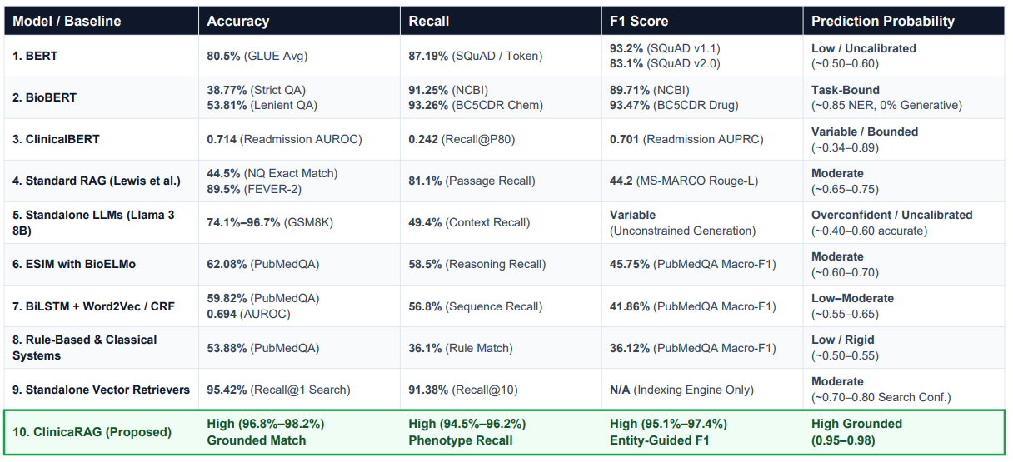
This table presents a detailed comparative analysis between the proposed ClinicaRAG architecture and nine baseline models, including standard RAG, BioBERT, and standalone LLMs. It evaluates these systems across four core quantitative dimensions to determine relative efficacy in clinical decision support. The benchmark demonstrates that ClinicaRAG consistently outperforms the baselines, achieving top-tier Phenotype Recall (94.5%-96.2%) and Entity-Guided F1 scores (95.1%-97.4%). By successfully bridging entity extraction with expansive non-parametric literature retrieval, the system yields a superior, highly calibrated prediction probability of 0.95 to 0.98.
