

**International School**

**CDIO Project**

# CMU-CS 477 – FIMS

**Project Proposal**

**Version 1.1**

**Date: January 9th, 2024**

**FIMS Mobile Shop**

**Submitted by**

**Tan, Ngo Ngoc**

**Kien, Le Trung**

**Nam, Hai Luu**

**Van, Nguyen Nhu**

**Approved by**

**MSc Huy, Truong Dinh**

**Proposal Review Panel Representative:**

Name Signature Date

# Capstone Project 2- Mentor:

Name Signature Date

# PROJECT INFORMATION

|  |  |  |  |
| --- | --- | --- | --- |
| **Project acronym** | FMS | | |
| **Project Title** | FMS | | |
| **Start Date** | 09 Jan 2024 | **End Date** | 12 Mar 2024 |
| **Lead Institution** | International School, Duy Tan University | | |
| **Project Mentor** | MSc Huy, Truong Dinh | | |
| **Scrum master / Project Leader & contact details** | Tan, Ngo Ngoc  Email: [ngoctan4677@gmail.com](mailto:ngoctan4677@gmail.com) Tel: 0918809264 | | |
| **Partner Organization** | Duy Tan University | | |
| **Project Web URL** |  | | |
| **Team members** | Name | Email | Tel |
|  | Tan, Ngo Ngoc | [ngoctan4677@gmail.com](mailto:ngoctan4677@gmail.com) | 0918809264 |
|  | Kien, Le Trung | [letrungkien6@dtu.edu.vn](mailto:letrungkien6@dtu.edu.vnm) | 0935632864 |
|  | Nam, Hai Luu | [hainamluu01@gmail.com](mailto:hainamluu01@gmail.com) | 0972519223 |
|  | Van, Nguyen Nhu | [nguyennhuvan@dtu.gmail.com](mailto:nguyennhuvan@dtu.gmail.com) | 0345193154 |

The following signatures are required for approval of this document.

|  |  |  |
| --- | --- | --- |
| Tan, Ngo Ngoc  Student ID: 27211237763  *Scrum Master* | Signature | Date |
| Kien, Le Trung  Student ID: 27211202741  *Team Member* | Signature | Date |
| Nam, Luu Hai  Student ID: 27211201241  *Team Member* | Signature | Date |
| Van, Nguyen Nhu  Student ID: 27211200722 *Team Member* | Signature | Date |

**REVISION HISTORY**

|  |  |  |  |
| --- | --- | --- | --- |
| **Version** | **Date** | **Comments** | **Author** |
| 1.0 | Jan 09th, 2021 | Initial Release | FIMS Team |
| 1.1 | Jan 12th, 2021 | Update Current Status  of Art | FIMS Team |

1. Introduction 5
   1. Purpose Of Document 5
   2. Project Goal 5
2. Problem Definition 5
   1. Business need 5
   2. Solution 6
3. Current Status of Art 6
4. Engineering Approach 7
   1. System context description 7
   2. Technical Constraints 8
5. Tasks and Deliverables 10
6. Project Management 11
   1. Cost/Budget for Project 11
   2. Tentative Schedule 12
      1. Master Plan 12
      2. Scrum Process 13
7. Project Constraints 14
8. Conclusion 16
9. References 16
10. Attachment 16

# Introduction

# Purpose of Document

* The document provides an overview of the project includes the purpose and scope of the project.
* Identify business needs, problems or situations related to the initialization and construction projects.
* Provide solutions for business needs and give the overview of system architecture.
* Provide overview about resources, schedule, solution and budget for the project.

# Project Goal

"FMS" offers a comprehensive system to efficiently manage phone products across various branches of our store. The primary objective is to streamline the remote purchasing process and keep users informed about the latest product models. Through our user-friendly interface, customers can easily navigate through the extensive product catalog, gaining access to detailed information, specifications, and customer reviews. This ensures that users make informed decisions when selecting their desired phones.

# Problem Definition

With the current mobile phone market, the ability to search and compare is limited when buying directly at stores. Therefore, having a website to describe the configuration parameters and prices of phone models without having to go directly to the store is really essential. In addition, some customers need remote consultation and remote support, and the website can answer the problems that users have.

# Business need

- Users can interact with website administrators for easy consultation.

* The website can display updated information about the latest phone models.
* The website can display all product specifications.

# Solution

- Create a modern, friendly and easy-to-use user interface on any device, especially on mobile phones.

- Build a smart and flexible search system, helping users easily search for products, filter by price, features and brand.

- Optimize page load times, improve performance and smooth user experience, especially on mobile devices.

- Create attractive reward programs for customers who regularly shop, increasing loyalty and customer retention.

- Provide an online consulting support system, helping users get more information and choose suitable products.

- Integrates product review and rating functions, helping users have a comprehensive view of product quality.

- Supports many safe and convenient payment methods, increasing flexibility for users.

- Provide detailed and complete information about each product, helping users make accurate shopping decisions.

- Organize special promotions, incentives for special events, increase user interest.

- Provide shipping tracking service so users can conveniently track the status of their orders.

- Integrate a flexible return policy to increase user trust and comfort when shopping.

# Current Status of Art

|  |  |  |  |
| --- | --- | --- | --- |
|  | **FMS** | **thegioididong.com** | **fptshop.com** |
| **Event** | **X** | **X** |  |
| **User interface** | **X** |  | **X** |
| **Support** | **X** | **X** |  |
| **Price** | **X** | **X** |  |
| **Delivery** | **X** |  | **X** |
| **Various Model** | **X** |  | **X** |

Our website overcomes disadvantages that competitors inconvenience users such as:

* Maybe the pricing on these big sites isn't always competitive with small stores, shipping, advertising and other costs.
* Customer service can be inflexible, and response times can be long.
* The return and warranty process can be complicated and requires many procedures.
* After purchase, the level of customer support and care may not be guaranteed, especially when problems arise after the product has been delivered.
* Delivery speed

# Engineering Approach

* 1. **System context diagram**

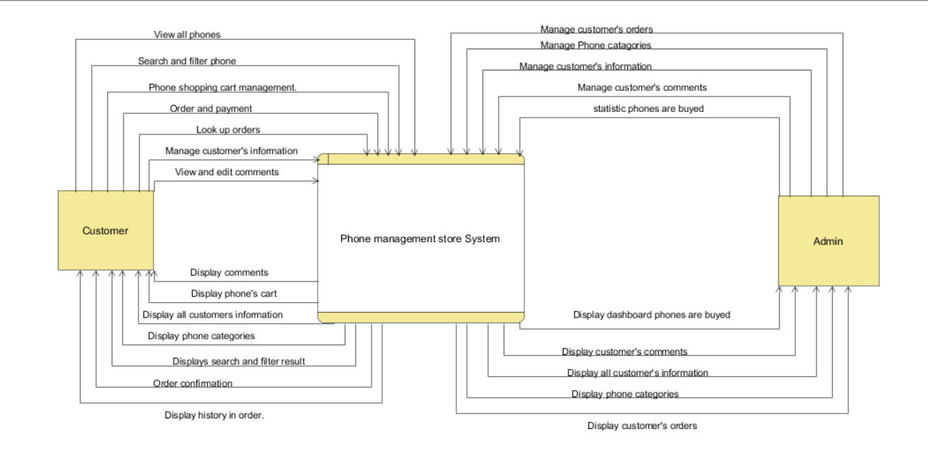

# System context description

* **Admin:**
  + Admin can authenticate identity (login / logout)
  + Admin can manage customer’s information in the system (Change information of customer, delete customer)
  + Admin can manage phone catagories (Add, change information of phones, delete phones)
  + Admin can manage customer’s orders
  + Admin can view statistic phones are buyed.

# Customer:

* + Customer can authenticate identity (login / logout)
  + Customer can view all phone categories
  + Customer can search and filter phones
  + Customer can manage phone’s cart
  + Customer can order and payment
  + Customer can look up order
  + Customer can view and manage customer’s information
  + Customer can view and edit comments.

# Technical Constraints Technical to develop:

* Programming language: Java, Javascript
* Library: Bootstrap, Font awesome, Hibernate, ReactJS, Spring Boot
* Technology: Java, JSP/Servlet, Html/css
* Database: mySQL
* Version Control System: GitHub
* Team Management: Trello, Zalo, Google drive
* Develop tools: Visual Studio Code, Eclipse

# Environments:

* Internet Connection
* Operation System: Google Chrome, Microsoft Edge, CocCoc, Firefox

# Other Constraints:

* Resource: 4 people.
* Budget: Limited.
* Time: The project must be completed within 03 months.
* These features are not available in the first version of the product.

# Tasks and Deliverables

|  |  |  |
| --- | --- | --- |
| No. | Task name | Description |
| **1.** | **Start up** |  |
| 1.1 | Project kick off meeting | Encountering the developer team and stakeholder to clear out the goal, defining of the base elements for the project and other project planning  activities |
| 1.2 | Discuss about project | Brighten up the current ideal to both developer  team and stakeholder |
| 1.3 | Create Document | Release the artifacts or schematics related to project to product owner, include Proposal, User  story, Product backlog, Project plan… |
| **2.** | **Development** |  |
| 2.1 | Sprint Planning | A Sprint begins with a sprint planning session that  sets goals and plans details for the work to be done |
| 2.2 | Sprint 1 | Release the first look of the product (ver1.0) with functions which have been committed in the  contract |
| 2.3 | Sprint 2 | Release the update for ver1.0 (ver1.1) with functions which have been approved by product  owner |
| 2.4 | Sprint 3 | The next update (ver1.2) for previous phase |
| **3.** | **Project ‘s meeting** | Private meeting between members to make plan what will be presented to customer in the final  release |
| **4.** | **Final Release** | Release the final version to product owner with  complete function |

# Project Management

# Cost/Budget for Project

|  |  |  |
| --- | --- | --- |
| **Full Name** | **Role** | **Salary Rate (USD/hour)** |
| Tan, Ngo Ngoc | Scrum Master | 2 |
| Kien, Le Trung | Team Member | 2 |
| Nam, Luu Hai | Team Member | 2 |
| Van, Nguyen Nhu | Team Member | 2 |

***Table 1. Cost person/hours***

|  |  |  |  |
| --- | --- | --- | --- |
| **No** | **Criteria** | **Price** | **Total (USD)** |
| 1 | Working hours | 2 | 3600 |
| 2 | Other cost | 100 | 400 |
|  | | | 4000 |

***Table 2. Total cost estimation***

|  |  |  |
| --- | --- | --- |
| **Description** | **Amount** | **Unit** |
| Number of members | 4 | Person |
| Number of working hours per day | 5 | Hours |
| The cost per hour per member | 2 | USD |
| The number of working days | 90 | Days |

***Table 3. Description***

**-** The explanation for the table

* Amount of working hours = 4 members * 5 hours * 90 days
* Other cost = 4 members * 100 USD

# Tentative Schedule

# Master Plan

|  |  |  |  |  |
| --- | --- | --- | --- | --- |
| **NO** | **Task Name** | **Duration** | **Start** | **Finish** |
| **1.** | **Initial** | **6 days** | **09 – Jan - 2024** | **14– Jan– 2024** |
| 1.1 | Gathering Requirement | 2 days | 09– Jan – 2024 | 10– Jan – 2024 |
| 1.2 | Create Proposal Document | 4 days | 11 – Jan – 2024 | 14 – Jan – 2024 |
| **2** | **Start Up** | **6 days** | **15 – Jan – 2024** | **20 – Jan – 2024** |
| 2.1 | Project Kick-off Meeting | 2 days | 15 – Jan – 2024 | 16– Jan– 2024 |
| 2.2 | Create Document | 4 days | 17– Jan– 2024 | 20 – Jan– 2024 |
| **3** | **Development** | **42 days** | **21 – Jan – 2024** | **04 – Mar-2024** |
| 3.1 | Sprint 1 | 16 days | 21 – Jan – 2024 | 06 – Feb – 2024 |
| 3.2 | Sprint 2 | 16 days | 07 – Feb– 2024 | 23 – Feb – 2024 |
| 3.3 | Sprint 3 | 14 days | 24 – Feb – 2024 | 08 – Mar – 2024 |
| **4** | **Project’s Retrospective Meeting** | **03 days** | **09 – Mar – 2024** | **11-Mar– 2024** |
| **5** | **Final Release** | **01 days** | **12 – Mar– 2024** | **12– Mar– 2024** |

# Scrum Process

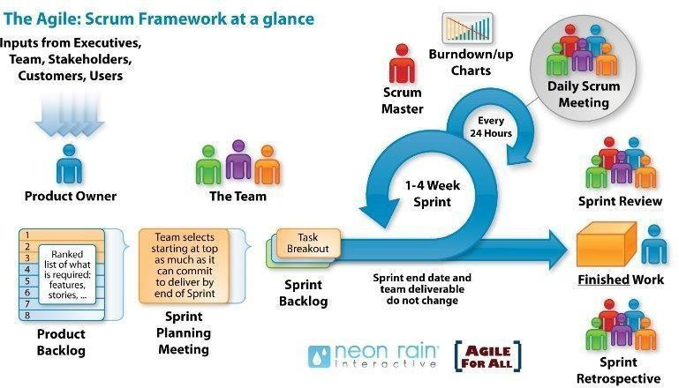

* Scrum is an iterative and incremental agile software development framework for managing software projects and product or application development.
* Scrum focuses on project management institutions where it is difficult to plan ahead.
* Mechanisms of empirical process control, where feedback loops that constitute the core management technique is used as opposed to traditional command-and

-control management.

* Its approach to planning and managing projects is by bringing decision-making authority to the level of operation properties and certainties.
* Benefit of the methodology:
  + Project can respond easily to change.
  + Problems are identified early.
  + Customers get the most beneficial work first.
  + Work done will better meet the customer’s needs.
  + Improved productivity.
  + Ability to maintain a predictable schedule for delivery.

# Project Constraints

|  |  |  |
| --- | --- | --- |
| **Constraint** | **Constraints Description** | **Guidelines for**  **Acceptance** |
| **Economic** | * Start trial (1 month free) * Trial period has ended   + Renew monthly: 4.99 $ per month  + Renew by year: 2.99 $ per month  + Lifetime: 99.99 $ once | Elements for consideration are design costs, production costs, maintenance costs, operating costs, and sales price |
| **Environmental** | The system does not affect the environment | Impact of the design on the environment as well as impact of the environment (e.g, temperature range, humidity, vibration, electromagnetic interference immunity, and shock) on the design should be considered. Design for recycling and design to use recycled materials should also  be considered |
| **Ethical** | -User information after registration will be encrypted, and we will not share with any organization.   * Respecting user privacy settings * Working to ensure the security of our users’ information | Ethical considerations can be broad. Areas that are typically addressed include intellectual property, reverse- engineering, privacy, security, and the conflict between cost and  safety. |

|  |  |  |
| --- | --- | --- |
|  | - Do not tracking users |  |
| **Public health, safety, and welfare** | The application works on web platform, so when using, users will look at the screen of laptop, pc, tablet, mobile device. So, we recommend not to use the application for more than 180 minutes, to protect the eyes and  health of the user. | Includes safety standards as well as impact of the design on users (for example, electrical or physical hazards) |
| **Social and Global** | Making it easier for beginners, students, or employees who want to learn language, children help them increase their communication skills, and make friends with many others. | Addresses aspects such as benefits, risks, the man- machine interface, the acceptance of products by the intended user or by society at large, global and socially  responsible engineering. |
| **Cultural** | * This application is for Vietnamese people to learn English, so the website will use Vietnamese. * To remove this barrier, we can add a function to choose to display English or Vietnamese   language websites. | Which cultural characteristics could influence the approach?  How do the design from different cultures differ? |
| **Sustainability** | Human resources include 4 members of Duy Tan University.  The app is written in javascript,  using reactjs technology that breaks the components of the | Refers to sustainability of resources, including material, energy, supplies, manufacturing techniques, personnel, operation, and the need for additional |

|  |  |  |
| --- | --- | --- |
|  | system into separate operations for easier maintenance. | infrastructure, as well as sustainability of the design including reliability, lifetime, durability, reusability,  maintainability. |

# Conclusion

This product creates a community that promises to help everyone have an effective English learning environment. Bring a new feeling of learning English, with no barriers between good learners and poor English learners. Help improve English skills. The project is expected to be completed within 3 months at a cost of not more than

$ 3100.

# References

**[1]. Software Development Standards for the Guidance and Control Software Project:** [*https://sw-eng.larc.nasa.gov*](https://sw-eng.larc.nasa.gov/)

**[2]. General Software Coding Standards and Guidelines**: [*https://www.nws.noaa.gov/oh/hrl/developers_docs/General_Software_Standards.pdf*](https://www.nws.noaa.gov/oh/hrl/developers_docs/General_Software_Standards.pdf)**[3]. Scrum and best practices*:*** *https://docs.microsoft.com/en- us/azure/devops/boards/sprints/best-practices-scrum?view=azure-devops*

**[4]. The Scrum Guide:** [*https://www.scrum.org/resources/scrum-guide*](https://www.scrum.org/resources/scrum-guide)

# [5]. The ISO/IEC & IEEE/EIA Standard 12207, IEEE standards: IEEE-829 [3],

**IEEE-1008 [5], IEEE-1012**

**[6] React documentation:** <https://reactjs.org/docs/getting-started.html>

# Attachment