WEEK 3 TASK

Advanced Data Analysis and Visualization in Logistics
Project: Exploratory Analysis of Logistics Performance
Submitted by: Tannu Kakkad
Role: Logistics Data Analyst Intern
Program: Yuva Internship

Executive Summary
This report demonstrates an advanced exploratory data analysis and visualization workflow for a hypothetical logistics operation. A simulated dataset of 180 shipment records was created with variables covering distance, shipment volume, traffic, vehicle type, weather, delivery time, transportation cost, and delay. Python with Pandas, NumPy, and Matplotlib was used to calculate descriptive statistics, explore relationships, and create visualizations.
The analysis focuses on operational efficiency, shipment trends, transportation costs, delivery-time behavior, and potential bottlenecks. The visualizations are interpreted from a business perspective so that the results can support decisions about routing, fleet use, traffic-sensitive planning, and cost control.

1. Data Simulation
Because the task permits a hypothetical logistics dataset, a reproducible synthetic dataset was created using NumPy. The dataset contains 180 shipment records. Delivery time and transportation cost are generated using relationships with distance, shipment volume, traffic, weather, and vehicle type, with random variation representing normal operational differences.
Variable | Type | Business Meaning
order_id | ID | Unique shipment identifier
date | Date | Shipment date
distance_km | Numeric | Travel distance
shipment_volume_units | Numeric | Shipment volume
traffic_level | Categorical | Traffic condition
vehicle_type | Categorical | Vehicle assigned
weather | Categorical | Weather condition
delivery_time_min | Numeric | Delivery duration
transport_cost | Numeric | Transportation cost
delay_min | Numeric | Estimated delay

2. Exploratory Data Analysis (EDA)
EDA was conducted to understand central tendency, spread, distribution, and relationships among logistics variables.

2.1 Summary Statistics
Average delivery time: 119.12 minutes. Median delivery time: 118.50 minutes. Average transportation cost: 194.84. Average shipment volume: 114.30 units. On-time delivery rate (delay <= 0): 31.11%.
Comparing mean and median delivery time provides a basic view of the typical service duration and whether unusually long deliveries may be influencing the average.

2.2 Correlation Analysis
Correlation helps identify the strength and direction of linear relationships among numerical variables. It does not prove causation, but it can guide further investigation and feature selection.
- Delivery time vs distance_km: 0.90
- Delivery time vs shipment_volume_units: 0.08
- Delivery time vs transport_cost: 0.63
- Delivery time vs delay_min: 0.88

3. Visualizations and Interpretation

3.1 Delivery Time Distribution
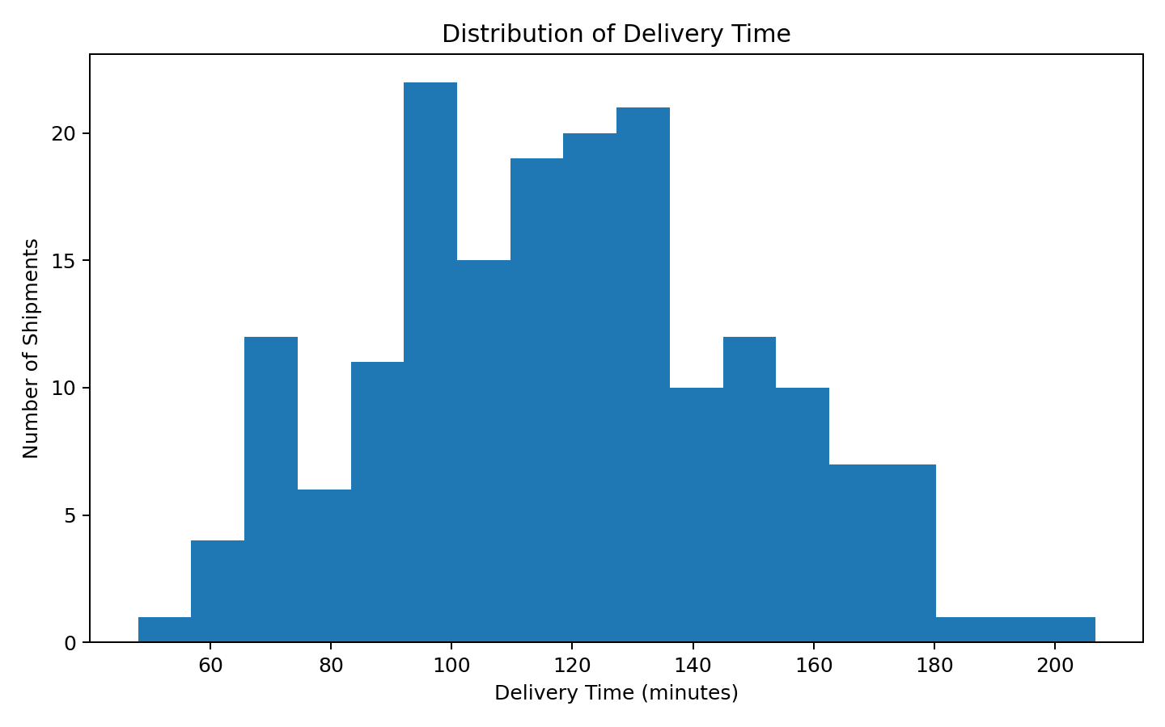
Interpretation: The histogram shows the spread of delivery durations. The longer-duration tail represents slower shipments and can highlight cases requiring operational investigation.

3.2 Monthly Shipment Volume Trend
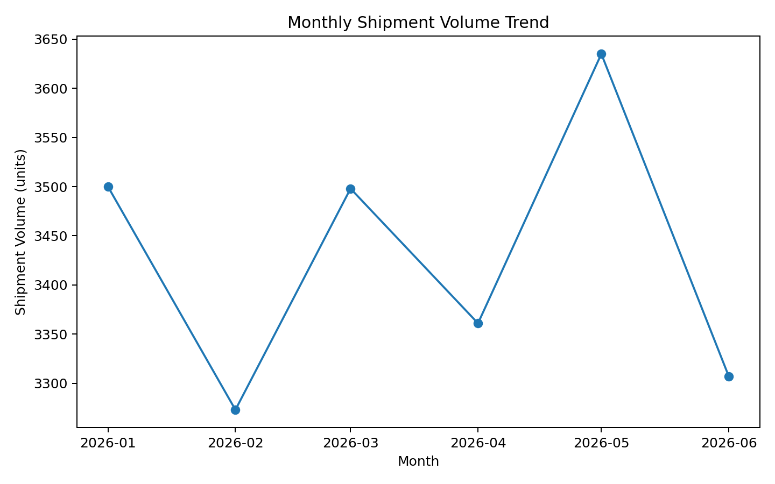
Interpretation: The monthly trend helps identify changes in workload. Higher-volume periods may require additional vehicles, drivers, or route-planning capacity.

3.3 Distance vs Delivery Time
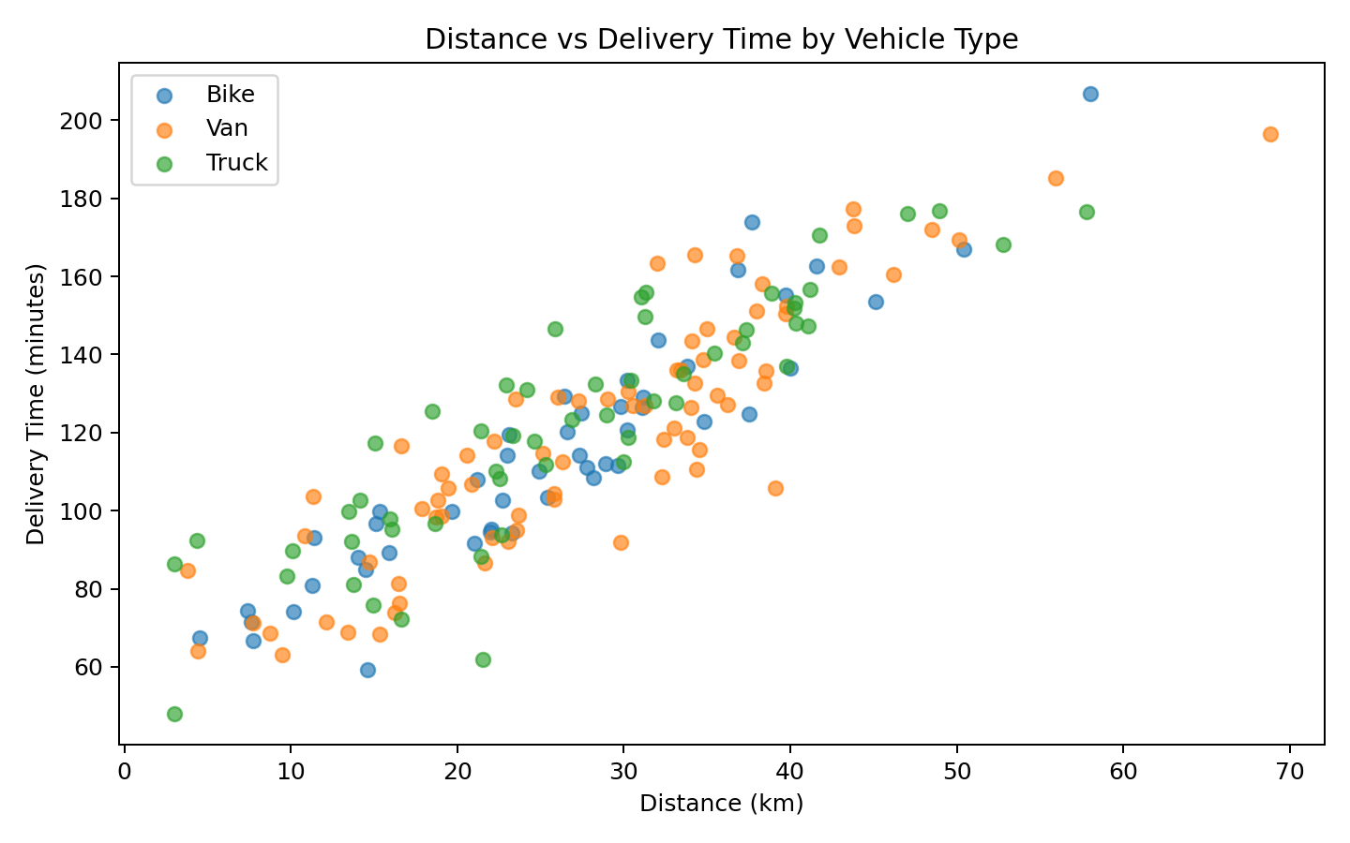
Interpretation: The scatter plot shows the relationship between distance and delivery time by vehicle type. Longer routes generally require more travel time; points far above the pattern may indicate traffic, weather, or route bottlenecks.

3.4 Average Transportation Cost by Vehicle
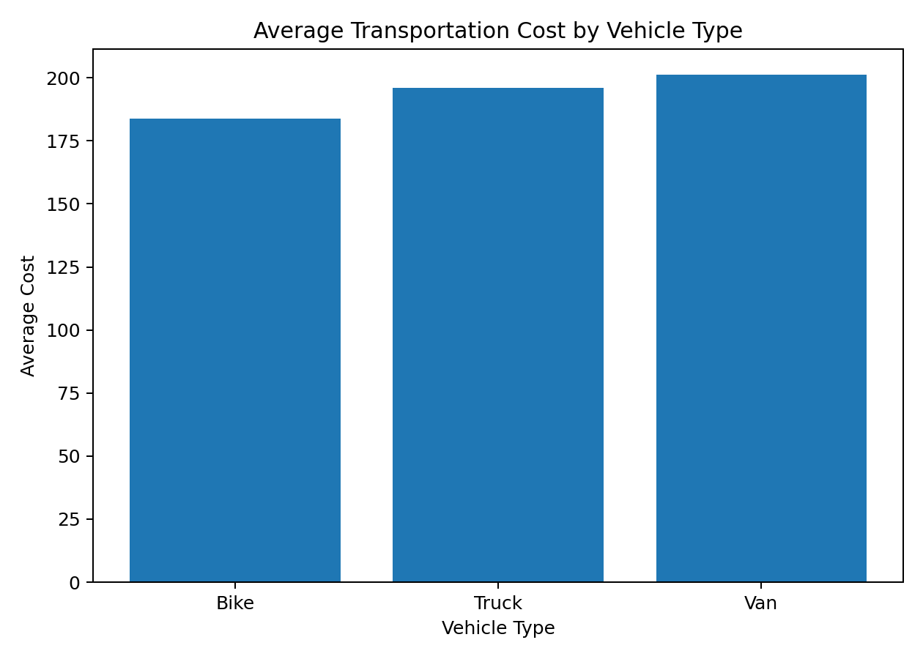
Interpretation: Comparing vehicle costs supports fleet allocation. Higher-cost vehicles may be justified for larger or longer shipments, while smaller vehicles may be more economical for short routes.

3.5 Average Delivery Time by Traffic Level
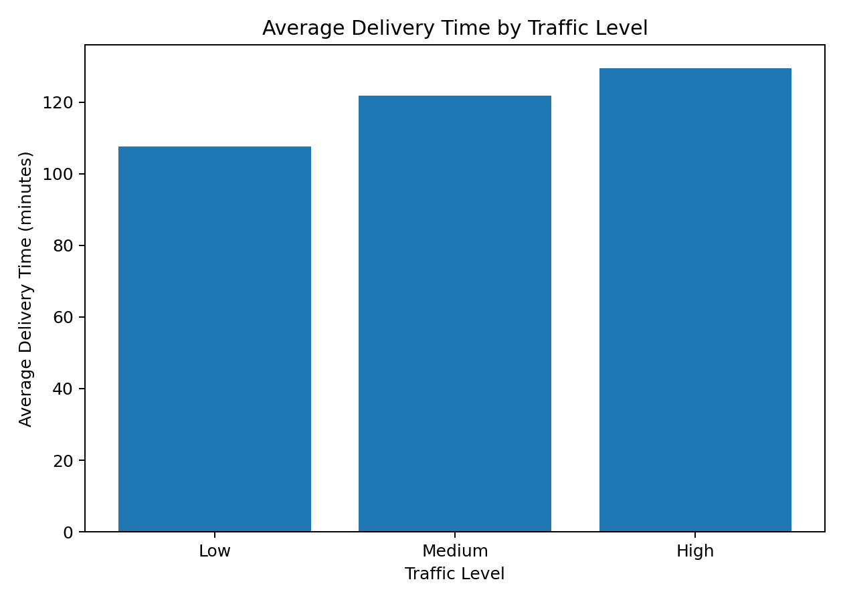
Interpretation: The traffic comparison illustrates the effect of congestion. Higher traffic levels are associated with longer delivery times in the simulated data, supporting traffic-aware planning.

3.6 Correlation Matrix
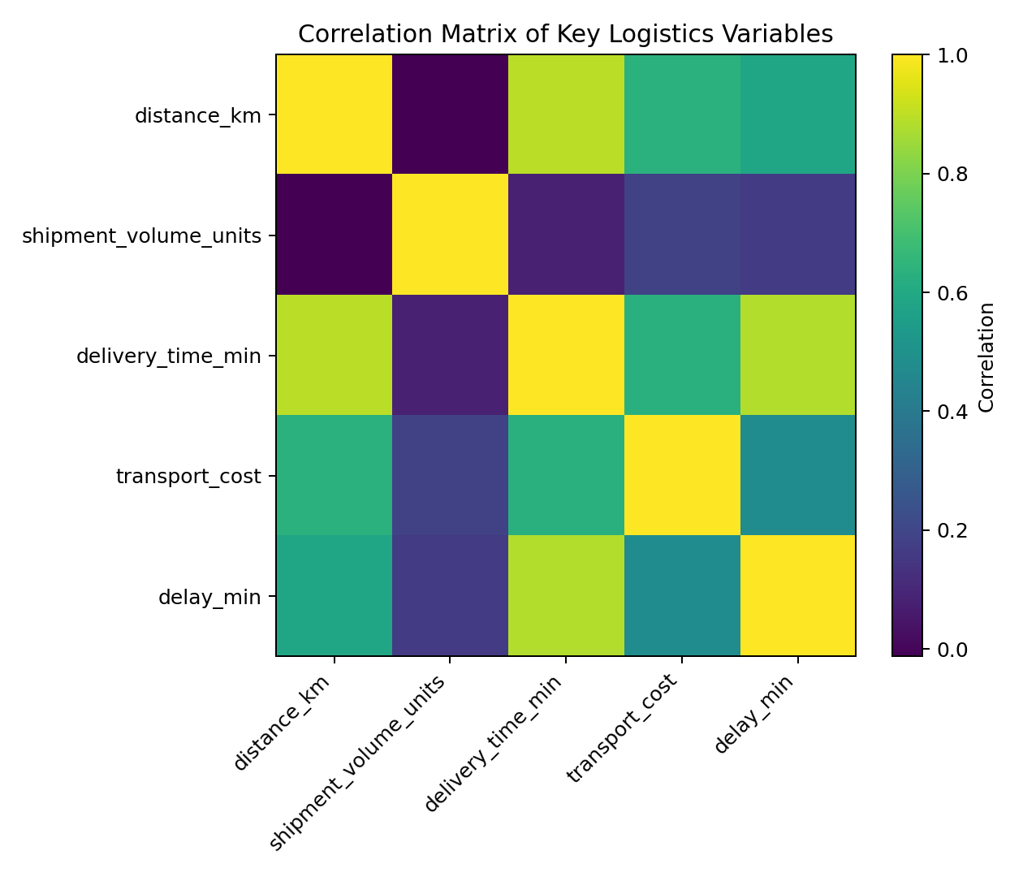
Interpretation: The matrix summarizes relationships between numerical variables and can guide feature selection for future predictive modeling.

4. Analytical Insights
- Distance is an important operational factor associated with delivery duration and transportation cost.
- Traffic conditions create a potential bottleneck because high-traffic periods are associated with longer delivery times.
- Shipment volume should be monitored alongside fleet capacity because higher workload can require additional planning resources.
- Vehicle-level cost comparisons can support more efficient fleet assignment.
- Long-delivery observations should be investigated individually rather than treated only as statistical outliers.
- Correlation analysis can guide future predictive modeling, but decisions should also incorporate business constraints and domain knowledge.

5. Potential Bottlenecks
- Traffic congestion during peak operating periods.
- Long-distance shipments requiring greater travel time and cost.
- High shipment volumes that may exceed available fleet capacity.
- Vehicle assignments that do not match shipment size or route requirements.
- Weather conditions that increase delivery uncertainty.

6. Recommendations
- Use traffic-sensitive route planning and consider alternative departure times during high-congestion periods.
- Assign vehicle types based on shipment volume, distance, and cost efficiency.
- Monitor delivery-time distributions and investigate the longest-delay cases separately.
- Use monthly shipment-volume trends for proactive fleet and workforce planning.
- Combine historical delivery data with external traffic and weather data for stronger predictive models.
- Use Week 3 EDA results as a foundation for the predictive and optimization stages proposed in Weeks 1 and 2.

7. Python Code Used
import pandas as pd
import matplotlib.pyplot as plt
df = pd.read_csv("logistics_week3_dataset.csv",
parse_dates=["date"])
print(df.describe())
numeric_cols = ["distance_km", "shipment_volume_units",
"delivery_time_min", "transport_cost", "delay_min"]
print(df[numeric_cols].corr())
plt.hist(df["delivery_time_min"], bins=18)
plt.title("Distribution of Delivery Time")
plt.xlabel("Delivery Time (minutes)")
plt.ylabel("Number of Shipments")
plt.show()
The complete Python script is included separately in the GitHub-ready project folder.

8. How Visualization Supports Logistics Decisions
Visualizations convert large tables of operational data into patterns that can be understood quickly. Histograms reveal distributions, line charts reveal demand trends, scatter plots show relationships, bar charts support category comparisons, and correlation matrices summarize numerical relationships. Together, these visuals help managers identify bottlenecks, prioritize investigations, allocate resources, and evaluate performance.

9. Limitations
- The dataset is hypothetical and the numerical findings do not represent an actual logistics company.
- Simulated relationships may be simpler than real-world logistics behavior.
- Traffic, weather, driver availability, road restrictions, and delivery windows are not modeled using real-time data.
- Correlation should not be interpreted as proof of causation.
- Real operational data would be required before implementing business changes.

10. Conclusion
This Week 3 analysis demonstrates how exploratory data analysis and visualization can support logistics decision-making. By examining delivery-time distributions, shipment-volume trends, distance relationships, transportation costs, traffic effects, and correlations, the analysis identifies practical areas for operational improvement.
The simulated results suggest that distance, traffic, workload, and vehicle selection are useful factors for understanding logistics performance. Visualization makes these patterns easier to communicate and provides a foundation for predictive and optimization work.

11. References and Tools
- Python – Programming language used for the analytical workflow.
- Pandas – Data loading, manipulation, aggregation, and exploratory analysis.
- NumPy – Numerical simulation and calculations.
- Matplotlib – Visualization library used to generate the figures.
- Kaggle and UCI Machine Learning Repository – Potential public dataset sources for future real-data implementation.

12. Submission Note
The dataset used in this report is simulated specifically for the Week 3 educational task. The report, Python script, dataset, and visualization images are organized so they can be uploaded to a GitHub repository as a technical internship project.

