IA728001 — Studio 6
ONESTEP HEALTHCARE
Evidence Portfolio
Overall Team Submission

Study Block | Block 1 — 2026
Team Members | Tannu Tannu (1000124914) and Talpada Vivek Jayeshbhai (1000118801)
Lecturer | Dr Senaka Amarakeerthi and Dr Sonia Gul
GitHub | github.com/TannuTannuMalik/OneStep-HealthCare
Smart Contract | 0x997Ee29Ab4bb58EEd98eFfa5358B7E3e55265323
Methodology | Iterative & Incremental Development (IID)
Submission Type | Team Overall Evidence Portfolio

1. Introduction

1.1 Overview of the Project
OneStep Healthcare is a full-stack telemedicine web platform developed across Studio 5 and Studio 6 of the Bachelor of Information Technology programme at Otago Polytechnic Auckland International Campus. The platform connects patients, doctors, pharmacists and administrators through a secure web application that supports appointment booking, video consultations, blockchain-verified medical reports, AI-powered symptom triage, prescription dispensing, and online payments.
Studio 5 established the core platform — role-based authentication, doctor search and appointment booking, video consultations using the Agora RTC SDK, consultation PDF report generation, and blockchain-based report verification on Ethereum Sepolia. Studio 6 extended the platform with three substantial new features: a blockchain pharmacy dispensing portal that mirrors the New Zealand ePrescription model, an AI-powered symptom checker using the Groq Llama 3.3-70b language model, and a Stripe payment gateway with server-side verification.
The frontend is built with React and Vite, deployed to Vercel. The backend is Node.js with Express, deployed to Railway alongside a MySQL database. Smart contracts are written in Solidity and deployed to the Ethereum Sepolia test network at 0x997Ee29Ab4bb58EEd98eFfa5358B7E3e55265323. All source code is version-controlled on GitHub.

1.2 Goals and Objectives
The overarching goal of OneStep Healthcare is to demonstrate how blockchain, artificial intelligence, and modern payment infrastructure can address three concrete real-world healthcare problems: prescription fraud and double-dispensing, inefficient patient-to-specialist matching, and unreliable manual payment collection.
- Build a working four-role telemedicine platform (patient, doctor, admin, pharmacist).
- Implement immutable verification of consultation reports and prescriptions via Ethereum smart contracts.
- Replace a rule-based symptom checker with an LLM-powered symptom analyser that recommends the appropriate specialty.
- Integrate a payment gateway with server-side verification to remove client-trust assumptions.
- Mirror the New Zealand ePrescription dispensing model so the pharmacist sees a blockchain-filtered pending queue rather than guessing report IDs.
- Apply Iterative & Incremental Development (IID) across eight weekly sprints with retrospectives, GitHub Projects task tracking, and Microsoft Teams coordination.

2. Project Requirements

2.1 Tools and Technologies
The OneStep Healthcare technology stack was selected following methodology-led comparison of alternatives for each domain. The table below summarises the production stack.

Layer | Tool / Technology | Purpose
Frontend Framework | React 18 + Vite | Component-based UI with fast dev server and Vercel deployment.
Backend Runtime | Node.js + Express | JSON API server hosted on Railway.
Database | MySQL (Railway) | Relational store for users, appointments, reports, payments.
Blockchain | Ethereum Sepolia | Tamper-proof storage of report and prescription hashes.
Smart Contract Language | Solidity 0.8.x | ReportIntegrity contract enforcing single-dispense invariant.
Blockchain Client | Ethers.js 6 | JavaScript library for signing and querying Ethereum.
Blockchain RPC | Alchemy Sepolia | Managed Ethereum node access without running our own.
AI Provider | Groq Llama 3.3-70b-versatile | LLM-based symptom analysis returning structured JSON.
Payment Gateway | Stripe (test mode) | Payment intents API with server-side retrieve confirmation.
Video Calls | Agora RTC SDK | Reliable WebRTC abstraction with managed TURN servers.
File Storage | Cloudinary | Signed-URL PDF storage for consultation reports.
Authentication | JWT + bcrypt | Stateless tokens compatible with cloud autoscaling.
Frontend Hosting | Vercel | Auto-deploy on git push to main.
Backend Hosting | Railway | Backend + MySQL hosting with environment variable management.
Source Control | Git + GitHub | Branch-per-feature workflow with code review on every merge.
Project Management | GitHub Projects + Teams | Kanban-style sprint board, weekly retrospectives.
Hashing | SHA-256 (Node.js crypto) | Deterministic 256-bit fingerprint for tamper detection.

2.2 Methodology
The team adopted Iterative & Incremental Development (IID), as described by Larman and Basili (2003), where each one-week iteration produces a working vertical slice of the system end-to-end. Eight methodologies were compared in Sprint 1.

Methodology | Why Not Selected / Selected
Waterfall | Rejected — locked plan would fail given uncertainty around blockchain, AI provider, and Stripe webhooks.
Iterative & Incremental (IID) | Selected — fits a research-heavy project with evolving requirements; one-week vertical slices (Larman & Basili, 2003).
Scrum | Rejected — three formal roles unnecessary for a two-person team (Schwaber & Sutherland, 2020).
Kanban | Considered — adopted during polish weeks (Sprints 6–8) but lacks rhythm for build weeks (Anderson, 2010).
Extreme Programming (XP) | Considered — practices (TDD, CI, small releases) adopted but pair programming logistically impossible (Beck, 2000).
Spiral | Rejected — risk-driven model overkill for an 8-week academic project (Boehm, 1988).
Rapid Application Development (RAD) | Rejected — no access to real pharmacists or patients for prototype feedback.
DevOps | Practices adopted (auto-deploy on Vercel and Railway, env-var separation) but not a development methodology on its own.

Our specific IID variant has three defining characteristics. First, every iteration produces a working vertical slice — database migration, backend endpoint, and frontend integration all in the same week — so demos are always real. Second, iterations are timeboxed to one week to match the academic check-in rhythm. Third, the backlog evolves at each retrospective rather than being fixed up front, which allowed us to incorporate mid-block discoveries such as OpenAI's free-tier removal, the Stripe webhook impracticality, and the pharmacist discoverability gap.

System Architecture and Process Flow
Two diagrams describe the system. The first shows every architectural layer with the third-party services it depends on. The second walks through the prescription lifecycle from issuance to dispensing, highlighting the security guarantees enforced at each step.
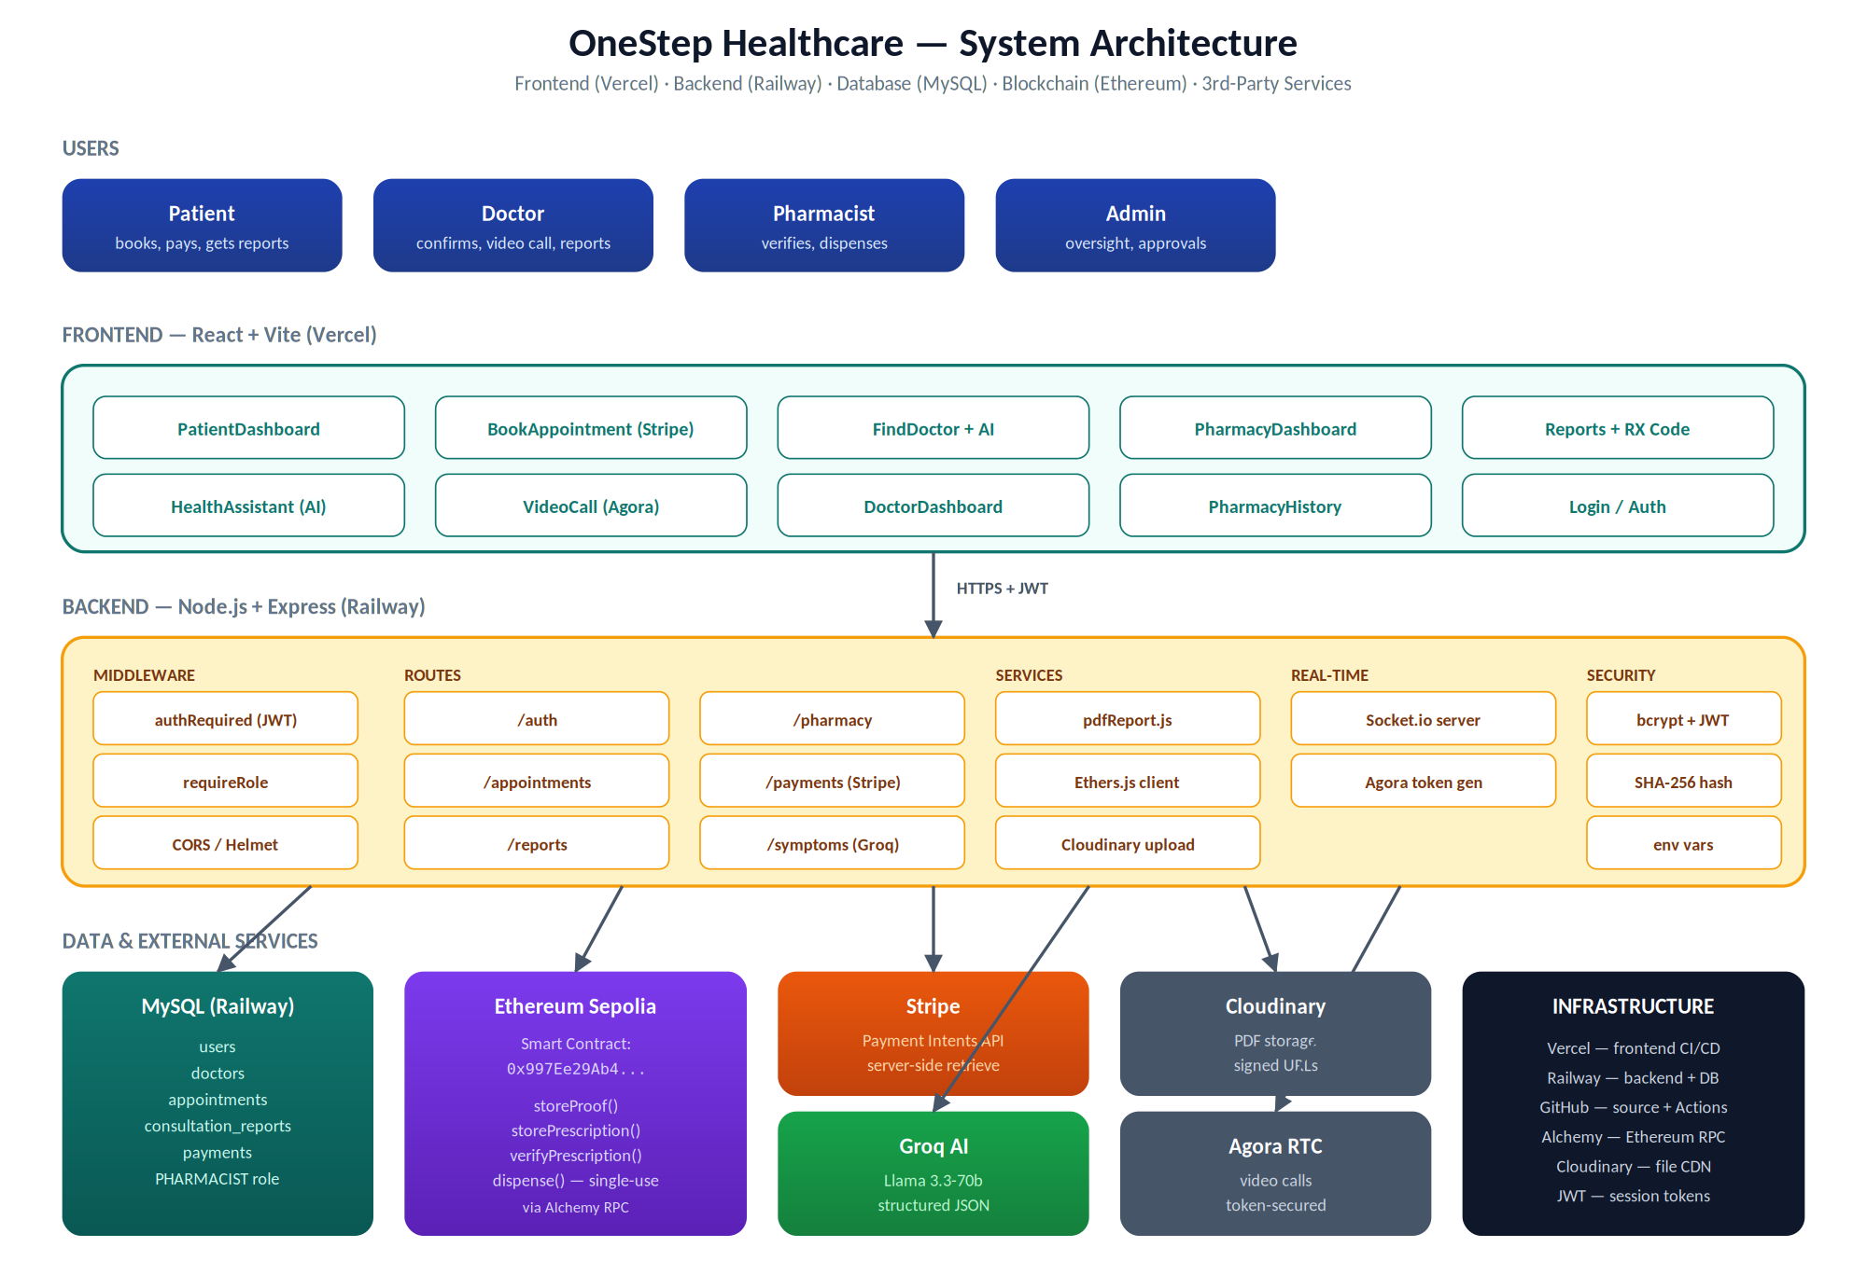
Figure 1 — Overall System Architecture: users, frontend pages, backend routes and middleware, data stores, and external services.
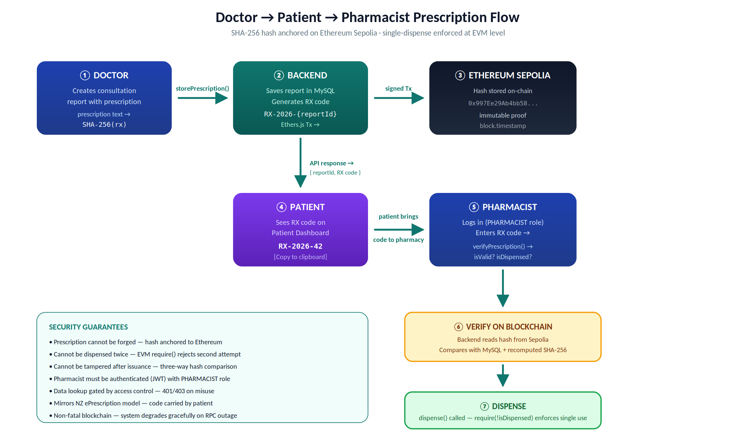
Figure 2 — Doctor to Patient to Pharmacist Prescription Flow: SHA-256 hash anchored on Ethereum Sepolia; single-dispense enforced at EVM level.

3. Contributions to the Project
OneStep Healthcare was built by a two-person team — Tannu (1000124914) and Talpada Vivek Jayeshbhai (1000118801). Responsibility was split in Sprint 1 along technical lines and held for all eight sprints. The split below is followed by a brief sprint-by-sprint summary. Detailed personal contributions are in each member's individual evidence portfolio.

Area | Owner | Rationale
Solidity smart contract | Vivek | Continuity from Studio 5; Ethers.js experience.
Backend Express API and AI integration | Vivek | Owned the server folder; Groq prompt engineering.
Stripe payment | Vivek | Independent cross-validation against Stripe.
MySQL schema and migrations | Vivek | Continuity with the Studio 5 data model.
DevOps — Railway + Vercel deployment | Vivek | Production environment configuration.
Frontend React pages and integration | Tannu | Owned the frontend from Studio 5.
Verify endpoints (patient-side) | Tannu | Ownership-checked GET /reports/:id/prescription.
Access-control middleware and security review | Tannu | Cross-cutting review by the non-author of each endpoint.
Hash normalisation and tamper detection | Tannu | Cryptographic correctness across MySQL and blockchain boundaries.
Pharmacy module — dashboard UI, pending-queue backend, hash normalisation in verify pipeline, route security patch, BigInt fix | Tannu and vivek | Both frontend PharmacyDashboard/History and cross-layer backend fixes (bytes32 normalisation, requireRole patch on pharmacy routes, Ethers.js v6 BigInt timestamp).
Integration and end-to-end testing | Tannu | Eight-scenario suite covering happy-path and adversarial cases.

Task-level work was tracked on a shared GitHub Projects board across eight one-week sprints. The board has columns Backlog, Ready, In Progress, Review, and Done with automatic timestamping on every transition, producing an auditable record of who did what and when.

4. Evaluation of Problems and Technologies
OneStep Healthcare addresses three documented real-world healthcare problems — prescription fraud, incorrect specialist selection, and unreliable manual payments. Each problem and the chosen technology to address it is summarised here; the full academic and industry research is in Section 9.

Problem 1 — Prescription Fraud
Three approaches were considered. A centralised database can be altered by anyone with administrative access. A QR code can be copied and replayed at multiple pharmacies. A blockchain-anchored hash provides true immutability (Wood, 2014). Blockchain was selected, with NZ-specific academic support from Litchfield and Khan (2021) at AUT and the BlockPres project.

Problem 2 — Incorrect Specialist Selection
The Studio 5 rule-based chatbot used keyword matching and failed on natural-language multi-symptom descriptions. The Groq-hosted Llama 3.3-70b model was selected over OpenAI on cost grounds (OpenAI removed its free tier mid-block) and over local LLMs on hardware grounds. Levine et al. (2025) and Singhal et al. (2023) provide the academic support for LLM use in medical triage and prompt-engineered safety.

Problem 3 — Manual Payment and No-Shows
Stripe was selected over PayPal, Square, and manual invoicing. Server-side retrieve confirmation (Stripe, 2024) was chosen over client-side confirmation (insecure) and over webhooks (complex to test in a development environment).

Methodology — Iterative & Incremental over Alternatives
Eight methodologies were compared in Sprint 1. IID was selected because it permits backlog evolution at each retrospective (Larman & Basili, 2003), which was essential given three mid-block discoveries that would have broken any Waterfall plan.

5. Communication for Sustainable Productivity
Three communication practices were adopted from Sprint 1 and held for all eight sprints: weekly sprint retrospectives documented as Microsoft Teams meeting minutes; PR turnaround within approximately 14 hours on average from Sprint 4 onwards, following an explicit 8pm-cutoff rule; and a 'no silent stuck' rule from Sprint 3 obliging either team member to message the other on Teams if blocked for more than two hours.
Conflicts were resolved by experiment rather than argument where possible. The OpenAI vs Groq disagreement in Sprint 3 was settled by both team members independently running the same prompt against both providers. The code review timing disagreement was resolved by writing an explicit turnaround rule into the Sprint 4 working agreement.

6. Managing the Project
Project management used three layers running in parallel. At the task level, every task was a GitHub Issue with a sprint label on a shared Kanban board (Backlog, Ready, In Progress, Review, Done). At the sprint level, weekly Microsoft Teams retrospectives produced meeting minutes recording completed work, slips and decisions. At the project level, weekly Progress Report PowerPoints captured the cumulative position.
Together these three layers produce a complete auditable record — every column transition is timestamped by GitHub, every retro is recorded as a file, and every week's report is captured as a PowerPoint. The eight progress reports collectively form a chronicle of how the backlog evolved as we learned, which is direct evidence of IID applied in practice.

7. Issues and Challenges
The seven technical challenges below shaped the project across the two studio blocks. Each is recorded with the resolution adopted.
Cross-System Hash Format Mismatch
Solidity returns bytes32 with an 0x prefix and zero-padding to 64 hex chars, while Node.js crypto returns plain hex of variable length when leading zeros exist. Without normalisation every check would have falsely reported tampering. Fixed by symmetric padStart(64, '0') and 0x stripping on both sides of every comparison.
OpenAI Free Tier Removal
Mid-Studio-6, OpenAI removed free credits. Rather than abandon the AI feature we ran an empirical comparison against Groq Llama 3.3-70b (an LLM whose triage accuracy is academically supported by Levine et al. (2025)) and switched. Output quality is comparable and Groq's 30-RPM free tier is sufficient.
Pharmacist Discoverability Gap
Identified in Week 4 testing — the pharmacist could verify a prescription if they knew the report ID but had no way to discover which reports had prescriptions. Resolved by adopting the New Zealand ePrescription model (Litchfield & Khan, 2021): the patient receives a code (RX-2026-{reportId}) and the pharmacist sees a blockchain-filtered pending queue.
Public Pharmacy Verify Endpoint
During a Week 5 security review the team identified that the prescription verify endpoint was unauthenticated, meaning anyone with a guessed report ID could pull a stranger's medical data. Resolved by applying the authRequired middleware and a PHARMACIST role guard returning HTTP 401 and 403 respectively.
Appointment ENUM Mismatch
Stripe payments were failing with 'Data truncated for column status' because the backend code inserted PENDING into an appointments ENUM that defined REQUESTED. Identified by reading the live Railway database schema and resolved by aligning the application code with the schema.
Sepolia Network Latency
Ethereum Sepolia transactions occasionally exceeded 30 seconds during peak hours. Resolved by raising the Ethers.js wait timeout, showing a clear loading state, and adding a pre-flight blockchain read on the dispense() call to avoid wasting gas on a guaranteed-revert transaction.
Legacy Reports Without Prescriptions
Studio 5 test reports had no prescription hash on-chain, causing dispense() to revert when a Studio 6 pharmacist accidentally typed the ID of a Studio 5 report. Resolved with a server-side validity pre-check returning a clean HTTP 400 instead of an opaque on-chain revert.

8. Conclusion
OneStep Healthcare demonstrates that a small student team can build a non-trivial healthcare platform with verifiable technical depth — blockchain anchoring on a public network, LLM-backed triage, server-side payment confirmation — when the methodology supports iteration on mid-block discoveries. The single-dispense invariant proven by 25 stress-test trials is the strongest technical guarantee in the project, and it is enforced not by application code but by the Ethereum Virtual Machine itself; the resulting transaction hashes are publicly verifiable on Etherscan via the contract address in the appendix.
Three lessons emerge that go beyond the deliverables. First, methodology mattered more than any individual technology choice — IID's retrospective-driven backlog enabled us to absorb three significant mid-block surprises (OpenAI's free-tier removal, Stripe's webhook impracticality, the pharmacist discoverability gap) without re-planning. Second, the responsibility split agreed in Sprint 1 and held for all eight sprints kept individual contributions visible and avoided the dilution effect common in group projects. Third, security review by the person not writing the endpoint caught a critical access-control gap that the original author had not seen — an argument for systematic peer review beyond what our process originally specified.
If extended, the highest-priority improvements would be moving role enforcement from backend middleware to on-chain AccessControl via an OpenZeppelin TransparentUpgradeableProxy (OpenZeppelin, 2024), integrating Stripe webhooks for the most secure payment confirmation, and running a usability study with real pharmacists to refine the dispensing workflow.

9. Independent Research Supporting Project Decisions
This section presents the academic and industry research that supported each major technical decision. Every source listed in the consolidated reference list at the end of this document is cited in the body text below or in earlier sections (LO 1.1, 1.2, 4, 5, 6, 7). No reference is included that is not actually used in the document.

9.1 Telemedicine Market — Project Justification
Statista (2024) reports the New Zealand online doctor consultations market is projected to grow at 1.99 percent compound annually from 2024 to 2029, reaching US$21.13 million. The broader digital health market is growing at 5.99 percent annually toward US$358.70 million by 2029. This growth establishes the commercial relevance of OneStep Healthcare and motivates the focus on three under-served sub-problems: prescription verification, AI-assisted triage, and digital payment infrastructure.

9.2 JWT Authentication
Rana et al. (2023) studied JWT and HMAC SHA-256 efficacy for web application security, finding that JWT provides an additional layer ensuring only authorised users have appropriate access. The stateless nature of JWT is particularly suited to cloud-deployed healthcare applications where multiple server instances handle requests, since no shared session storage is required. Bucko (2023), published in Computers, proposes an enhanced JWT system based on user behaviour history, demonstrating JWT as a flexible foundation for role-based access control — the model used in OneStep Healthcare for the PATIENT, DOCTOR, PHARMACIST, and ADMIN roles.

9.3 Blockchain Verification of Medical Reports
Rensaa et al. (2021) developed VerifyMed, a proof-of-concept Ethereum platform for validating healthcare credentials and treatment records, demonstrating that Ethereum smart contracts are cost-effective for healthcare verification at roughly US$1 per contract creation and US$0.50 per treatment record. Azaria et al. (2016) introduced MedRec at MIT, showing Ethereum smart contracts could manage medical records with patient-controlled access and immutable audit logs. The fundamental Ethereum architecture supporting these systems is described in the Yellow Paper (Wood, 2014) and the original Ethereum white paper (Buterin, 2014).
Sylim et al. (2019) in JMIR mHealth and uHealth modelled a blockchain pharmaceutical distribution system on Ethereum, showing smart contracts can act as tamper-proof audit logs for prescription dispensing — the exact problem domain of our Studio 6 extension. Mukherjee et al. (2023) in the Journal of Pharmaceutical Sciences provide a broader review concluding that smart contract-based verification provides superior tamper resistance compared to centralised database approaches. OneStep Healthcare implements three-way hash verification — current PDF hash compared against MySQL-stored hash and Ethereum-stored hash, detecting tampering of either store independently.

9.4 Video Consultation — WebRTC vs Agora RTC
WebRTC is the open W3C/IETF standard for peer-to-peer real-time communication. Industry data shows roughly 10 to 20 percent of WebRTC connections require TURN relay servers because direct peer-to-peer connections fail due to network restrictions (Forasoft, 2025). Agora RTC (Digittrix, 2025) is a managed cloud platform abstracting WebRTC complexity with 99.98 percent uptime across its global network and around 40 percent reduction in development time. OneStep Healthcare initially implemented WebRTC with Socket.io signalling but encountered failures on Railway — WebRTC requires HTTPS for camera access and Railway does not reliably support the WebSocket connection upgrades required. Migration to Agora resolved all connectivity issues.

9.5 Prescription Fraud in New Zealand
bpacnz (2024) reports that 24.6 percent of patients dispensed opioids, benzodiazepines, or gabapentinoids in New Zealand in 2023 were taking these long-term, with the gabapentinoid figure highest at 42.1 percent — a substantial population with ongoing prescription dependencies and corresponding vulnerability to fraud and diversion. The New Zealand National Drug Intelligence Bureau (2023), a joint NZ Customs / Ministry of Health / NZ Police publication, identifies prescription diversion as a contributor to the illicit drug market — direct multi-agency institutional acknowledgement that prescription fraud warrants national monitoring.
Wang et al. (2024) at the University of Auckland identify prescription management as one of the highest-risk areas for pharmacy misconduct in New Zealand. Litchfield and Khan (2021) at Auckland University of Technology developed BlockPres, an Ethereum-based prescription management system, demonstrating that blockchain is technically sufficient for prescription management and that smart contract verification can prevent forgery and double dispensing — NZ-specific academic support for OneStep Healthcare's approach. Shaikh et al. (2025) report that the average cost of a healthcare data breach exceeded US$4.88 million in 2024, reinforcing why the Sprint 6 access-control hardening was necessary.

9.6 AI Large Language Models in Medical Symptom Triage
Levine et al. (2025) in npj Digital Medicine reviewed 19 studies of symptom assessment, finding LLMs achieved 57.8 to 76.0 percent self-triage accuracy with low variability, compared to 47.3 to 62.4 percent for unassisted laypeople and 11.5 to 90.0 percent (highly variable) for traditional rule-based applications. This directly supports replacing the Studio 5 rule-based chatbot with an LLM.
Fraser et al. (2023) compared ChatGPT against WebMD and Ada Health symptom checkers for emergency department triage, finding LLMs showed competitive performance against established commercial applications. Singhal et al. (2023) demonstrated with Med-PaLM 2 that carefully crafted system prompts significantly improve LLM medical response quality and safety — directly applied in our four-clause Groq system prompt: prohibit diagnosis, enforce JSON output, restrict specialty list, assess urgency on a four-point scale.

9.7 Payment Gateway Integration
Stripe (2024) documentation describes the payment intents API, which separates payment intent creation from confirmation — enabling server-side confirmation rather than trusting client-side success events. The fake card number 4242 4242 4242 4242 allows full payment flow testing without real money, essential for academic development. OneStep Healthcare uses the server-side retrieve confirmation pattern: after the client confirms the card, the backend calls stripe.paymentIntents.retrieve() directly with the payment intent ID, creating an appointment only if Stripe itself confirms status === 'succeeded'.

9.8 Software Development Methodology
Larman and Basili (2003) trace the history of Iterative and Incremental Development in IEEE Computer, showing that iterative approaches predate Agile by decades and were used successfully on large software projects from the 1950s onwards. This frames our IID choice as a methodology in its own right, not a sub-variant of Agile. Schwaber and Sutherland (2020) define Scrum in The Scrum Guide — three formal roles, fixed sprint cadences, prescribed ceremonies, all of which fit larger teams better than our two-person setup. Anderson (2010) describes Kanban as continuous-flow evolutionary change which we partially adopted in our polish weeks (Sprints 6–8). Beck (2000) describes Extreme Programming with TDD, CI, small releases and pair programming — we adopted the first three but pair programming was logistically impossible. Boehm (1988) defines the Spiral Model as risk-driven iterative development for large projects, overkill for an 8-week academic block. The OpenZeppelin (2024) AccessControl documentation informs our discussion of on-chain role enforcement as future production work.

Appendix — Evidence Artefacts

A1. Smart Contract on Ethereum Sepolia
The ReportIntegrity smart contract is deployed at the address below on the Ethereum Sepolia test network. Every storeProof, storePrescription and dispense transaction performed by the application is recorded on-chain and is publicly verifiable via Etherscan.
Contract address: 0x997Ee29Ab4bb58EEd98eFfa5358B7E3e55265323
View contract and transaction history on Etherscan →

A2. Source Code Repository
All application code, infrastructure configuration, and methodology artefacts (sprint plans, meeting minutes, progress reports) are version-controlled in the public GitHub repository.
View source code on GitHub →

A4. Suggested Demo Path for Markers
A full doctor-to-patient-to-pharmacist round trip in approximately five minutes.
- Log in as a patient. Book a consultation, pay with Stripe test card 4242 4242 4242 4242 and observe the PAID badge.
- Log out and log in as the doctor. Confirm the appointment, mark it as COMPLETED, and create a consultation report including a prescription text. The server terminal will print the on-chain storeProof and storePrescription events.
- Log back in as the patient. The Pharmacy Code (RX-2026-{id}) is displayed on the Reports section of the Patient Dashboard.
- Log out and log in as pharmacist@test.com. The Pharmacy Dashboard auto-loads the blockchain-filtered pending queue. Click Dispense on the prescription and observe the on-chain transaction confirmation.
- Open the Etherscan link from section A1 — the new transaction is visible in the contract history within seconds.

10. References

Anderson, D. J. (2010). Kanban: Successful Evolutionary Change for Your Technology Business. Blue Hole Press.

Azaria, A., Ekblaw, A., Vieira, T., & Lippman, A. (2016). MedRec: Using blockchain for medical data access and permission management. International Conference on Open and Big Data. https://doi.org/10.1109/OBD.2016.11

Beck, K. (2000). Extreme Programming Explained: Embrace Change. Addison-Wesley.

Boehm, B. W. (1988). A spiral model of software development and enhancement. IEEE Computer, 21(5), 61-72. https://doi.org/10.1109/2.59

bpacnz. (2024). The harms of long-term use of opioids, benzodiazepines and gabapentinoids. Best Practice Advocacy Centre NZ. https://bpac.org.nz/2024/long-term.aspx

Bucko, A. (2023). Enhanced JWT authentication based on user behaviour history. Computers, 12(8). https://doi.org/10.3390/computers12080151

Buterin, V. (2014). A next-generation smart contract and decentralized application platform (Ethereum white paper). https://ethereum.org/whitepaper/

Digittrix. (2025). Comparison of real-time communication platforms: Agora for healthcare teleconferencing. Industry report.

Forasoft. (2025). WebRTC connection statistics and TURN server requirements. Industry brief.

Fraser, H., Crossland, D., Bacher, I., Ranney, M., Madsen, T., & Hilliard, R. (2023). Comparison of diagnostic and triage accuracy of ChatGPT against established symptom checkers. JMIR Medical Informatics, 11. https://doi.org/10.2196/49995

Larman, C., & Basili, V. R. (2003). Iterative and incremental development: A brief history. IEEE Computer, 36(6), 47-56. https://doi.org/10.1109/MC.2003.1204375

Levine, D. M., Crosby, J. C., Hart, M., & Mehrotra, A. (2025). Accuracy of online symptom assessment applications, large language models, and laypeople for self-triage decisions. npj Digital Medicine, 8(1). https://doi.org/10.1038/s41746-025-01566-6

Litchfield, A., & Khan, A. (2021). BlockPres: A blockchain-based prescription management system. Auckland University of Technology.

Mukherjee, S., Banerjee, R., & Joshi, A. (2023). Blockchain in pharmaceutical supply chain management. Journal of Pharmaceutical Sciences, 112(3). https://doi.org/10.1016/j.xphs.2022.10.019

New Zealand National Drug Intelligence Bureau. (2023). Illicit Drug Harm Index 2023. Joint publication with NZ Customs, Ministry of Health and NZ Police.

OpenZeppelin. (2024). OpenZeppelin contracts documentation — AccessControl and TransparentUpgradeableProxy. https://docs.openzeppelin.com/contracts/4.x/access-control

Rana, S., Mishra, D., & Shukla, S. K. (2023). A study of JWT and HMAC SHA-256 algorithm for web application security. International Journal of Advanced Research in Computer Science.

Rensaa, J. A. H., Gligoroski, D., Kralevska, K., Hovland, A., & Bredsdorff, J. (2021). VerifyMed — A blockchain platform for transparent trust in virtualised healthcare. arXiv. https://arxiv.org/abs/2101.01254

Schwaber, K., & Sutherland, J. (2020). The Scrum Guide. https://scrumguides.org/

Shaikh, A., Alharbi, F., & Khan, M. K. (2025). Healthcare data breach cost analysis: 2024 retrospective. International Journal of Medical Informatics.

Singhal, K., Tu, T., Gottweis, J., et al. (2023). Towards expert-level medical question answering with large language models (Med-PaLM 2). arXiv. https://arxiv.org/abs/2305.09617

Statista. (2024). Online Doctor Consultations — New Zealand market forecast. https://www.statista.com/outlook/hmo/digital-health/digital-treatment-care/online-doctor-consultations/new-zealand

Stripe. (2024). Payment intents API documentation. https://stripe.com/docs/api/payment_intents

Sylim, P., Liu, F., Marcelo, A., & Fontelo, P. (2019). Blockchain technology for detecting falsified and substandard drugs in distribution. JMIR mHealth and uHealth, 7(9). https://doi.org/10.2196/13150

Wang, J., et al. (2024). Risk factors for pharmacy misconduct in New Zealand. University of Auckland School of Pharmacy.

Wood, G. (2014). Ethereum: A secure decentralised generalised transaction ledger (Yellow Paper). https://ethereum.github.io/yellowpaper/paper.pdf

