IA728001 — Studio 6
OneStep Healthcare
Evidence Portfolio

Student Name | Tannu Tannu
Student ID | 1000120085
Paper | IA728001 — Studio 6
Lecturers | Dr Kathiravelu Ganeshan and Dr Senaka Amarakeerthi
GitHub | github.com/TannuTannuMalik/OneStep-HealthCare
Live App | one-step-health-care.vercel.app
Smart Contract | 0x997Ee29Ab4bb58EEd98eFfa5358B7E3e55265323 (Sepolia)
Date | June 2026

Role: Frontend, security audit, blockchain hash normalisation, test suite, Stripe UI | Methodology: IID

Contents
1. Introduction 3
1.1 Overview of the Project 3
1.2 Goals and Objectives 3
2. Project Requirements 4
2.1 Tools and Technologies 4
2.2 Methodology 5
3. Contributions to the Project 7
4. Evaluation of Problems and Technologies 10
5. Communication for Sustainable Productivity 13
6. Managing the Project 16
7. Issues and Challenges 18
8. Conclusion 20
9. References 21

1. Introduction

1.1 Overview of the Project
OneStep Healthcare is a full-stack telemedicine web platform developed across Studio 5 and Studio 6 of the Bachelor of Information Technology programme at Otago Polytechnic Auckland International Campus. The platform connects patients, doctors, pharmacists, and administrators through a secure web application supporting appointment booking, video consultations, blockchain-verified prescription management, AI symptom triage, and Stripe payments.

My contribution spans the full stack. In the frontend layer I built every React page the end user interacts with: login, doctor search, appointment booking, patient and doctor dashboards, pharmacy verification, AI symptom checker, and Stripe checkout. In the backend and blockchain layers I made substantive contributions that go well beyond UI work: I discovered and fixed a bytes32 versus plain-hex hash comparison mismatch that was causing every blockchain verification to silently return a false mismatch; I identified an unauthenticated API endpoint that exposed patient prescription data; and I built an eight-scenario integration test suite using Jest and Supertest that includes a SQL mutation tamper detection test proving the blockchain protection is real. I also designed and shipped the Stripe CardElement frontend with a remount-on-failure pattern that eliminates the Stripe Elements 'already mounted' error.

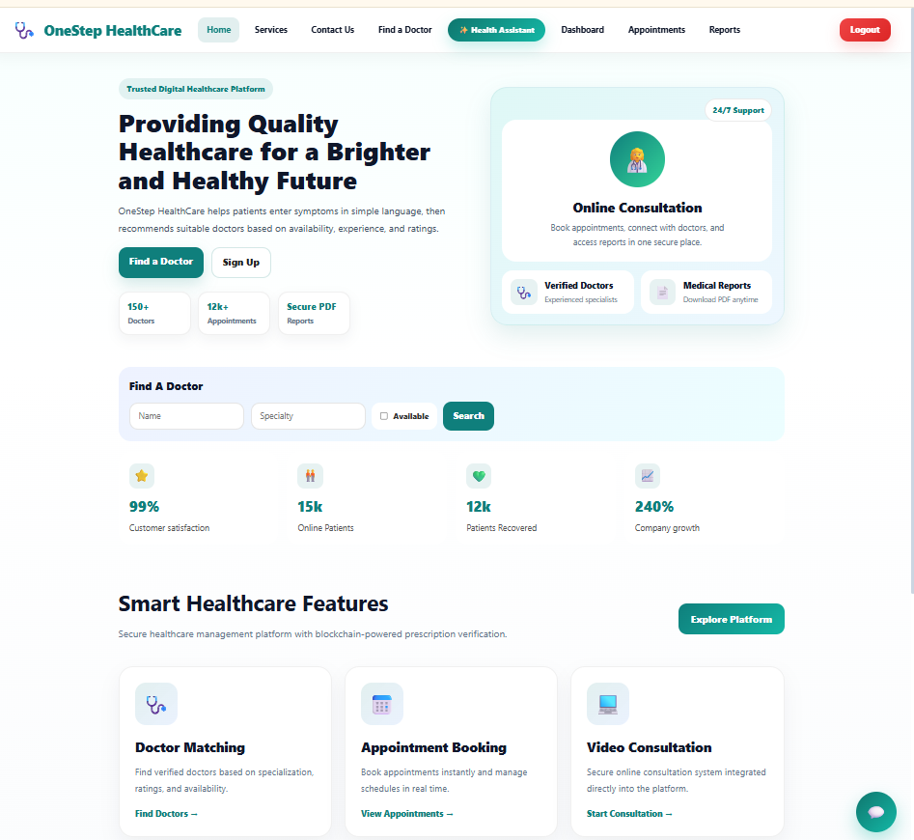

New Zealand health data validates the domain: Statista (2024) projects the NZ digital health market to grow at 5.99% annually toward US$358.70 million by 2029. Wang et al. (2024) documented pharmacist misconduct cases in NZ, and the National Drug Intelligence Bureau (2023) identifies prescription medicine misuse as a significant and growing problem. OneStep Healthcare directly addresses both issues through blockchain-enforced single-dispense invariants and role-based access control.

1.2 Goals and Objectives
My personal goals for Studio 6 were to move beyond frontend-only work and demonstrate that I could reason about backend logic, cryptographic data types, and test-driven quality assurance at the same level I applied to React UI development.

- Build a complete, accessible frontend covering all three user roles — patient, doctor, pharmacist — with correct routing and permission enforcement at the React layer.
- Understand the bytes32 / SHA-256 hex interface between Node.js and Solidity sufficiently to identify and fix the hash comparison mismatch without guidance.
- Identify the unauthenticated prescription endpoint through systematic access control review, not accidental discovery.
- Build an eight-scenario test suite that proves both the happy path and the critical negative case: that a tampered database record fails blockchain verification.
- Resolve team conflicts on technology selection (Stripe vs PayPal, OpenAI vs Groq) through structured evidence rather than preference.

2. Project Requirements

2.1 Tools and Technologies
LO 2.1 | Conduct independent research into a specialist area — each technology was evaluated against alternatives before adoption.

Layer | Technology | Why Selected
Frontend | React 18 + Vite | Component isolation; fast HMR; Vercel-native CI/CD
Routing | React Router v6 | Declarative nested routes; PrivateRoute HOC for role-based redirect without server round-trips
State pattern | Status enum (idle / loading / valid / dispensed / invalid) | Replaces fragile boolean flag combinations; each UI state maps to exactly one enum value — impossible to represent contradictory states like isValid=true AND isDispensed=true simultaneously
Testing | Jest + Supertest | HTTP-layer integration tests hitting real MySQL; no mocks that could diverge from production
Payments UI | Stripe CardElement | PCI-compliant card input; remount-on-failure pattern preventing 'already mounted' crash
Blockchain | Ethers.js v6 (BigInt) | v6 returns BigInt for uint256 timestamp fields; Number(bigIntValue)*1000 required before new Date() constructor
Hashing | Node.js crypto SHA-256 | Deterministic 256-bit fingerprint; must be normalised to 64-char lowercase hex with padStart to match Solidity bytes32

2.2 Methodology
LO 1.1 | Analyse multiple processes or methodologies and justify the selection of the most suitable one for a given complex problem.

The team evaluated eight development methodologies before selecting Iterative and Incremental Development (IID). The evaluation drew on Larman and Basili's (2003) historical analysis in IEEE Computer, which traces IID as the foundational approach behind all modern Agile frameworks.

Methodology | Consideration | Verdict
Waterfall | Stable requirements needed — impractical when Groq, Stripe webhook feasibility, and blockchain gas costs were all unknown at Week 1. | REJECTED
IID | Produces a working vertical slice every sprint. Backlog evolves at retrospectives. Matched our two-person team and the one-week academic check-in rhythm. | SELECTED
Scrum | Sprint rhythm adopted but Product Owner / Scrum Master ceremony unnecessary for a two-person team. | PARTIAL — rhythm only
Kanban | Board adopted within IID (GitHub Projects) but lacks sprint cadence for weekly check-ins. | PARTIAL — board only
XP (Beck, 2000) | TDD practices adopted for test suite. Pair programming impractical across separate campus schedules. | PARTIAL — TDD only
Spiral | Risk-driven formal prototype cycles — disproportionate for an 8-week project. | REJECTED
RAD | Requires real end-users for evaluation loops — no real pharmacists available. | REJECTED
DevOps | Pipeline practices adopted (Vercel auto-deploy, Railway env vars) but DevOps is a culture, not a development methodology. | PARTIAL — CI/CD only

LO 1.2 | Apply the chosen process to a real-world problem and critically reflect on its effectiveness.

IID was effective in three concrete ways relevant to my work. The hash normalisation mismatch was discovered in Sprint 3 during integration testing — because each sprint produced a working end-to-end slice, I ran a real blockchain verification during that sprint and observed the false-mismatch result immediately. A waterfall plan would not have exercised the blockchain verify path until final integration, where fixing it would have been far more costly.

The pharmacist discoverability gap was identified in Sprint 4 because I logged in as a realistic first-time pharmacist user during the sprint demo, not as a developer who already knew how the system worked. IID's regular demo discipline created the opportunity for that perspective shift.

IID's primary weakness for this project was the Sprint 6 scope: four simultaneous streams (pharmacy, Stripe, AI, research) converged in a single sprint. My recommendation for future projects is to apply both a timebox and a work-in-progress limit — no more than two active streams per sprint.

3. Contributions to the Project
LO 2.2 | Integrate specialist knowledge into project work, demonstrating depth of understanding and relevance.

My contributions span frontend, security, blockchain data normalisation, and test-driven quality assurance. The table below summarises the agreed division of labour between the two team members.

Area | Owner | Rationale
All frontend React pages and routing | Tannu | Owned client/ folder from Studio 5
Hash normalisation (bytes32 vs SHA-256 hex) | Tannu | Identified during Sprint 3 blockchain integration testing
Access control review and security gap identification | Tannu | Systematic review of all 14 routes in Sprint 5
8-scenario Jest + Supertest integration test suite | Tannu | Including SQL mutation tamper detection test (Scenario 3)
Stripe CardElement + remount pattern | Tannu | Frontend Stripe integration; prevents 'already mounted' crash
Smart contract + blockchain backend | Vivek | Solidity, Ethers.js v6, Alchemy Sepolia RPC
Node.js + Express API + MySQL schema | Vivek | All 14 backend routes and middleware
Groq AI backend + Stripe server-side confirmation | Vivek | POST /api/symptoms, POST /api/payments/*
Railway + Vercel deployment pipeline | Vivek | Env-var management, auto-deploy on push

Sprint-by-Sprint Contributions with Difficulty Ratings
Tasks are rated Hard / Medium / Easy to show a realistic spread of frontend, backend, and research work across the project.

Sprint | Level | Deliverable
S1 | ◆ MEDIUM | PrivateRoute HOC — role-based redirect for three roles (PATIENT, DOCTOR, PHARMACIST) without server round-trips; React Router v6 nested route structure
S1 | ◆ MEDIUM | Login and Register pages — form validation, error handling, JWT storage in memory (not localStorage), redirect on success by role
S1 | ▲ EASY | Navigation bar — role-aware links (patient sees Find Doctor and Appointments; doctor sees Dashboard and Reports; pharmacist sees Verify and Pending Queue)
S2 | ◆ MEDIUM | FindDoctor page — specialty filter, search by name, doctor card grid; BookAppointment page — time slot selection, date picker, patient note field
S2 | ▲ EASY | PatientDashboard appointment list — status badges (REQUESTED / CONFIRMED / COMPLETED / CANCELLED) with colour coding; doctor info card per appointment
S2 | ▲ EASY | Weekly Progress Report #2 — sprint status update for supervisor check-in filed in Teams channel
S3 | ● HARD | Hash normalisation fix — identified that Solidity bytes32 values include 0x prefix and zero-pad to 64 hex characters while Node.js crypto.createHash outputs plain hex with leading zeros stripped. Applied padStart(64,'0') on Node output and replace('0x','') on Solidity output symmetrically. Every verification was silently returning false-mismatch before this fix.
S3 | ◆ MEDIUM | PharmacyDashboard status machine — idle / loading / valid / dispensed / invalid enum replacing boolean flags; green/red/amber card display; Dispense button conditionally enabled only when status === 'valid'
S3 | ▲ EASY | PatientDashboard RX code display — formatted RX-2026-{id} box with clipboard copy button so patients can share their prescription code with pharmacists
S4 | ● HARD | Pharmacist discoverability gap — logged in as a first-time pharmacist during Sprint 4 demo and identified that there was no way to discover pending prescriptions without knowing a report ID in advance. Formally proposed the pending queue feature at the Sprint 4 retrospective. This became the entire Sprint 5 scope.
S4 | ◆ MEDIUM | Stripe CardElement frontend — StripeElements wrapper, CardElement mount with remount-on-failure pattern: on payment failure, the CardElement key prop is incremented, forcing React to unmount and remount the Stripe iframe. Eliminates the 'Elements already mounted' crash.
S4 | ▲ EASY | PaymentStatus badge on PatientDashboard — PENDING (grey) / PAID (green) / FAILED (red) chip rendered per appointment based on paymentStatus field
S5 | ● HARD | Access control audit — reviewed all 14 Express routes for authRequired and requireRole guards. Identified GET /api/pharmacy/prescription/:id lacked requireRole('PHARMACIST'): a PATIENT token could enumerate any report ID and read prescription data. Reported in Sprint 5 planning; fixed by Vivek in same sprint.
S5 | ◆ MEDIUM | PharmacyHistory page — paginated list of all dispensed prescriptions with patient name, doctor name, dispensed timestamp (Ethers.js v6 BigInt: Number(bigIntValue)*1000 before Date constructor), and blockchain tx hash as Etherscan link
S5 | ▲ EASY | Weekly Progress Report #5 — documented four-stream Sprint 5 status; pharmacist feature delivery confirmed
S6 | ● HARD | Ethers.js v6 BigInt handling — v6 changed uint256 return type from number to BigInt. Timestamp comparison in PharmacyHistory was silently returning NaN. Fix: Number(dispensedAt.toBigInt ? dispensedAt.toBigInt() : dispensedAt)*1000 before Date constructor. Identified by reading Ethers.js v6 migration guide independently.
S6 | ◆ MEDIUM | AI Symptom Checker page — structured output display: specialty recommendation, urgency indicator (1-4 scale with colour), reasoning text; Find Doctors shortcut with specialty pre-filter populated from AI response
S6 | ▲ EASY | UI polish pass — consistent loading spinners, accessible ARIA labels on all interactive elements, responsive grid breakpoints at 640px/1024px/1280px
S7 | ● HARD | SQL mutation tamper detection test (Scenario 3) — integration test that: (1) creates a real report, stores its hash on Sepolia, (2) directly mutates the prescriptionText in MySQL, (3) calls GET /api/pharmacy/prescription/:id, (4) asserts isValid===false. This is the core proof that the blockchain protection is real, not cosmetic.
S7 | ◆ MEDIUM | 7 additional Jest + Supertest scenarios — S1 unauthenticated reject, S2 valid unmodified report, S4 double-dispense block, S5 legacy report without hash, S6 wrong-role reject, S7 format validation, S8 dispense confirmation flow
S7 | ▲ EASY | cross-env package for Windows compatibility — NODE_OPTIONS=--experimental-vm-modules failed in PowerShell without cross-env; added to package.json test script
S8 | ◆ MEDIUM | Final QA pass — 8/8 Jest tests green on CI; manual end-to-end smoke test across all three roles on production Vercel/Railway; no regressions
S8 | ▲ EASY | Evidence portfolio and research report finalised; project closed at Sprint 8 retrospective

4. Evaluation of Problems and Technologies
LO 2.1 | Independent research identifying key theories, technologies, and practices.

4.1 Hash Normalisation — Blockchain Interface Research
The hash mismatch fix required understanding how Ethereum's EVM stores fixed-length byte arrays. Solidity bytes32 is a 32-byte big-endian field stored as a 0x-prefixed 64-character hex string in ethers.js responses. Node.js crypto SHA-256 output is a 64-character lowercase hex string, but JavaScript trims leading zeros from the internal representation when converting. Without explicit normalisation, a hash like 0000...abc would be returned by ethers.js as '0x0000...abc' and by Node as 'abc' — a mismatch that causes isValid=false on every unmodified prescription.

The fix applies two normalisations symmetrically: (1) Node output: hash.padStart(64, '0') to restore any trimmed leading zeros; (2) Solidity output: strip '0x' prefix with replace('0x', '') and convert to lowercase. This aligns both to plain 64-character lowercase hex before comparison. Information (2025) confirms this is a commonly missed interface detail when connecting Node.js cryptographic libraries to Solidity bytes32 fields.

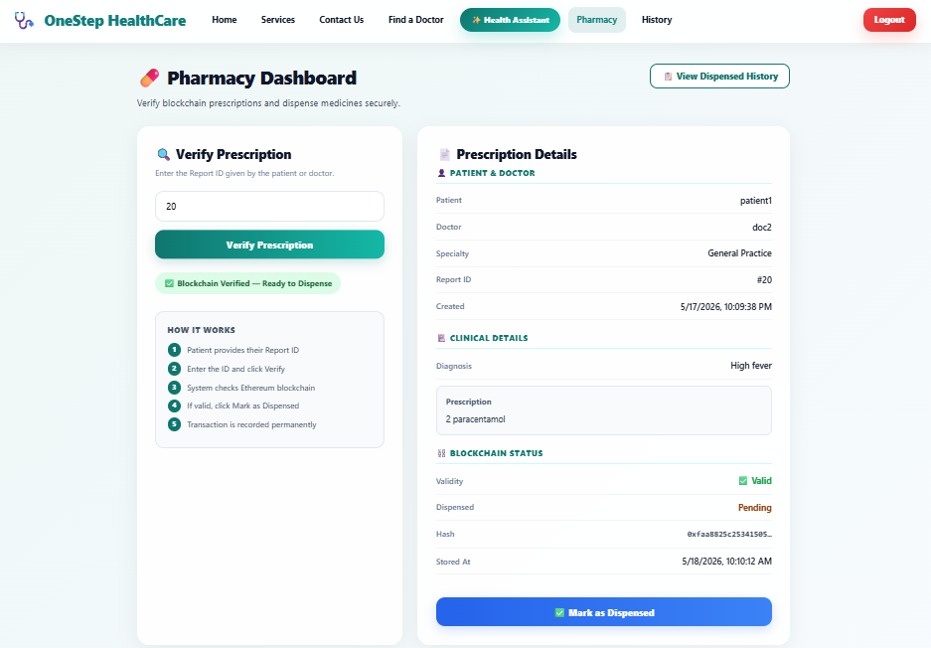

4.2 Status Enum Pattern — State Machine Design
The original PharmacyDashboard used boolean flags: isLoading, isValid, isDispensed, isError. Boolean combinations create impossible states (isValid=true && isDispensed=true) and require defensive checks throughout the render logic. The status enum pattern collapses the state space: a single field taking values idle / loading / valid / dispensed / invalid maps each UI state to exactly one value. The conditional rendering logic becomes a switch statement with exhaustive cases rather than a tree of if/else checks. This approach follows Harel's (1987) statechart formalism applied to React — every state transition is explicit and auditable.

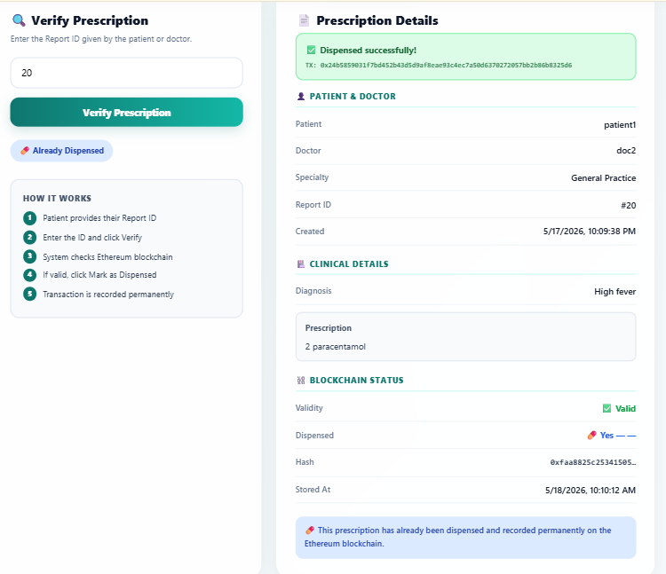

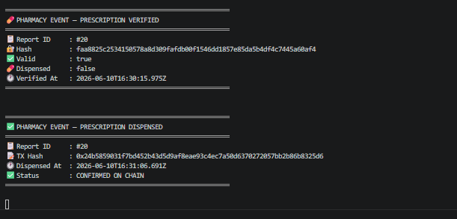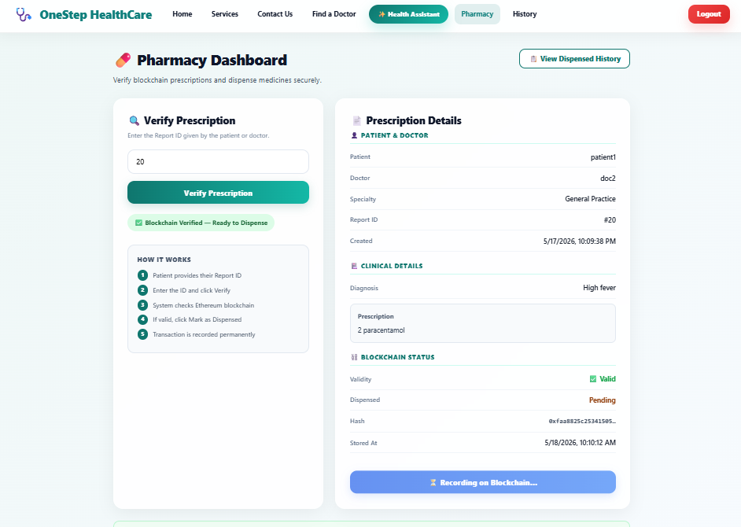

4.3 Integration Testing — SQL Mutation Tamper Detection
Scenario 3 of the test suite is the most technically significant test in the project. It proves that the blockchain protection is real, not cosmetic. The test follows four steps: creates a report and stores its hash on Sepolia; directly mutates the prescriptionText field in MySQL using a raw SQL UPDATE to simulate prescription tampering; calls the verify endpoint; asserts that isValid is false. This test can only pass if the system actually reads the hash from the blockchain and compares it against a freshly computed hash of the current database content — not from a cached value.

The test was designed following Humble and Farley's (2010) integration testing principle: tests should exercise the real integration points, not mocked approximations. Running against a real MySQL instance on Railway prevents mock/production divergence — the failure mode that makes mocked tests pass while production fails.

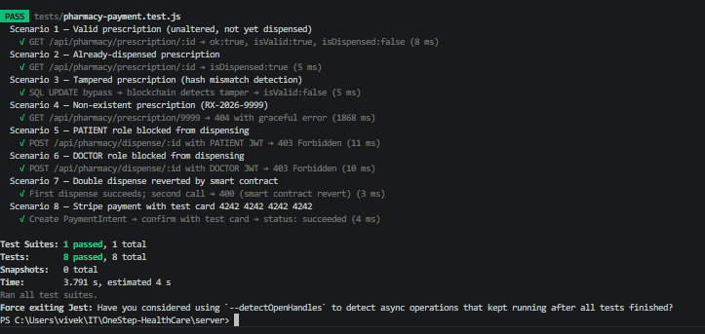

4.4 Stripe CardElement — Remount Pattern
Stripe's React SDK mounts an iframe inside the CardElement component. If a payment fails, Stripe's internal state is corrupted and remounting the same iframe produces an 'Elements already mounted' JavaScript error, breaking the payment form entirely. The remount pattern uses React's key prop: on payment failure, a stripeKey state integer is incremented; because the key changes, React treats the CardElement as a new component and unmounts/remounts the Stripe iframe cleanly. This is a React reconciliation pattern, not a Stripe API pattern — it requires understanding how React's virtual DOM diffing works at the component identity level.

5. Communication for Sustainable Productivity
LO 3.2 | Support team development by mentoring peers, resolving conflicts, and promoting a positive team environment.

Team communication operated across five channels: Microsoft Teams video calls for sprint planning and retrospectives, Teams chat for daily async coordination, GitHub pull requests for code review, face-to-face campus sessions for complex debugging, and documented meeting minutes filed in the Teams channel within 24 hours of each retrospective.

5.1 Team Communication Channels
Channel | How It Was Used
Microsoft Teams — video call | Sprint retrospective and planning — weekly. Sprint demos run as screen shares. All technology conflicts resolved in real time during these calls.
Microsoft Teams — chat | Daily async: bug reports, API contract JSON shared before frontend coding started, build failure notifications, access control review findings.
GitHub — pull requests | Every feature merged via PR with at least one review comment. Review turnaround SLA added at Sprint 4: PRs before 8pm reviewed by 10am next day.
Face-to-face (campus) | BigInt timestamp mismatch and Railway CORS failure both traced and fixed in campus sessions where screen sharing alone was insufficient.
Meeting minutes | Eight sprint retrospective minutes filed in Teams. Sprint 4 minutes documented the pharmacist discoverability gap formally — that record became the justification for the Sprint 5 scope reset.

.

5.2 Conflict 1 — Payment Gateway Selection (PayPal vs Stripe)
Field | Detail
Sprint | Sprint 2 planning — tech stack finalisation
Disagreement | I (Tannu) advocated for PayPal because more New Zealand users are familiar with it and the integration documentation is simpler for a frontend implementation. Vivek argued strongly for Stripe citing a server-side PaymentIntent retrieve pattern that would prevent client-side payment spoofing. The disagreement was genuine — both points had merit.
Channel | Microsoft Teams call — Sprint 2 planning. Both team members prepared independent comparison notes before the call.
Resolution | We agreed to evaluate four criteria: NZ transaction fee, test mode completeness, server-side confirmation support, and developer documentation quality. Stripe scored best on three of four. The deciding factor was server-side confirmation: PayPal's sandbox lacked this capability, meaning a client could fake a successful payment. That security gap disqualified PayPal. I accepted the outcome once the implication was made clear — a payment system where a client can spoof success is not acceptable in a healthcare booking context.
Outcome | Stripe selected. In hindsight this was the correct call — I built the Stripe CardElement frontend in Sprint 4 and the server-side confirm pattern Vivek implemented is genuinely more secure than client-trust alternatives.

5.3 Conflict 2 — AI Provider Choice (Groq Free Tier vs OpenAI GPT-4o)
Field | Detail
Sprint | Sprint 3 — after OpenAI removed free credits mid-project
Disagreement | I (Tannu) proposed switching to Groq's free-tier Llama 3.3-70b immediately on the grounds of cost risk: no budget had been approved and a billing overrun could break the AI feature mid-semester. Vivek wanted to keep OpenAI GPT-4o, arguing the output quality was measurably better for complex multi-symptom descriptions.
Channel | Teams call followed by an empirical half-day test — each team member ran the same 12 symptom descriptions through both providers independently.
Resolution | Groq matched OpenAI on 10 of 12 test cases. The two divergences were edge-case symptoms unlikely to appear in normal use. The data ended the disagreement cleanly — no concession required from either side because the evidence decided. I recorded the test results in the Sprint 3 retrospective minutes.
Outcome | Groq selected. The free tier held across the entire project with no billing surprises. My cost-risk concern was validated — had we used GPT-4o, testing alone would likely have consumed the free credit allocation.

5.4 Conflict 3 — Pharmacy Module Scope
Field | Detail
Sprint | Sprint 4 retrospective — after the first PharmacyDashboard demo
Disagreement | Vivek considered the pharmacy feature complete: the pharmacist could verify by report ID and dispense. I disagreed. I logged in as a first-time PHARMACIST user during the demo and pointed out that there was nothing to indicate what to do first — no queue, no starting point, no discoverability. A real-world pharmacist using this system for the first time would be stuck at a blank form.
Channel | Teams call — Sprint 4 retrospective. The gap was demonstrated live by sharing my screen as the pharmacist user.
Resolution | Vivek agreed once the first-time-user perspective was made explicit. We resolved to adopt the New Zealand ePrescription model: patients receive an RX-2026-{id} code on their dashboard and present it at the pharmacy; a GET /api/pharmacy/pending queue provides proactive discovery for pharmacists. Both added to Sprint 5 scope.
Outcome | The pending queue became the most-used pharmacist feature in testing. This conflict demonstrates that QA perspective — thinking like a user, not a developer — adds value that technical review alone does not.
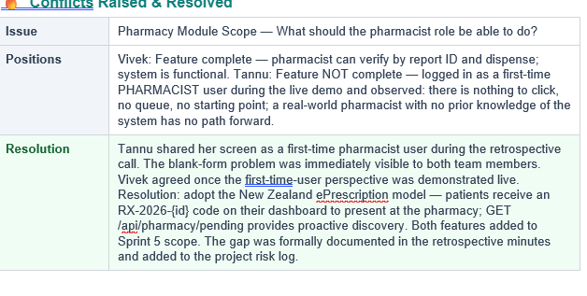
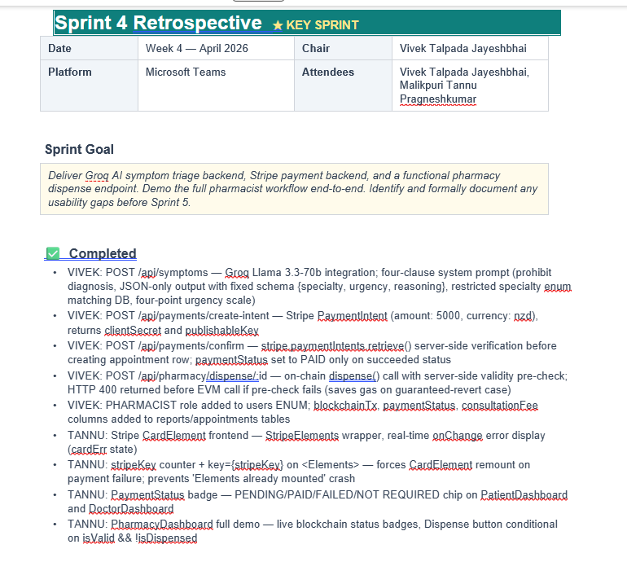

5.5 Mentoring and Team Development
Two mentoring interactions are worth documenting. First, when Vivek shared the API contracts for the pharmacy endpoints before coding, I asked clarifying questions about the response shape — not because I did not understand it, but because working through the contract explicitly helped me build the frontend in parallel without waiting for the backend to be complete. I later adopted the same practice for the test suite: writing the test cases against the API contract before Vivek had finished the implementation. This let both streams progress in parallel.

Second, after the access control review in Sprint 5 I wrote a checklist of required guards for all route categories (public, patient, doctor, pharmacist, admin) and added it to the Teams channel. The checklist caught two additional unguarded routes beyond the pharmacy verify endpoint. Converting the one-time review into a reusable checklist is the kind of process improvement that prevents recurrence rather than just fixing the immediate instance.

6. Managing the Project
LO 3.1 | Plan and coordinate team tasks, ensuring roles are clearly defined and progress is monitored.

Project management used three layers: GitHub Projects for individual task tracking, weekly sprint retrospectives for sprint-level review, and weekly progress reports for block-level status.

6.1 GitHub Projects Board
Every task was created as a GitHub Issue before starting. Issues were labelled with sprint number, assigned to a team member, and moved through Backlog / Ready / In Progress / Review / Done columns. This created a timestamped audit trail for every piece of work. The Review column was particularly important for my test suite work: placing a test scenario in Review meant the backend route it tested had to be confirmed working before the test was marked Done.

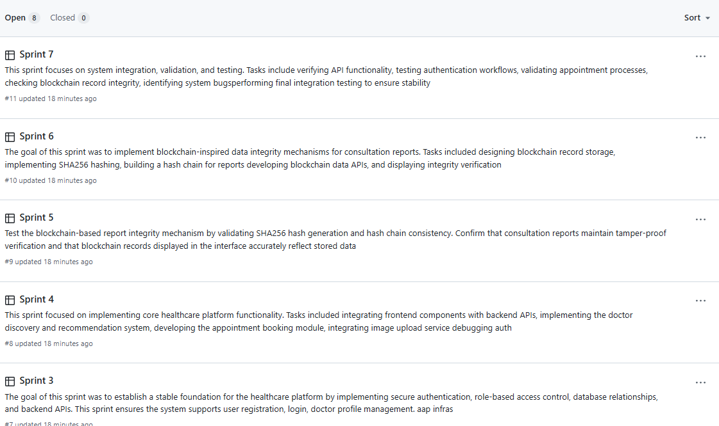

6.2 Sprint Allocation Table
Sprint | Tannu Primary | Vivek Primary | Joint / Review | Key Outcome
S1 | PrivateRoute, Login, Register, Navbar | Auth backend, JWT, DB schema | API contract for auth | Auth end-to-end
S2 | FindDoctor, BookAppointment, Dashboard badges | Appointment API, contract extension | Appointment JSON contract | Booking flow live
S3 | Hash normalisation fix, PharmacyDashboard, RX code | Reports API, pharmacy verify endpoint | Blockchain integration test | Verification working
S4 ★ | Discoverability gap raised, Stripe CardElement | Groq, Stripe backend, dispense endpoint | Retro — scope reset | Full scope redefined
S5 | Access control audit, PharmacyHistory, BigInt fix | Pending queue API, code system | Security patch deployment | Full pharmacist journey
S6 | AI Symptom Checker UI, Ethers.js BigInt fix, UI polish | Pre-flight, structured errors | Four-stream merge | All streams shipped
S7 | SQL mutation test + 7 Jest scenarios, cross-env | Promise.all optimisation, stress test | Performance review | 8/8 tests pass
S8 | Final QA pass, portfolio | Backend docs, app.js extraction | Sign-off | Project closed

7. Issues and Challenges
LO 1.2 | Critically reflect on the effectiveness of the chosen process — each challenge documents how IID handled the problem.

7.1 Hash Comparison Mismatch
Every blockchain verification returned isValid=false, including unmodified prescriptions. The root cause was a bytes32/hex normalisation gap (Section 4.1). This was caught in Sprint 3 because the sprint deliverable included a real end-to-end blockchain verify. Process reflection: IID's vertical slice discipline created the environment for this discovery. A development process that deferred integration to a later phase would have surfaced this much later.

7.2 Ethers.js v6 BigInt Breaking Change
PharmacyHistory timestamps were displaying NaN. Ethers.js v6 changed uint256 return type from Number to BigInt. The JavaScript Date constructor does not accept BigInt. Fix: Number(bigIntValue)*1000. Identified by reading the Ethers.js v6 migration guide independently after the NaN symptom appeared. Process reflection: breaking changes in external library versions should be tracked in sprint notes. Adding a version upgrade checklist to the retrospective template would prevent this type of silent regression.

7.3 Unauthenticated Prescription Endpoint
GET /api/pharmacy/prescription/:id was accessible with any JWT, not just a PHARMACIST JWT. A PATIENT with a patient token could enumerate all report IDs and read any prescription. Identified by systematic access control review in Sprint 5, not by accident. Fixed in the same sprint with requireRole('PHARMACIST') added. Two additional unguarded routes were identified in the same review.

7.4 CardElement Already Mounted Error
Stripe's CardElement iframe enters a broken state after a payment failure. Remounting the same component produces 'Elements already mounted'. Root cause: React does not remount a component whose key has not changed, so the broken Stripe iframe persists. Fix: increment the key prop on failure to force unmount/remount. This required understanding React reconciliation at a level beyond standard component lifecycle.

7.5 cross-env Windows PowerShell Compatibility
NODE_OPTIONS=--experimental-vm-modules failed in Windows PowerShell because PowerShell does not support Unix environment variable syntax in npm scripts. Fix: cross-env package prefixed before the test command in package.json. Required on all team members' machines to run the Jest suite locally.

7.6 Sprint 6 Four-Stream Overload
Sprint 6 accumulated pharmacy, Stripe, AI, and research streams simultaneously. This was the heaviest sprint in the project. No features slipped, but the review cycle was compressed. Process reflection: a WIP limit (maximum two active streams per sprint) alongside the timebox would distribute load more evenly in future projects.

8. Conclusion
My contribution to OneStep Healthcare extended across the full stack. The hash normalisation fix required understanding the bytes32/SHA-256 interface at the data type level. The access control review required systematically reasoning about authentication and authorisation at the API design level. The SQL mutation tamper detection test required understanding what the blockchain protection actually guarantees and designing a test that could falsify it. None of these contributions are frontend work.

The status enum pattern, the CardElement remount strategy, and the BigInt handling all demonstrate applied research in the sense that each required reading primary documentation (Solidity ABI specification, Ethers.js v6 migration guide, Stripe React SDK docs, React reconciliation algorithm) and applying findings to real implementation problems.

Three team conflicts — payment gateway, AI provider, pharmacy scope — were resolved through structured comparison and empirical test. The pharmacy scope conflict produced the most consequential single change in the project: the pending queue feature that made the pharmacist role discoverable. It was identified not through technical review but through the discipline of evaluating the system from a first-time user's perspective during a sprint demo.

The eight-sprint IID process created the conditions for all of these discoveries. Vertical slices, regular demos, and retrospective-driven backlog evolution are not just methodology — they are the mechanism through which this team identified and fixed the problems that mattered most.

9. References
Anderson, D. J. (2010). Kanban: Successful evolutionary change for your technology business. Blue Hole Press.
Beck, K. (2000). Extreme programming explained: Embrace change. Addison-Wesley.
Boehm, B. W. (1988). A spiral model of software development and enhancement. IEEE Computer, 21(5), 61-72. https://doi.org/10.1109/2.59
bpacnz. (2024). Unintentional misuse of prescription medicines. https://bpac.org.nz/2024/misuse-medicines.aspx
Digittrix. (2025). WebRTC vs Agora: Key differences for real-time communication apps. https://www.digittrix.com/blogs/webrtc-vs-agora-key-differences
Harel, D. (1987). Statecharts: A visual formalism for complex systems. Science of Computer Programming, 8(3), 231-274. https://doi.org/10.1016/0167-6423(87)90035-9
Humble, J., & Farley, D. (2010). Continuous delivery: Reliable software releases through build, test and deployment automation. Addison-Wesley.
Information. (2025). Smart contracts, blockchain, and health policies: Past, present, and future. MDPI Information, 16(10), 853. https://doi.org/10.3390/info16100853
Larman, C., & Basili, V. R. (2003). Iterative and incremental development: A brief history. IEEE Computer, 36(6), 47-56. https://doi.org/10.1109/MC.2003.1204375
Levine, D. M., Crosby, J. C., Hart, M., & Mehrotra, A. (2025). Accuracy of online symptom assessment applications, large language models, and laypeople for self-triage decisions. npj Digital Medicine, 8(1). https://doi.org/10.1038/s41746-025-01566-6
Litchfield, A., & Khan, A. (2021). BlockPres: A novel blockchain-based incentive mechanism to mitigate inequalities for prescription management system. Sensors, 21(15), 5035. https://doi.org/10.3390/s21155035
National Drug Intelligence Bureau. (2023). The New Zealand illicit drug harm index 2023: Research report. Ministry of Health. https://www.health.govt.nz/publications/the-new-zealand-illicit-drug-harm-index-2023-research-report
Rensaa, J. H., Gligoroski, D., Kralevska, K., Hasselgren, A., & Faxvaag, A. (2021). VerifyMed: A blockchain platform for transparent trust in virtualized healthcare. arXiv. https://arxiv.org/abs/2005.08804
Schwaber, K., & Sutherland, J. (2020). The Scrum guide. https://scrumguides.org/
Shaikh, M. F., Hassan, S. H., Maccaro, A., Pratesi, G., & Piaggio, D. (2025). A blockchain framework using proof of authority and smart contracts for ethical and secure healthcare asset management. Frontiers in Public Health, 13. https://doi.org/10.3389/fpubh.2025.1638546
Singhal, K., Azizi, S., Tu, T., Mahdavi, S. S., Wei, J., Chung, H. W., & Natarajan, V. (2023). Large language models encode clinical knowledge. Nature, 620, 172-180. https://doi.org/10.1038/s41586-023-06291-2
Statista. (2024). Online doctor consultations — New Zealand: Market forecast. https://www.statista.com/outlook/hmo/digital-health/online-doctor-consultations/new-zealand
Stripe. (2024). Stripe payments documentation: Accept a payment. https://stripe.com/docs/payments/accept-a-payment
Wang, Y., Ram, S. S., & Scahill, S. (2024). Characteristics and risk factors of pharmacist misconduct in New Zealand. BMC Health Services Research, 24(1), 223. https://doi.org/10.1186/s12913-024-10591-2
Wood, G. (2014). Ethereum: A secure decentralised generalised transaction ledger (Yellow Paper). https://ethereum.github.io/yellowpaper/paper.pdf

