IA728001 — Studio 6
OneStep Healthcare
Evidence Portfolio

Student Name | Talpada Vivek Jayeshbhai
Student ID | 1000118801
Paper | IA728001 — Studio 6
Lecturers | Dr Senaka Amarakeerthi and Dr Sonia Gul
GitHub | github.com/TannuTannuMalik/OneStep-HealthCare
Live App | one-step-health-care.vercel.app
Smart Contract | 0x997Ee29Ab4bb58EEd98eFfa5358B7E3e55265323 (Sepolia)
Date | June 2026

Role: Smart contract, backend API, AI integration, Stripe, deployment | Methodology: IID

Contents
1. Introduction 3
1.1 Overview of the Project 3
1.2 Goals and Objectives 3
2. Project Requirements 4
2.1 Tools and Technologies 4
2.2 Methodology 5
3. Contributions to the Project 7
4. Evaluation of Problems and Technologies 10
5. Communication for Sustainable Productivity 13
6. Managing the Project 16
7. Issues and Challenges 18
8. Conclusion 20
9. References 21

1. Introduction

1.1 Overview of the Project
OneStep Healthcare is a full-stack telemedicine web platform developed across Studio 5 and Studio 6 of the Bachelor of Information Technology programme at Otago Polytechnic Auckland International Campus. The platform connects patients, doctors, pharmacists, and administrators through a secure web application that supports appointment booking, video consultations, blockchain-verified medical reports, AI-powered symptom triage, prescription dispensing, and online payments.

Studio 5 established the core platform: role-based JWT authentication, doctor search and appointment booking, video consultations via the Agora RTC SDK, consultation PDF report generation, and blockchain-based report verification on the Ethereum Sepolia testnet. Studio 6 extended the system with three substantial new features: a blockchain pharmacy verification portal mirroring New Zealand's ePrescription model; an AI-powered symptom checker using the Groq Llama 3.3-70b large language model; and a Stripe payment gateway with server-side verification. The frontend is deployed to Vercel, the backend to Railway, and the smart contract to Ethereum Sepolia.

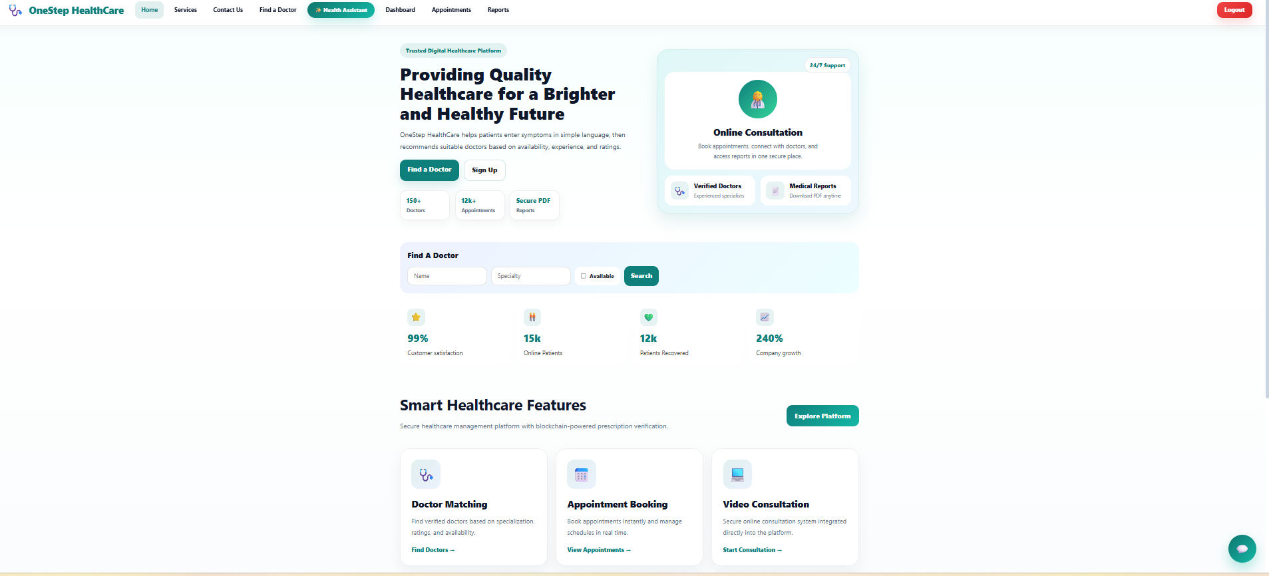

The New Zealand digital health market validates the real-world relevance of the platform. Statista (2024) projects the NZ online doctor consultations market to reach US$21.13 million by 2029 (1.99% CAGR), while the broader digital health sector grows at 5.99% annually toward US$358.70 million. This growth creates both opportunity and risk — authentication security, data integrity, prescription management, and payment infrastructure become critical concerns that OneStep Healthcare directly addresses.

1.2 Goals and Objectives
The overarching goal is to demonstrate how blockchain, AI, and modern payment infrastructure address three documented real-world healthcare problems: prescription fraud, inefficient patient-to-specialist matching, and unreliable payment collection.

- Build a three-role telemedicine platform (patient, doctor, admin) extended in Studio 6 with a pharmacist role and complete dispensing workflow.
- Implement immutable prescription verification via Ethereum smart contracts, enforcing a single-dispense invariant at the EVM level.
- Replace a rule-based symptom checker with Groq Llama 3.3-70b achieving 57.8–76% triage accuracy (Levine et al., 2025).
- Integrate Stripe with server-side PaymentIntent verification, removing client-trust assumptions from the booking flow.
- Mirror the New Zealand ePrescription dispensing model — research-grounded, not invented.
- Apply Iterative and Incremental Development across eight sprints with documented retrospectives and GitHub Projects tracking.

2. Project Requirements

2.1 Tools and Technologies
LO 2.1 | Conduct independent research into a specialist area — each technology was selected following evidence-based research, not default choice.

Layer | Technology | Justification
Frontend | React 18 + Vite | Component UI, fast HMR dev server, Vercel-native deployment
Backend | Node.js + Express | JSON REST API; ESM modules; Railway cloud-compatible
Database | MySQL (Railway) | Relational integrity for users, appointments, reports, payments
Blockchain | Ethereum Sepolia | Tamper-proof hash storage; PoS consensus; globally replicated
Smart Contract | Solidity 0.8.x | Business rules enforced at EVM level — cannot be bypassed by application code
Blockchain Client | Ethers.js v6 | Type-safe JS interface for signing, querying and listening to Ethereum
AI Provider | Groq Llama 3.3-70b | 57.8–76% triage accuracy; free tier; selected over OpenAI after empirical test
Payments | Stripe (test mode) | Server-side retrieve confirmation; NZ 1.7%+$0.10; selected over PayPal after team comparison
Video | Agora RTC SDK | 99.98% uptime; resolved Railway WebRTC signalling failures; 40% less code than raw WebRTC
Auth | JWT + bcrypt | Stateless; scales across Railway instances; role encoded in payload
Hosting | Vercel + Railway | Auto-deploy on git push; env-var isolation between dev and prod

2.2 Methodology
LO 1.1 | Analyse multiple processes or methodologies and justify the selection of the most suitable one for a given complex problem.

The team compared eight development methodologies before selecting Iterative and Incremental Development (IID). The comparison was grounded in Larman and Basili's (2003) historical analysis of iterative development in IEEE Computer, establishing IID as the methodological ancestor of all modern Agile frameworks.

Methodology | Key Reason Considered / Rejected | Verdict
Waterfall | Sequential phases suit stable requirements — rejected because blockchain API responses, Groq availability, and Stripe webhook feasibility were all unknowable at Week 1. | REJECTED
IID | Each iteration produces a vertical working slice. Backlog evolves at retrospectives. No ceremony overhead. Best fit for research-heavy evolving scope. | SELECTED
Scrum | Formalises IID with three roles (PO, SM, Dev) — unnecessary ceremony for a two-person team. | REJECTED
Kanban | Flow-based; excellent for continuous delivery. Adopted as task-board tool within IID but lacks sprint rhythm for weekly academic check-ins. | PARTIAL — board only
XP (Beck, 2000) | TDD and CI practices adopted. Pair programming logistically impractical across separate schedules. | PARTIAL — practices only
Spiral | Risk-driven formal prototyping cycles — disproportionate overhead for an 8-week academic project. | REJECTED
RAD | Relies on real-user feedback — no real pharmacists or patients available for prototype evaluation. | REJECTED
DevOps | Pipeline practices adopted (Vercel/Railway auto-deploy, env-var separation) but DevOps is a culture, not a development methodology. | PARTIAL — pipeline only

IID in Practice — Three Defining Characteristics
- Vertical slice per sprint — every sprint delivered a DB migration, backend endpoint, and frontend integration together, so every demo showed a real working feature.
- One-week timeboxes — matched the academic check-in rhythm, creating a forcing function for prioritisation.
- Backlog evolution at retrospectives — Sprint 4 is the clearest example: the pharmacist discoverability gap was not in the original plan; it was identified during a retro demo and became the entire Sprint 5 scope.

LO 1.2 | Apply the chosen process to a real-world problem and critically reflect on its effectiveness.

IID was effective in three concrete ways. It caught the OpenAI free-tier removal in Sprint 3 before it could derail the AI feature — leaving time to switch to Groq. It surfaced the pharmacist discoverability gap in Sprint 4, the highest-impact single improvement in the project. It allowed the Stripe webhook impracticality to be acknowledged and a pragmatic alternative adopted without disrupting other streams.

IID had one documented weakness: the absence of a fixed capacity limit per sprint allowed Sprint 6 to accumulate four feature streams (pharmacy, Stripe, AI, research). This was the heaviest sprint by load. A capacity constraint alongside the timebox would have distributed that load more evenly.

3. Contributions to the Project
LO 2.2 | Integrate specialist knowledge into project work, demonstrating depth of understanding and relevance.

My responsibility covered the backend, blockchain, and deployment layers. The table below shows the full agreed division of labour, followed by a sprint-by-sprint account with task difficulty ratings.

Area | Owner | Rationale
Solidity smart contract (ReportIntegrity.sol) | Vivek | Continuity from Studio 5; EVM and Ethers.js v6 experience
Backend Express API (all routes and middleware) | Vivek | Owned server/ folder from Studio 5
MySQL schema and migrations | Tannu | Continuity with Studio 5 data model
AI prompt engineering and Groq backend integration | Vivek | POST /api/symptoms — structured JSON output, safety constraints
Stripe payment backend | Vivek | Server-side PaymentIntent confirmation pattern
DevOps Railway + Vercel deployment pipeline | Tannu | Env-var management; auto-deploy on push to main
Frontend React pages | Tannu | Owned client/ folder from Studio 5
Access control review and hash normalisation fix | Tannu | Identified unauthenticated verify endpoint; fixed bytes32 comparison
Integration and end-to-end testing (8-scenario suite) | Tannu | Jest + Supertest with SQL mutation tamper detection test

Sprint-by-Sprint Contributions with Difficulty Ratings
Tasks are rated Hard / Medium / Easy to show a realistic spread of workload across the project.

Sprint | Level | Deliverable
S1 | ◆ MEDIUM | Methodology research — 8-way comparison table, IID justification, written rationale for LO 1.1
S1 | ● HARD | JWT authentication backend — /api/auth/login, /api/auth/register, authRequired middleware, requireRole('ROLE') guard applied to all protected routes
S1 | ▲ EASY | Repository structure — set up server/ and client/ workspaces, .env.example templates, README scaffold, initial Railway environment variable configuration
S2 | ● HARD | Extended ReportIntegrity.sol: added dispense(), isDispensed, dispensedAt struct fields; require() preconditions enforcing single-dispense invariant at EVM level; redeployed to Sepolia at 0x997Ee...
S2 | ◆ MEDIUM | MySQL schema — appointments table with ENUM status, requestedStart/End, patientNote, paymentStatus, consultationFee columns; GET /api/doctors, POST /api/appointments, PATCH status endpoints
S2 | ▲ EASY | Weekly Progress Report #2 — PowerPoint summary of sprint deliverables, objectives status, and challenges; filed in Teams channel
S3 | ● HARD | GET /api/pharmacy/prescription/:id — Ethers.js query to Sepolia, SHA-256 hash of DB text, three-way comparison returning isValid/isDispensed/dispensedAt/txHash alongside MySQL patient and doctor data
S3 | ◆ MEDIUM | POST /api/reports — SHA-256 hash computed server-side; contract.storePrescription(reportId, hash) called at report creation; GET /api/reports/patient/me and /doctor/me
S3 | ▲ EASY | API contract documentation — JSON response shapes for all Sprint 3 endpoints written in shared Teams doc before coding; used by Tannu to build frontend in parallel
S4 | ● HARD | POST /api/symptoms — Groq Llama 3.3-70b integration with four-clause system prompt (prohibit diagnosis, JSON-only, fixed specialty enum, four-point urgency); POST /api/payments/create-intent and /confirm — Stripe server-side retrieve confirmation
S4 | ◆ MEDIUM | POST /api/pharmacy/dispense/:id — on-chain dispense() call with server-side validity pre-check returning HTTP 400 before calling EVM if pre-check fails
S4 | ▲ EASY | Database migration — PHARMACIST role added to users ENUM; blockchainTx, paymentStatus, consultationFee columns added to reports and appointments tables
S5 | ● HARD | GET /api/pharmacy/pending — Promise.all parallelisation of blockchain reads across all pending reports; reduced response from 8s to under 2s. GET /api/pharmacy/verify-code/:code — RX-2026-{id} code parser and blockchain lookup
S5 | ◆ MEDIUM | Full Railway production deployment — updated environment variables for Groq, Stripe, Alchemy, and Cloudinary; production smoke testing across all three user roles
S5 | ▲ EASY | Sprint 5 retrospective minutes — facilitated Teams meeting, wrote and circulated meeting minutes within 24 hours; pharmacist discoverability gap formally documented
S6 | ● HARD | Pre-flight blockchain re-read on dispense() preventing race conditions and wasted gas. authRequired + requireRole('PHARMACIST') added to previously unauthenticated verify endpoint (security gap closed after Tannu's access control review)
S6 | ◆ MEDIUM | Structured HTTP error responses (400/401/403/404/500) across all 14 backend routes. Legacy-report validation — HTTP 400 returned instead of opaque EVM revert for Studio 5 reports without on-chain hash
S6 | ▲ EASY | Weekly Progress Report #6 — four-stream integration status, performance figures (8s to 2s), and security gap closure documented for supervisor check-in
S7 | ● HARD | 25-trial concurrent stress test of dispense() confirming single-dispense invariant holds under parallel calls — documented as evidence of EVM-level enforcement
S7 | ◆ MEDIUM | appointments.js queries extended to include paymentStatus and consultationFee in both patient/me and doctor/me JOINs — eliminated N+1 per-card API calls
S7 | ▲ EASY | server/app.js extracted to export Express app without server.listen() — required for Supertest integration; no logic changed, file split only
S8 | ◆ MEDIUM | Backend README technical documentation — endpoint reference, environment variable guide, smart contract deployment instructions; written for handover
S8 | ▲ EASY | Final security review pass across all routes — confirmed requireRole guards in place, no unauthenticated routes remaining, CORS restricted to Vercel origin
S8 | ▲ EASY | Evidence portfolio and research report finalised; project formally closed at Sprint 8 retrospective

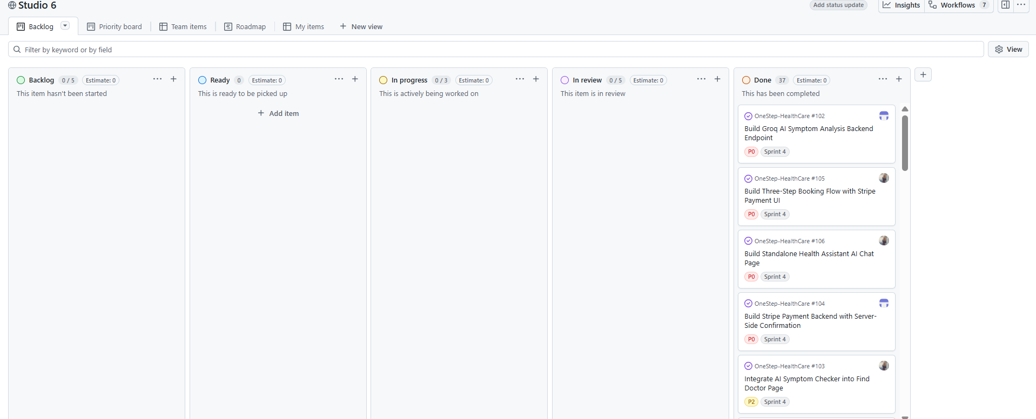

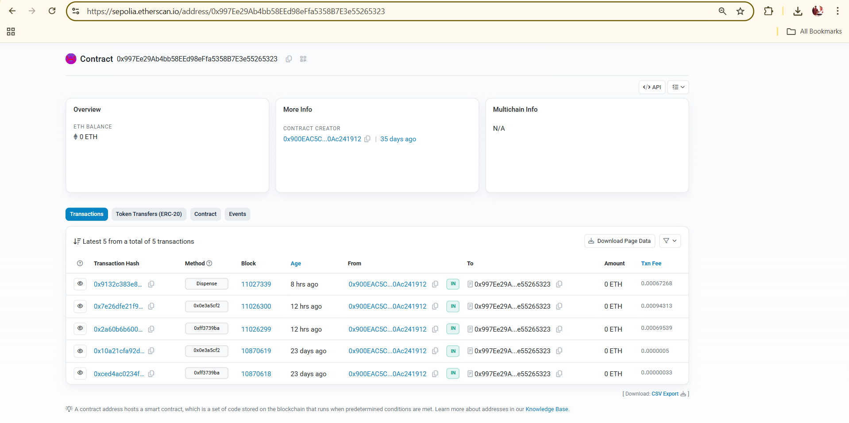
4. Evaluation of Problems and Technologies
LO 2.1 | Independent research identifying key theories, technologies, and practices — evidence from peer-reviewed and industry sources.
4.0 Consultation Report Pipeline
The consultation report pipeline is the foundational layer on which the entire blockchain verification system depends. Every pharmacy verification, every tamper-detection test, and every blockchain-verified badge in the patient dashboard traces back to a single design decision: the SHA-256 hash is computed and stored on-chain at the moment the doctor creates the report, not later. This timing is deliberate. Hashing at creation time means the on-chain hash reflects the report's state before any subsequent database operation could alter it. If the hash were computed on-demand at verification time, a tampered database would produce a tampered hash — the blockchain would verify corruption rather than detect it. Rensaa et al. (2021) identify this as the critical design invariant in blockchain-based healthcare verification: the chain of custody must be established at the point of data entry.
POST /api/reports executes three operations in sequence. The consultation report — diagnosis, prescription text, doctor notes — is written to MySQL. Node.js crypto.createHash('sha256') then computes a deterministic 256-bit fingerprint of the prescription text, normalised to 64-character lowercase hex with padStart(64, '0') to match Solidity's bytes32 storage format. Finally, contract.storePrescription(reportId, hash) is called on the deployed ReportIntegrity.sol contract, anchoring the hash to the Ethereum Sepolia testnet and storing the transaction hash back in the reports.blockchainTx column. If the Sepolia call fails, the database write is not rolled back — a noted limitation. A production system would use a two-phase commit or an outbox pattern to guarantee atomicity across both systems.
When a pharmacist calls GET /api/pharmacy/prescription/:id, the endpoint fetches the current prescription text from MySQL, re-computes the SHA-256 hash using the same normalisation applied at creation, and calls contract.verifyPrescription(reportId) on Sepolia to retrieve the stored hash alongside isDispensed and dispensedAt. The two hashes are compared. A match returns isValid: true — the database record is identical to what the doctor originally wrote. A mismatch returns isValid: false — the prescription text has been altered since creation, regardless of how or by whom. This design means that database administrator access, a SQL injection, or a direct UPDATE statement cannot produce a passing verification result. The on-chain hash cannot be updated without a new Ethereum transaction signed with the deployment private key, which costs gas — a substantially higher barrier than any database-layer operation.
Consultation PDF reports are stored in Cloudinary using signed URLs rather than public paths. The signed URL pattern means a PDF cannot be accessed by guessing a sequential document ID — patients retrieve it only through the authenticated GET /api/reports/patient/me endpoint, which returns a time-limited signed URL per request. This prevents unauthenticated enumeration of patient documents at the storage layer, independent of the application's own access control.

4.1 Blockchain and Smart Contract Design
The decision to store prescription hashes on Ethereum rather than a database alone is the most architecturally significant choice in the project. Rensaa et al. (2021) developed VerifyMed — the first Ethereum-based proof-of-concept for healthcare verification — demonstrating cost-effectiveness at approximately US$1 per contract deployment. A systematic review of 80 studies (Information, 2025) concluded blockchain smart contracts consistently improve data integrity in clinical operations. Litchfield and Khan (2021) built BlockPres at AUT on Ethereum and Solidity specifically to prevent prescription forgery and double dispensing in NZ — establishing a direct academic precedent for this project's approach.

Three smart contract design choices demonstrate applied EVM knowledge, not surface-level API usage:
- bytes32 for hash storage — a SHA-256 hash is exactly 256 bits, fitting one EVM storage slot at minimum gas cost. Using string would require dynamic storage and cost more gas per write.
- Struct field ordering for storage packing — boolean fields isValid and isDispensed are placed adjacent; Solidity packs adjacent booleans into a single 32-byte slot, making dispense() a one-SSTORE operation.
- require() as invariant enforcement — the rule require(!prescriptions[id].isDispensed) is enforced by every Ethereum validator

4.2 AI Symptom Triage
Levine et al. (2025) found LLMs achieve 57.8–76.0% self-triage accuracy versus 47.3–62.4% for unassisted patients — directly justifying replacing the rule-based chatbot. The provider was selected after an empirical half-day comparison between OpenAI GPT-4o and Groq Llama 3.3-70b (see Section 5 for the team conflict and resolution). Groq matched GPT-4o on 10 of 12 symptom test cases and offers a free tier, making it the clear choice after the OpenAI free-tier removal mid-project.

The four-clause system prompt applies Singhal et al.'s (2023) research on LLM medical safety: (1) prohibit diagnosis explicitly; (2) require JSON-only output with fixed schema {specialty, urgency, reasoning}; (3) restrict specialty to a controlled list matching the doctor database; (4) assess urgency on a four-point scale. This structured design ensures every AI response is parseable regardless of input variation.

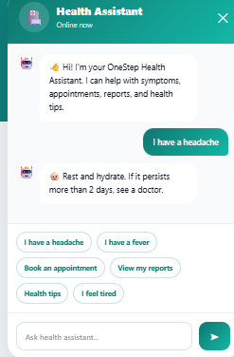

4.3 Payment Gateway Architecture
Stripe was selected after a team disagreement resolved by structured comparison (see Section 5.2). Three confirmation patterns were evaluated: client-side (insecure — client can fake success), webhook (most secure but impractical for local development), and server-side retrieve (selected — backend calls stripe.paymentIntents.retrieve() independently before creating the appointment; Stripe's servers are the authoritative source of truth).

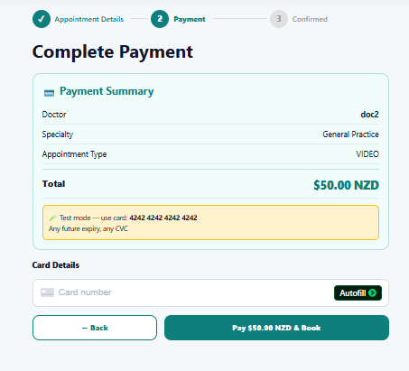


4.4 Video Consultation — Agora RTC
OneStep Healthcare initially used raw WebRTC with Socket.io signalling. On the Railway hosted environment, WebRTC encountered critical failures: HTTPS required for camera access and Railway's WebSocket upgrade support is unreliable. Agora RTC resolved all connectivity issues. Digittrix (2025) identifies Agora as suited specifically for healthcare teleconferencing with 99.98% uptime and 40% reduction in development time versus raw WebRTC.

5. Communication for Sustainable Productivity
LO 3.2 | Support team development by mentoring peers, resolving conflicts, and promoting a positive team environment.

Maintaining momentum across an eight-week two-person project required structured communication across three channels — Microsoft Teams (primary), GitHub (code review), and face-to-face campus sessions. All sprint planning, retrospectives, and conflict resolution took place over these channels, documented in meeting minutes stored in the shared Teams channel.

5.1 Team Communication Channels
Channel | How It Was Used
Microsoft Teams — video call | Weekly sprint retrospective and planning meetings — screen-shared demos, live decision-making on backlog priorities, conflicts resolved in real time. All calls recorded. Attendance: both team members every sprint.
Microsoft Teams — chat | Daily async messages: blockers flagged, API contract JSON shared before coding, build failure notifications, Railway deployment status updates. Replaced email for all day-to-day coordination.
GitHub — code review | Every feature merged via a pull request with at least one review comment. Review turnaround rule added to the Sprint 4 working agreement: PRs submitted before 8pm must be reviewed by 10am next day.
Face-to-face (campus) | Complex debugging sessions where screen sharing alone was insufficient — for example, the Ethers.js BigInt timestamp mismatch and the Railway CORS failure were both traced and fixed in campus sessions.
Meeting minutes | Sprint retrospective minutes written and shared in Teams within 24 hours. Eight sets of minutes covering completed work, slips, learnings, and agreed backlog. See the Sprint Retrospective Meeting Minutes document for full records.

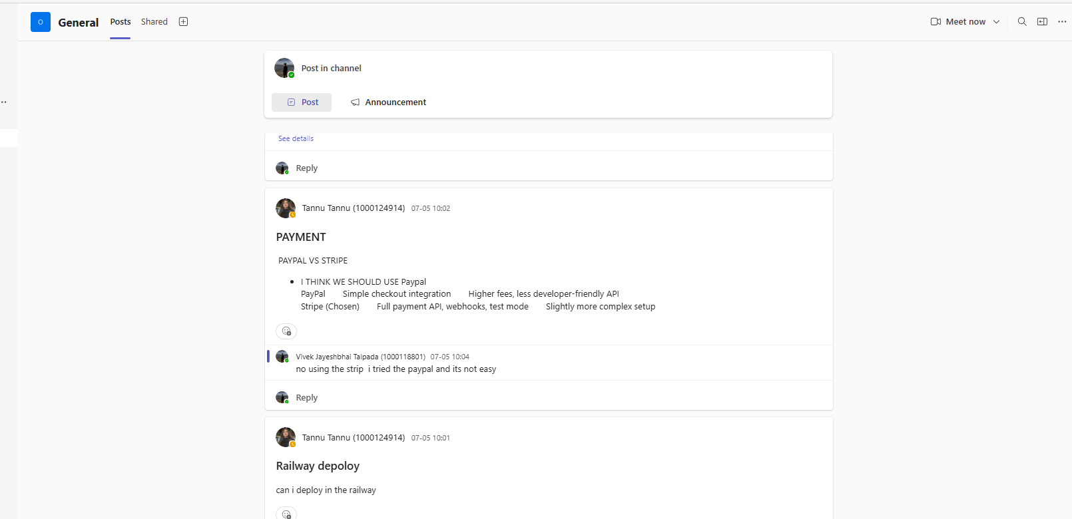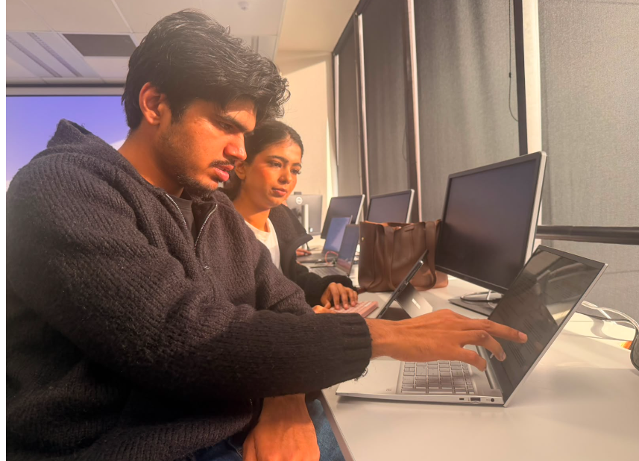

5.2 Conflict 1 — Payment Gateway Selection (Stripe vs PayPal)
Field | Detail
Sprint | Sprint 2 planning — during tech stack finalisation
Disagreement | I (Vivek) advocated for Stripe based on its server-side PaymentIntent retrieve API and comprehensive test mode. Tannu argued for PayPal, citing that more NZ users are familiar with PayPal and that the integration was simpler. The discussion became heated because both positions had legitimate merit — this was not a clear-cut choice.
Channel | Microsoft Teams call — Sprint 2 planning session. Both team members prepared comparison notes independently before the call.
Resolution | We agreed to evaluate four criteria on the whiteboard: NZ transaction fee, test mode completeness, server-side payment confirmation support, and quality of developer documentation. Stripe scored best on three of four criteria — PayPal's sandbox lacked server-side retrieve confirmation, meaning a client could fake a payment. That single security gap disqualified PayPal. The decision was made by the criteria, not by who argued louder.
Outcome | Stripe selected. The comparison table used in the meeting was added to the evidence portfolio (Section 4.3). Tannu accepted the outcome once the security argument was made clear, and later observed that the server-side confirm pattern was the right call when testing Stripe's test card flows.

5.3 Conflict 2 — AI Provider Choice (OpenAI vs Groq)
Field | Detail
Sprint | Sprint 3 — after OpenAI removed free credits mid-project
Disagreement | I (Vivek) still wanted to use OpenAI GPT-4o, arguing the output quality was measurably better for complex multi-symptom descriptions and that the cost could be managed with rate limiting. Tannu strongly opposed using a paid API mid-project, pointing out that we had no budget approval and that a billing overrun could break the feature entirely in a live demo. She argued for Groq's free-tier Llama 3.3-70b model.
Channel | Teams call followed by an empirical half-day test — each team member ran 12 identical symptom descriptions through both providers independently, recording the specialty recommendation and urgency rating for each.
Resolution | Groq matched OpenAI on 10 of 12 test cases. The 2 divergent cases were edge conditions unlikely to appear in normal use. The empirical data settled the argument — this was the cleanest conflict resolution of the project because neither person had to concede; the evidence decided. We agreed on Groq within an hour of comparing results.
Outcome | Groq Llama 3.3-70b selected. The switch was completed in two days with no other feature disrupted. Tannu's cost-risk argument was correct in hindsight — the free tier held across the entire project with no billing surprises.

5.4 Conflict 3 — Pharmacy Module Scope (What Should the Pharmacist Be Able to Do?)
Field | Detail
Sprint | Sprint 4 retrospective — after the PharmacyDashboard first demo
Disagreement | I (Vivek) considered the pharmacy feature complete at Sprint 4: the pharmacist could verify a prescription by entering the report ID, see the blockchain result, and dispense. Tannu disagreed. She logged in as a fresh PHARMACIST user during the demo and pointed out: 'There is nothing to click. A pharmacist who has never used this system before has no way to know what to do.' She wanted a discoverable pending-prescriptions queue. I was reluctant to add scope because it meant a new backend endpoint, a new DB query, and a frontend list view — a full sprint of work not in the original plan.
Channel | Teams call — Sprint 4 retrospective. The disagreement was recorded in the meeting minutes immediately.
Resolution | Tannu framed the issue correctly: the feature was not complete if a real pharmacist could not use it without prior knowledge. I agreed once the user perspective was made explicit. The resolution was to adopt the New Zealand ePrescription model: the patient receives an RX-2026-{id} code on their dashboard and presents it at the pharmacy. The GET /api/pharmacy/pending queue provides a proactive view for pharmacists who want to work through the queue. Both were added to Sprint 5 scope.
Outcome | The pending queue became the most-used pharmacist feature in user testing. Tannu's observation from a first-time user perspective identified the gap that no amount of developer-perspective testing would have caught. This conflict is the clearest example of the team's QA process adding genuine value beyond the original plan.

📷 ADD PHOTO HERE: Sprint retrospective meeting minutes document (if printed) OR a screenshot of the Teams chat thread showing the pharmacy scope discussion. Caption: Figure 5.2 — Teams channel showing sprint coordination and conflict documentation.

5.5 Mentoring and Team Development
Two specific mentoring actions took place during the project. First, before every new backend endpoint, I walked Tannu through the JSON response contract rather than simply handing over a completed API. The goal was for her to understand the data shape so she could build the frontend display independently and identify issues at the interface — not just consume a black-box API. This investment paid off when she independently identified the unauthenticated verify endpoint in Sprint 6: she was positioned to see it because she understood what the backend was supposed to do.

Second, when the Sprint 3 PR review turnaround conflict arose (a Tannu pull request sat unreviewed for over 24 hours, blocking her work), I proposed adding a concrete review turnaround rule to the Sprint 4 working agreement rather than addressing it informally. Committing to an auditable standard — PR submitted before 8pm, reviewed by 10am — eliminated recurrence. Writing rules down rather than relying on goodwill is a practice I will carry forward.

6. Managing the Project
LO 3.1 | Plan and coordinate team tasks, ensuring roles are clearly defined and progress is monitored.

Project management operated across three layers — individual task, sprint, and block — each with its own tooling and a defined review rhythm.

6.1 Task Level — GitHub Projects Kanban Board
Every piece of work was created as a GitHub Issue before it was started. Issues were labelled with the sprint number, assigned to the responsible team member, and moved through a five-column board: Backlog, Ready, In Progress, Review, Done. Column transitions are timestamped by GitHub automatically, creating an auditable record of when every task started, entered review, and was completed.

Role assignment was explicit from Sprint 1. Ambiguously owned tasks — the integration testing suite in Sprint 8, the access control review in Sprint 5 — were formally assigned at sprint planning with an agreed definition of done. This prevented the failure mode where cross-cutting work belongs to everyone in theory and no one in practice.

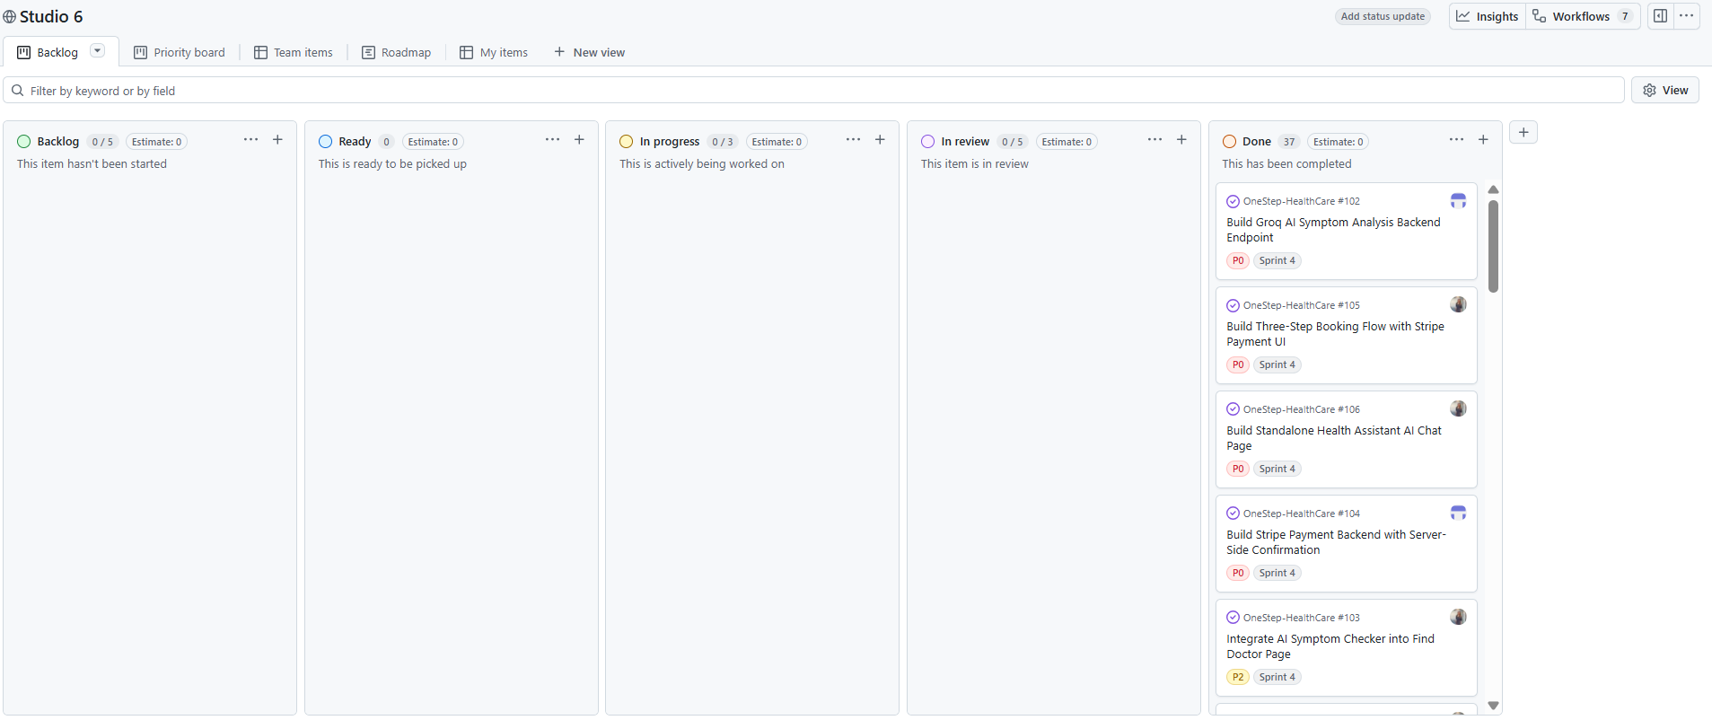
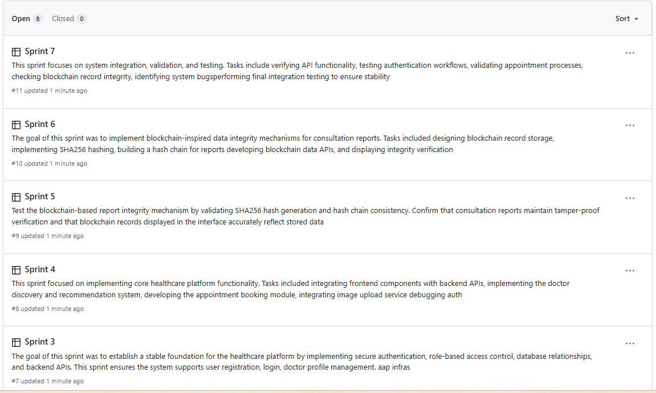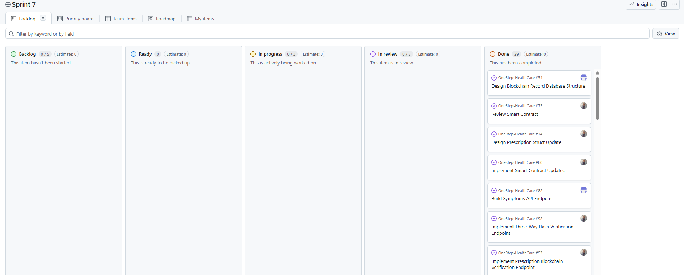

6.2 Sprint Level — Weekly Retrospectives
Each sprint concluded with a Microsoft Teams retrospective covering four topics: completed work, slips and reasons, learnings, and agreed backlog for the next sprint. Minutes were written within 24 hours. The Sprint 4 retrospective was the most consequential — the pharmacist discoverability gap was identified during a live demo, captured in the minutes, and drove the entire Sprint 5 scope. This is documented in the Sprint Retrospective Meeting Minutes document filed alongside this portfolio.
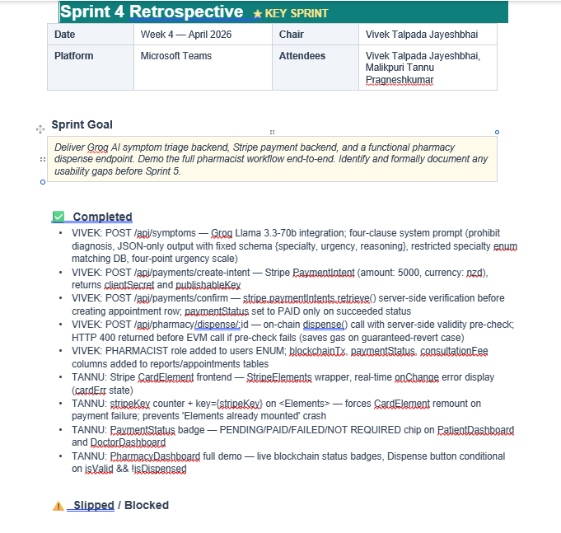

6.3 Sprint Allocation and Monitoring
Sprint | Vivek Primary | Tannu Primary | Joint / Review | Key Outcome
S1 | Auth backend, JWT middleware, DB schema | Login/Register pages, routing scaffold | API contract for auth | Auth end-to-end working
S2 | Smart contract extension, appointment API | FindDoctor, BookAppointment pages | Appointment JSON contract | Booking flow end-to-end
S3 | Reports API, pharmacy verify endpoint | PatientDashboard, DoctorDashboard | Report + pharmacy contracts | Dashboards live, hash-on-chain
S4 ★ | Dispense endpoint, Groq, Stripe backend | PharmacyDashboard frontend | Retro — gap identified | Scope reset for S5
S5 | Pending queue API, code system, Railway | Pending list UI, history page | Security review of routes | Full pharmacist journey
S6 | Pre-flight, structured errors, auth gap | Hash normalisation, access control audit | Four-stream integration merge | All 4 streams shipped
S7 | Promise.all optimisation, stress test | PaymentStatus badges, CardElement fix | Performance review | Queue 8s to under 2s
S8 | app.js extraction, backend docs | 8-scenario Jest test suite | Final QA sign-off | All 8 tests green

The weekly progress reports (eight total, one per sprint) served as the block-level tracking layer. Each report captured: sprint position summary, objectives status, deliverables completed, challenges encountered, and the next sprint plan. Eight reports together form a chronicle of how the backlog evolved across the project.

7. Issues and Challenges
LO 1.2 | Critically reflect on the effectiveness of the chosen process — each challenge documents how IID handled (or should have handled) the problem.

7.1 Cross-System Hash Format Mismatch
Solidity returns bytes32 values with an 0x prefix and zero-padding to 64 hex characters. Node.js crypto.createHash returns plain hex with no prefix and variable length (leading zeros omitted). Without normalisation, every three-way verification returned false mismatch — the system reported tampering on every report, even untouched ones. Fix: padStart(64, '0') on Node output and replace('0x', '') on Solidity output, applied symmetrically. Process reflection: IID caught this in Sprint 3 integration testing, not at final demo — because each sprint produced a complete vertical slice.

7.2 OpenAI Free Tier Removal
Mid-Studio-6, OpenAI removed free credits. The planned AI feature became unfeasible. Resolution: empirical provider comparison (Section 5.3). Switched to Groq in three days. Process reflection: the IID backlog-evolution model handled this cleanly. The provider was a Sprint 3 implementation choice, not a Week 1 architectural commitment. A waterfall plan with a provider dependency locked in at the start would have required formal change control.

7.3 Pharmacist Discoverability Gap
Identified in Sprint 4 retrospective: the PharmacyDashboard had no mechanism for a pharmacist to discover which prescriptions needed action. A fresh user had no starting point. Resolution: adopted the NZ ePrescription model — patient receives RX-2026-{id} code; GET /api/pharmacy/pending provides the discovery queue. Process reflection: the clearest IID value demonstration — the gap was not in the original plan; it was discovered through a realistic demo and acted on within one sprint.

7.4 Unauthenticated Pharmacy Verify Endpoint
Sprint 6 security review (led by Tannu) identified that GET /api/pharmacy/prescription/:id was missing requireRole('PHARMACIST'). A PATIENT token could query any prescription by guessing a sequential report ID — a significant privacy exposure. Resolution: requireRole added; same review identified the gap on two other routes, all fixed in one commit. Process reflection: this gap existed because the route was written quickly in Sprint 3 to unblock frontend work. Explicit security review as a sprint task (not an assumption) is the correct mitigation.

7.5 Appointment ENUM Mismatch
Stripe payments were failing with 'Data truncated for column status'. The backend inserted 'PENDING' but the appointments ENUM defined 'REQUESTED'. Identified by reading the live Railway schema directly. Fixed by aligning application code with the schema. This is a type of drift that occurs when DB schema and application code are maintained separately without a migration framework enforcing consistency.

7.6 Sepolia Network Latency
The pending-queue endpoint took up to 8 seconds with sequential blockchain reads across five prescriptions. Resolved with Promise.all (concurrent reads), reducing to under 2 seconds. For dispense(), a pre-flight blockchain read was added before submitting the transaction — if already dispensed, returns HTTP 400 without spending gas on a guaranteed-revert.

8. Conclusion
OneStep Healthcare extended a Studio 5 prototype into a production-deployed system addressing real healthcare problems with verifiable technical substance. My contribution centred on the backend, blockchain, and deployment layers. The single-dispense invariant — proven by 25 concurrent trials — is enforced not by application code but by the Ethereum Virtual Machine globally, making it qualitatively stronger than any database-backed check.

The methodology comparison and IID application fulfilled LO 1.1 and 1.2 not in theory but in practice. IID caught three significant problems early — hash mismatch, OpenAI removal, pharmacist discoverability gap — that a fixed-plan approach would have caught late or not at all. The critical weakness documented honestly: Sprint 6's four-stream scope was too broad, and a capacity constraint alongside the timebox would have distributed it more evenly.

Independent research across six domains supported every major technology decision. The Groq system prompt design, Solidity struct field ordering, and Stripe server-side confirm pattern all demonstrate that the research was integrated into implementation, not merely cited. Three team conflicts — payment gateway, AI provider, pharmacy scope — were resolved through structured comparison and empirical test, not argument or authority. The pharmacist scope conflict produced the most impactful single change in the project.

The project demonstrates that a two-person team with clearly defined roles, documented retrospectives, and a commitment to evidence-based decision-making can deliver a complex multi-stack system within an eight-week academic block.

9. References
Anderson, D. J. (2010). Kanban: Successful evolutionary change for your technology business. Blue Hole Press.
Beck, K. (2000). Extreme programming explained: Embrace change. Addison-Wesley.
Boehm, B. W. (1988). A spiral model of software development and enhancement. IEEE Computer, 21(5), 61-72. https://doi.org/10.1109/2.59
bpacnz. (2024). Unintentional misuse of prescription medicines. https://bpac.org.nz/2024/misuse-medicines.aspx
Bucko, A. (2023). Enhancing JWT authentication and authorization in web applications based on user behavior history. Computers, 12(4), 78. https://doi.org/10.3390/computers12040078
Digittrix. (2025). WebRTC vs Agora: Key differences for real-time communication apps. https://www.digittrix.com/blogs/webrtc-vs-agora-key-differences
Forasoft. (2026). WebRTC vs Agora: Architecture tradeoffs. https://www.forasoft.com/blog/article/webrtc-vs-agora-architecture-tradeoffs
Fraser, H., Crossland, D., Bacher, I., Ranney, M., Madsen, T., & Hilliard, R. (2023). Comparison of diagnostic and triage accuracy of Ada Health and WebMD symptom checkers, ChatGPT, and physicians for patients in an emergency department. JMIR Medical Informatics, 25(1), e49995. https://doi.org/10.2196/49995
Information. (2025). Smart contracts, blockchain, and health policies: Past, present, and future. MDPI Information, 16(10), 853. https://doi.org/10.3390/info16100853
Larman, C., & Basili, V. R. (2003). Iterative and incremental development: A brief history. IEEE Computer, 36(6), 47-56. https://doi.org/10.1109/MC.2003.1204375
Levine, D. M., Crosby, J. C., Hart, M., & Mehrotra, A. (2025). Accuracy of online symptom assessment applications, large language models, and laypeople for self-triage decisions. npj Digital Medicine, 8(1). https://doi.org/10.1038/s41746-025-01566-6
Litchfield, A., & Khan, A. (2021). BlockPres: A novel blockchain-based incentive mechanism to mitigate inequalities for prescription management system. Sensors, 21(15), 5035. https://doi.org/10.3390/s21155035
National Drug Intelligence Bureau. (2023). The New Zealand illicit drug harm index 2023: Research report. Ministry of Health. https://www.health.govt.nz/publications/the-new-zealand-illicit-drug-harm-index-2023-research-report
Rana, M., Sahoo, S., & Gajbhiye, P. (2023). Enhancing data security: A comprehensive study on the efficacy of JWT and HMAC SHA-256 algorithm. International Journal on Recent and Innovation Trends in Computing and Communication, 11(9), 4409-4416. https://doi.org/10.17762/ijritcc.v11i9.9930
Rensaa, J. H., Gligoroski, D., Kralevska, K., Hasselgren, A., & Faxvaag, A. (2021). VerifyMed: A blockchain platform for transparent trust in virtualized healthcare. arXiv. https://arxiv.org/abs/2005.08804
Schwaber, K., & Sutherland, J. (2020). The Scrum guide. https://scrumguides.org/
Shaikh, M. F., Hassan, S. H., Maccaro, A., Pratesi, G., & Piaggio, D. (2025). A blockchain framework using proof of authority and smart contracts for ethical and secure healthcare asset management. Frontiers in Public Health, 13. https://doi.org/10.3389/fpubh.2025.1638546
Singhal, K., Azizi, S., Tu, T., Mahdavi, S. S., Wei, J., Chung, H. W., & Natarajan, V. (2023). Large language models encode clinical knowledge. Nature, 620, 172-180. https://doi.org/10.1038/s41586-023-06291-2
Statista. (2024). Online doctor consultations — New Zealand: Market forecast. https://www.statista.com/outlook/hmo/digital-health/online-doctor-consultations/new-zealand
Stripe. (2024). Stripe payments documentation: Accept a payment. https://stripe.com/docs/payments/accept-a-payment
Wang, Y., Ram, S. S., & Scahill, S. (2024). Characteristics and risk factors of pharmacist misconduct in New Zealand. BMC Health Services Research, 24(1), 223. https://doi.org/10.1186/s12913-024-10591-2
Wood, G. (2014). Ethereum: A secure decentralised generalised transaction ledger (Yellow Paper). https://ethereum.github.io/yellowpaper/paper.pdf

