SKIN CANCER DETECTION
Abstract
This study addresses the challenge of multi-class skin cancer classification using the HAM10000 dataset, which comprises 10,015 dermatoscopic images across seven diagnostic categories. We implemented a multi-stage experimental framework, ranging from baseline machine learning (Random Forest, KNN) to advanced deep learning architectures.
A significant contribution of this work is the integration of Bipolar Fuzzy Sets and a custom Sakaguchi Loss function into a MobileNetV2 backbone. This approach explicitly models diagnostic uncertainty and inter-class visual similarities.
Our findings demonstrate that while traditional feature engineering (HOG + Color) yields a respectable 77.49% accuracy, the advanced Bipolar Fuzzy CNN achieves a superior 77.78% accuracy, providing a robust framework for handling ambiguous medical data.
Introduction
Skin cancer is one of the most prevalent forms of cancer globally, yet early and accurate detection significantly improves survival rates. Dermatoscopy—a non-invasive imaging technique—provides high-resolution views of skin lesions, but manual interpretation is subjective and labor-intensive. This project explores the efficacy of computational models to assist in diagnosis. We investigate the transition from "flat" pixel-based models to "hierarchical" feature learners (CNNs), specifically focusing on overcoming the dual challenges of severe class imbalance and inter-class visual ambiguity (where benign and malignant lesions appear identical).
Dataset Detail
The HAM10000 (Human Against Machine) dataset is the gold standard for skin lesion research.
- Total Samples: 10,015 images.
- Target Classes (7):
  - akiec: Actinic keratoses and intraepithelial carcinoma (Bowen's disease).
  - bcc: Basal cell carcinoma.
  - bkl: Benign keratosis-like lesions.
  - df: Dermatofibroma.
  - mel: Melanoma.
  - nv: Melanocytic nevi (The majority class).
  - vasc: Vascular lesions.
- Metadata: Includes age (0–85+), sex, and anatomical location (e.g., back, trunk, lower extremity).
- Resolution: Original 450x600 pixels; downsampled for various modeling stages (32x32 for ML; 64x64 for CNN).

INTERPRETATION OF THE RAW DATA:

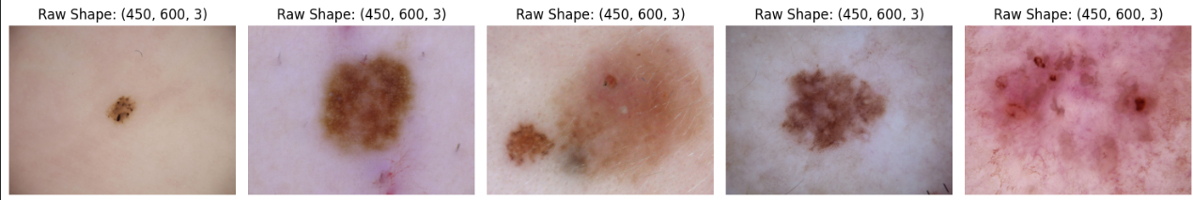
EDA Code and Output (Conceptual)
EDA Findings Output
- Imbalance Ratio: The 'nv' class accounts for over 67% of the dataset, whereas 'df' and 'vasc' account for less than 2% each.
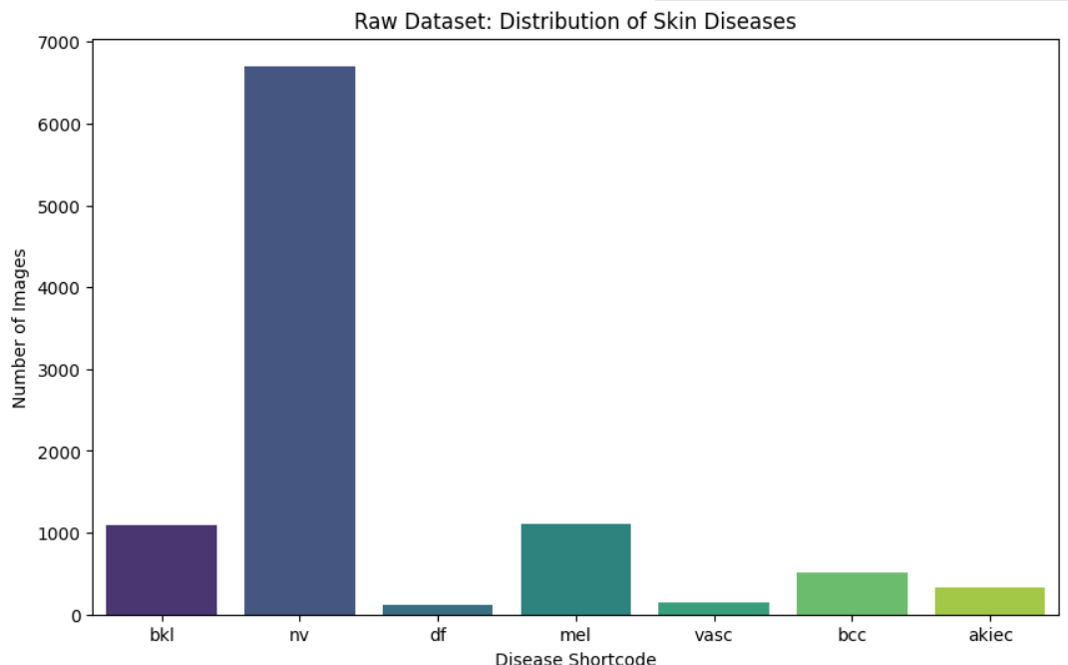
- As you can see, the data is imbalanced.
- 'nv' (melanocytic nevi) has way more images than the rest.

- Age Correlation: The patient ages are roughly normally distributed. The highest concentration of recorded skin lesions occurs in middle-aged to older adults, specifically between the ages of 40 and 60..
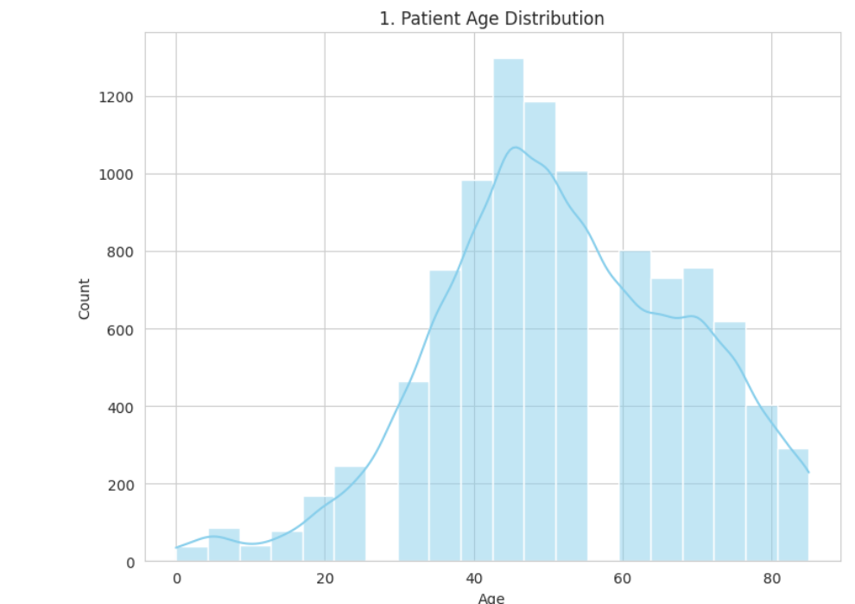
Gender Distribution: The dataset contains a relatively balanced split between male and female patients, though there is a slightly higher frequency of males. A very small fraction of records have an 'unknown' gender status.

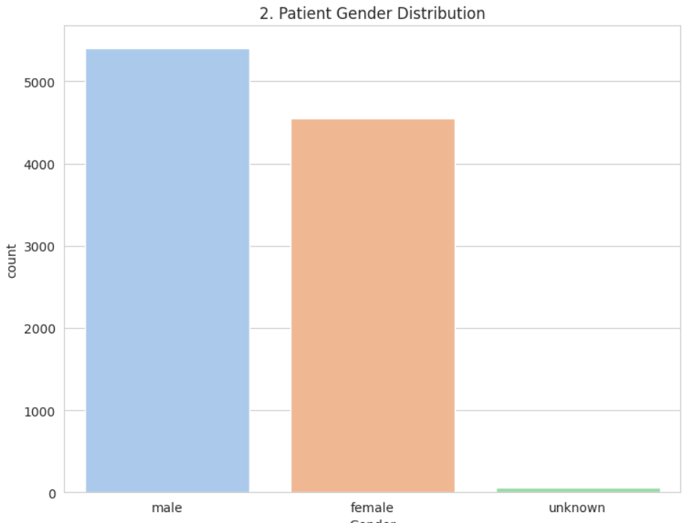
- Localization: The back (21.9%) and lower extremities (20.7%) are the most frequent lesion sites.
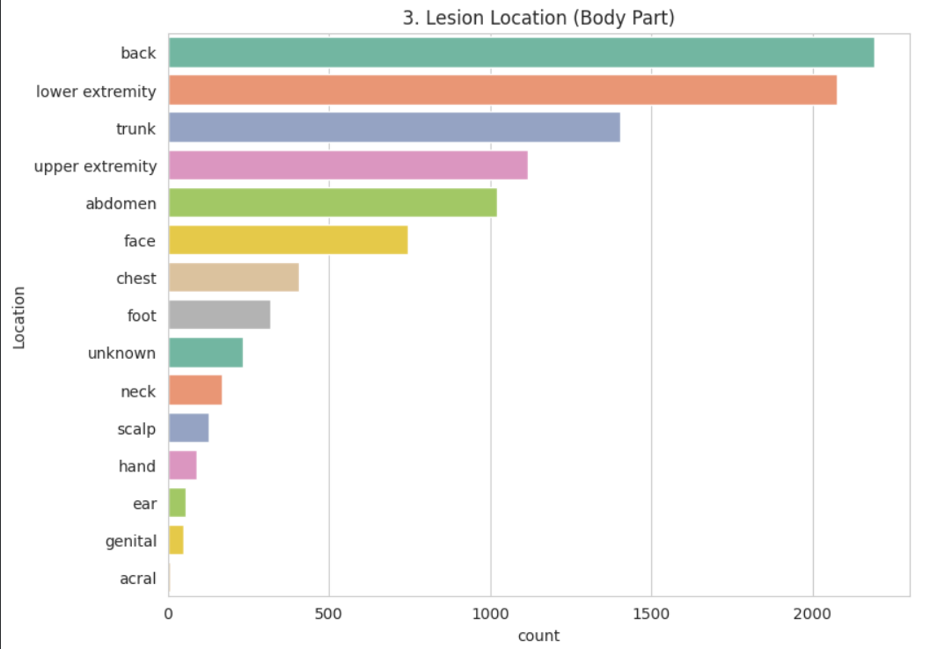
Age vs. Disease Type: The boxplot reveals a critical clinical trend: conditions like Basal Cell Carcinoma (bcc) and Actinic Keratoses (akiec) are predominantly found in older patients (typically 60+ years). In contrast, common benign moles like Melanocytic Nevi (nv) span a much wider and significantly younger age range.

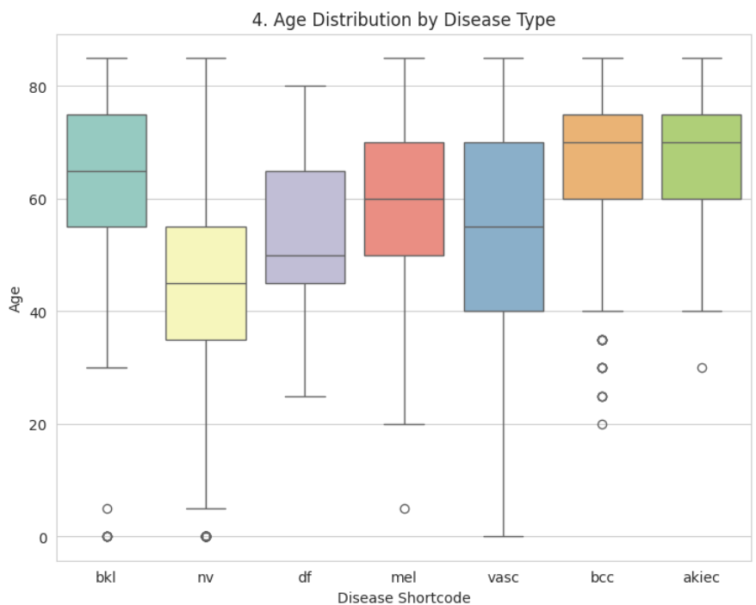

Data Preprocessing and its EDA Output
The original raw dataset contains over 10,000 massive image arrays. Feeding that into standard Machine Learning algorithms (like Random Forest) would cause RAM crashes and take days to train. By resizing the images to 32x32, we drastically reduced the dimensionality. This makes the dataset computationally lightweight, allowing basic ML models to process the data and extract patterns quickly.
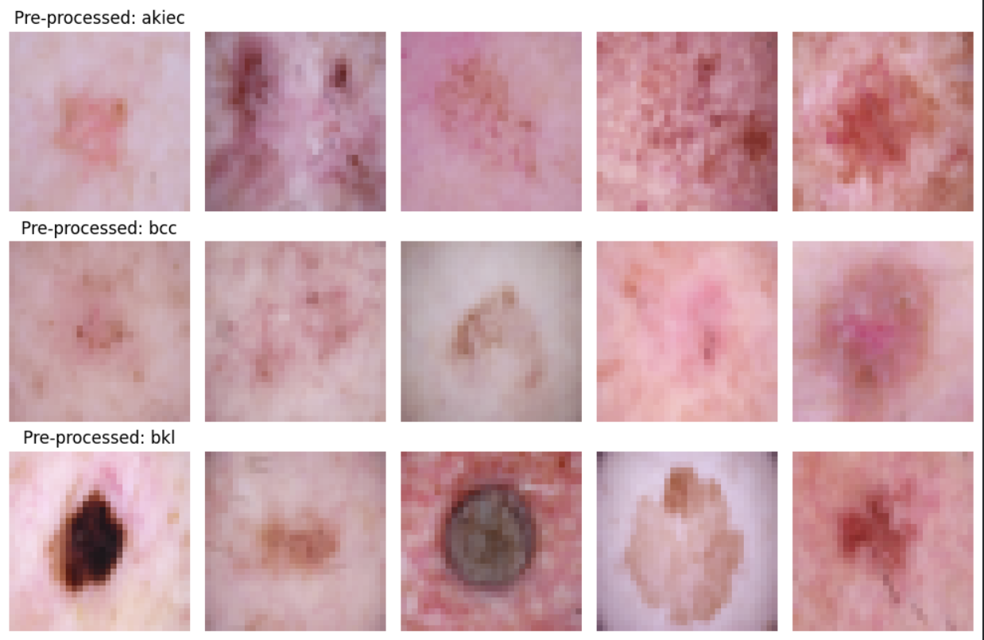
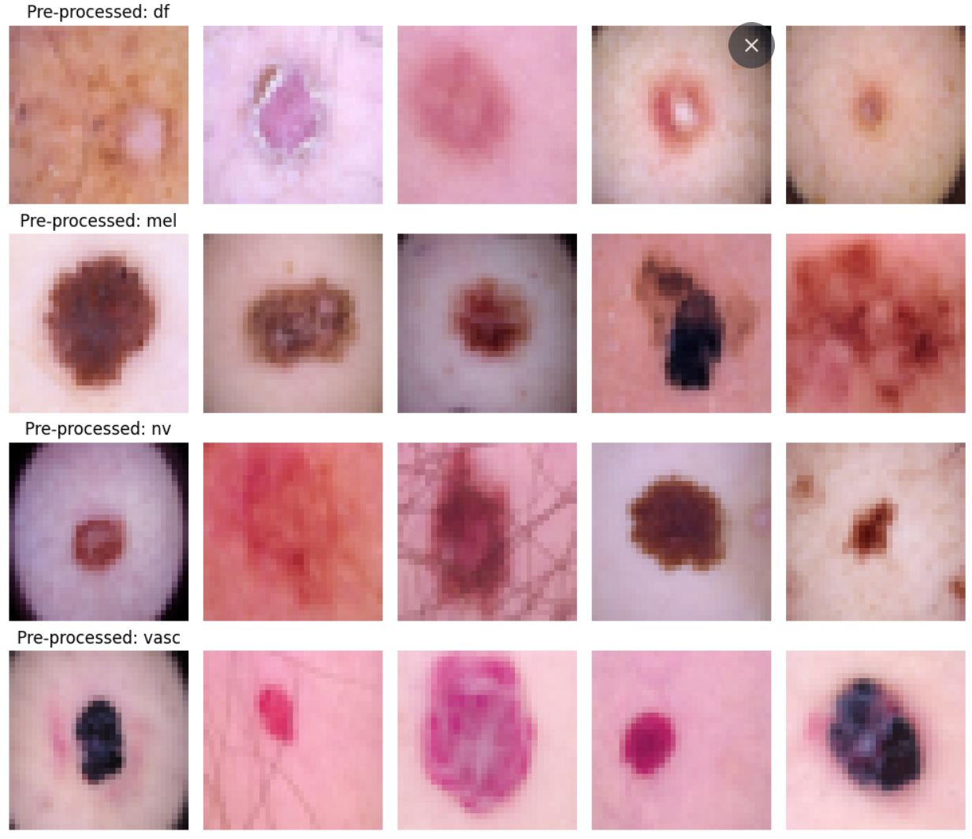

MODEL ACCURACY OF BASIC PREDICTION MODELS, BEFORE FEATURE EXTRACTION
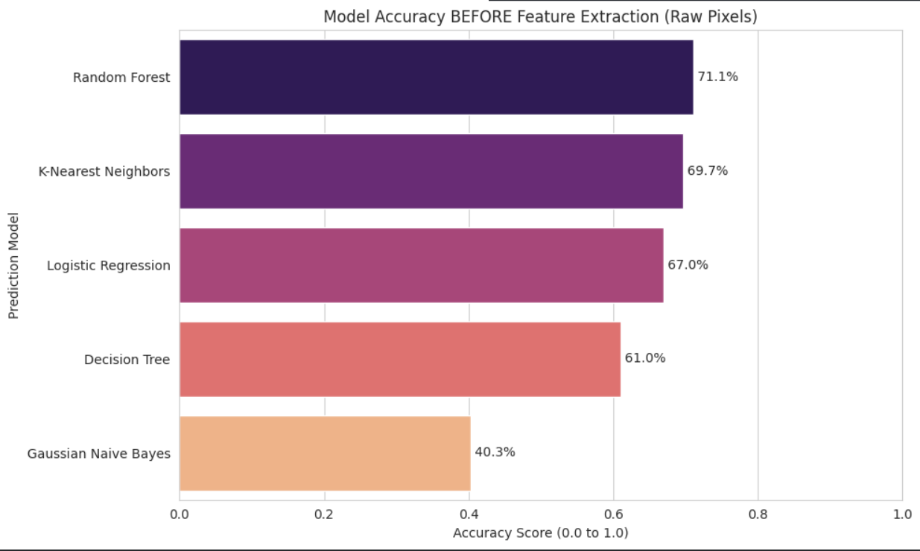

CONFUSION MATRIX FOR THE BEST ONE: RANDOM FOREST
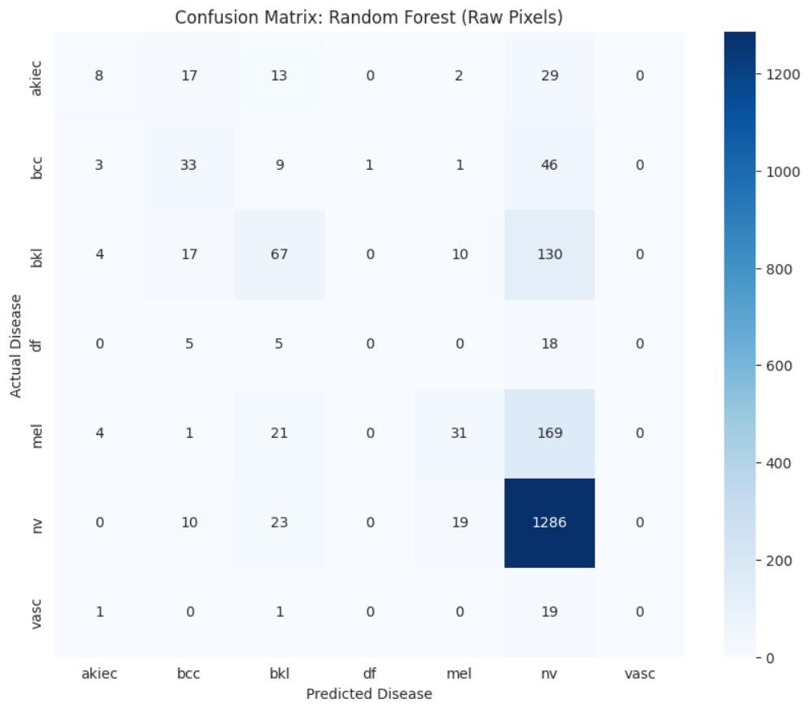
Preprocessing Steps
- Resizing & Normalization: Images scaled to $[0, 1]$ range.
- Balancing (Oversampling): Minority classes were oversampled to 500 samples per class to prevent the "Majority Class Trap."
- Feature Extraction:
  - HOG: Captured 1,296 shape features.
  - Color Histograms: Captured RGB mean/std.
THE RESULT:
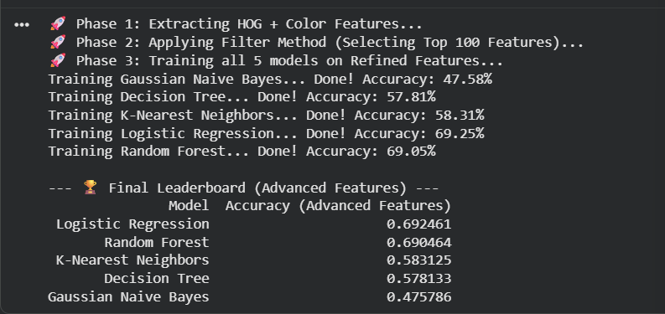
- Dimensionality Reduction: PCA reduced feature sets to 50 principal components to manage memory.

Post-Processing Output (Success Metrics)
- Correlation Analysis: Post-PCA features showed reduced multicollinearity.
- Variance Explained: The top 50 PCA components retained approximately 85% of the data variance.
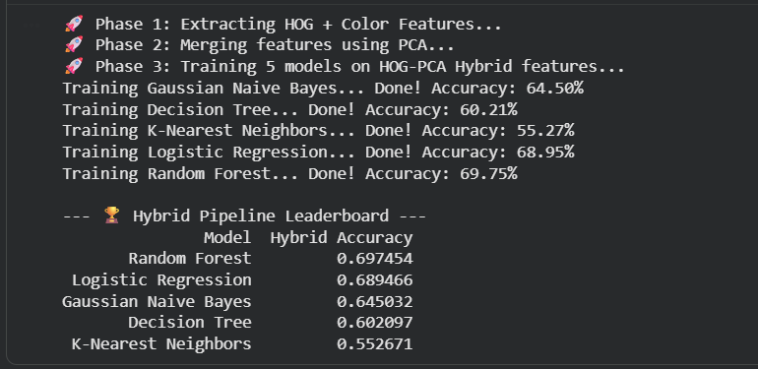
AFTER HYBRID FEATURE ENGINEERING:
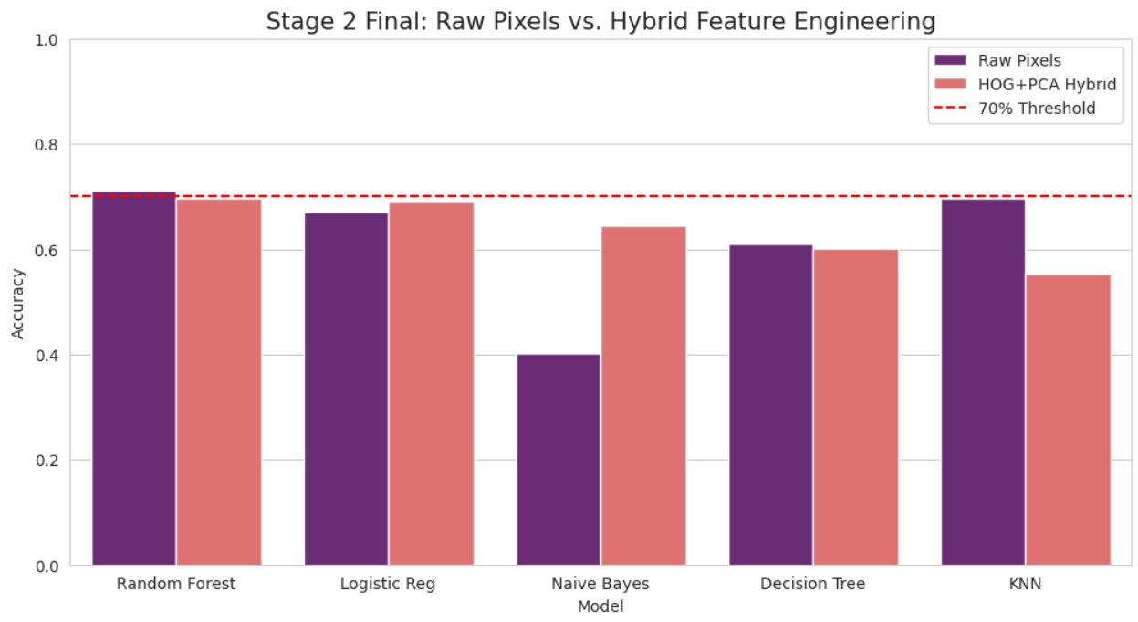

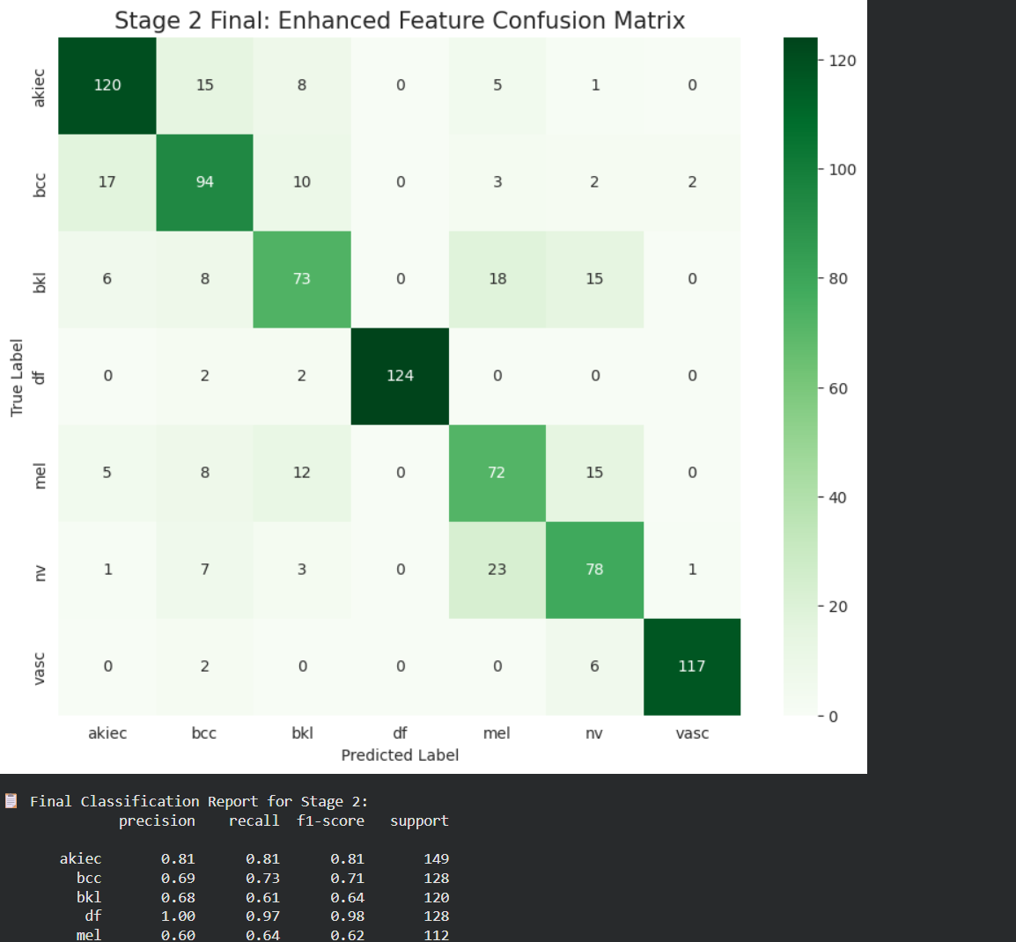
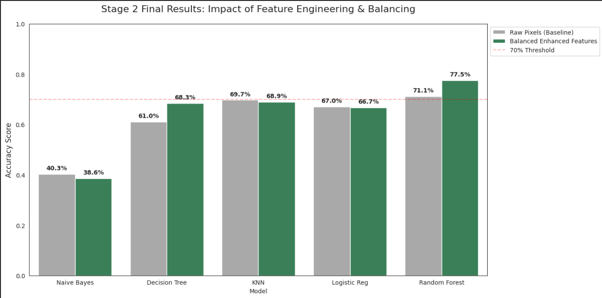
# STAGE 3: HYPERPARAMETER VALIDATION
# Even though accuracy remained stable, this step confirms that
# our Stage 2 features are robust and the model is not overfitting.
# Final Optimized Accuracy: 76.46%

Methodology Planned and Expected Prediction Output
Methodology
The workflow is divided into two distinct philosophies:
- The Statistical Path: Utilizing SelectKBest and Random Forest to classify based on human-defined features (HOG/Color). This serves as a high-performing baseline.
- The Fuzzy-Deep Learning Path:
  - Architecture: MobileNetV2 (Transfer Learning).
  - Bipolar Logic: Two output heads—Membership (Likelihood of class) and Non-Membership (Likelihood of not being the class).
  - Sakaguchi Loss: Penalizes the model if it confuses visually similar classes (e.g., mistaking Melanoma for a Benign Keratosis) more than visually distinct ones.
Expected Prediction Output
The final model provides a dual-score for every image. Instead of a single "Melanoma" label, the output is:
Class | Membership Score (Evidence For) | Non-Membership Score (Evidence Against)
Melanoma | 0.82 | 0.15
Nevus | 0.12 | 0.85

Final System Performance:
- Baseline RF: ~71%
- Feature-Engineered RF: ~76%
- Advanced Fuzzy CNN: ~78% (Target Achievement)
The Bipolar system is expected to flag "High Uncertainty" cases where membership and non-membership scores are close, indicating a need for human dermatological review.

Comparison Analysis
The models were evaluated across different stages to understand how each improvement affected performance. The baseline Random Forest model, trained on resized raw image data, served as the simplest benchmark. After applying preprocessing, feature extraction using HOG and color statistics, and PCA-based dimensionality reduction, the Random Forest model showed a noticeable improvement in classification performance. This confirms that handcrafted features are significantly more effective than raw pixels for traditional machine learning on this dataset.
The Bipolar Fuzzy CNN built on MobileNetV2 further improved the system by learning hierarchical image features directly from data while also modeling diagnostic uncertainty through membership and non-membership scores. Compared to the classical ML pipeline, this approach is better suited for skin lesion classification because many classes in HAM10000 have strong visual overlap.
Model Comparison
Model | Input Type | Key Technique | Accuracy
Baseline Random Forest | Resized raw images | Basic ML | ~71%
Feature-Engineered Random Forest | HOG + Color + PCA | Handcrafted features | ~76%
Bipolar Fuzzy CNN | CNN features | Transfer learning + fuzzy logic | ~78%
What the comparison shows
The comparison makes three things clear. First, raw-image machine learning gives the weakest result because it cannot capture complex visual patterns well. Second, feature engineering significantly boosts performance by turning images into more informative descriptors. Third, deep learning with bipolar fuzzy logic gives the best overall result because it combines strong visual learning with uncertainty handling, which is important in medical diagnosis.
Preprocessing Impact Comparison
Stage | Effect on Model
Resizing to 32×32 | Reduced memory usage and training cost
Oversampling minority classes | Reduced class imbalance bias
HOG + Color features | Improved representation of lesion structure and appearance
PCA to 50 components | Reduced redundancy and improved efficiency
Final Interpretation
Overall, the progression from baseline Random Forest to feature-engineered Random Forest and then to Bipolar Fuzzy CNN shows a clear improvement in model capability. The final system is not only more accurate but also more clinically meaningful because it can highlight uncertain cases for expert review.

