HE TRAY

You can't drink and drive, but you can definitely snack and steer!

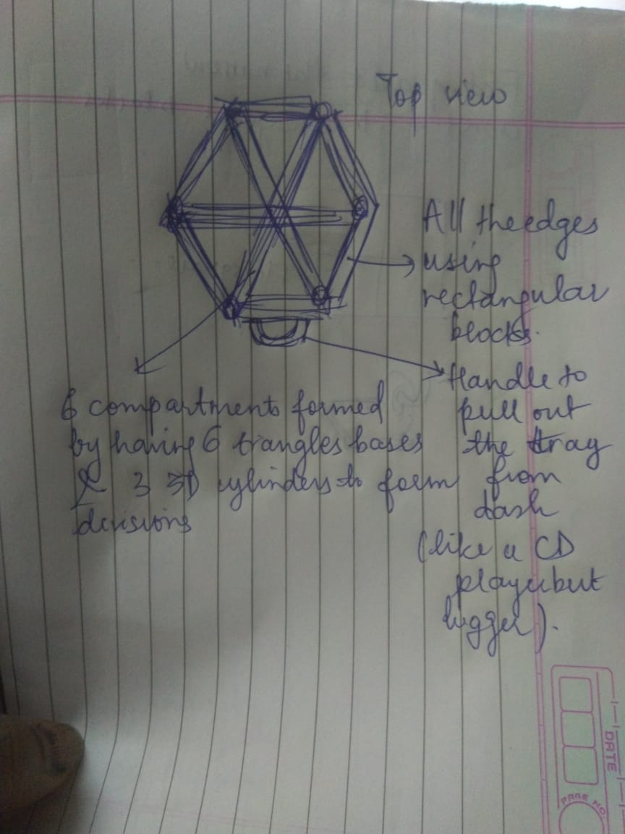

Composed of 6 flat triangles,

3 3D Cylinders,

6 3D rectangular blocks

1 3D Handle

5 Reasons I think my idea of the HexTray is creative-

1. It is of hexagon shape.
2. It has compartments to store different types of food
3. It is symmetric so no need to use the brain on where to keep the food in quick situations
4. It has rectangular sides will prevent food from falling
5. The cylinders for compartments will prevent food from mixing with other foods
6. I think the name and tagline are very innovative