CIS520 Project 4: One Program, Three Ways
Group 04: Jackson Seim, Tannyr Singleterry, Jacob Wuthnow
1) Experimental Configuration
All experiments were done on the Kansas State University’s Beocat super cluster. We used the slurm batch scheduler. Jobs were constrained to mole class nodes to keep hardware consistent.

2) What We Are Measuring
We aim to show the following performance analysis guidelines:
- Scalability: How does wall time improve as we add threads from 1 to 20?
- Parallel efficiency: Are threads being used effectively, or are they mostly idle?
- RAM usage: Does memory consumptions change with thread count or memory budget?
- I/O vs. computer balance: Is the bottleneck in the file reading or character scanning?
- Implementation comparison: How does pthreads performance compare to MPI for the same work load?
For this first part, the input file sized is fixed at 1.7 GB. We vary thread count and Slurm memory allocation. We repeat each configuration 3 times to obtain standard deviations to assess measurement noise.

3) Software Architecture: Pthreads
This design starts with N threads being crated once at start up and reused for every batch, avoiding repeated pthread_create overhead. The main thread reads lines in batches of up to 4096 using fgets(), signal workers, then waits for all processes to complete before printing results and loading the next batch.

3.1) Software Architecture: MPI
The MPI implementation distributes work across processes using a coordinator/worker pattern. Rank 0 acts as the coordinator. It reads lines form the file and uses MPI_Send to distribute batches to the workers. Each worker receives its assigned lines, computers the maximum ASCII value, and returns results to rank 0.

4) Results: Pthreads
Memory Usage
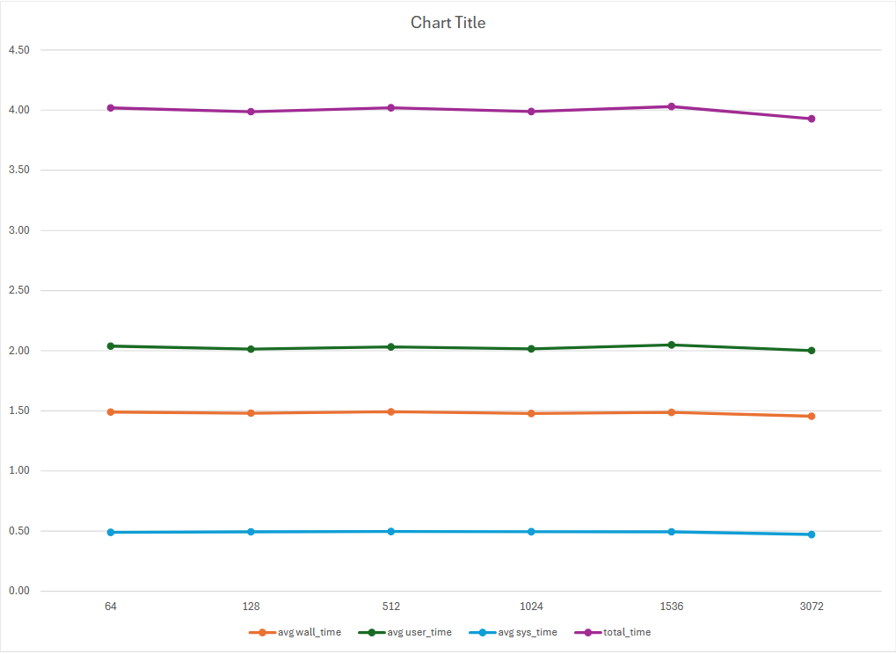
Figure 1: Shows the Amount of Memory Usage per Process.

Thread Count
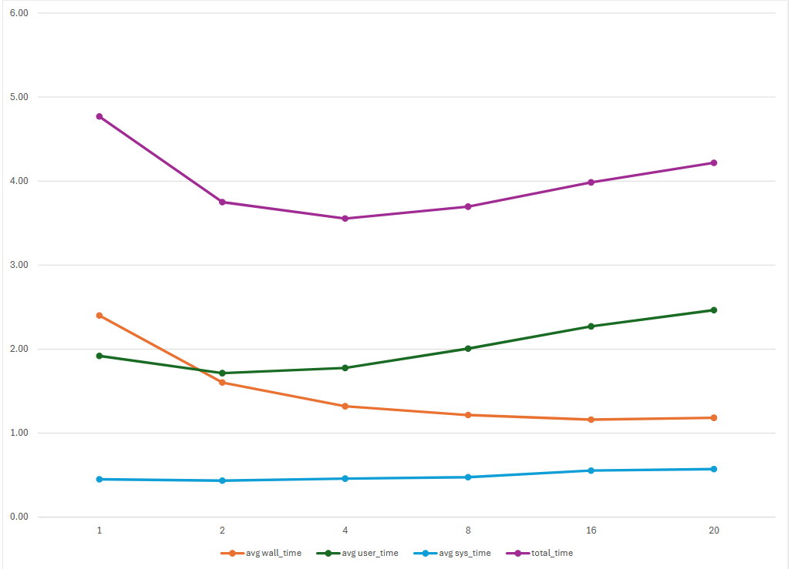
Figure 2: Shows the Number of Threads per Process Over Time

Threads | Mean Wall (s) | Speedup | CPU Efficiency | Peak RSS (MB)
1 | 2.400 | 1.00 | 98.7% | 25.6
2 | 1.602 | 1.50 | 67.0% | 25.5
4 | 1.321 | 1.82 | 42.3% | 25.5
8 | 1.216 | 1.97 | 25.5% | 25.5
16 | 1.161 | 2.07 | 15.2% | 25.4
20 | 1.183 | 2.03 | 12.8% | 25.4

4.1) Results: MPI
Memory Usage
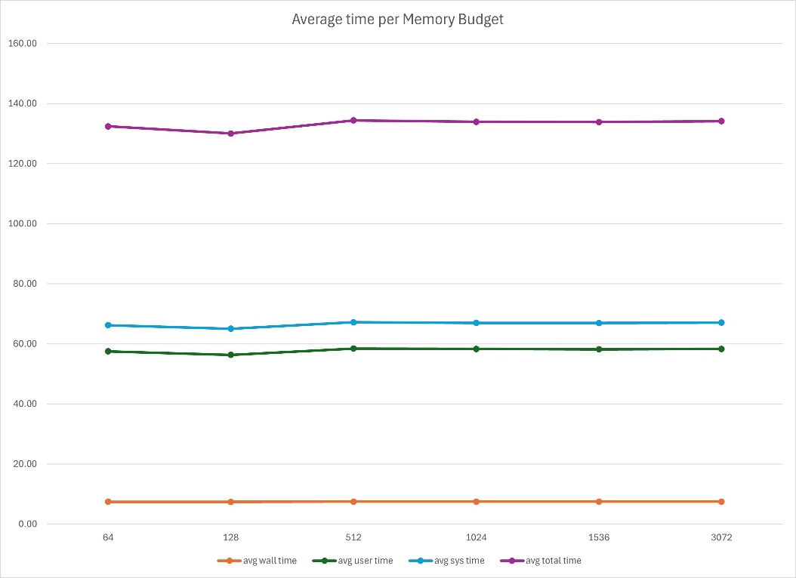
Figure 3: Average Time per Memory Budget per Process.

Like pthreads, memory budget has not measurable effect on MPI wall time. Average wall time stays flat at about 7.6s regardless of budget. However, unlike pthreads, MPI peak RSS does decrease as process count increases, each rank only holds its portion of the data.

Process Count
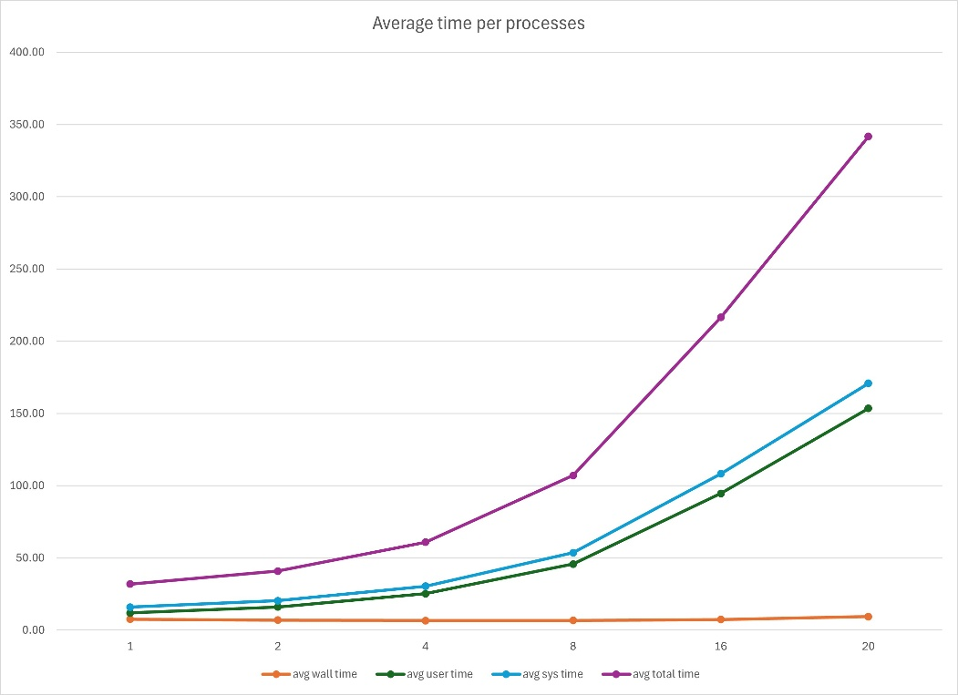
Figure 4: Average Time per Process.

Threads | Mean Wall (s) | Speedup | CPU Efficiency | Peak RSS (MB)
1 | 7.594 | 1.00 | 110.0% | 82.1
2 | 6.941 | 1.09 | 97.2% | 66.8
4 | 6.624 | 1.15 | 89.8% | 59.0
8 | 6.748 | 1.13 | 86.6% | 55.6
16 | 7.387 | 1.03 | 85.3% | 54.6
20 | 9.411 | 0.81 | 85.7% | 54.1

5) Discussion
Pthreads
The pthreads workload is I/O bound at the application level. The main thread’s fgets() loop serializes all file reads, creating a ceiling on parallel speedup regardless of how many worker threads are added. Here are major takeaways from the analysis:
- I/O is the dominant bottleneck. Wall time drops from 2.40s at 1 thread to 1.60s at 2 threads, but plateaus at 1.16s beyond 8 threads.
- Diminishing returns beyond 4 threads. Going from 1 to 2 threads saves 0.80s. Going from 8 to 20 threads saves only 0.05s.
- CPU efficiency collapses with thread count. At 20 threads, efficiency falls to 12.8% meaning threads spend 87% of their time blocked on cond_go waiting for the main thread to finish reading each back.
MPI
The MPI implementation shows a different and problematic scaling pattern. While CPU efficiency remains high, wall time barely improves and degrades beyond 8 processes. Here are major takeaways from the analysis:
- Wall time barely improves, then worsens. Best wall time is 6.62s at 4 processes. Beyond 4, wall time increases, reaching 9.41s at 20 processes, which is ~24% slower than the 1 process baseline
- Communication overhead dominates. The rank 0 coordinator must sequentially send batches to and receive results form every worker process. As process count grows, this serialized communication loop grows proportionally, overwhelming any parallel benefit from the distributed computation.
- Memory per process decreases with more processes. Peak RSS drops from 82.1 MB at 1 process to 54.1 MB at 20 processes, since each rank only holds its portion of the line buffer.

