PLL=148.5 MHz
First read from memory (from .rgb file)
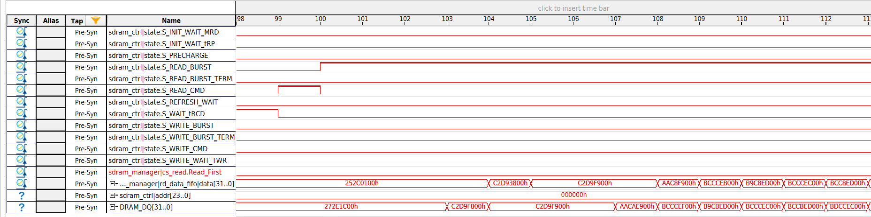

PLL=100 MHz
First write (512 words) to SDRAM
