**DAILY ONLINE ACTIVITIES SUMMARY**

|  |  |  |  |  |  |  |  |
| --- | --- | --- | --- | --- | --- | --- | --- |
| **Date:** | **05-06-20** | | | | **Name:** | **TANOJ M** | |
| **Sem & Sec** | **VI A** | | | | **USN:** | **4AL16CS113** | |
| **Online Test Summary** | | | | | | | |
| **Subject** | | **OR IA** | | | | | |
| **Max. Marks** | | **30** | | **Score** | | **30** | |
| **Certification Course Summary** | | | | | | | |
| **Course** | **FRONT END DEVELOPMENT-CSS** | | | | | | |
| **Coding Challenges** 1) Java program to implement Circular Linked List Using Array And Class 2)Python program to square each odd number in the list  3)The program takes a string and removes the nth index character from the non-empty string. | | | | | | | |
| **Certificate Provider** | | | **Great learning** | **Duration** | | | **3 days** |
| **Status:Completed** | | | | | | | |
| **Uploaded the report in Github** | | | | **Yes** | | | |
| **If yes Repository name** | | | | **https://github.com/Tanoj8296/DAILY-STATUS** | | | |
| **Uploaded the report in slack** | | | | **Yes** | | | |

**IA MARKS DETAILS:**

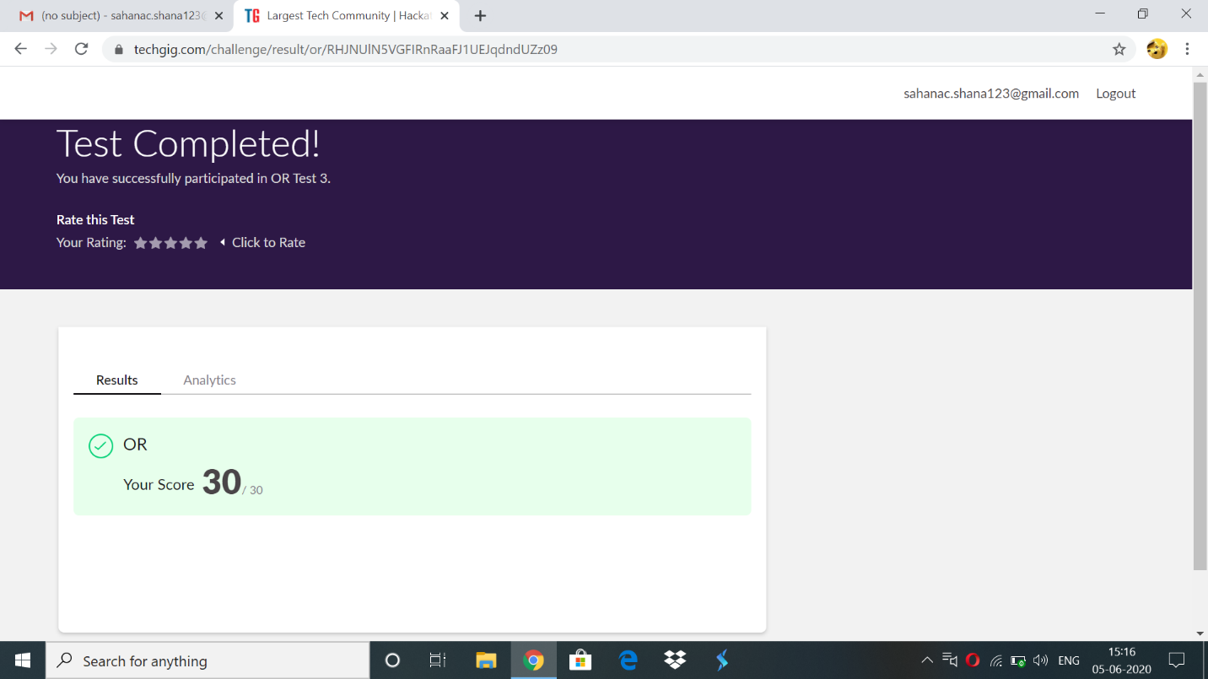

**Online Certification Details:**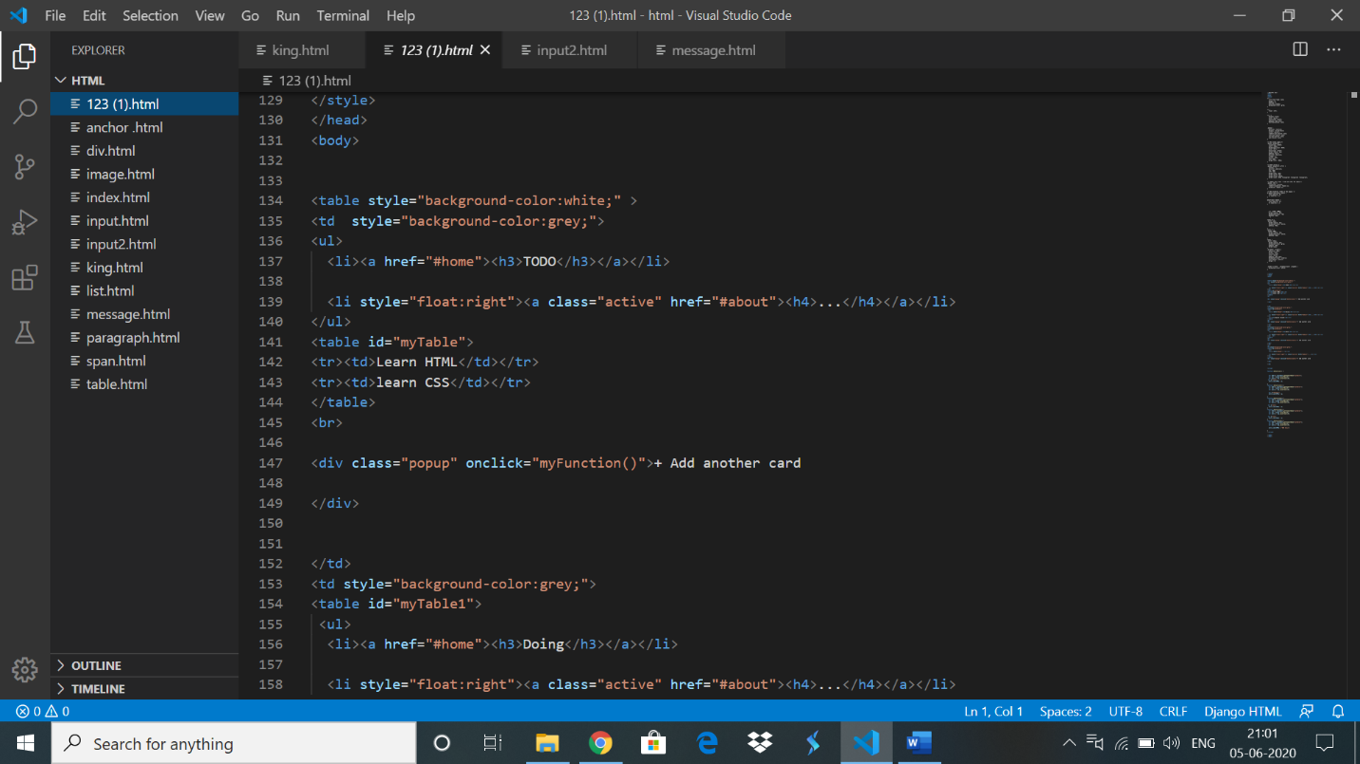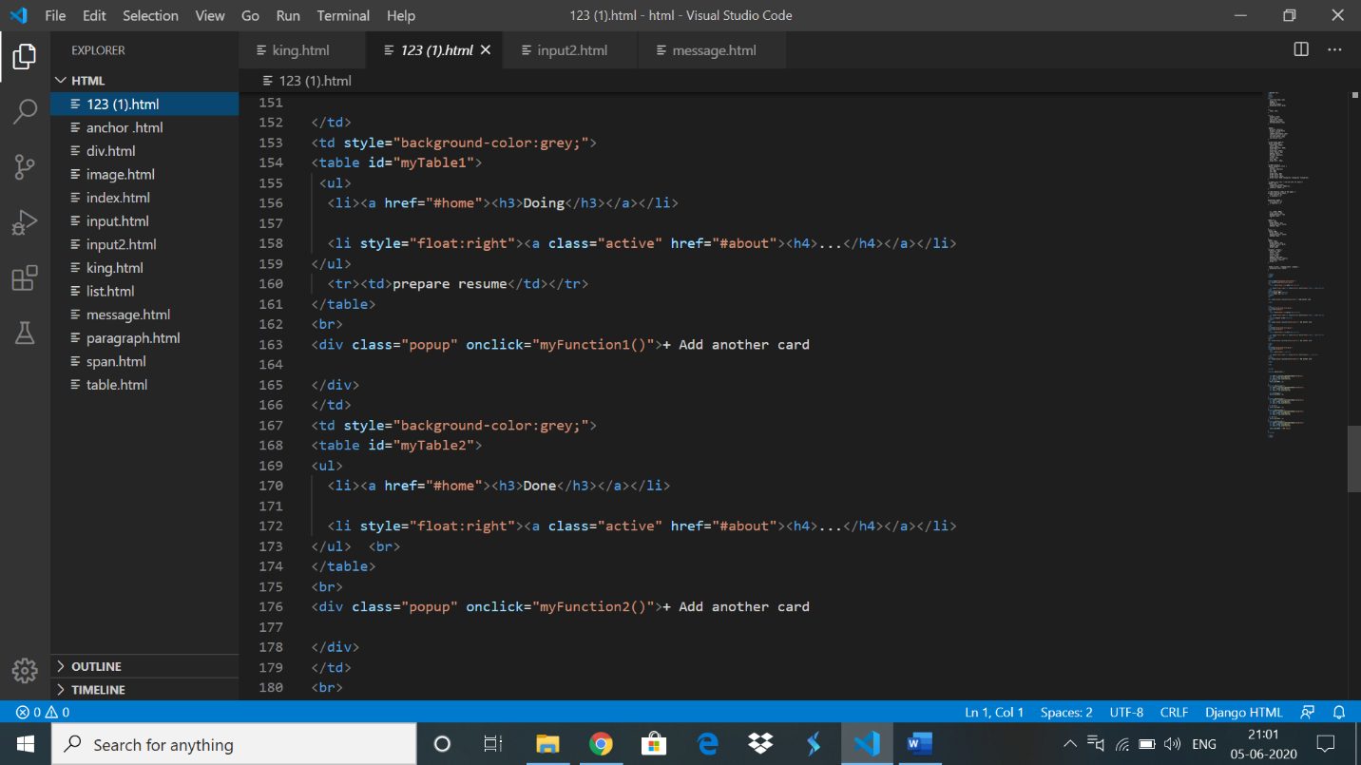



**Online coding:**

**1)**

*Java Program to Implement Circular Singly Linked List*

**package** friday;

**import** java.util.*;

**public** **class** CircularSinglyLinkedList {

**public** **static** **void** main(String[] args)

{

Scanner scan = **new** Scanner(System.***in***);

/* Creating object of linkedList */

linkedList list = **new** linkedList();

System.***out***.println("Circular Singly Linked List Test\n");

**char** ch;

/* Perform list operations */

**do**

{

System.***out***.println("\nCircular Singly Linked List Operations\n");

System.***out***.println("1. insert at begining");

System.***out***.println("2. insert at end");

System.***out***.println("3. insert at position");

System.***out***.println("4. delete at position");

System.***out***.println("5. check empty");

System.***out***.println("6. get size");

**int** choice = scan.nextInt();

**switch** (choice)

{

**case** 1 :

System.***out***.println("Enter integer element to insert");

list.insertAtStart( scan.nextInt() );

**break**;

**case** 2 :

System.***out***.println("Enter integer element to insert");

list.insertAtEnd( scan.nextInt() );

**break**;

**case** 3 :

System.***out***.println("Enter integer element to insert");

**int** num = scan.nextInt() ;

System.***out***.println("Enter position");

**int** pos = scan.nextInt() ;

**if** (pos <= 1 || pos > list.getSize() )

System.***out***.println("Invalid position\n");

**else**

list.insertAtPos(num, pos);

**break**;

**case** 4 :

System.***out***.println("Enter position");

**int** p = scan.nextInt() ;

**if** (p < 1 || p > list.getSize() )

System.***out***.println("Invalid position\n");

**else**

list.deleteAtPos(p);

**break**;

**case** 5 :

System.***out***.println("Empty status = "+ list.isEmpty());

**break**;

**case** 6 :

System.***out***.println("Size = "+ list.getSize() +" \n");

**break**;

**default** :

System.***out***.println("Wrong Entry \n ");

**break**;

}

/* Display List */

list.display();

System.***out***.println("\nDo you want to continue (Type y or n) \n");

ch = scan.next().charAt(0);

} **while** (ch == 'Y'|| ch == 'y');

}

}

**package** friday;

**class** linkedList {

**protected** Node start ;

**protected** Node end ;

**public** **int** size ;

/* Constructor */

**public** linkedList()

{

start = **null**;

end = **null**;

size = 0;

}

/* Function to check if list is empty */

**public** **boolean** isEmpty()

{

**return** start == **null**;

}

/* Function to get size of the list */

**public** **int** getSize()

{

**return** size;

}

/* Function to insert element at the begining */

**public** **void** insertAtStart(**int** val)

{

Node nptr = **new** Node(val,**null**);

nptr.setLink(start);

**if**(start == **null**)

{

start = nptr;

nptr.setLink(start);

end = start;

}

**else**

{

end.setLink(nptr);

start = nptr;

}

size++ ;

}

/* Function to insert element at end */

**public** **void** insertAtEnd(**int** val)

{

Node nptr = **new** Node(val,**null**);

nptr.setLink(start);

**if**(start == **null**)

{

start = nptr;

nptr.setLink(start);

end = start;

}

**else**

{

end.setLink(nptr);

end = nptr;

}

size++ ;

}

/* Function to insert element at position */

**public** **void** insertAtPos(**int** val , **int** pos)

{

Node nptr = **new** Node(val,**null**);

Node ptr = start;

pos = pos - 1 ;

**for** (**int** i = 1; i < size - 1; i++)

{

**if** (i == pos)

{

Node tmp = ptr.getLink() ;

ptr.setLink( nptr );

nptr.setLink(tmp);

**break**;

}

ptr = ptr.getLink();

}

size++ ;

}

/* Function to delete element at position */

**public** **void** deleteAtPos(**int** pos)

{

**if** (size == 1 && pos == 1)

{

start = **null**;

end = **null**;

size = 0;

**return** ;

}

**if** (pos == 1)

{

start = start.getLink();

end.setLink(start);

size--;

**return** ;

}

**if** (pos == size)

{

Node s = start;

Node t = start;

**while** (s != end)

{

t = s;

s = s.getLink();

}

end = t;

end.setLink(start);

size --;

**return**;

}

Node ptr = start;

pos = pos - 1 ;

**for** (**int** i = 1; i < size - 1; i++)

{

**if** (i == pos)

{

Node tmp = ptr.getLink();

tmp = tmp.getLink();

ptr.setLink(tmp);

**break**;

}

ptr = ptr.getLink();

}

size-- ;

}

/* Function to display contents */

**public** **void** display()

{

System.***out***.print("\nCircular Singly Linked List = ");

Node ptr = start;

**if** (size == 0)

{

System.***out***.print("empty\n");

**return**;

}

**if** (start.getLink() == start)

{

System.***out***.print(start.getData()+ "->"+ptr.getData()+ "\n");

**return**;

}

System.***out***.print(start.getData()+ "->");

ptr = start.getLink();

**while** (ptr.getLink() != start)

{

System.***out***.print(ptr.getData()+ "->");

ptr = ptr.getLink();

}

System.***out***.print(ptr.getData()+ "->");

ptr = ptr.getLink();

System.***out***.print(ptr.getData()+ "\n");

}

}

**package** friday;

**class** Node {

**protected** **int** data;

**protected** Node link;

/* Constructor */

**public** Node()

{

link = **null**;

data = 0;

}

/* Constructor */

**public** Node(**int** d,Node n)

{

data = d;

link = n;

}

/* Function to set link to next Node */

**public** **void** setLink(Node n)

{

link = n;

}

/* Function to set data to current Node */

**public** **void** setData(**int** d)

{

data = d;

}

/* Function to get link to next node */

**public** Node getLink()

{

**return** link;

}

/* Function to get data from current Node */

**public** **int** getData()

{

**return** data;

}

**OUTPUT:-**

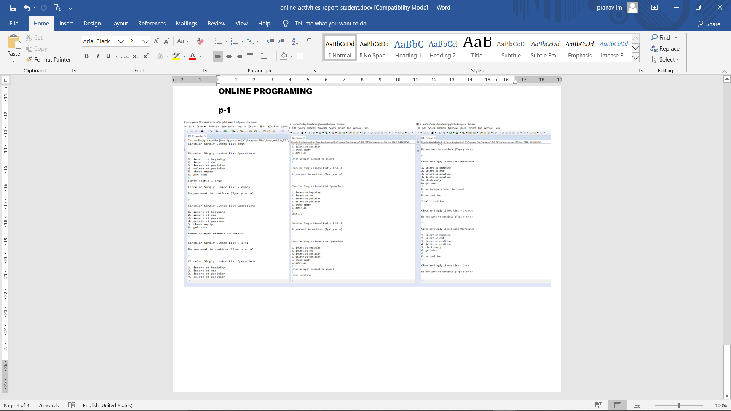

2) Python program to square each odd number in the list

l=[]

n=int(input("enter n value\n"))

print("enter list elements\n")

for i in range(0,n):

  a=int(input())

  l.append(a)

print("list is : ",l)

print("output\n")

for i in l:

  if(i%2!=0):

    print(i*i,end=" ")

OUTPUT:

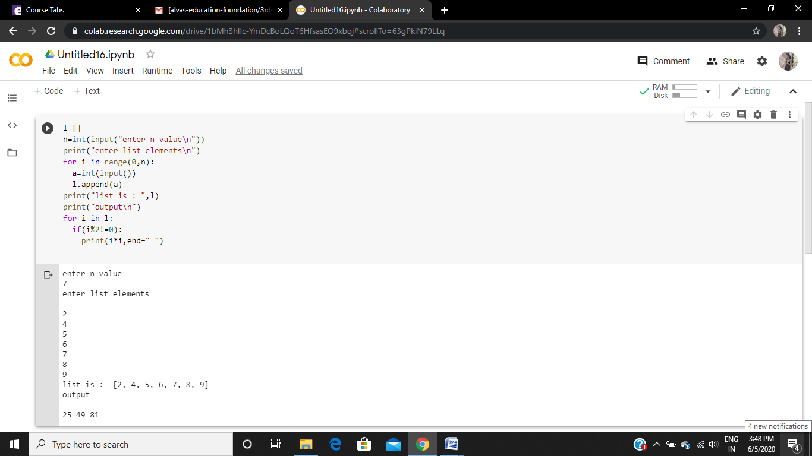

3) **The program takes a string and removes the nth index character from the non-empty string.**

s = input("Enter The String: ")

n = int(input("Enter Index Position(Starts from 0) To Remove Character: "))

print("The Final String: ", s[:n] + s[n+1:])

**Output:**

